House Price Analysis

- Introduction
This report analyses a housing dataset to understand factors that influence house prices. The analysis includes data visualization, correlation analysis and regression modelling. The goal of this analysis is to identify which variables are strongly related to house price and to build a model to predict house prices for new houses.
- Explanation of the dataset
The dataset has 996 properties and different variables such as: Square Footage, Number of bedrooms, Number of bathrooms, Year built, Lot size, Garage size and Neighbourhood quality. The main variable, we used for this analysis is the House Price.

- Comprehensive descriptive analysis
Figure 1:
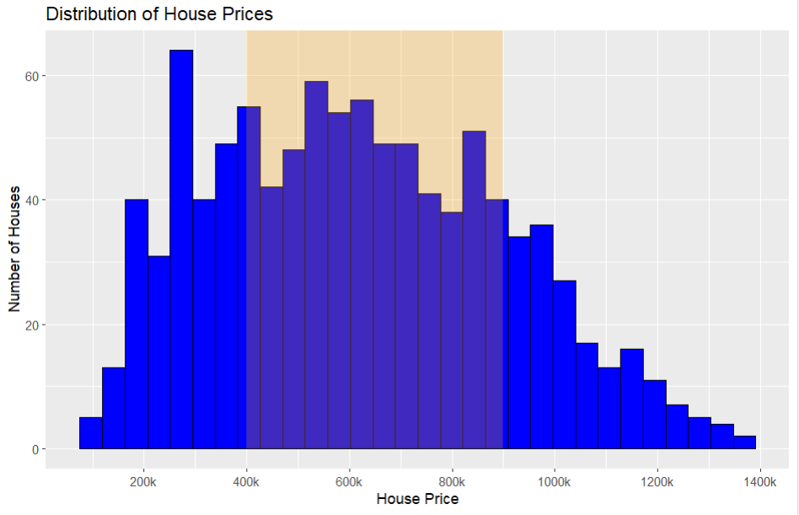
This histogram shows the distribution of house prices. Most houses fall between £400k and £900k, which is the main price range in the dataset. The graph is right-skewed, meaning there are few houses are very expensive.
Figure 2:
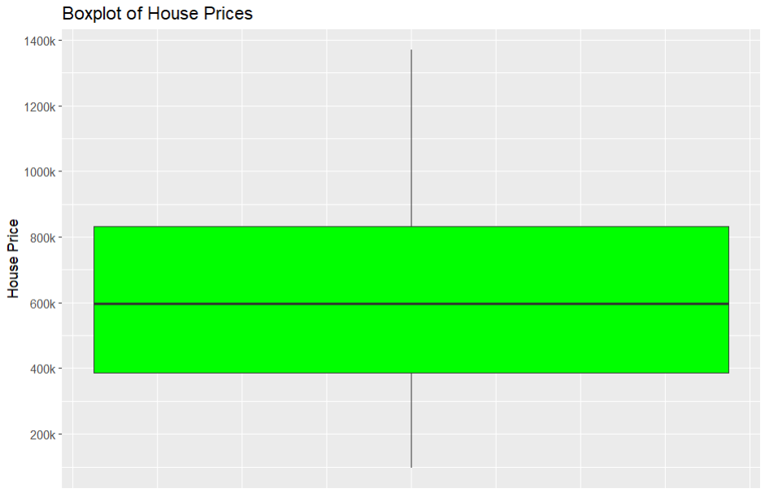
The boxplot shows how house prices are spread in the dataset. The middle line represents the median house price, which is around £600k. Most houses are priced roughly between £400k and £900k. The lines extending from the box show the overall range of prices, from about £150k up to around £1.35M. This means most houses are in the middle price range, while only a few houses are very expensive.

Figure 3:
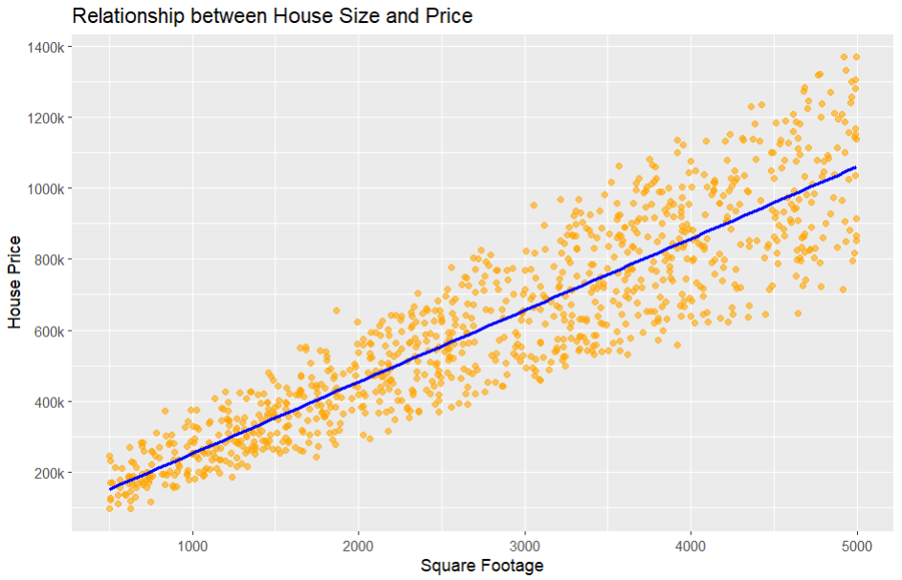
This graph was created to analyse the relationship between square footage and house price. Each dot on the graph represents a house. The blue line, calls regression line, shows the trend between the variables. This graph has positive relationship what means larger houses tend to be more expensive.

Figure 4:
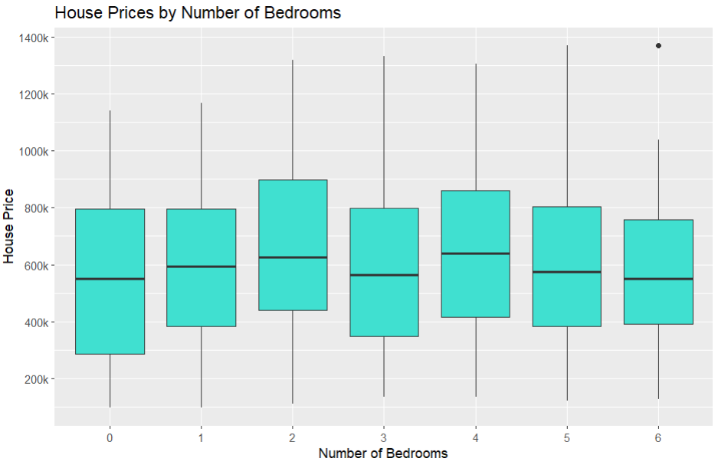
The boxplot compares house prices for different numbers of bedrooms. Each box shows how prices are spread within that bedroom group, and the line inside the box shows the middle price. Houses with two to four bedrooms generally have higher average prices. There is also one very expensive house in the six-bedroom group, which appears as an outlier.

Figure 5:
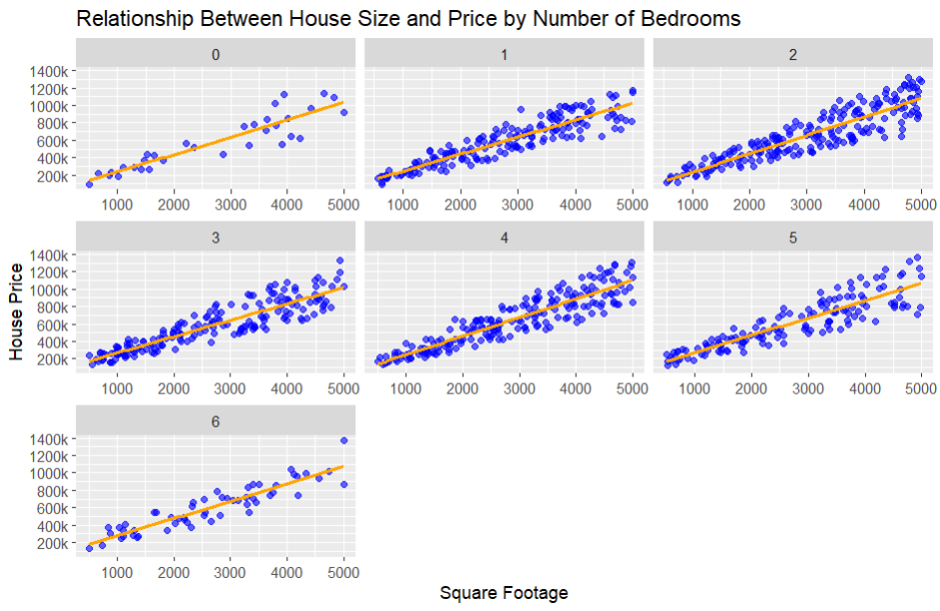
This set of graphs shows how house size affects price for houses with different numbers of bedrooms. Each panel represents houses with a specific number of bedrooms. In every panel, the line goes upward, which means that larger houses generally more expensive. This panels shows that house size has a strong influence on house price.

Figure 6:
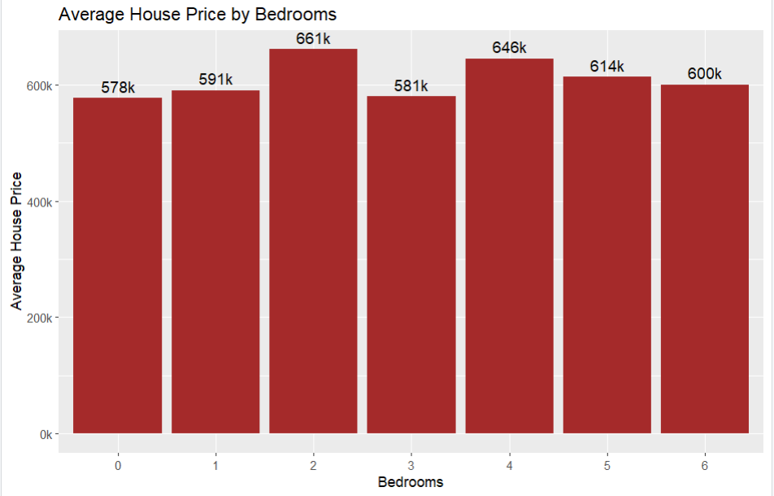
The bar chart shows the average house price for different numbers of bedrooms. Mean values were calculated and labelled above each bar. This graph shows how the average price change as the number of the bedrooms changes.

Figure 7:
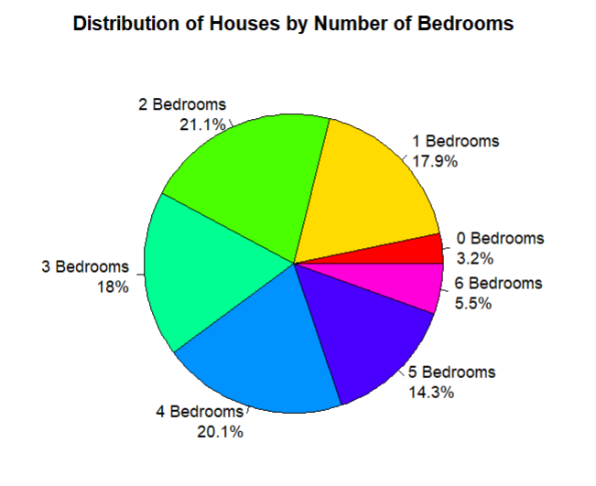
This pie chart shows the proportion of houses by the number of bedrooms. This graph helps to understand which bedroom types are the most common.

Figure 8:
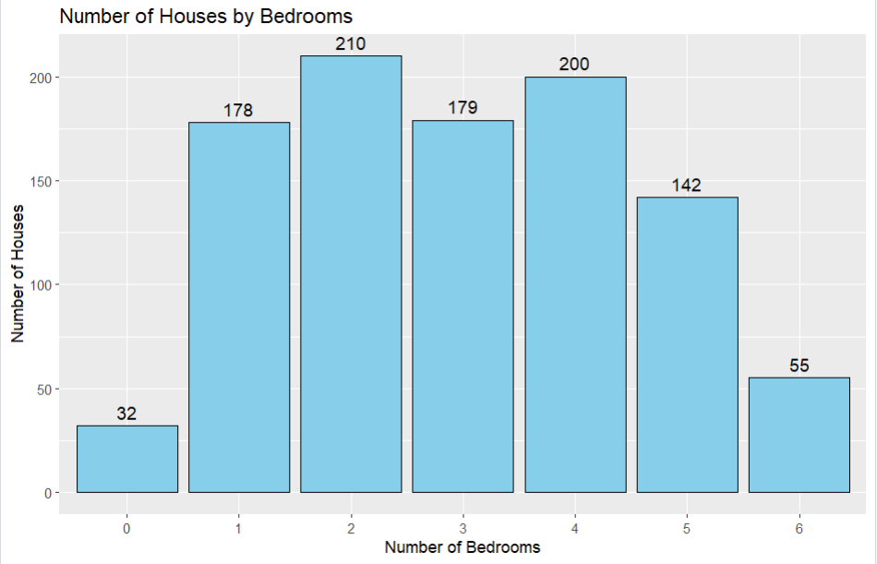
This graph shows how many houses exist in each bedroom category. The numbers above the bars represent the exact number of properties in each bedroom group, helping us see which types of properties are the most common in the dataset.

- Correlation Analysis
Correlation analysis was performed to examine how House Price is related to other variables. Correlation matrix was created from the numerical variables.
Figure 9:
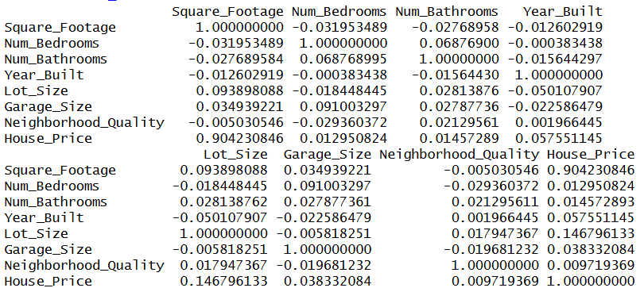
The following results shows that Square Footage has the strongest relationship with House Price compared to the other variables (r = 0.904).
Figure 10:
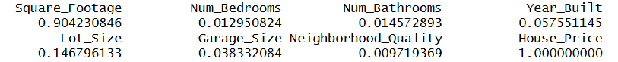
This means that larger houses tend to be more expensive.

- Regression Model
A multiple linear regression model was created to examine how different variables influence house price.
Figure 11:
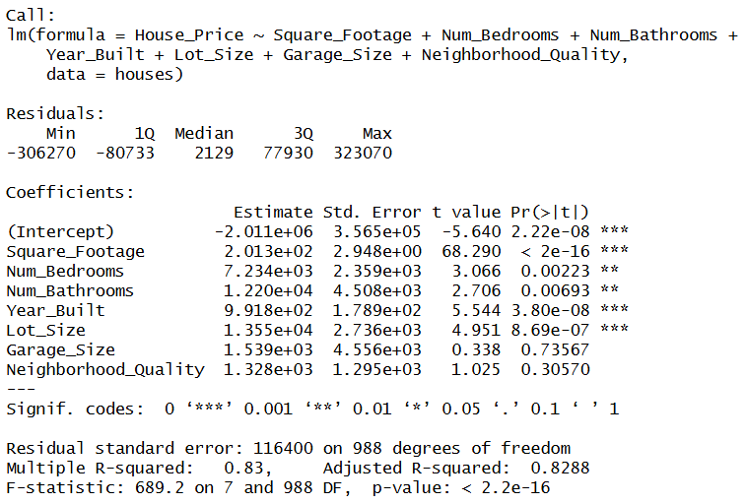
The regression model shows the coefficients for each variable. Coefficients explains how house price change if one variable changes and the rest stays as they are.
p-value show what variable has the biggest effect on House Price.
R-squared that 83% of the variation in house prices can be explained by the model.
The results also confirm the earlier correlation analysis, which showed that Square Footage has the strongest relationship with House Price.

- VIF test
The Variance Inflation Factor (VIF) was calculated to check how strongly the variables are related to each other.
Figure 12:
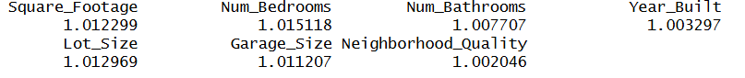
In this model all VIF values are close to 1, which means variables are independent and the regression results are reliable

- Cook’s Distance
Cook’s Distance was used to identify observations that could strongly influence the regression model.
Figure 13:
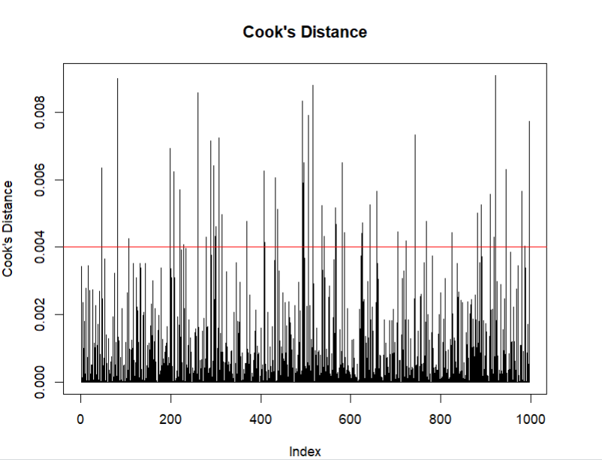
Cook’s Distance was used to check if any houses have too much influence on the regression model. The red line shows the limit used to detect influential observations (4/n). In this dataset the limit is approximately 0.004. Most observations are below this line, which means that most houses do not strongly affect the model.
A few observations are above the line, but their values are still small, so no single house has a large influence on the regression results.

- Leverage Values
This model were used to check if any observations have unusual predictor values that could affect het regression model.
Figure 14:
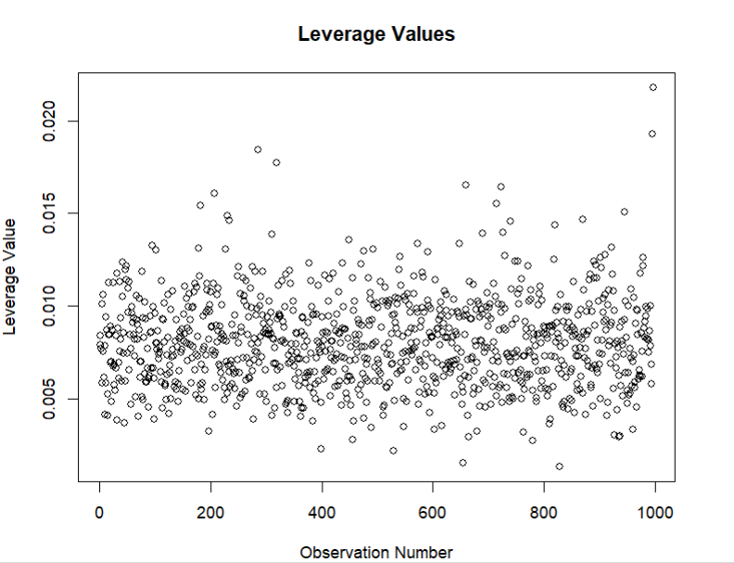
The graph shows the leverage values for all observations. Most values are low, which means that most houses do not have unusual predictor values and the model is not strongly influenced by any single observation.

- Diagnostic Plots
Figure 15:
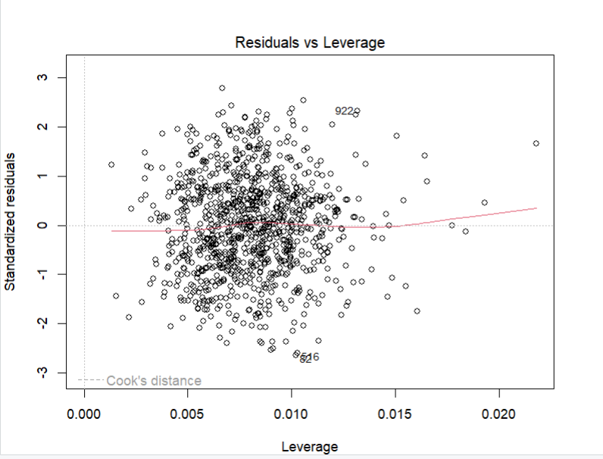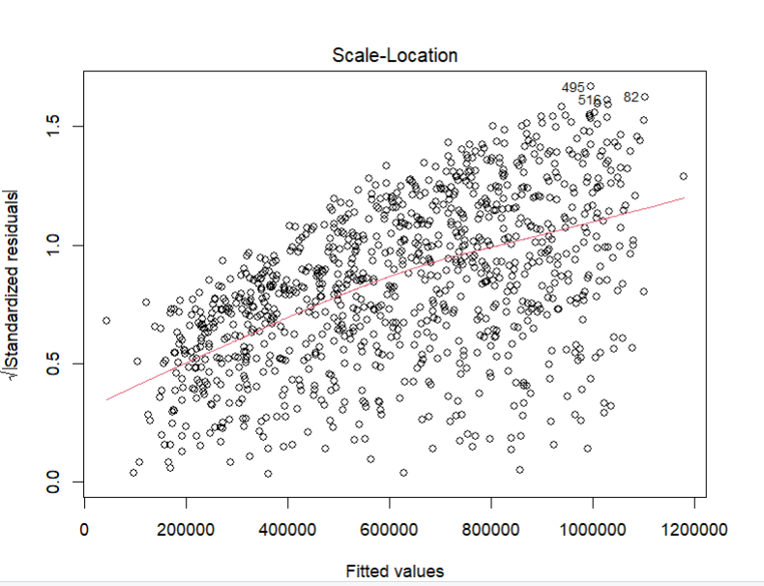
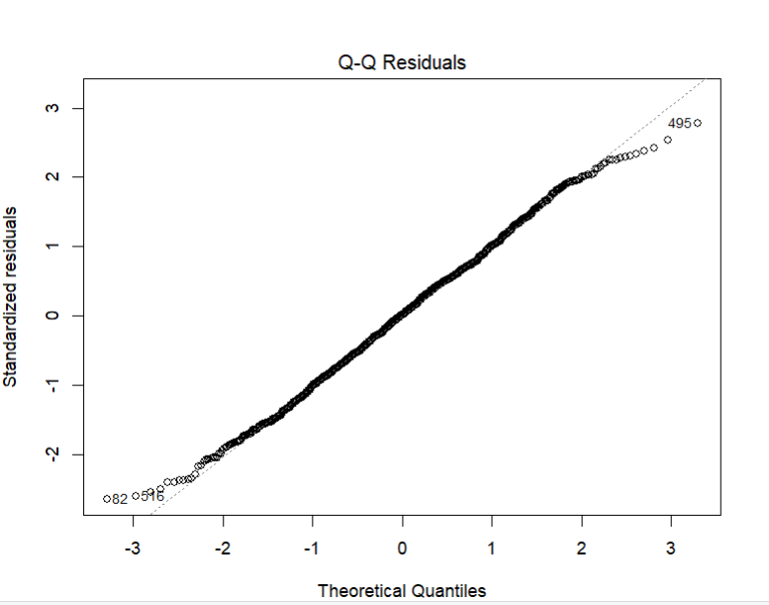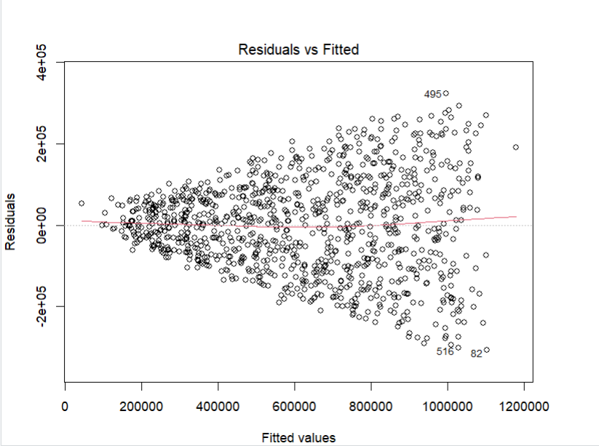
Diagnostic plots is to check if the regression model meets the main assumptions. The plots help identify patterns, unusual observations, or problems in the model.

- House Price Prediction
Figure 16:
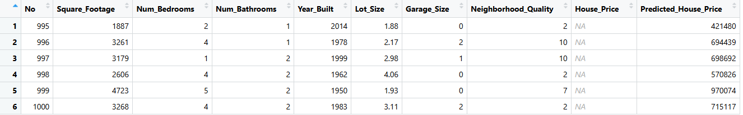
The regression model was used to predict house prices for new houses in the test dataset. The predicted price were added in a new column called Predicted_House_Price. These predictions show how the model can predict house prices based on the characteristics of the houses.

- Conclusion
This analysis examined the factors that influence house prices using data visualisation, correlation analysis, and regression modelling. The results show that Square Footage has the strongest relationship with House Price, meaning that larger houses tend to be more expensive. The regression model explains a large proportion of the variation in house prices, with an R-squared value of about 0.83. Diagnostic tests also showed that the model does not have major problems. Overall, the model provides a useful way to estimate house prices based on the characteristics of a house.

