CEU-R-Tools-Project

## This is my new project

install.packages('data.table') install.packages('nycflights13') install.packages('dplyr') install.packages("lubridate") install.packages("tidyr") install.packages("pander")

# CLEAR MEMORY

rm(list = ls())

library(nycflights13)

## Warning: package 'nycflights13' was built under R version 3.3.2

library(data.table)

## Warning: package 'data.table' was built under R version 3.3.2

library(dplyr)

## -------------------------------------------------------------------------

## data.table + dplyr code now lives in dtplyr.  
## Please library(dtplyr)!

## -------------------------------------------------------------------------

##   
## Attaching package: 'dplyr'

## The following objects are masked from 'package:data.table':  
##   
## between, first, last

## The following objects are masked from 'package:stats':  
##   
## filter, lag

## The following objects are masked from 'package:base':  
##   
## intersect, setdiff, setequal, union

library(ggplot2)

## Warning: package 'ggplot2' was built under R version 3.3.2

library(scales)

## Warning: package 'scales' was built under R version 3.3.2

library(plyr)

## -------------------------------------------------------------------------

## You have loaded plyr after dplyr - this is likely to cause problems.  
## If you need functions from both plyr and dplyr, please load plyr first, then dplyr:  
## library(plyr); library(dplyr)

## -------------------------------------------------------------------------

##   
## Attaching package: 'plyr'

## The following objects are masked from 'package:dplyr':  
##   
## arrange, count, desc, failwith, id, mutate, rename, summarise,  
## summarize

library(lubridate)

##   
## Attaching package: 'lubridate'

## The following object is masked from 'package:plyr':  
##   
## here

## The following objects are masked from 'package:data.table':  
##   
## hour, isoweek, mday, minute, month, quarter, second, wday,  
## week, yday, year

## The following object is masked from 'package:base':  
##   
## date

library(tidyr)

## Warning: package 'tidyr' was built under R version 3.3.2

library(class)  
library(pander)

Read the data table.

dtflights <- data.table(flights)  
dtairpoirts <- data.table(airports)  
dtairlines <- data.table(airlines)  
dtplanes <- data.table(planes)  
dtweather <- data.table(weather)  
str(flights)

## Classes 'tbl_df', 'tbl' and 'data.frame': 336776 obs. of 19 variables:  
## $ year : int 2013 2013 2013 2013 2013 2013 2013 2013 2013 2013 ...  
## $ month : int 1 1 1 1 1 1 1 1 1 1 ...  
## $ day : int 1 1 1 1 1 1 1 1 1 1 ...  
## $ dep_time : int 517 533 542 544 554 554 555 557 557 558 ...  
## $ sched_dep_time: int 515 529 540 545 600 558 600 600 600 600 ...  
## $ dep_delay : num 2 4 2 -1 -6 -4 -5 -3 -3 -2 ...  
## $ arr_time : int 830 850 923 1004 812 740 913 709 838 753 ...  
## $ sched_arr_time: int 819 830 850 1022 837 728 854 723 846 745 ...  
## $ arr_delay : num 11 20 33 -18 -25 12 19 -14 -8 8 ...  
## $ carrier : chr "UA" "UA" "AA" "B6" ...  
## $ flight : int 1545 1714 1141 725 461 1696 507 5708 79 301 ...  
## $ tailnum : chr "N14228" "N24211" "N619AA" "N804JB" ...  
## $ origin : chr "EWR" "LGA" "JFK" "JFK" ...  
## $ dest : chr "IAH" "IAH" "MIA" "BQN" ...  
## $ air_time : num 227 227 160 183 116 150 158 53 140 138 ...  
## $ distance : num 1400 1416 1089 1576 762 ...  
## $ hour : num 5 5 5 5 6 5 6 6 6 6 ...  
## $ minute : num 15 29 40 45 0 58 0 0 0 0 ...  
## $ time_hour : POSIXct, format: "2013-01-01 05:00:00" "2013-01-01 05:00:00" ...

?flights

## Flights departure delay

plot(sort(flights$dep_delay), type="h", ylab="Departure Delay")

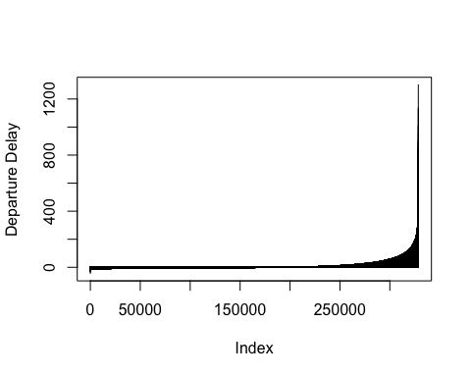

## Arrival Time delays in minute

hist(dtflights$arr_delay, main = "Arrival Time Delays [in minutes]")

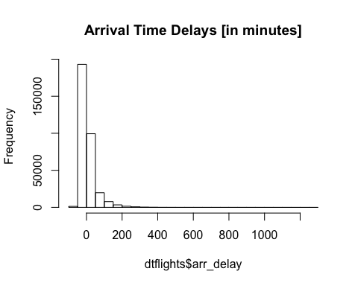

## Flights departure delay with histogram and density plot

hist(flights$dep_delay, xlab="Departure Delay")

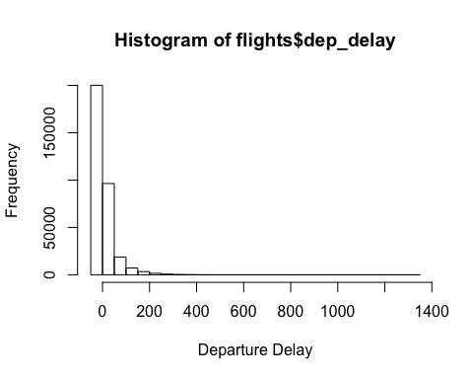

plot(density(flights$dep_delay, na.rm=TRUE), xlab="Departure Delay")

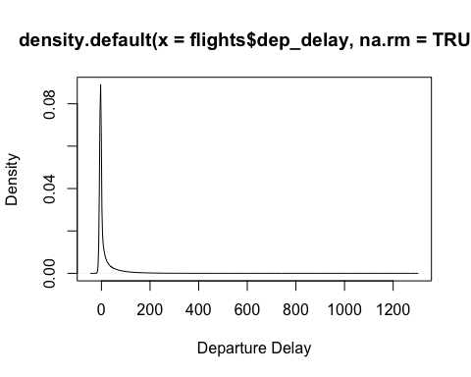

## Flights departure delay with boxplot

boxplot(log(flights$dep_delay -   
 min(flights$dep_delay,na.rm=TRUE)  
 +1), ylab="Departure Delay")

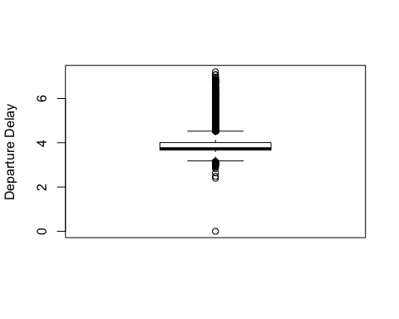 ##The average departure and arrival delays per destination

dta <- dtflights[, .(departure = mean(dep_delay, na.rm = TRUE),  
 arrival = mean(arr_delay, na.rm = TRUE)), by = dest]  
ggplot(dta, aes(departure, arrival, label = dest)) + geom_text()

## Warning: Removed 1 rows containing missing values (geom_text).

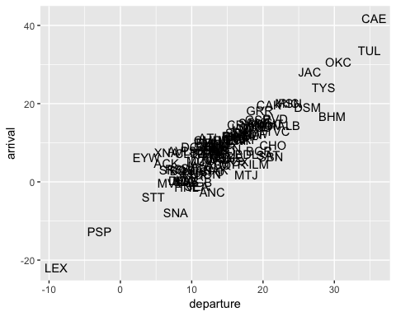

## Histogram of Flight Air time

hist(dtflights$air_time, xlab = "Flight Air Time [in minutes]", main = "Histogram of Flight Air Time")

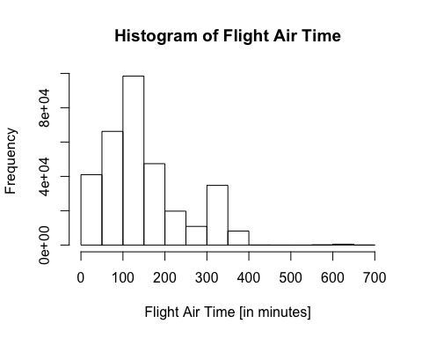

## Which destination has the lowest average delay from 'EWR'?

dta <- dtflights[origin == 'EWR', .(delay = mean(arr_delay, na.rm = TRUE)), by = dest]  
setorder(dta, delay)  
head(dta)

## dest delay  
## 1: LGA NaN  
## 2: SNA -7.868227  
## 3: SBN -5.500000  
## 4: EGE -5.349057  
## 5: ANC -2.500000  
## 6: RSW -2.259129

dta[1]

## dest delay  
## 1: LGA NaN

## The average delay to all destinations from 'EWR

ggplot(dta, aes(dest, delay)) + geom_bar(stat = 'identity') + theme(axis.text.x = element_text(angle = 90, hjust = 1))

## Warning: Removed 1 rows containing missing values (position_stack).

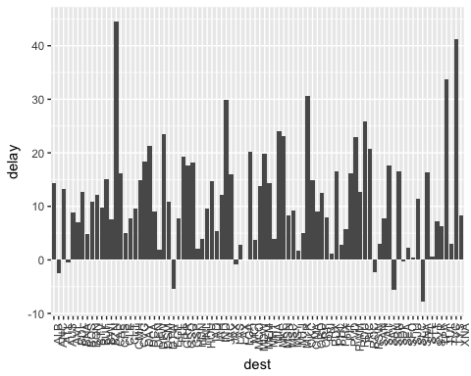

## The number of flights per month

ggplot(dtflights[, .N, by = month], aes(month, N)) + geom_bar(stat = 'identity')

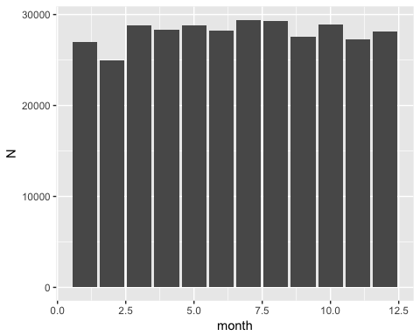

## Heatmap on the number of flights per month and hour of the day

ggplot(dtflights[, .N, by = .(month, hour)], aes(hour, month, fill = N)) + geom_tile()

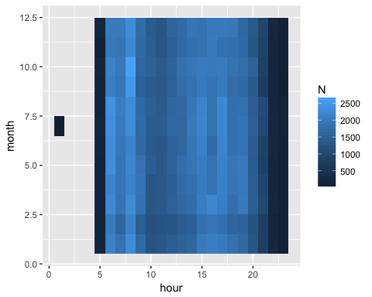 #The average temperature at noon in JFK for each month based on the weather dataset

dt <- data.table(weather)  
ggplot(dt[origin == 'JFK', .(temp = mean(temp, na.rm = TRUE)), by = month], aes(month, temp)) +  
 geom_bar(stat = 'identity', color = 'red')

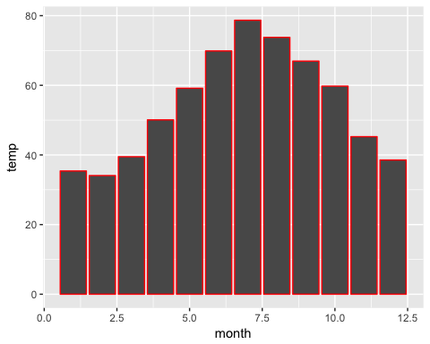

## The average seats and engines per manufacturer

dta <- dtplanes[, .(seats = mean(seats, na.rm = TRUE),  
 engines = mean(engines, na.rm = TRUE)), by = manufacturer]  
ggplot(dta, aes(seats, engines, label = manufacturer)) + geom_bar(stat = 'identity', color = 'red') + geom_text()

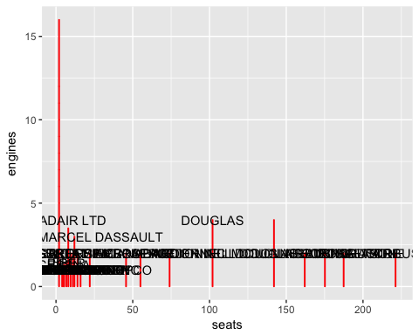

## The average windspeed and wind direction per origin

dta <- dtweather[, .(wind_dir = mean(wind_dir, na.rm = TRUE),  
 wind_speed = mean(wind_speed, na.rm = TRUE)), by = origin]  
ggplot(dta, aes(wind_speed, wind_dir, label = origin)) + geom_bar(stat = 'identity', color = 'red') + geom_text()

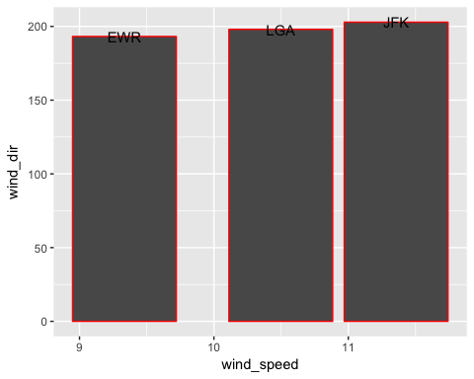

## The average temperature and humid per origin

dta <- dtweather[, .(temp = mean(wind_dir, na.rm = TRUE),  
 humid = mean(wind_speed, na.rm = TRUE)), by = origin]  
ggplot(dta, aes(temp, humid, label = origin)) + geom_bar(stat = 'identity', color = 'red') + geom_text()

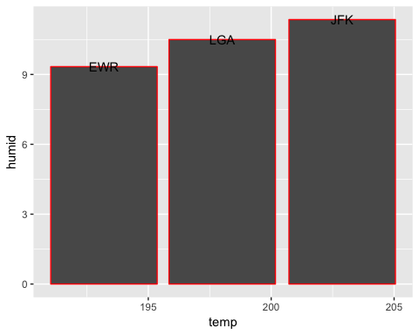

## How to affect humidity or temperature on delays

## Featuring

dtflights$hour <- ifelse(dtflights$hour == 24, 0, flights$hour)  
  
flights_weather <- left_join(dtflights, dtweather)

## Joining, by = c("year", "month", "day", "origin", "hour", "time_hour")

flights_weather$arr_delay <- ifelse(flights_weather$arr_delay >= 0,  
 flights_weather$arr_delay, 0)  
flights_weather$dep_delay <- ifelse(flights_weather$dep_delay >= 0,  
 flights_weather$dep_delay, 0)  
flights_weather$total_delay <- flights_weather$arr_delay + flights_weather$dep_delay  
  
data <- select(flights_weather, total_delay, temp, dewp, humid,  
 wind_dir, wind_speed, wind_gust, precip, pressure, visib)

## Effect of the humidity on delays

g <- ggplot(data, aes(y = humid, x = total_delay,   
 title = "Total Delay / Humidity"))  
g + geom_smooth() + ylab("Relative Humidity") +   
 xlab("Total Delay (mins)")

## `geom_smooth()` using method = 'gam'

## Warning: Removed 202037 rows containing non-finite values (stat_smooth).

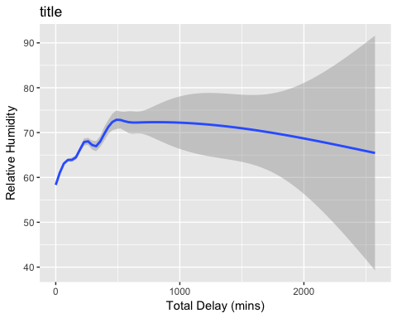

## Effect of the temperature on delays

g <- ggplot(data, aes(y = temp, x = total_delay,   
 title = "Total Delay / Temperature"))  
g + geom_smooth() + ylab("Temperature") +   
 xlab("Total Delay (mins)")

## `geom_smooth()` using method = 'gam'

## Warning: Removed 202037 rows containing non-finite values (stat_smooth).

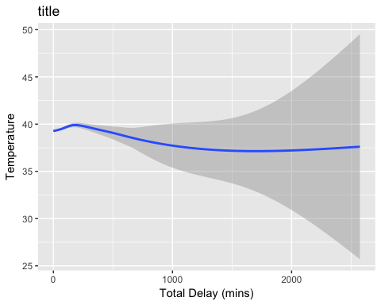

## Effect of the wind speed on delays

g <- ggplot(data, aes(y = wind_speed, x = total_delay,   
 title = "Total Delay / wind speed"))  
g + geom_smooth() + ylab("wind speed") +   
 xlab("Total Delay (mins)")

## `geom_smooth()` using method = 'gam'

## Warning: Removed 202053 rows containing non-finite values (stat_smooth).

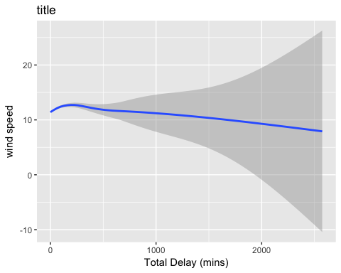

### Average departure delay by manufacutrer

flights_planes <- left_join(dtflights, dtplanes, by = 'tailnum')  
dta <- ddply(flights_planes,~manufacturer,summarise, delay=mean(dep_delay, na.rm=TRUE))  
setorder(dta, delay)  
  
ggplot(dta, aes(manufacturer, delay)) + geom_bar(stat = 'identity') + theme(axis.text.x = element_text(angle = 90, hjust = 1))

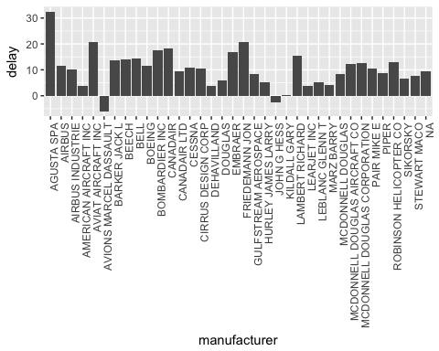

### Average arrival delay by manufacutrer

dta <- ddply(flights_planes,~manufacturer,summarise, delay=mean(arr_delay, na.rm=TRUE))  
setorder(dta, delay)  
  
ggplot(dta, aes(manufacturer, delay)) + geom_bar(stat = 'identity') + theme(axis.text.x = element_text(angle = 90, hjust = 1))

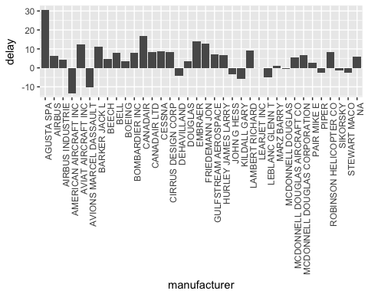

### More feature engineering

Data table without NA's, make binary variable which shows if an airplane delay more than 15 minutes. I decreased the observations number to 15.0000.

dtflights <- subset (flights, !is.na(flights$dep_time) &  
 !is.na(flights$dep_delay) &  
 !is.na(flights$arr_delay) &  
 !is.na(flights$dep_time) &  
 !is.na(flights$arr_time))  
dtflights$tailnumfac <- as.factor(dtflights$tailnum)  
dtflights$carrierfac <- as.factor(dtflights$carrier)  
dtflights$originfac <- as.factor(dtflights$origin)  
dtflights$destfac <- as.factor(dtflights$dest)  
  
dtflights <- dtflights[sample(1:nrow(dtflights), 15000, replace=FALSE),]  
  
dtflights$tailnumnum <- as.numeric(dtflights$tailnumfac)  
dtflights$carriernum <- as.numeric(dtflights$carrierfac)  
dtflights$originnum <- as.numeric(dtflights$originfac)  
dtflights$destnum <- as.numeric(dtflights$destfac)  
  
dtflights$year <- NULL  
dtflights$tail_num <- NULL  
dtflights$tailnum <- NULL  
dtflights$carrier <- NULL  
dtflights$dest <- NULL  
dtflights$origin <- NULL  
dtflights$tailnum <- NULL  
dtflights$tailnumfac <- NULL  
dtflights$carrierfac <- NULL  
dtflights$destfac <- NULL  
dtflights$originfac <- NULL  
dtflights$tailnumfac <- NULL  
  
str(dtflights)

## Classes 'tbl_df', 'tbl' and 'data.frame': 15000 obs. of 18 variables:  
## $ month : int 1 9 4 2 11 12 1 4 4 4 ...  
## $ day : int 24 8 17 15 20 3 29 25 16 13 ...  
## $ dep_time : int 2045 1854 1824 1936 1409 726 1803 2105 1010 1255 ...  
## $ sched_dep_time: int 1935 1900 1829 1929 1415 730 1810 1945 1015 1300 ...  
## $ dep_delay : num 70 -6 -5 7 -6 -4 -7 80 -5 -5 ...  
## $ arr_time : int 2343 2133 2009 2206 1625 1112 1931 29 1149 1409 ...  
## $ sched_arr_time: int 2220 2151 2032 2210 1637 1105 1945 2300 1212 1410 ...  
## $ arr_delay : num 83 -18 -23 -4 -12 7 -14 89 -23 -1 ...  
## $ flight : int 4204 883 297 1715 673 183 4484 1709 1427 2175 ...  
## $ air_time : num 214 123 78 186 108 389 125 154 76 49 ...  
## $ distance : num 1325 944 541 1183 746 ...  
## $ hour : num 19 19 18 19 14 7 18 19 10 13 ...  
## $ minute : num 35 0 29 29 15 30 10 45 15 0 ...  
## $ time_hour : POSIXct, format: "2013-01-24 19:00:00" "2013-09-08 19:00:00" ...  
## $ tailnumnum : num 70 2085 2024 887 3136 ...  
## $ carriernum : num 6 4 13 5 5 14 10 2 13 13 ...  
## $ originnum : num 1 2 2 3 1 1 3 3 2 3 ...  
## $ destnum : num 67 54 24 62 5 90 11 58 24 29 ...

dtflights$arrdelay15 <- ifelse(dtflights$arr_delay > 15,1,0)  
dtflights$year <- NULL  
time_format <- "%Y-%m-%d %H:%M:%S"  
dtflights$weekday <- as.factor(format(strptime(dtflights$time_hour, format=time_format),"%A"))  
dtflights$time_hour <- NULL

## 2-Nearest Neighbors algorithm

dtflights$rnd <-runif(dim(dtflights[1]))   
dtflights <- dtflights[order(dtflights$rnd),]  
  
  
dtflights

## # A tibble: 15,000 × 20  
## month day dep_time sched_dep_time dep_delay arr_time sched_arr_time  
## <int> <int> <int> <int> <dbl> <int> <int>  
## 1 9 8 1854 1900 -6 2133 2151  
## 2 2 15 1936 1929 7 2206 2210  
## 3 12 3 726 730 -4 1112 1105  
## 4 4 25 2105 1945 80 29 2300  
## 5 4 13 1255 1300 -5 1409 1410  
## 6 7 2 1909 1800 69 2039 1930  
## 7 7 12 810 815 -5 926 930  
## 8 10 1 2030 2035 -5 2308 2340  
## 9 3 29 1035 1035 0 1341 1404  
## 10 10 24 1432 1444 -12 1616 1641  
## # ... with 14,990 more rows, and 13 more variables: arr_delay <dbl>,  
## # flight <int>, air_time <dbl>, distance <dbl>, hour <dbl>,  
## # minute <dbl>, tailnumnum <dbl>, carriernum <dbl>, originnum <dbl>,  
## # destnum <dbl>, arrdelay15 <dbl>, weekday <fctr>, rnd <dbl>

train <- dtflights[0:round((dim(dtflights)[1])*0.7),]  
test <- dtflights[(round((dim(dtflights)[1])*0.7)+1):(dim(dtflights)[1]),]  
dtflights$rnd <-NULL  
  
fit <- knn(train[,1:15], test[,1:15], train$arrdelay15, k = 2)  
  
pander(table(test$arrdelay15,fit))

|  |  |  |
| --- | --- | --- |
|  | 0 | 1 |
| **0** | 3046 | 368 |
| **1** | 612 | 474 |

## 5-Nearest Neighbors algorithm

fit2 <- knn(train[,1:15], test[,1:15], train$arrdelay15, k = 5)  
pander(table(test$arrdelay15,fit2))

|  |  |  |
| --- | --- | --- |
|  | 0 | 1 |
| **0** | 3282 | 132 |
| **1** | 726 | 360 |

total <- dim(test)[1]

All in all the 2-NN model has provided 78 % result, the 5- NN model has provided 80 % good result.

# Modeling

### CLEAR MEMORY

rm(list = ls())

library(h2o)

## Warning: package 'h2o' was built under R version 3.3.2

##   
## ----------------------------------------------------------------------  
##   
## Your next step is to start H2O:  
## > h2o.init()  
##   
## For H2O package documentation, ask for help:  
## > ??h2o  
##   
## After starting H2O, you can use the Web UI at http://localhost:54321  
## For more information visit http://docs.h2o.ai  
##   
## ----------------------------------------------------------------------

##   
## Attaching package: 'h2o'

## The following objects are masked from 'package:lubridate':  
##   
## day, hour, month, week, year

## The following objects are masked from 'package:data.table':  
##   
## hour, month, week, year

## The following objects are masked from 'package:stats':  
##   
## cor, sd, var

## The following objects are masked from 'package:base':  
##   
## &&, %*%, %in%, ||, apply, as.factor, as.numeric, colnames,  
## colnames<-, ifelse, is.character, is.factor, is.numeric, log,  
## log10, log1p, log2, round, signif, trunc

h2o.init()

##   
## H2O is not running yet, starting it now...  
##   
## Note: In case of errors look at the following log files:  
## /var/folders/_2/ny9pbkp90zb9ks3c034xd0j80000gn/T//RtmpUfT1ge/h2o_Attila_started_from_r.out  
## /var/folders/_2/ny9pbkp90zb9ks3c034xd0j80000gn/T//RtmpUfT1ge/h2o_Attila_started_from_r.err  
##   
##   
## Starting H2O JVM and connecting: ..... Connection successful!  
##   
## R is connected to the H2O cluster:   
## H2O cluster uptime: 4 seconds 569 milliseconds   
## H2O cluster version: 3.10.3.3   
## H2O cluster version age: 23 days   
## H2O cluster name: H2O_started_from_R_Attila_ceh598   
## H2O cluster total nodes: 1   
## H2O cluster total memory: 0.12 GB   
## H2O cluster total cores: 4   
## H2O cluster allowed cores: 2   
## H2O cluster healthy: TRUE   
## H2O Connection ip: localhost   
## H2O Connection port: 54321   
## H2O Connection proxy: NA   
## R Version: R version 3.3.1 (2016-06-21)   
##   
## Note: As started, H2O is limited to the CRAN default of 2 CPUs.  
## Shut down and restart H2O as shown below to use all your CPUs.  
## > h2o.shutdown()  
## > h2o.init(nthreads = -1)

## write demo data to disk

library(nycflights13)  
write.csv(flights, 'flights.csv', row.names = FALSE)  
flights.hex <- h2o.uploadFile('flights.csv', destination_frame = 'flights')

##   
 |   
 | | 0%  
 |   
 |=================================================================| 100%

str(flights.hex)

## Class 'H2OFrame' <environment: 0x7f895fe3ed18>   
## - attr(*, "op")= chr "Parse"  
## - attr(*, "id")= chr "flights"  
## - attr(*, "eval")= logi FALSE  
## - attr(*, "nrow")= int 336776  
## - attr(*, "ncol")= int 19  
## - attr(*, "types")=List of 19  
## ..$ : chr "int"  
## ..$ : chr "int"  
## ..$ : chr "int"  
## ..$ : chr "int"  
## ..$ : chr "int"  
## ..$ : chr "int"  
## ..$ : chr "int"  
## ..$ : chr "int"  
## ..$ : chr "int"  
## ..$ : chr "enum"  
## ..$ : chr "int"  
## ..$ : chr "enum"  
## ..$ : chr "enum"  
## ..$ : chr "enum"  
## ..$ : chr "int"  
## ..$ : chr "int"  
## ..$ : chr "int"  
## ..$ : chr "int"  
## ..$ : chr "time"  
## - attr(*, "data")='data.frame': 10 obs. of 19 variables:  
## ..$ year : num 2013 2013 2013 2013 2013 ...  
## ..$ month : num 1 1 1 1 1 1 1 1 1 1  
## ..$ day : num 1 1 1 1 1 1 1 1 1 1  
## ..$ dep_time : num 517 533 542 544 554 554 555 557 557 558  
## ..$ sched_dep_time: num 515 529 540 545 600 558 600 600 600 600  
## ..$ dep_delay : num 2 4 2 -1 -6 -4 -5 -3 -3 -2  
## ..$ arr_time : num 830 850 923 1004 812 ...  
## ..$ sched_arr_time: num 819 830 850 1022 837 ...  
## ..$ arr_delay : num 11 20 33 -18 -25 12 19 -14 -8 8  
## ..$ carrier : Factor w/ 16 levels "9E","AA","AS",..: 12 12 2 4 5 12 4 6 4 2  
## ..$ flight : num 1545 1714 1141 725 461 ...  
## ..$ tailnum : Factor w/ 4044 levels "D942DN","N0EGMQ",..: 180 524 2401 3204 2661 1142 1829 3300 2207 1178  
## ..$ origin : Factor w/ 3 levels "EWR","JFK","LGA": 1 3 2 2 3 1 1 3 2 3  
## ..$ dest : Factor w/ 105 levels "ABQ","ACK","ALB",..: 44 44 59 13 5 70 36 43 55 70  
## ..$ air_time : num 227 227 160 183 116 150 158 53 140 138  
## ..$ distance : num 1400 1416 1089 1576 762 ...  
## ..$ hour : num 5 5 5 5 6 5 6 6 6 6  
## ..$ minute : num 15 29 40 45 0 58 0 0 0 0  
## ..$ time_hour : num 1.36e+12 1.36e+12 1.36e+12 1.36e+12 1.36e+12 ...

head(flights.hex)

## year month day dep_time sched_dep_time dep_delay arr_time sched_arr_time  
## 1 2013 1 1 517 515 2 830 819  
## 2 2013 1 1 533 529 4 850 830  
## 3 2013 1 1 542 540 2 923 850  
## 4 2013 1 1 544 545 -1 1004 1022  
## 5 2013 1 1 554 600 -6 812 837  
## 6 2013 1 1 554 558 -4 740 728  
## arr_delay carrier flight tailnum origin dest air_time distance hour  
## 1 11 UA 1545 N14228 EWR IAH 227 1400 5  
## 2 20 UA 1714 N24211 LGA IAH 227 1416 5  
## 3 33 AA 1141 N619AA JFK MIA 160 1089 5  
## 4 -18 B6 725 N804JB JFK BQN 183 1576 5  
## 5 -25 DL 461 N668DN LGA ATL 116 762 6  
## 6 12 UA 1696 N39463 EWR ORD 150 719 5  
## minute time_hour  
## 1 15 1.357013e+12  
## 2 29 1.357013e+12  
## 3 40 1.357013e+12  
## 4 45 1.357013e+12  
## 5 0 1.357016e+12  
## 6 58 1.357013e+12

head(flights.hex, 3)

## year month day dep_time sched_dep_time dep_delay arr_time sched_arr_time  
## 1 2013 1 1 517 515 2 830 819  
## 2 2013 1 1 533 529 4 850 830  
## 3 2013 1 1 542 540 2 923 850  
## arr_delay carrier flight tailnum origin dest air_time distance hour  
## 1 11 UA 1545 N14228 EWR IAH 227 1400 5  
## 2 20 UA 1714 N24211 LGA IAH 227 1416 5  
## 3 33 AA 1141 N619AA JFK MIA 160 1089 5  
## minute time_hour  
## 1 15 1.357013e+12  
## 2 29 1.357013e+12  
## 3 40 1.357013e+12

summary(flights.hex)

## Warning in summary.H2OFrame(flights.hex): Approximated quantiles  
## computed! If you are interested in exact quantiles, please pass the  
## `exact_quantiles=TRUE` parameter.

## year month day dep_time   
## Min. :2013 Min. : 1.000 Min. : 1.00 Min. : 1.0   
## 1st Qu.: NaN 1st Qu.: 4.000 1st Qu.: 8.00 1st Qu.: 905.8   
## Median : NaN Median : 7.000 Median :16.00 Median :1400.2   
## Mean :2013 Mean : 6.549 Mean :15.71 Mean :1349.1   
## 3rd Qu.: NaN 3rd Qu.:10.000 3rd Qu.:23.00 3rd Qu.:1743.4   
## Max. :2013 Max. :12.000 Max. :31.00 Max. :2400.0   
## NA's :8255   
## sched_dep_time dep_delay arr_time sched_arr_time  
## Min. : 106.0 Min. : -43.00 Min. : 1 Min. : 1   
## 1st Qu.: 903.9 1st Qu.: -5.34 1st Qu.:1103 1st Qu.:1124   
## Median :1357.0 Median : -2.65 Median :1535 Median :1556   
## Mean :1344.3 Mean : 12.64 Mean :1502 Mean :1536   
## 3rd Qu.:1728.9 3rd Qu.: 10.80 3rd Qu.:1938 3rd Qu.:1945   
## Max. :2359.0 Max. :1301.00 Max. :2400 Max. :2359   
## NA's :8255 NA's :8713   
## arr_delay carrier flight tailnum origin   
## Min. : -86.000 UA:58665 Min. : 1 N725MQ: 575 EWR:120835   
## 1st Qu.: -18.050 B6:54635 1st Qu.: 545 N722MQ: 513 JFK:111279   
## Median : -5.819 EV:54173 Median :1488 N723MQ: 507 LGA:104662   
## Mean : 6.895 DL:48110 Mean :1972 N711MQ: 486   
## 3rd Qu.: 13.207 AA:32729 3rd Qu.:3460 N713MQ: 483   
## Max. :1272.000 MQ:26397 Max. :8500 N258JB: 427   
## NA's :9430 NA :2512   
## dest air_time distance hour   
## ORD:17283 Min. : 20.0 Min. : 17.0 Min. : 1.00   
## ATL:17215 1st Qu.: 82.0 1st Qu.: 498.8 1st Qu.: 9.00   
## LAX:16174 Median :129.0 Median : 871.3 Median :13.00   
## BOS:15508 Mean :150.7 Mean :1039.9 Mean :13.18   
## MCO:14082 3rd Qu.:192.0 3rd Qu.:1387.9 3rd Qu.:17.00   
## CLT:14064 Max. :695.0 Max. :4983.0 Max. :23.00   
## NA's :9430   
## minute time_hour  
## Min. : 0.00   
## 1st Qu.: 8.00   
## Median :29.00   
## Mean :26.23   
## 3rd Qu.:44.00   
## Max. :59.00   
##

## convert numeric to factor/enum

flights.hex[, 'flight'] <- as.factor(flights.hex[, 'flight'])  
summary(flights.hex)

## Warning in summary.H2OFrame(flights.hex): Approximated quantiles  
## computed! If you are interested in exact quantiles, please pass the  
## `exact_quantiles=TRUE` parameter.

## year month day dep_time   
## Min. :2013 Min. : 1.000 Min. : 1.00 Min. : 1.0   
## 1st Qu.: NaN 1st Qu.: 4.000 1st Qu.: 8.00 1st Qu.: 905.8   
## Median : NaN Median : 7.000 Median :16.00 Median :1400.2   
## Mean :2013 Mean : 6.549 Mean :15.71 Mean :1349.1   
## 3rd Qu.: NaN 3rd Qu.:10.000 3rd Qu.:23.00 3rd Qu.:1743.4   
## Max. :2013 Max. :12.000 Max. :31.00 Max. :2400.0   
## NA's :8255   
## sched_dep_time dep_delay arr_time sched_arr_time  
## Min. : 106.0 Min. : -43.00 Min. : 1 Min. : 1   
## 1st Qu.: 903.9 1st Qu.: -5.34 1st Qu.:1103 1st Qu.:1124   
## Median :1357.0 Median : -2.65 Median :1535 Median :1556   
## Mean :1344.3 Mean : 12.64 Mean :1502 Mean :1536   
## 3rd Qu.:1728.9 3rd Qu.: 10.80 3rd Qu.:1938 3rd Qu.:1945   
## Max. :2359.0 Max. :1301.00 Max. :2400 Max. :2359   
## NA's :8255 NA's :8713   
## arr_delay carrier flight tailnum origin dest   
## Min. : -86.000 UA:58665 15 :968 N725MQ: 575 EWR:120835 ORD:17283   
## 1st Qu.: -18.050 B6:54635 27 :898 N722MQ: 513 JFK:111279 ATL:17215   
## Median : -5.819 EV:54173 181:882 N723MQ: 507 LGA:104662 LAX:16174   
## Mean : 6.895 DL:48110 301:871 N711MQ: 486 BOS:15508   
## 3rd Qu.: 13.207 AA:32729 161:786 N713MQ: 483 MCO:14082   
## Max. :1272.000 MQ:26397 695:782 N258JB: 427 CLT:14064   
## NA's :9430 NA :2512   
## air_time distance hour minute   
## Min. : 20.0 Min. : 17.0 Min. : 1.00 Min. : 0.00   
## 1st Qu.: 82.0 1st Qu.: 498.8 1st Qu.: 9.00 1st Qu.: 8.00   
## Median :129.0 Median : 871.3 Median :13.00 Median :29.00   
## Mean :150.7 Mean :1039.9 Mean :13.18 Mean :26.23   
## 3rd Qu.:192.0 3rd Qu.:1387.9 3rd Qu.:17.00 3rd Qu.:44.00   
## Max. :695.0 Max. :4983.0 Max. :23.00 Max. :59.00   
## NA's :9430   
## time_hour  
##   
##   
##   
##   
##   
##   
##

flights.hex$flight <- as.factor(flights.hex$flight)  
for (v in c('month', 'day', 'dep_delay', 'arr_delay')) {  
 flights.hex[, v] <- as.factor(flights.hex[, v])  
}  
summary(flights.hex)

## Warning in summary.H2OFrame(flights.hex): Approximated quantiles  
## computed! If you are interested in exact quantiles, please pass the  
## `exact_quantiles=TRUE` parameter.

## year month day dep_time sched_dep_time   
## Min. :2013 7 :29425 18:11399 Min. : 1.0 Min. : 106.0   
## 1st Qu.: NaN 8 :29327 11:11359 1st Qu.: 905.8 1st Qu.: 903.9   
## Median : NaN 10:28889 22:11345 Median :1400.2 Median :1357.0   
## Mean :2013 3 :28834 15:11317 Mean :1349.1 Mean :1344.3   
## 3rd Qu.: NaN 5 :28796 8 :11271 3rd Qu.:1743.4 3rd Qu.:1728.9   
## Max. :2013 4 :28330 10:11227 Max. :2400.0 Max. :2359.0   
## NA's :8255   
## dep_delay arr_time sched_arr_time arr_delay carrier flight   
## -5:24821 Min. : 1 Min. : 1 -13:7177 UA:58665 15 :968   
## -4:24619 1st Qu.:1103 1st Qu.:1124 -10:7088 B6:54635 27 :898   
## -3:24218 Median :1535 Median :1556 -12:7046 EV:54173 181:882   
## -2:21516 Mean :1502 Mean :1536 -14:6975 DL:48110 301:871   
## -6:20701 3rd Qu.:1938 3rd Qu.:1945 -11:6863 AA:32729 161:786   
## -1:18813 Max. :2400 Max. :2359 -9 :6815 MQ:26397 695:782   
## NA: 8255 NA's :8713 NA :9430   
## tailnum origin dest air_time distance   
## N725MQ: 575 EWR:120835 ORD:17283 Min. : 20.0 Min. : 17.0   
## N722MQ: 513 JFK:111279 ATL:17215 1st Qu.: 82.0 1st Qu.: 498.8   
## N723MQ: 507 LGA:104662 LAX:16174 Median :129.0 Median : 871.3   
## N711MQ: 486 BOS:15508 Mean :150.7 Mean :1039.9   
## N713MQ: 483 MCO:14082 3rd Qu.:192.0 3rd Qu.:1387.9   
## N258JB: 427 CLT:14064 Max. :695.0 Max. :4983.0   
## NA :2512 NA's :9430   
## hour minute time_hour  
## Min. : 1.00 Min. : 0.00   
## 1st Qu.: 9.00 1st Qu.: 8.00   
## Median :13.00 Median :29.00   
## Mean :13.18 Mean :26.23   
## 3rd Qu.:17.00 3rd Qu.:44.00   
## Max. :23.00 Max. :59.00   
##

## drop columns

dt <- data.table(flights)  
dt$delay15 <- ifelse(dt$arr_delay > 15,1,0)  
str(dt)

## Classes 'data.table' and 'data.frame': 336776 obs. of 20 variables:  
## $ year : int 2013 2013 2013 2013 2013 2013 2013 2013 2013 2013 ...  
## $ month : int 1 1 1 1 1 1 1 1 1 1 ...  
## $ day : int 1 1 1 1 1 1 1 1 1 1 ...  
## $ dep_time : int 517 533 542 544 554 554 555 557 557 558 ...  
## $ sched_dep_time: int 515 529 540 545 600 558 600 600 600 600 ...  
## $ dep_delay : num 2 4 2 -1 -6 -4 -5 -3 -3 -2 ...  
## $ arr_time : int 830 850 923 1004 812 740 913 709 838 753 ...  
## $ sched_arr_time: int 819 830 850 1022 837 728 854 723 846 745 ...  
## $ arr_delay : num 11 20 33 -18 -25 12 19 -14 -8 8 ...  
## $ carrier : chr "UA" "UA" "AA" "B6" ...  
## $ flight : int 1545 1714 1141 725 461 1696 507 5708 79 301 ...  
## $ tailnum : chr "N14228" "N24211" "N619AA" "N804JB" ...  
## $ origin : chr "EWR" "LGA" "JFK" "JFK" ...  
## $ dest : chr "IAH" "IAH" "MIA" "BQN" ...  
## $ air_time : num 227 227 160 183 116 150 158 53 140 138 ...  
## $ distance : num 1400 1416 1089 1576 762 ...  
## $ hour : num 5 5 5 5 6 5 6 6 6 6 ...  
## $ minute : num 15 29 40 45 0 58 0 0 0 0 ...  
## $ time_hour : POSIXct, format: "2013-01-01 05:00:00" "2013-01-01 05:00:00" ...  
## $ delay15 : num 0 1 1 0 0 0 1 0 0 0 ...  
## - attr(*, ".internal.selfref")=<externalptr>

dt <- dt[, .(month, day, dest, origin,  
 carrier, flight, tailnum, distance, delay15)]

## transform to factor

for (v in c('month', 'day', 'flight', 'carrier')) {  
 set(dt, j = v, value = as.factor(dt[, get(v)]))  
}  
str(dt)

## Classes 'data.table' and 'data.frame': 336776 obs. of 9 variables:  
## $ month : Factor w/ 12 levels "1","2","3","4",..: 1 1 1 1 1 1 1 1 1 1 ...  
## $ day : Factor w/ 31 levels "1","2","3","4",..: 1 1 1 1 1 1 1 1 1 1 ...  
## $ dest : chr "IAH" "IAH" "MIA" "BQN" ...  
## $ origin : chr "EWR" "LGA" "JFK" "JFK" ...  
## $ carrier : Factor w/ 16 levels "9E","AA","AS",..: 12 12 2 4 5 12 4 6 4 2 ...  
## $ flight : Factor w/ 3844 levels "1","2","3","4",..: 1382 1545 1042 677 425 1527 469 3700 69 266 ...  
## $ tailnum : chr "N14228" "N24211" "N619AA" "N804JB" ...  
## $ distance: num 1400 1416 1089 1576 762 ...  
## $ delay15 : num 0 1 1 0 0 0 1 0 0 0 ...  
## - attr(*, ".internal.selfref")=<externalptr>

## re-upload to H2O

h2o.ls()

## key  
## 1 RTMP_sid_a144_7  
## 2 flights

h2o.rm('flights')  
as.h2o(dt, 'flights')

##   
 |   
 | | 0%  
 |   
 |=================================================================| 100%

## month day dest origin carrier flight tailnum distance delay15  
## 1 1 1 IAH EWR UA 1545 N14228 1400 0  
## 2 1 1 IAH LGA UA 1714 N24211 1416 1  
## 3 1 1 MIA JFK AA 1141 N619AA 1089 1  
## 4 1 1 BQN JFK B6 725 N804JB 1576 0  
## 5 1 1 ATL LGA DL 461 N668DN 762 0  
## 6 1 1 ORD EWR UA 1696 N39463 719 0  
##   
## [336776 rows x 9 columns]

## split the data

flights.hex <- h2o.getFrame('flights')  
h2o.splitFrame(data = flights.hex , ratios = 0.75, destination_frames = c('train', 'test'))

## [[1]]  
## month day dest origin carrier flight tailnum distance delay15  
## 1 1 1 IAH EWR UA 1545 N14228 1400 0  
## 2 1 1 IAH LGA UA 1714 N24211 1416 1  
## 3 1 1 MIA JFK AA 1141 N619AA 1089 1  
## 4 1 1 BQN JFK B6 725 N804JB 1576 0  
## 5 1 1 ATL LGA DL 461 N668DN 762 0  
## 6 1 1 ORD EWR UA 1696 N39463 719 0  
##   
## [252676 rows x 9 columns]   
##   
## [[2]]  
## month day dest origin carrier flight tailnum distance delay15  
## 1 1 1 FLL EWR B6 507 N516JB 1065 1  
## 2 1 1 BOS JFK B6 1806 N708JB 187 0  
## 3 1 1 PBI EWR B6 343 N644JB 1023 0  
## 4 1 1 MSP LGA DL 1919 N971DL 1020 0  
## 5 1 1 MIA EWR UA 1077 N53442 1085 0  
## 6 1 1 SJU JFK B6 709 N794JB 1598 0  
##   
## [84100 rows x 9 columns]

h2o.ls()

## key  
## 1 flights  
## 2 test  
## 3 train

## build the first model

flights.rf <- h2o.randomForest(  
 x = names(flights.hex),  
 y = 'delay15',  
 training_frame = 'train',  
 validation_frame = 'test')

## Warning in .verify_dataxy(training_frame, x, y): removing response variable  
## from the explanatory variables

## Warning in .h2o.startModelJob(algo, params, h2oRestApiVersion): Dropping constant columns: [origin, tailnum, dest].

##   
 |   
 | | 0%  
 |   
 |= | 2%  
 |   
 |=== | 4%  
 |   
 |===== | 8%  
 |   
 |====== | 10%  
 |   
 |========= | 14%  
 |   
 |========== | 16%  
 |   
 |============= | 20%  
 |   
 |================ | 24%  
 |   
 |================= | 26%  
 |   
 |================== | 28%  
 |   
 |===================== | 32%  
 |   
 |====================== | 34%  
 |   
 |========================= | 38%  
 |   
 |=========================== | 42%  
 |   
 |============================== | 46%  
 |   
 |================================ | 50%  
 |   
 |================================== | 52%  
 |   
 |==================================== | 56%  
 |   
 |======================================= | 60%  
 |   
 |======================================== | 62%  
 |   
 |============================================ | 68%  
 |   
 |============================================== | 70%  
 |   
 |================================================ | 74%  
 |   
 |================================================= | 76%  
 |   
 |=================================================== | 78%  
 |   
 |===================================================== | 82%  
 |   
 |======================================================= | 84%  
 |   
 |========================================================= | 88%  
 |   
 |========================================================== | 90%  
 |   
 |============================================================ | 92%  
 |   
 |============================================================= | 94%  
 |   
 |============================================================== | 96%  
 |   
 |================================================================ | 98%  
 |   
 |=================================================================| 100%

flights.rf

## Model Details:  
## ==============  
##   
## H2ORegressionModel: drf  
## Model ID: DRF_model_R_1488049182704_1   
## Model Summary:   
## number_of_trees number_of_internal_trees model_size_in_bytes min_depth  
## 1 50 50 9336017 20  
## max_depth mean_depth min_leaves max_leaves mean_leaves  
## 1 20 20.00000 2970 10002 7237.16000  
##   
##   
## H2ORegressionMetrics: drf  
## ** Reported on training data. **  
## ** Metrics reported on Out-Of-Bag training samples **  
##   
## MSE: 0.1573373  
## RMSE: 0.3966577  
## MAE: 0.3218809  
## RMSLE: 0.2770118  
## Mean Residual Deviance : 0.1573373  
##   
##   
## H2ORegressionMetrics: drf  
## ** Reported on validation data. **  
##   
## MSE: 0.1552548  
## RMSE: 0.3940238  
## MAE: 0.3210073  
## RMSLE: 0.2752397  
## Mean Residual Deviance : 0.1552548