PROJECT REPORT
on
PlacementHub – Full Stack Placement Management & Job Application Tracking Platform
BATCH-2024
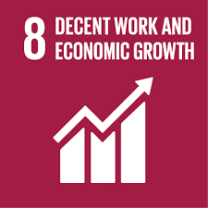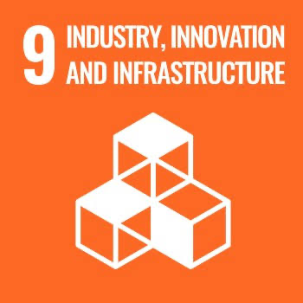
Project Mentor: Mr. Baljeet Matta
Student Name & ID
- Mahesh Shamra (2411981320)
Index
1. Introduction
1.1 Objective
1.2 Technology Stack
2. Project Description
3. System Architecture & Design
3.1 High-Level System Architecture
3.2 Detailed System Design
3.3 UML Diagrams
4. Database Design
4.1 ER Diagram (Simplified)
4.2 Relationships
5. Data Flow Diagrams (DFD)
5.1 Level 0 DFD (Context Level)
5.2 Level 1 DFD
6. Features Implemented
7. Challenges Faced
8. Pending Tasks
9. Conclusion
10. Appendix

Project Report: PlacementHub – MERN Stack Web Application
Project Title:
PlacementHub – Full Stack Placement Management & Job Application Tracking Platform

1. Introduction

1.1 Objective
The objective of PlacementHub is to digitize and centralize the campus placement process for students, college placement cells, and recruiters, replacing manual, spreadsheet- and email-based coordination with a single, real-time, role-based web platform. The system aims to give students transparent visibility into their application status, give placement cells efficient tools to manage drives and track outcomes, and give recruiters a streamlined way to post openings and manage candidate pipelines.

1.2 Technology Stack
- Frontend: React.js (Vite), Tailwind CSS, Zustand (state management)
- Backend: Node.js with Express.js
- Database: MongoDB (NoSQL) with Mongoose ODM
- Real-Time Layer: Socket.io
- Automation: Nodemailer (email), node-cron (scheduled jobs)
- File Uploads: Multer
- Analytics/Visualization: Recharts
- Authentication: Role-based authentication (Student / Placement Cell / Recruiter)

2. Project Description
PlacementHub provides users with the ability to:
- Register and log in securely with role-based access (Student, Placement Cell, Recruiter)
- Post, browse, and filter job openings
- Apply to jobs and track application status in real time
- Move candidates through a drag-and-drop Kanban board across stages: Applied → Shortlisted → Interview → Offered → Rejected
- Receive real-time in-app notifications and automated email alerts
- Upload and manage documents such as resumes and offer letters
- View analytics dashboards summarizing placement statistics and drive outcomes

3. System Architecture & Design

3.1 High-Level System Architecture
PlacementHub follows a three-tier architecture: a React (Vite) frontend communicates with an Express/Node.js REST API layer over HTTP and a persistent Socket.io WebSocket connection, which in turn interacts with a MongoDB database via Mongoose. Scheduled background tasks (node-cron) and outbound email (Nodemailer) operate alongside the API layer, independent of individual user requests.
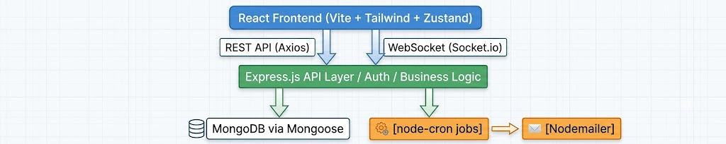
Fig: 1

3.2 Detailed System Design
Component | Description
Client (React) | Displays role-based UI (Student / Placement Cell / Recruiter), handles routing, communicates via Axios, manages global state with Zustand
API Layer (Express) | RESTful endpoints: /api/auth, /api/jobs, /api/applications, /api/users, /api/notifications
Authentication | Role-based authentication and access control for Students, Placement Cells, and Recruiters
Real-Time Layer (Socket.io) | Pushes live notifications on application status changes to connected clients
Scheduler (node-cron) | Runs deadline reminders and periodic status digests; triggers Nodemailer for email delivery
File Storage (Multer) | Handles resume and document uploads
Database (MongoDB) | Stores user, job, application, company, notification, and interview documents

3.3 UML Diagrams
[Insert UML diagrams here — e.g., use case diagram covering Student / Placement Cell / Recruiter actors, and a sequence diagram for the job application and status-update flow. Recommended tools: draw.io, Lucidchart.

4. Database Design

4.1 ER Diagram (Simplified)

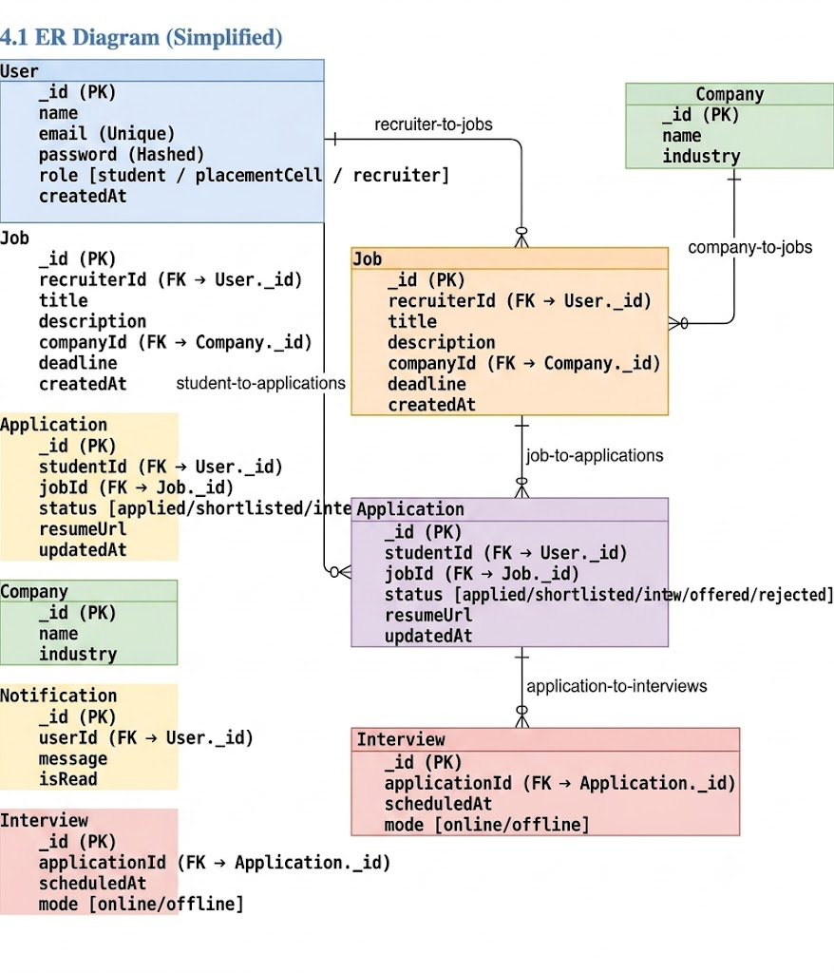

Fig: 2

4.2 Relationships
- One-to-Many: One User (Recruiter) → Many Jobs
- One-to-Many: One User (Student) → Many Applications
- One-to-Many: One Job → Many Applications
- One-to-One: One Application → One Interview
- One-to-Many: One User → Many Notifications
- companyId in Job, studentId/jobId in Application, and applicationId in Interview are foreign keys referencing their respective parent documents

5. Data Flow Diagrams (DFD)

5.1 Level 0 DFD (Context Level)

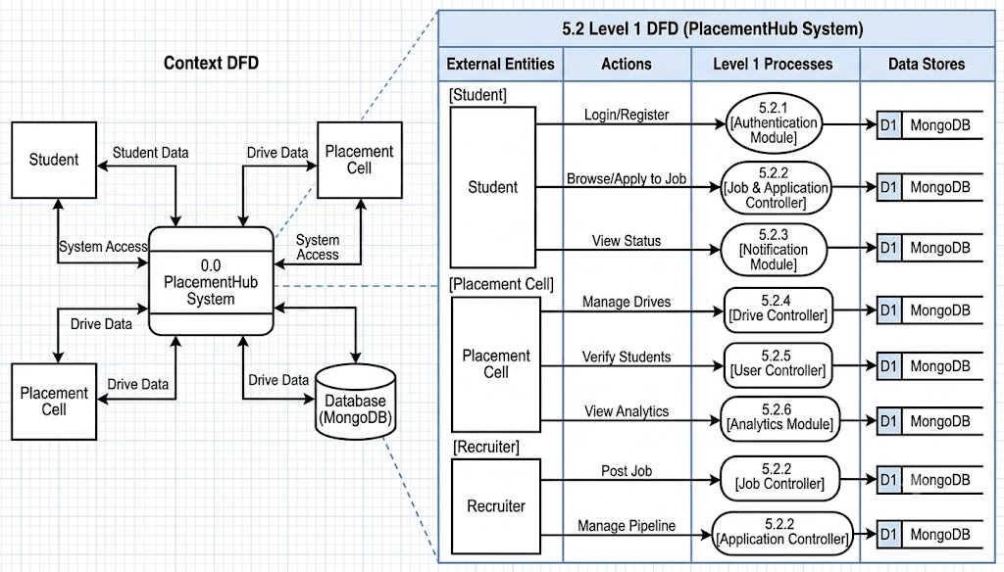

Fig: 3

6. Features Implemented
Feature | Description
Role-Based Authentication | Separate login and dashboards for Student, Placement Cell, and Recruiter
Job Posting & Browsing | Recruiters post jobs; students browse and filter listings
Kanban Application Tracker | Drag-and-drop board across Applied / Shortlisted / Interview / Offered / Rejected
fReal-Time Notifications | Socket.io pushes instant updates on status changes
Automated Emails | Nodemailer sends alerts; node-cron triggers scheduled reminders and digests
File Uploads | Multer handles resume and document uploads
Analytics Dashboard | Recharts-based visualizations of placement statistics
Responsive UI | Tailwind CSS ensures mobile and desktop compatibility

7. Challenges Faced
Challenge | Solution
Syncing real-time Socket.io updates with Zustand state | Centralized socket event handlers that dispatch directly into the Zustand store
Flexible schema for three different user roles | Single User model with a role field and role-specific optional fields
Keeping Kanban drag-and-drop in sync with backend | Optimistic UI updates followed by an API call to persist the new status
Secure, validated file uploads | Multer configured with file-type and size validation middleware
Avoiding duplicate cron-triggered emails | Idempotency checks and a "lastNotifiedAt" timestamp before sending

8. Pending Tasks
- Further UI/UX polish and mobile responsiveness testing across all three dashboards
- Additional analytics filters (batch-wise, department-wise placement statistics)
- Load and performance testing for concurrent users during peak placement drives
- Final round of security testing, including input validation and API rate limiting
- Add tags/categories to job postings
- Push notifications and Google OAuth login as future enhancements

9. Conclusion
This MERN stack project showcases a production-ready placement management platform with clean separation of frontend and backend logic. It demonstrates RESTful API integration, role-based authentication, real-time communication via Socket.io, task automation via node-cron and Nodemailer, and scalable database design using MongoDB. PlacementHub replaces fragmented, manual placement coordination with a centralized, transparent system that benefits students, placement cells, and recruiters alike.

10. Appendix
- GitHub Repo: ______________________
- Live App: ______________________
- Postman Docs: Included in repository

