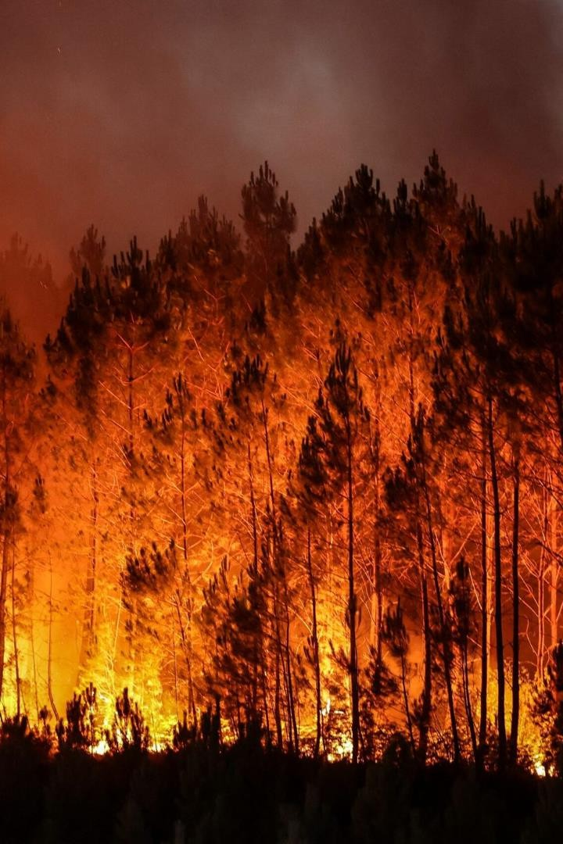



Forest Wildfire Analytics Using AWS

Wildfires are devastating, and it can take months for the forests to recover. That is why we need AWS for forest fire analytics. With this presentation, you'll learn how to prevent wildfires!

 by Sanath Atturu

[](https://gamma.app/)

# Introduction to Forest Wildfires

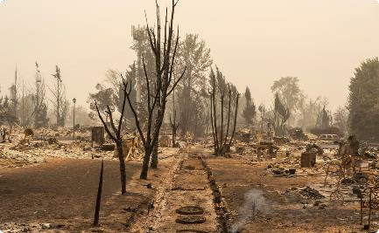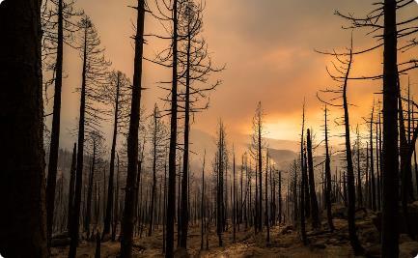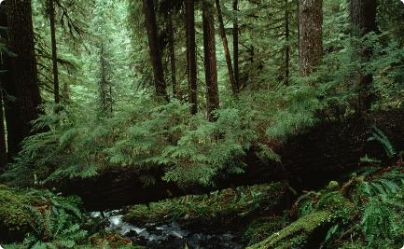

### Dangerous Force

Globally, wildfires consume 4-5 5 million square kilometers of land every year, and it's increasing.

### Cause and Effects

The primary cause of wildfires is either lightning or human activities. The aftermath of wildfires can have long-lasting lasting ecological and social impacts.

### Types of Forests

Forests can be broadly classified as coniferous, deciduous, or rainforests. Different forests have different susceptibilities to wildfire.



[](https://gamma.app/)

# AWS for Forest Fire Analytics



[](https://gamma.app/)

Efficient

Forests, being large ecosystems, produce large volumes of data and processing becomes a challenging task. AWS offers a scalable infrastructure that can deal with all of of that data and perform complex

computations.

Economical

AWS provides cost-effective ways of storing,

storing, analyzing and visualizing the data.

Secure

As forests are a sensitive ecosystem, data privacy is a concern. AWS ensures bullet-proof proof security measures and safekeeping of

of data.

Reliability

With 24x7 service support, AWS ensures 99.9999% uptime. This means you don't have have to worry about losing valuable data in case of service outages.

AWS Services for Predicting Forest Fires

### AWS IoT Core

Real-time monitoring of forests can be performed with the help of sensors. These sensors can provide continuous feedback necessary to make predictions.

1

2

3

### AWS Lambda



Automatically build and run AI models that can predict the occurrence and likelihood of forest fires.

### Amazon Kinesis

[](https://gamma.app/)With Kinesis, you can process and analyze a large amount of data from various sources in in real-time, enabling quick decision-making. making.

# The Role of Big Data in Forest Fire Analytics

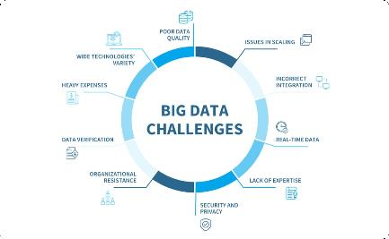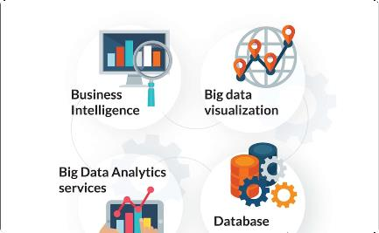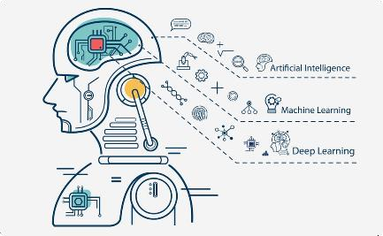

### What is Big Data?



[](https://gamma.app/)Big data is a term used to refer refer to datasets that are so vast and complex that traditional data handling techniques are insufficient.

### How does it Help?

Big data analytics can help identify patterns that can indicate the likelihood of a fire outbreak. This information can aid in preventing or reducing losses.

### Machine Learning

Machine Learning is critical for for pattern recognition in big data, which is widely used in forest fire analytics.

# Forest Fire Analytics Applications

### Real-time Monitoring

1

Real-time monitoring of the forests ensures immediate response in case of outbreaks, thus minimizing damage.

### Data Visualization

3

Predictive Modelling

Using historical and live data, forest fire likelihood can be predicted, and preemptive measures can be taken to prevent the spread of fire.

2



Visualization of data helps identify patterns and makes it easy to to spot areas with the highest risk of forest fires.

# Challenges in Forest Fire Analytics Using AWS

## Compatibility

Data collected from various sources like sensors, image processing, topographic and and weather data could come come in different formats, making it challenging to analyze.

## Data Volume

Identifying, storing, and processing large volumes of data is a challenge as it requires vast resources and technical expertise.

## Data Quality

Data quality can be a challenge as the accuracy of the predictions depends on the quality of data fed into the system.



[](https://gamma.app/)

Conclusion and Key Takeaways

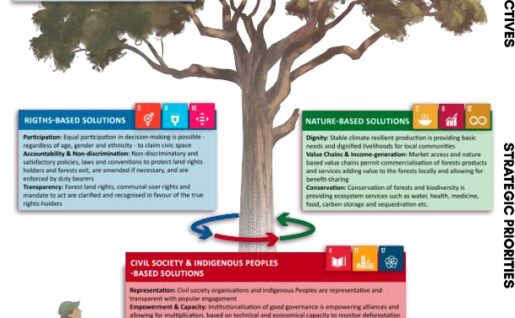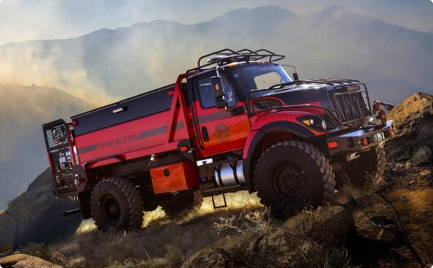

#### The way forward



Preventing wildfires is vital for ensuring that the the forest ecosystem remains healthy. AWS has the capability to make your data work for you to to ensure a better future.

#### Key Takeaways

* AWS services are economical, secure, and and reliable, making forest fire analytics an efficient process.
* Predictive modeling using big data analytics is a game-changer for forest fire
* [](https://gamma.app/)Rmeaanl-atgimeme ednatt.a acquisition and processing processing are essential for early detection detection and prevention.