EXISTING IDEAS
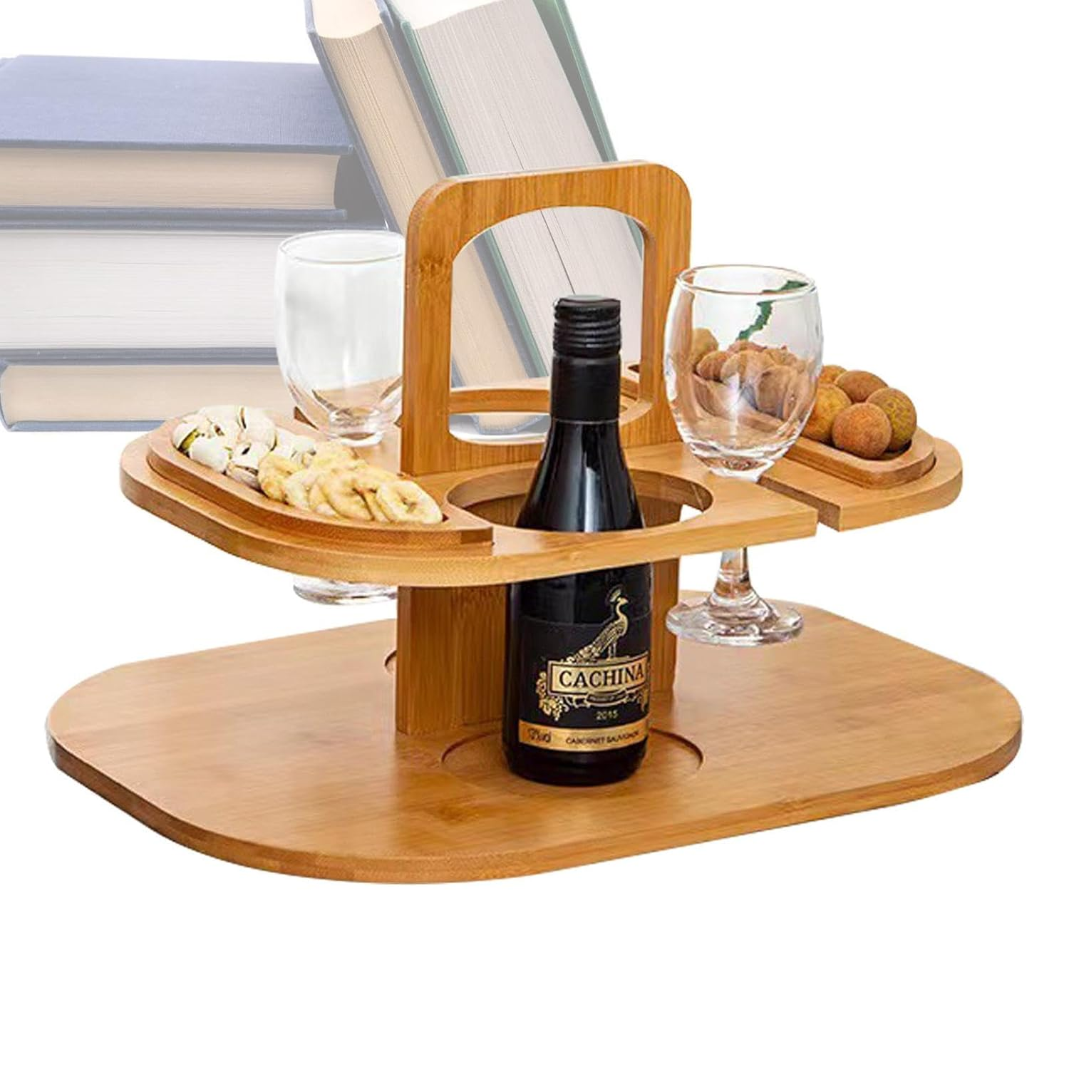
Name: Vertical wine serving tray | Name: Simple use wine tray
Relation to design brief: ITThis tray is made to keep bottles, glasses and snacks steady and safe. It has round holes that tightly fit the base of wine bottles and glasses, which helps stop them from tipping over if the table is bumped. The bottle is placed in the centre to keep the tray balanced and stable. On each side, there are flat arms that hold snacks or small dishes, preventing them from sliding off. This relates to the design brief the compact design keeps everything close together, which lowers the chance of the bottles and glasses from falling. | Relation to design brief: This wooden wine and cheese holder tray is made to keep everything neat and steady. It has built-in round spaces to hold wine bottles, so they stay in place and don’t fall over. The flat surface

SITUATION
My brother owns a restaurant that is usually at full capacity with customers. He normally serves wine by carrying multiple wine glasses and bottles at once in his hands for fast service, but the glasses and bottles always fall.

PROBLEM
Due to his clumsiness, the wine bottles fall off easily from his hands and shatters.

DESIGN BRIEF
Design and make an artefact that my brother will use to carry wine bottles to his customers so that they are prevented from falling and shattering.

DESIGN SPECIFICATIONS

ELEMENT | STATEMENT | JUSTIFICATION
Function | The product should be able to hold the wine glasses and bottles when my brother is serving without falling off easily. | To prevent the wine glasses form falling and breaking.
Properties of materials | The material should be durable and strong. | To carry the weight of the wine bottles and glasses without collapsing.
Structural consideration | The project should have permanent joints. | To make the product last longer without falling apart.
Size | Width:230mm-370mm  Length:320mm-400mm  Height:70mm-120mm | So that it is portable enough not to occupy a lot of space on the table.
Safety | It should be stable. | To avoid spilling off spilling its contents
Finish | Product should be finished with a waterproof finish | To avoid damage in case it comes in contact with liquids.
Cost | It should cost around P100.00-P200.00’ | To make it compete with other products in the market which ranges.

TESTING AND EVALUATION

EVIDENCE OF TESTING
To test the

