

**TRIBHUVAN UNIVERSITY**

**INSTITUTE OF ENGINEERING**

**THAPATHALI CAMPUS**

**A Minor Project**

**On**

**Formula Encyclopedia 2.0**

**Submitted By:**

Atul Shreewastav (THA077BCT013)

Bidhan Acharya (THA077BCT015)

Nischal Paudel (THA077BCT028)

Yugratna Humagain (THA077BCT047)

**Submitted** **To**:

Department of Electronics and Computer Engineering

Thapathali Campus

Kathmandu, Nepal

**Under the Supervision of**

Er. Saroj Shakya

November, 2022

# CERTIFICATE OF APPROVAL

The undersigned certify that they have read and recommended to the Department of Electronics and Computer Engineering, IOE, Thapathali Campus, a project work entitled “Formula Encyclopedia 2.0” submitted by Atul Shreewastav, Bidhan Acharya, Nischal Paudel, Yugratna Humagain. The Project was carried out under special supervision and within the time frame prescribed by the syllabus. We found the students to be hardworking, skilled and ready to undertake any related work to their field of study.

__________________________________________

Examiner

Er. Saroj Shakya

Department of Electronics and Computer Engineering, Thapathali Campus Thapathali,

Kathmandu

# COPYRIGHT

The author has agreed that the Library, Department of Electronics and Computer Engineering, Thapathali Campus, Institute of Engineering may make this report freely available for inspection. Moreover, the author has agreed that permission for extensive copying of this project report for scholarly purpose may be granted by the supervisors who supervised the project work recorded herein or, in their absence, by the Head of the Department wherein the project report was done. It is understood that the recognition will be given to the author of this report and to the Department of Electronics and Computer Engineering, Thapathali Campus, Institute of Engineering in any use of the material of this project report. Copying or publication or the other use of this report for financial gain without approval of to the Department of Electronics and Computer Engineering, Thapathali Campus, Institute of Engineering and author’s written permission is prohibited.

Request for permission to copy or to make any other use of the material in this report in whole or in part should be addressed to:

Head,

Department of Electronics and Computer Engineering,

Thapathali Campus, Institute of Engineering

Kathmandu, Nepal.

# ACKNOWLEDGEMENT

We would like to express our gratitude towards our Department of Electronics and Computer Engineering for providing us with the opportunity to explore and implement the knowledge of programming in this project. Not just with the exploration and implementation of the programs, the project was also helpful for us to collaborate as a team and serve as a way to showcase our creativity. All the project members did a lot of work in learning and contributing towards the project. We tried our best to resolve all the problems we faced and, in the journey, we ended up learning more than ever. It was a pleasure doing this project and we would like to acknowledge the equal contributions of every individual for the project

‘Formula Encyclopedia 2.0’. We would also like to express our respect towards to the authors and various developers whose works we have referenced in making this project. The article served as a great source of knowledge and inspiration for all of us.

The entire project wouldn’t have gone so smoothly without their help. We would like to thank our lecturer Er. Saroj Shakya in particular who was the first person we looked upon when we faced any problems. His encouragement and words drove us into this creating this wonderful project. Finally, we would like to express our thankfulness to all the friends, teacher, authors and developers who have been involved with us in the project in one way or the other. We are extremely grateful for their support, cooperation, help, guidance and encouragement in doing this project

Atul Shreewastav (077/BCT/013)

Bidhan Acharya (077/BCT/015)

Nischal Paudel (077/BCT/028)

Yugratna Humagain (077/BCT/047)

# ABSTRACT

This project is intended to organize some of the basic formulas that are required in our semesters using C++ programming language with the help of QT Framework. Our formulas are stored in a database using MYSQL. This will enable students to focus on the actual problem rather than wasting time searching for formulas. This will help boost productivity of students and also enable them to have a quick recap over all the formulas.

*Keywords: C++, formula, g++, MinGW, MYSQL, QT6*

# TABLE OF CONTENT

CERTIFICATE OF APPROVAL i

COPYRIGHT ii

ACKNOWLEDGEMENT iii

ABSTRACT iv

TABLE OF CONTENT v

LIST OF FIGURES vi

LIST OF TABLES vi

1 INTRODUCTION 1

1.1 Background 1

1.2 Motivation 1

1.3 Problem Definition 1

1.4 Objectives 1

2 LITERATURE REVIEW 2

2.1 Database Management 2

2.2 QT Widgets 2

2.2.1 QPushButton 2

2.2.2 QComboBox 3

2.2.3 QListWidget 3

2.2.4 QLabel 3

2.2.5 QStackedWidget 3

2.3 Formulas 3

3 METHODOLOGY 4

3.1 Home Screen 4

3.2 Login Page 4

3.3 Modes 4

3.3.1 Admin mode 4

3.3.2 User mode 5

3.3.3 Guest mode 5

3.4 Exit 5

4 SYSTEM DESCRIPTION 5

4.1 Formula Encyclopedia 6

4.1.1 Block Diagram 6

4.1.2 Data Flow Diagram 6

4.2 Tools and Environment 7

5 RESULTS AND ANALYSIS 8

5.1 Homepage 8

5.1.1 Look for a formula 9

5.1.2 View Formula sorted by Subjects 10

5.1.3 List all Formulas 10

5.1.4 Add a new Formula 11

6 CONCLUSION AND FUTURE ENHANCEMENT 13

6.1 Conclusion 13

6.2 Limitations 13

6.3 Future Enhancement 13

References 14

# LIST OF FIGURES

Figure 4-1: Block Diagram ........................................................................................................ 7

Figure 4-2: Data Flow Diagram ................................................................................................. 8

# LIST OF TABLES

Table 2-1: Some Functions for File Handling in C.................................................................... 2

# INTRODUCTION

“Formula Encyclopedia 2.0” is the improvised version of our first project “Formula Encyclopedia” related with all the formula required for the students. As finding a certain formula can get difficult, in general, this program is made to provide the users each and every formula required in the semesters of BCT.

## Background

Formula is an important part of problem-solving in engineering. In some cases, finding a formula for a certain problem can get hectic. In turn when not being able to find certain formula the progress in the problem halts. As there can be multiple formulas for a single problem the task of finding appropriate formulas can be very difficult for students.

## Motivation

When we first created "Formula Encyclopedia," it was riddled with bugs and had an entirely CUI-based user interface, so we decided to change it and create a GUI using the same ideas but a different methodology. We first investigated a wide range of potential Frameworks that were on the market and ultimately chose to work with QT because it had a simpler user interface and made it simpler for us to develop a GUI-based program than other Frameworks that were on the market. By giving them easy access to the necessary formulas of their choice, this app will help students enjoy the task of solving problems.

## Problem Definition

All of us, team members, in some way or the other have experienced the need of one stop solution for referring to formulas for different subjects on the go. It is such a hassle for a student to go and look back for formulas while solving several questions. As an engineering student there are tons and tons of formulas to remember which is not really feasible. This application will help tackle these problems and have better focus on studies.

## Objectives

The main objectives of our project are listed below:

* To develop an application that compiles most of the formulas
* To increase the efficiency of students in solving problems.

# LITERATURE REVIEW

There is no direct resemblance to our work on the web or other sources but the techniques that we will be using to develop this app are widely using in almost every sectors. Database Management, QT widgets such as QPushButton, QComboBox, QListWidget, QLineEdit, QStackedWidget, etc. also formulas are the fundamental elements of our project.

## Database Management

A database management system (DBMS) is a software package designed to store, retrieve, query and manage data. User interfaces (UIs) allows data to be created, read, updated and deleted by authorized entities. The management system that we used in our software is MYSQL.

MySQL, the most popular Open-Source SQL database management system, is developed, distributed, and supported by Oracle Corporation. MySQL databases are relational i.e. Instead of placing all the data in one huge warehouse, a relational database keeps the data in individual tables. Physical files that are designed for speed contain the database structures. The logical model provides a flexible programming environment with objects like databases, tables, views, rows, and columns. One-to-one, one-to-many, unique, compulsory or optional, and "pointers" between distinct tables are a few examples of the rules you might build up to regulate the relationships between various data fields.

## QT Widgets

The Qt Widgets Module provides a set of UI elements to create classic desktop-style user interfaces. Widgets are the primary elements for creating user interfaces in Qt. Widgets can display data and status information, receive user input, and provide a container for other widgets that should be grouped together. A widget that is not embedded in a parent widget is called a window. The QWidget class provides the basic capability to render to the screen, and to handle user input events. All UI elements that Qt provides are either subclasses of QWidget, or are used in connection with a QWidget subclass.

Some of the most used QT Widgets that are used in our program is listed below:

### QPushButton

A command button is offered by the QPushButton widget. The push button, often known as a command button, is arguably the widget that is used the most frequently in graphical user interfaces. To instruct the computer to carry out a task or provide an answer, press (click) a button. OK, Apply, Cancel, Close, yes, no, and Help are examples of common buttons.

### QComboBox

A QComboBox offers a way to provide the user a list of options while using the least amount of screen real estate possible. A ComboBox is a selection widget that shows the currently selected item and can open a list of additional things to choose from. An editable ComboBox enables the user to change each item in the list.

### QListWidget

QListWidget is a convenience class that provides a list view similar to the one supplied by QListView, but with a classic item-based interface for adding and removing items. QListWidget uses an internal model to manage each QListWidgetItem in the list.

### QLabel

For displaying text or a picture, use QLabel. There is no feature for user interaction. A focus mnemonic key for another widget can be specified by altering the label's visual look in a variety of ways.

### QStackedWidget

QStackedWidget can be used to create a user interface similar to the one provided by QTabWidget. It is a convenience layout widget built on top of the QStackedLayout class.

## Formulas

The formulas are the key element of our project. Formulas are a mathematical relationship or rule expressed in symbols among different parameters used to solve problems. These formulas took years of challenging work of scientists, scholars, mathematicians, professors to be deduced and are widely used in to solve various problems in different fields. Being able to access it easily will really boost up the efficiency of learning that topic and help to approach a problem logically.

# METHODOLOGY

Formula Encyclopedia works on the principle of extracting the data from the database using MYSQL. Numbers of formula are stored and sorted in the database on the basis of subjects. The subjects are:

* Engineering Mathematics
* Engineering Physics
* Engineering Chemistry
* Electrical Circuit Theory
* Electromagnetics
* Applied Mechanics

## Designing the Home Screen

Homepage is a gate way of any program which allows user to access various features of the program. The homepage of our application contains 2 buttons labelled as Login and Exit. The homepage buttons were created using QPushButton class. A simple background relevant to our project was selected for the homepage.

## Rendering and Designing the Login Page window

At first, we render a window using inbuilt class QDialog of QT library. A window is created and opened directly when the login button on homepage is clicked. A top pane with the project name and logo was added using QWidget and QLabel. A QGroupBox class object was added for creating the login section of the UI. At first a QComboBox class object was added to select the type of user logging in. Then, two QLineEdit class objects were used to enter the username and password. A QPushButton class object was used as the login button which would connect to a MySQL database and match the credentials with the user entered values and login and render a new window according to the user type (Admin, User, Guest) if the match is successful.

## Rendering and Designing the Admin Mode window

The Admin Mode window consists of 4 QPushButton class objects three being used to manage users by the admin and the fourth one is used to log out of the admin mode. The three different user management buttons are:

* Register a User
* Delete a User
* View Users

Clicking each of these buttons renders a new QStackedWidget class objects and create a new page according to the button clicked and perform the user management operation.

## Rendering and Designing the User Mode window

The User Mode window consists of QPushButton class objects which are used to view formulas of the different subjects. Each subject button is paired with a beautiful thumbnail of the respective subject to give a sleek look and feel to the UI. The different subject buttons are:

* Applied Mechanics
* Engineering Chemistry
* Electric Circuit Theory
* Electromagnetism
* Engineering Mathematics
* Engineering Physics

Clicking each of these buttons renders a new QStackedWidget class objects and create a new page according to the button clicked and loads up the formula images stored in a MySQL database.

The top of the User Mode page contains a QStackedWidget which contains two QComboBox and a QPushButton class object. The QComboBox objects and QPushButton are used to navigate to different titles within the list of subjects.

## Rendering and Designing the Guest Mode window

The Guest Mode window consists of two QPushButton class object which offers users to get a preview of limited number of formulas. To access the entire database, they have to be registered by an admin as a user.­

# SYSTEM DESCRIPTION

Formula Encyclopedia 2.0 is a Graphical User Interface based app i.e., there are GUI components and inputs can be given from the keyboard as well as mouse by simply clicking on the buttons and icons and desired output will be displayed.

## Formula Encyclopedia 2.0

Formula Encyclopedia 2.0 is a simple QT based GUI application so user can directly give input to the application by simply clicking on different buttons. The app runs a match through a database and displays the desired output.

### Block Diagram

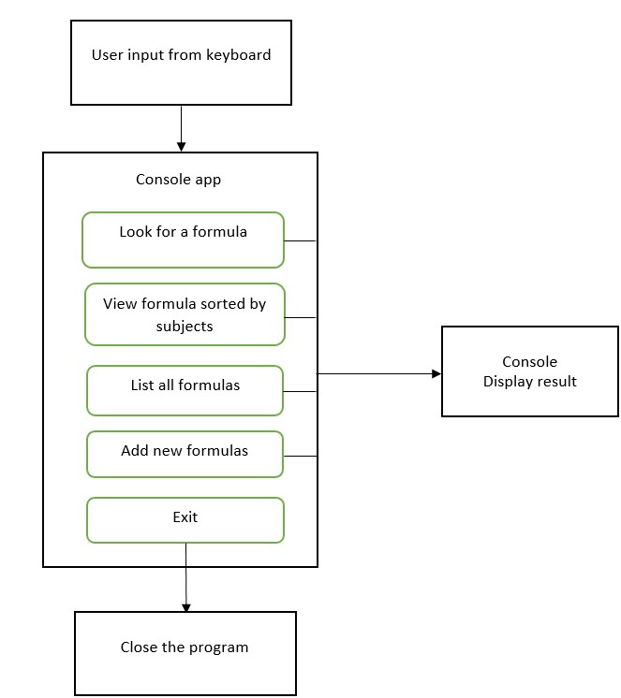

Figure 4-1: Block Diagram

### Data Flow Diagram

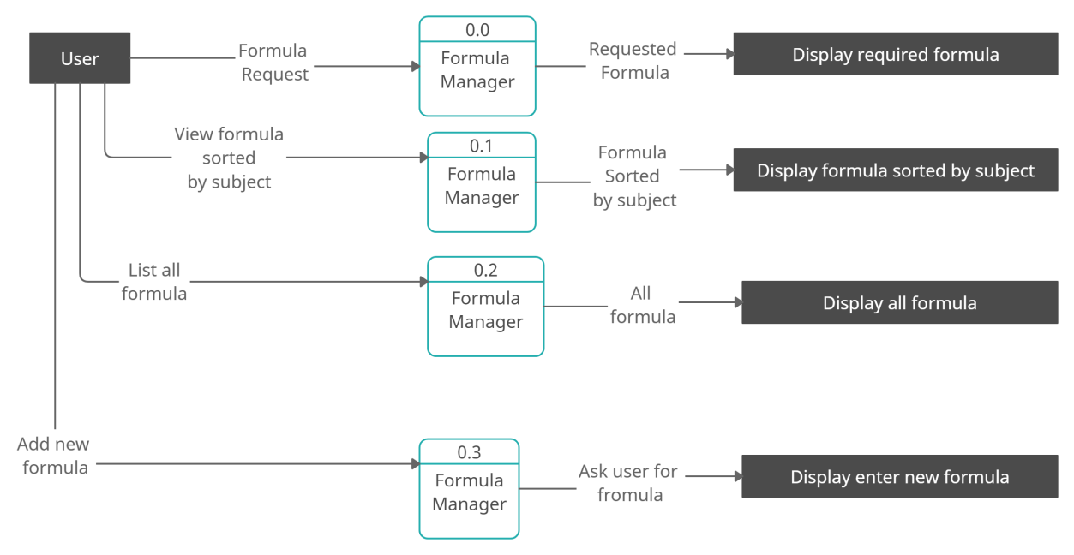

Figure 4-2: Data Flow Diagram

## Tools and Environment

* QT Creator 8.0.1 (Community)
* MySQL 8.0 Command Line Client
* MinGW 11.2.0 (64-bit)
* C++ Language (Standard: C17)

# RESULTS AND ANALYSIS

With the end of the project, we have been able to secure our objective as we intended. Like we have described in the early part of the project, the “Formula Encyclopedia 2.0” comes with very handy functions embedded with it which eases the process for looking up formulas for the engineering students.

## Homepage

This is the homepage for our project the “Formula Encyclopedia 2.0”.

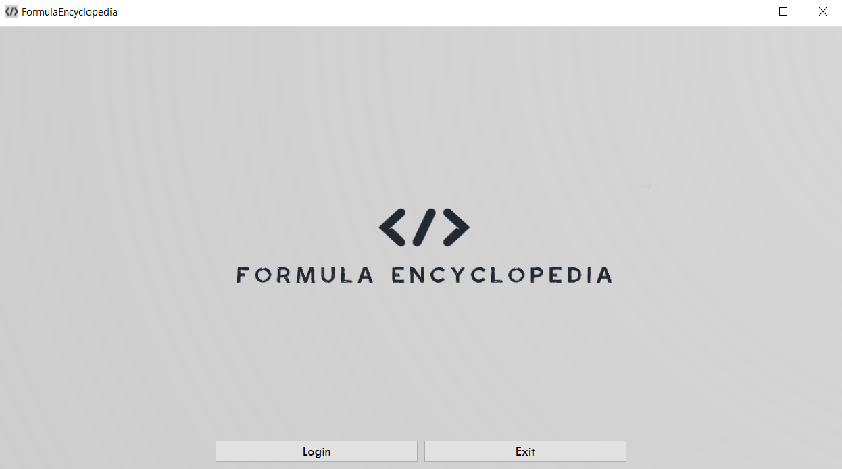

### Login

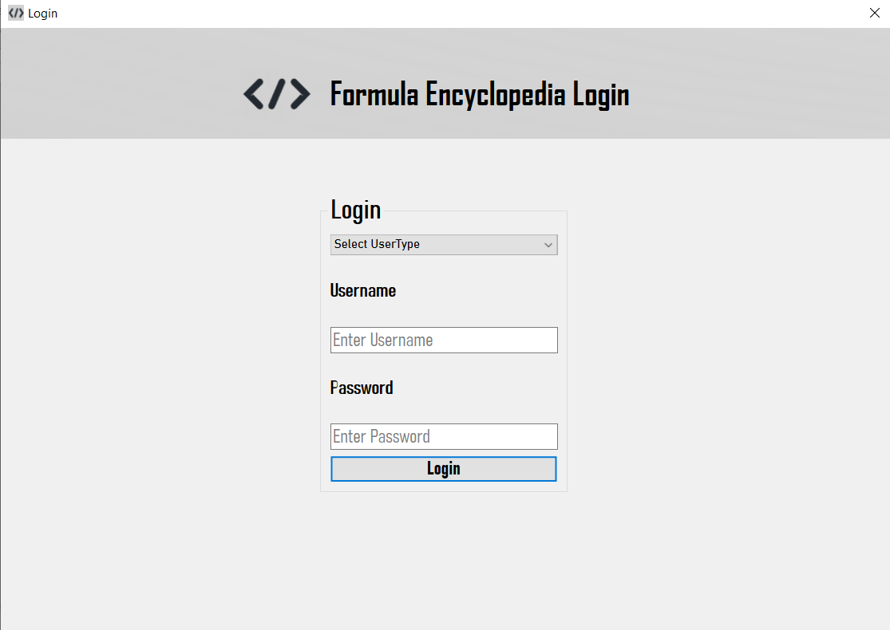

When you select login option, the application redirects to a new window where user is required to enter its type, username and password in order to login and access the features of the application.

#### Admin Mode

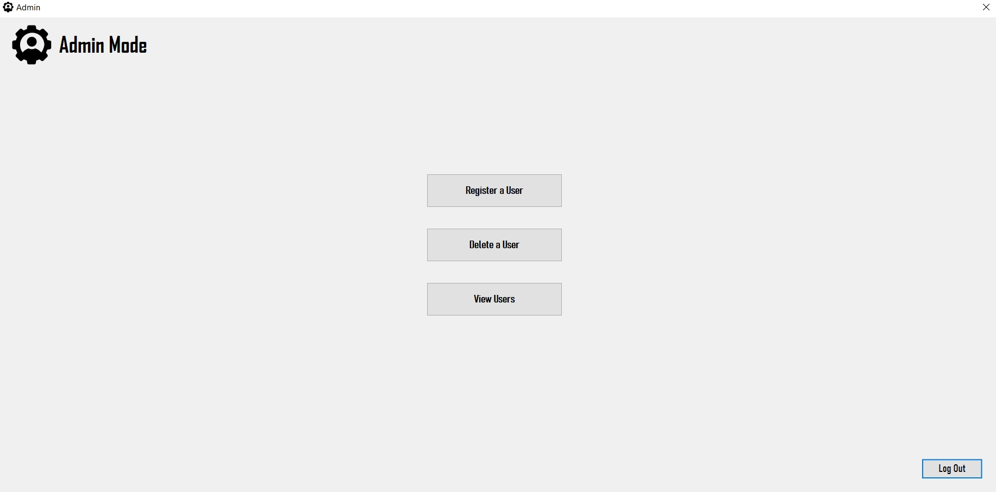

If the user selects Admin Mode and enters the correct credentials for admin then the application is redirected to Admin window where Admin can manage the users.

##### Register a User

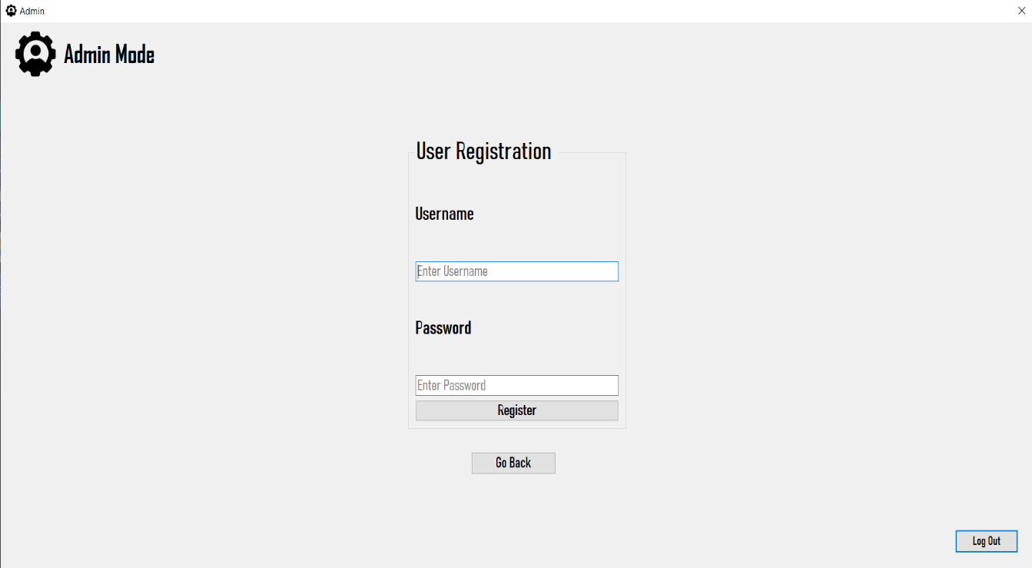

In Register a User section, the admin can add a new user to the database.

##### Delete a User

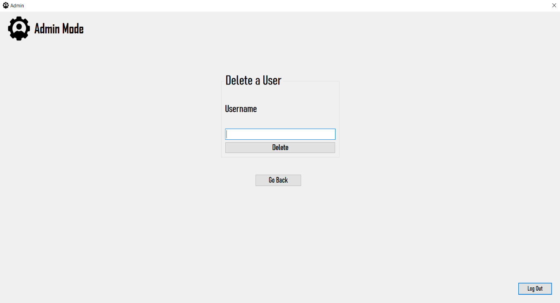

In Delete a User section, the admin can remove a user from the database by entering the required username.

##### View Users

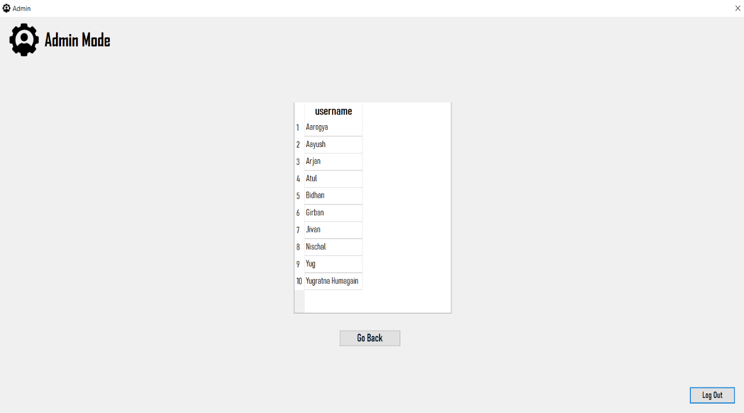

In View Users section, the admin can view the list of usernames stored in the database.

#### User mode

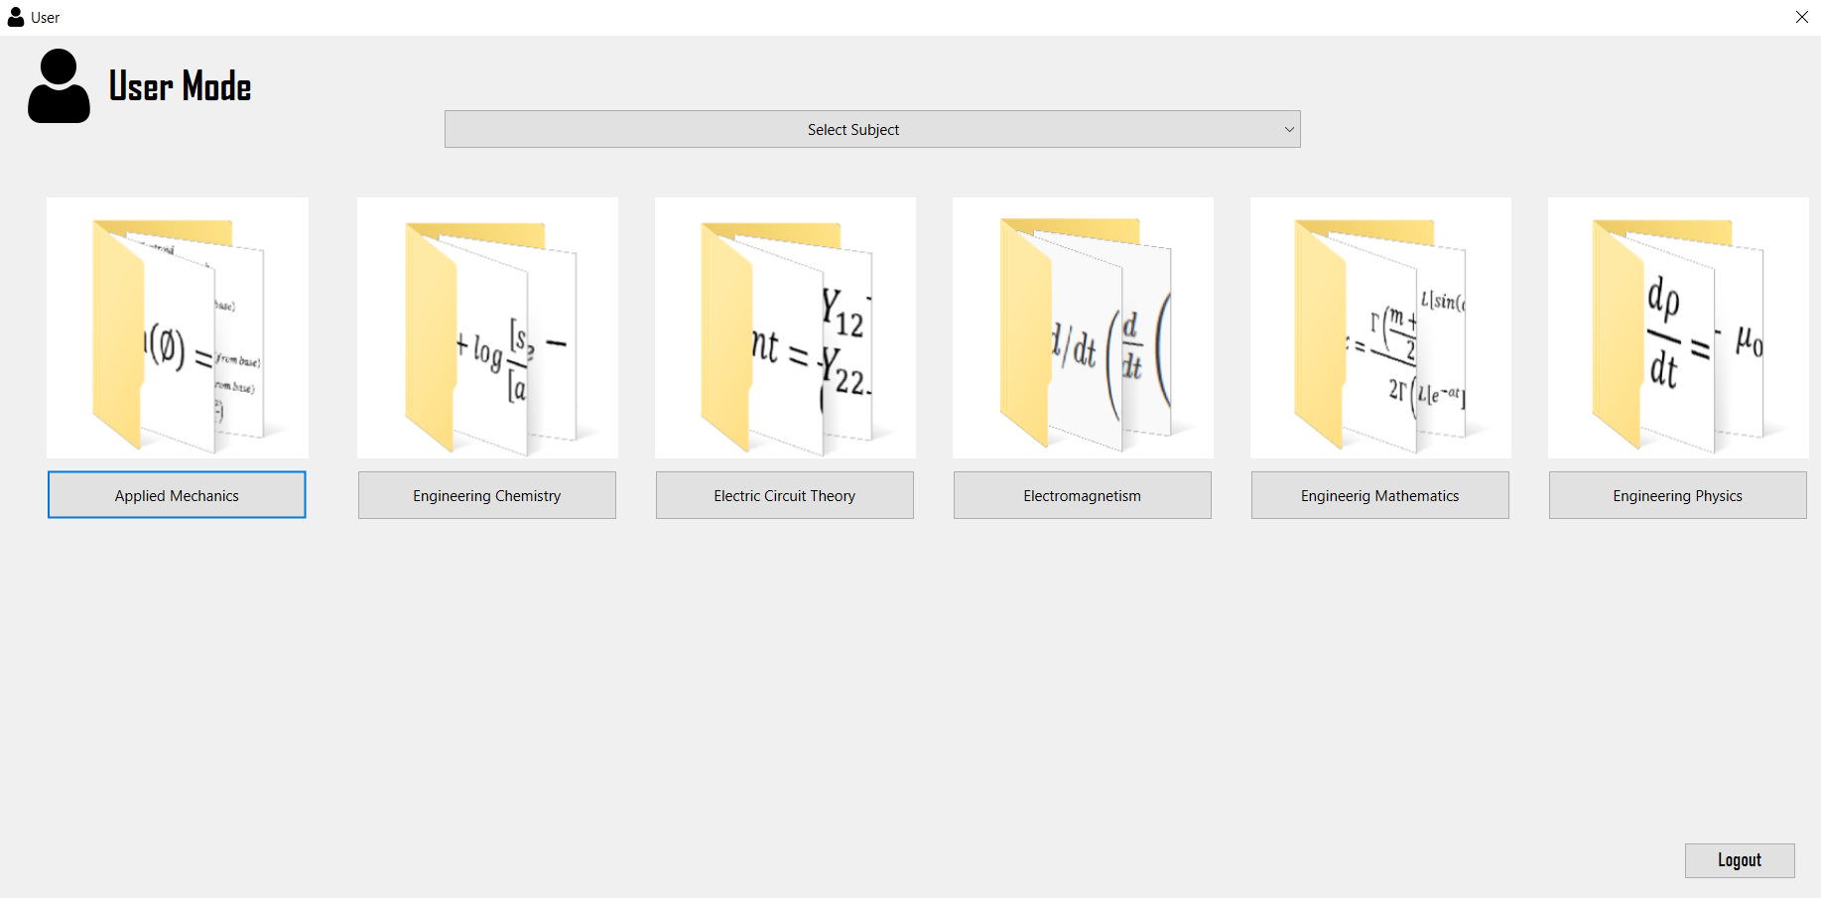

If the user selects User Mode and enters the correct credentials for user then the application is redirected to User window where user can view formulas.

##### Viewing formula by title

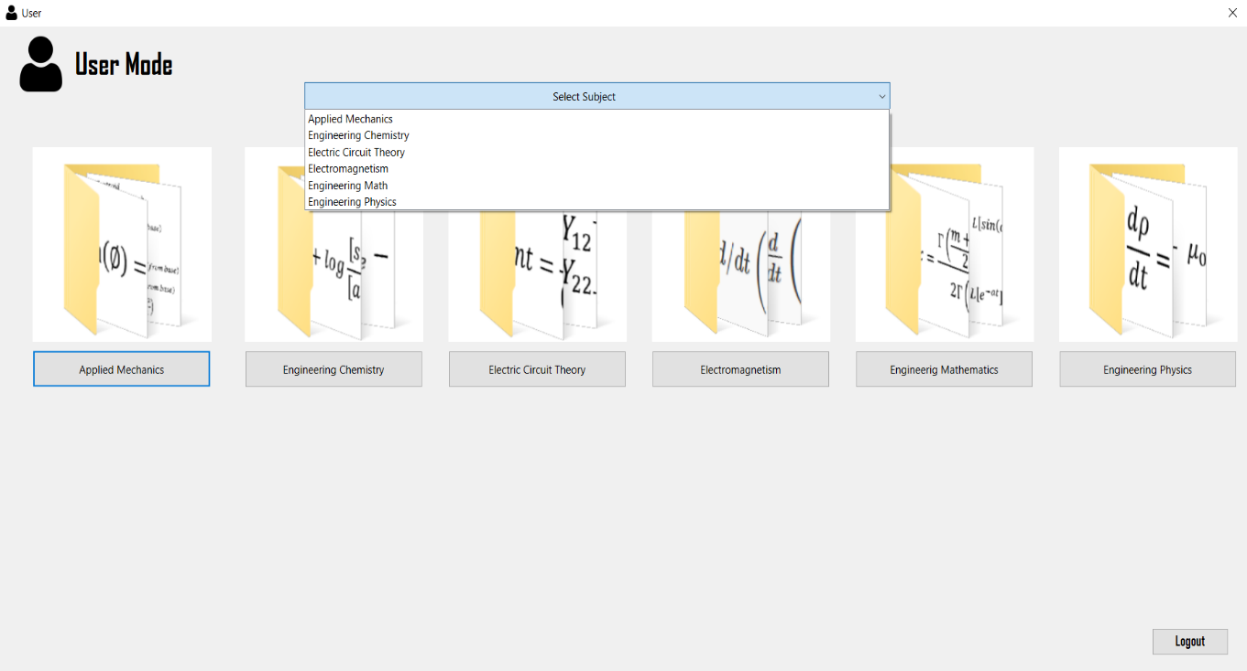

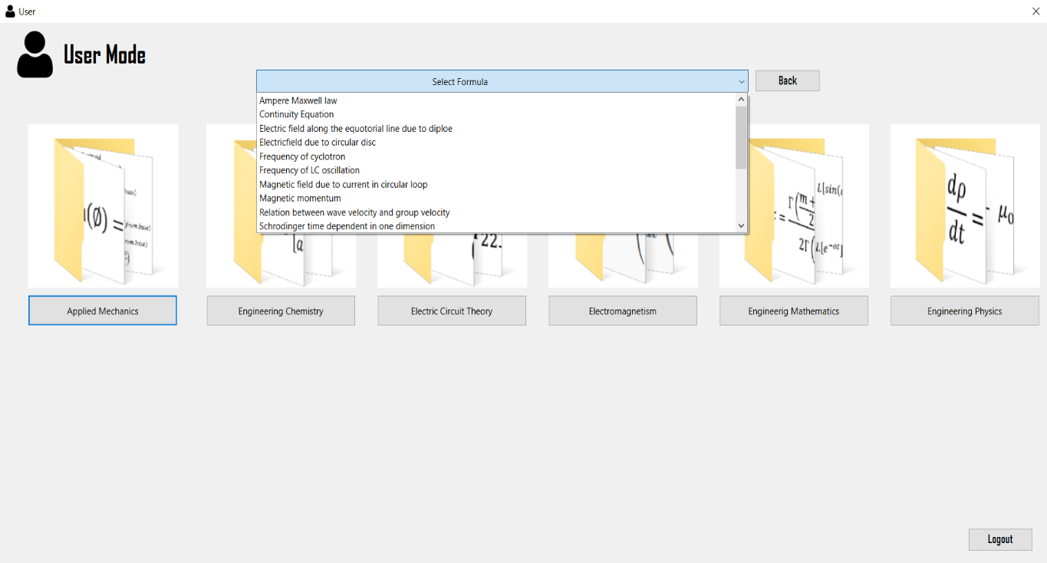

From Combo box the user can select the subject and title of the formula respectively as per their wish.

##### View formula by subject

PHOOTOTOTOOT

By clicking the Push Button of required subject, the user is redirected to a new window where all the formulas of the selected subject are displayed.

#### Guest Mode

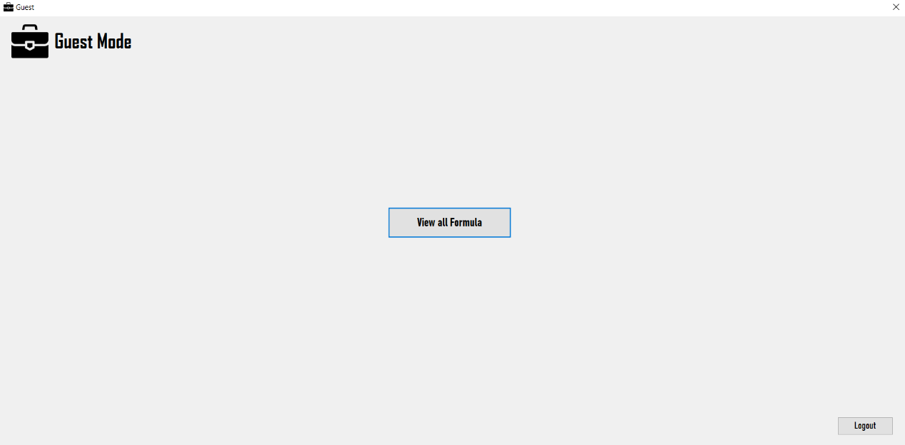

If the user selects Guest Mode and logs in then the application is redirected to Guest window where user can get a preview of limited formulas.

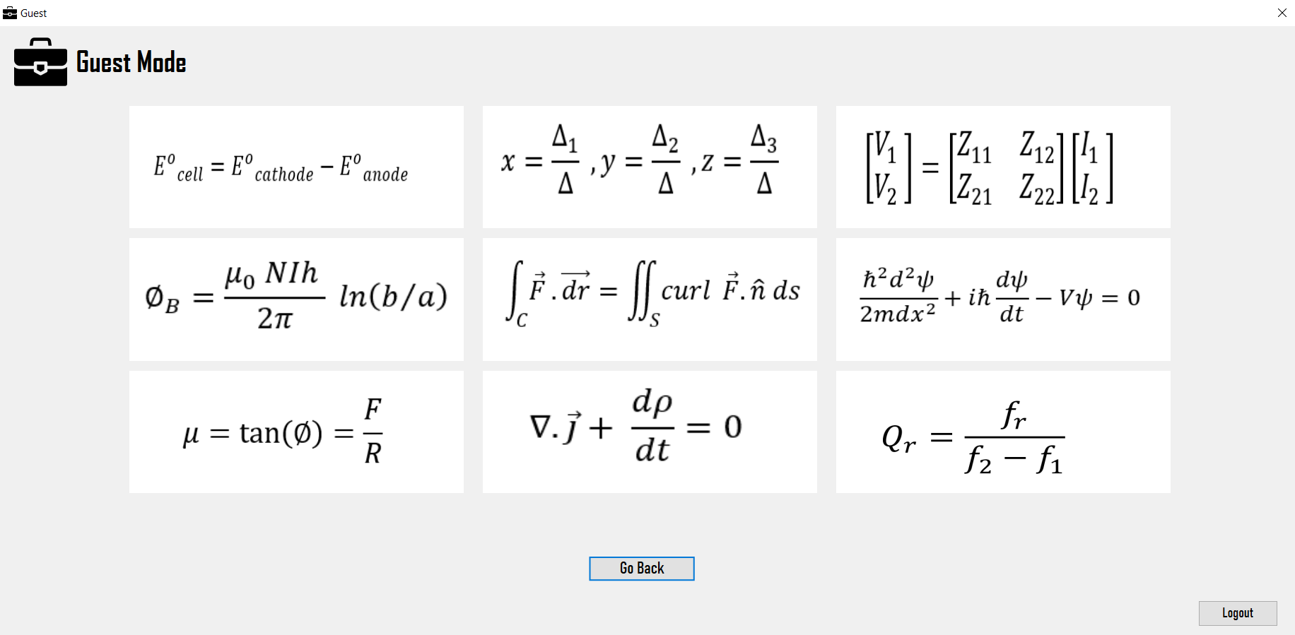

# CONCLUSION AND FUTURE ENHANCEMENT

## Conclusion

Formula Encyclopedia 2.0, a GUI app developed by us as a project for the course of CT501, is a small project built within a limited time period. This program can be further brushed up to make it more user-friendly and more reliable with many more functionalities.

## Limitations

As we know, it is not possible to develop a program which can be 100% efficient and effective, so there are some drawbacks in our system and lack of some features due to time constraint which are listed as follows:

* There may be some glitches during runtime.
* The formula in our database is limited.
* The formula cannot be managed dynamically

## Future Enhancement

The formula database can be more diversified. Program can be made more memory efficient and faster. The aesthetics of the program can be improved by the use of external graphics libraries and modules.