<DEPARTMENT OF COMPUTER SCIENCE & ENGINEERING>
<ABES ENGINEERING COLLEGE, GHAZIABAD>
SOFTWARE REQUIREMENTS
SPECIFICATION (SRS)
Project Title: SmartHire: AI-Assisted Resume Screening and Candidate Ranking System
Standard Academic Compliance: IEEE Std 830-1998
————————————————————————————
SUBMITTED BY:  1. Atul Kushwaha (Roll No: 2400321540059)  Degree: Bachelor of Technology (B.Tech)  Academic Year: 2026 - 2027 | UNDER THE GUIDANCE OF:  Prof. / Dr. <Ankit Mishra>  <Data Scientist>  Department of Computer Science & Engg.  Status: 3rd Year Project Specification  Date of Submission: <01-10-2026>

Document Revision & Approval History
Version | Date | Description / Major Changes | Prepared By | Reviewed By
0.1 | 15-Sep-2026 | Initial Draft & Scope Definition | Project Team | Project Guide
1.0 | 30-Sep-2026 | Final 3rd Year Mid-Term SRS Baseline | Project Team | HOD / Committee

Guidance Note: This Software Requirements Specification document conforms to the IEEE 830-1998 standard recommended practice. All sections are strictly designed for 3rd-year university lab evaluation, project reviews, and system design baselines.

1. Introduction
1.1 Purpose
The purpose of this Software Requirements Specification (SRS) document is to provide a complete, clear, and unambiguous definition of the functionality, external interfaces, performance targets, and constraints of the proposed system: 'SmartHire: AI-Assisted Resume Screening and Candidate Ranking System' (hereafter SmartHire, formerly named SmartScreener). This specification serves as a binding reference agreement between student developers, project evaluators, academic supervisors, and prospective end users during the 3rd-year engineering curriculum.
1.2 Scope of the System
The proposed application is designed to solve the problem of slow, inconsistent, and hard-to-justify first-pass resume screening by delivering an end-to-end automated platform. A recruiter supplies a job description and a batch of resumes; the system extracts a structured profile for every candidate, scores it against the role, and presents a ranked, explainable shortlist. Key boundary guidelines include:
- In-Scope Capabilities: Job description intake with automatic skill-requirement extraction; bulk resume upload (PDF, DOCX/DOC, TXT) with text extraction; structured candidate profiling using a local LLM (Ollama) with an offline rule-based fallback; weighted scoring (technical, experience, education); ranked leaderboard with sorting, search and skill filters; candidate detail view with score-breakdown chart; side-by-side comparison of up to three candidates; local SQLite persistence.
- Out-of-Scope Boundaries: Full applicant-tracking workflow (pipeline stages, interview scheduling, offers); automated acceptance or rejection of candidates; candidate-facing application portal; integrations with job boards, ATS or HRIS; OCR of scanned resumes; user authentication and role-based access control (planned for a later release, see Module 4 in Section 3).
- Expected Benefits: Targeted reduction of first-pass screening time (proposed target of 50% against manual review, to be validated in a pilot), the same criteria applied to every candidate, a visible score breakdown behind every ranking, and candidate data kept on the local machine by default. SmartHire supports a recruiter's judgement; it does not replace it.
1.3 Definitions, Acronyms, and Abbreviations
Category | Term / Acronym | Definition / Standard Context
Standard | SRS | Software Requirements Specification (IEEE Std 830-1998 format).
Architecture | API / REST | Application Programming Interface; stateless HTTP architectural style exchanging JSON.
Domain | JD | Job Description: the free-text role description pasted in by the recruiter.
Domain | ATS | Applicant Tracking System (out of scope; possible future integration).
AI / NLP | LLM | Large Language Model. SmartHire uses the Mistral model served locally by Ollama.
AI / NLP | Ollama | Open-source runtime for running LLMs locally; HTTP API on localhost:11434.
AI / NLP | Fallback Mode | Rule-based extraction (regular expressions plus a skills dictionary) used when Ollama is unavailable.
AI / NLP | Cosine Similarity | Measure of word-overlap similarity between resume text and JD text, from 0 to 1.
Database | SQLite / CRUD | File-based relational database; Create, Read, Update, Delete operations.
Network | CORS | Cross-Origin Resource Sharing: browser policy controlling which origins may call the API.
Project Specific | Match Score | Overall 0-100 weighted score of a candidate against a job (technical 40%, experience 40%, education 20%).
Project Specific | PII | Personally Identifiable Information (names, emails, phone numbers) contained in resumes.

1.4 References
- IEEE Std 830-1998: IEEE Recommended Practice for Software Requirements Specifications.
- Software Engineering (10th Edition): Ian Sommerville, Pearson Education.
- Project Source Code: SmartHire repository, github.com/thevyanzu-ship-it/SmartHire-app (FastAPI backend, Next.js frontend, sample resumes in test_resumes).
- Official Documentation: FastAPI, Next.js, Ollama API, SQLite, pypdf, python-docx, Recharts and Tailwind CSS manuals.
- Regulatory Context: New York City Local Law 144 of 2021 (automated employment decision tools); Regulation (EU) 2024/1689 (EU AI Act); Regulation (EU) 2016/679 (GDPR).
1.5 Document Overview
The remainder of this SRS is partitioned into structural sections: Section 2 outlines the product perspective, target user personas, operational context, and design constraints. Section 3 itemizes detailed functional requirements organized into logical software modules. Section 4 specifies external interfaces (UI, Hardware, Software, Network). Section 5 defines non-functional attributes (Performance, Reliability, Security). Finally, Section 6 provides standard academic modeling diagrams.
2. Overall Description
2.1 Product Perspective
SmartHire is a self-contained multi-tier web system comprising a presentation layer (a Next.js 16 / React 19 single-page dashboard styled with Tailwind CSS 4, charts drawn with Recharts), an application/API tier (a FastAPI service exposing a REST/JSON interface, organised into parser, extractor and scoring services), and a persistent database backend (a SQLite file, db.sqlite). The only optional external dependency is a locally running Ollama server hosting the Mistral model, used for LLM-based extraction. When Ollama is not reachable the system automatically runs in Local NLP Fallback Mode, so no cloud service is required.
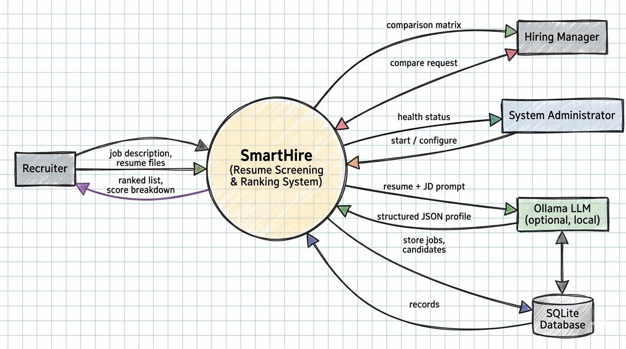
Figure 2.1: System context diagram (Data Flow Diagram, Level 0)
2.2 User Classes and Characteristics
The target software accommodates the following user personas. The current release has no login screen: everyone using an installation shares one workspace. Authentication and role-based access control are specified as planned requirements (FR-4.1).
User Role / Persona | Technical Proficiency | Core Responsibilities & Rights
Recruiter / Talent Partner | Intermediate (general web user) | Creates jobs, uploads resumes, sorts and filters the leaderboard, reviews candidate details, compares candidates, deletes jobs and associated data.
Hiring Manager | Basic to Intermediate | Reviews the ranked list and candidate detail, and compares shortlisted candidates. Same interface rights as the recruiter in the current release.
System Administrator | High (DevOps / environment setup) | Installs and starts the backend and frontend, runs and updates Ollama and its model, configures the API base URL and CORS, backs up or removes db.sqlite.

2.3 Operating Environment
The application operates within the following software and hardware environments:
- Client Requirements: Modern web browser (Google Chrome >= v110, Mozilla Firefox >= v108, Edge, Safari); minimum display resolution 1366x768 for desktop, with a responsive layout targeted down to 360x640.
- Server Runtime Environment: Windows 10/11, macOS or Linux (Ubuntu 22.04 LTS or later); Python 3.10+ for the FastAPI backend (Uvicorn on port 8000); Node.js 20 LTS or later for the Next.js frontend (port 3000).
- Database Storage Tier: SQLite 3 via Python's built-in sqlite3 module; a single file (backend/db.sqlite), no separate database server.
- Optional AI Runtime: Ollama with the mistral model at http://localhost:11434, on hardware able to run a 7-billion-parameter model (typically 8 GB RAM or more; a GPU improves speed).
2.4 Design and Implementation Constraints
- Academic Budget Constraint: Open-source technologies only; the system runs on a student laptop with no paid cloud service or commercial API.
- Data Privacy: Resume text and PII are processed locally and stored in the local SQLite file, which is excluded from version control through .gitignore. CORS currently allows all origins and must be restricted before any deployment beyond localhost.
- Modularity Standards: Layered service pattern: REST routes (main.py), services (parser, extractor, scorer), data access (database.py) and typed Pydantic schemas on the backend; component-based React UI on the frontend.
- Human Oversight: The system ranks and informs only. Final hiring decisions must be made by a person; no automatic rejection is permitted.
- Fixed Scoring Weights: Until configurable scoring is delivered (FR-4.4), the weights are fixed at technical 40%, experience 40% and education 20%.
2.5 Assumptions and Dependencies
- Assumptions: The tool runs on a trusted local machine or internal network; job descriptions and resumes are primarily in English; resumes are text-based documents rather than scanned images; job descriptions name skills in common forms present in the built-in skills dictionary.
- Dependencies: Python packages FastAPI, Uvicorn, python-multipart, pypdf, python-docx, Pydantic and requests; Node packages Next.js, React, Recharts, lucide-react and Tailwind CSS; optionally Ollama with the mistral model (the system remains functional without it).
3. System Features and Functional Requirements
Requirements are categorized by functional subsystem modules with unique requirement identifiers (FR-x.x):
3.1 Module 1: Job Management
Req ID | Feature Description | Input / Validation Rule | Priority
FR-1.1 | Create a job from a title and description | Title and description both required (non-empty text) | High
FR-1.2 | Automatically extract required skills from the job description | Case-insensitive match against the built-in skills dictionary with word-boundary rules (special handling for c++, c#, next.js, node.js) | High
FR-1.3 | Fallback requirement tags from the title | If no skill is detected, use title words longer than 3 characters (maximum 4) | Medium
FR-1.4 | List all jobs and retrieve one job | Integer job ID; HTTP 404 if the job does not exist | High
FR-1.5 | Delete a job together with all its candidates | Integer job ID; cascade delete through the foreign key; HTTP 404 if absent | High

3.2 Module 2: Resume Ingestion, Profiling and Scoring
Req ID | Feature Description | Input / Validation Rule | Priority
FR-2.1 | Bulk resume upload against a selected job | Multiple files per request (multipart); .pdf, .docx, .doc, .txt accepted; job must exist | High
FR-2.2 | Text extraction and normalisation | PDF text per page (pypdf); DOCX paragraphs and table cells (python-docx); other files decoded as UTF-8; blank lines removed | High
FR-2.3 | Skip unusable files without failing the batch | Files yielding fewer than 50 characters are skipped; an error on one file does not stop the others | High
FR-2.4 | LLM-based structured extraction | If Ollama responds to a probe (1.5 s), send JD and resume to model mistral (temperature 0.1, JSON output, 8 s timeout); response must contain name, skills and experience | High
FR-2.5 | Rule-based fallback extraction | Used when Ollama is unreachable, errors, or returns invalid JSON: regex for name, email, phone; dictionary skills; experience years; education | High
FR-2.6 | Compute technical, experience, education and overall scores | Rules in Table 3.2; each score clamped to 0-100 and rounded to one decimal | High
FR-2.7 | Persist the candidate profile and scores | Stored with foreign key job_id; skills and experience stored as JSON text | High
FR-2.8 | Report AI backend status | Health endpoint returns connected or fallback_mode | Medium

Table 3.2: Scoring rules
Score Component | Weight | Rule (as implemented)
Technical | 40% | 100 x (0.7 x skill coverage + 0.3 x cosine similarity). Coverage = matched JD skills / JD skills; if the JD has no recognised skills, coverage = min(candidate skills / 8, 1).
Experience | 40% | Candidate years / target years, capped at 100. Target = largest 'N years' figure in the JD; otherwise Senior/Lead/Principal = 5, Junior/Associate = 2, Intern = 0, default 3. Target 0 gives 100.
Education | 20% | Associate 70, Bachelor 80, Master/MBA 90, PhD 100, otherwise 60. If the JD asks for a PhD and the candidate has none, subtract 15 (minimum 40).
Overall | 100% | 0.4 x Technical + 0.4 x Experience + 0.2 x Education, rounded to one decimal.

3.3 Module 3: Ranking, Review and Comparison
Req ID | Feature Description | Input / Validation Rule | Priority
FR-3.1 | Leaderboard of candidates for the active job | Default order: overall score, descending | High
FR-3.2 | Sort by overall score or years of experience | Ascending or descending toggle | Medium
FR-3.3 | Search and skill filter | Free-text search; filter by any skill present in the candidate pool | Medium
FR-3.4 | Colour-coded score badges | Score >= 80 high, >= 50 medium, below 50 low | Low
FR-3.5 | Candidate detail panel | Contact details, skills, experience, education, two-sentence summary and bar chart of technical, experience and education scores; HTTP 404 if absent | High
FR-3.6 | Side-by-side comparison | Select up to 3 candidates (alert if more); IDs sent comma-separated; only candidates belonging to the job are returned; malformed IDs give HTTP 400 | High
FR-3.7 | Upload progress and processing log | Per-file status (uploading, success, error) and a loading skeleton while processing | Medium

3.4 Module 4: Planned Enhancements (not in the current release)
Req ID | Feature Description | Input / Validation Rule | Priority
FR-4.1 | User registration, login and role-based access | Email/username and password (>= 8 characters); salted hash (bcrypt); signed token session | High
FR-4.2 | Matched and missing skills per candidate | Computed against the job's extracted requirements | Medium
FR-4.3 | Export ranked list and comparison | CSV and PDF downloads | Low
FR-4.4 | Configurable scoring | Adjustable weights; must-have versus nice-to-have skills | Medium
FR-4.5 | Report skipped or failed files with the reason | Shown in the upload log and returned by the API | Medium
FR-4.6 | Data governance controls | Retention period, deletion on request, audit log | Medium

4. External Interface Requirements
4.1 User Interfaces (UI)
The interface follows standard UX usability practice: a single-page dashboard, clear status feedback, and immediate visual feedback for success and error states (status chips, loading skeletons, inline messages). The screens and the source components that implement them are listed below.
Table 4.1: User interface inventory
Screen / Component | Source File | Purpose and Key Elements
Dashboard (shell) | dashboard.tsx | Job list and selection, job deletion, AI status indicator from the health check; hosts the other components.
Job Input | job-input.tsx | Form for job title and description; displays the detected requirement tags.
Upload Zone | upload-zone.tsx | Drag-and-drop or browse for .pdf, .docx, .doc, .txt; processing log with per-file status.
Leaderboard | leaderboard.tsx | Ranked candidate table with score badges, sorting, search, skill filter, and selection of up to 3 candidates for comparison.
Candidate Detail | candidate-detail.tsx | Slide-over panel with match summary, contact details, skills, experience, education and score-breakdown bar chart.
Comparison Matrix | comparison-matrix.tsx | Modal grid comparing up to three candidates side by side.

[Insert screenshots of the running application for the screens above before final submission.]
4.2 Hardware Interfaces
Specification of physical interaction points:
- Standard Deployment: Standard input/output peripherals (keyboard, mouse, display >= 720p) on a host machine able to run the backend, the frontend and, optionally, Ollama.
- Embedded / IoT Variants: Not applicable. SmartHire has no microcontroller or sensor interface.
4.3 Software Interfaces
- Ollama HTTP API: Availability probe GET http://localhost:11434/; extraction request POST http://localhost:11434/api/chat with model mistral, JSON output format and temperature 0.1.
- Database Connector: Python sqlite3 module accessing backend/db.sqlite with parameterised queries; foreign key job_id with ON DELETE CASCADE.
- File Parsing Libraries: pypdf for PDF text extraction; python-docx for DOCX paragraphs and tables.
- Internal REST API: Consumed by the frontend through the base URL in config.ts (NEXT_PUBLIC_API_URL, default http://localhost:8000). Interactive documentation is generated by FastAPI at /docs.
Table 4.3: REST API summary
Method | Endpoint | Purpose
GET | /api/health | Ollama connectivity status (connected or fallback_mode).
POST | /api/jobs | Create a job and extract its required skills.
GET | /api/jobs | List all jobs.
GET | /api/jobs/{job_id} | Retrieve one job.
DELETE | /api/jobs/{job_id} | Delete a job and all its candidates.
POST | /api/jobs/{job_id}/resumes | Upload resumes; parse, extract, score and store candidates.
GET | /api/jobs/{job_id}/candidates | List candidates for a job.
GET | /api/candidates/{candidate_id} | Retrieve one candidate.
GET | /api/jobs/{job_id}/compare?ids=1,2,3 | Candidates selected for comparison.

4.4 Communication Interfaces
- Web Traffic Protocol: HTTP between browser (port 3000), API (port 8000) and Ollama (port 11434) on the local machine. HTTPS with TLS must be placed in front of the API for any deployment beyond localhost.
- Data Serialization: Request and response bodies use UTF-8 application/json, except resume upload, which uses multipart/form-data.
- Cross-Origin Policy: CORS currently permits all origins for development convenience; it must be limited to the frontend origin in production.
5. Non-Functional Requirements (NFRs)
Attribute | Target Metric / Standard | Verification & Testing Method
5.1 Performance | Targets (proposed): list and detail API calls under 500 ms locally; 20 typical resumes processed in under 30 s in fallback mode and under 3 minutes with the LLM (each LLM call is bounded by an 8 s timeout). | Timing of the sample resumes in test_resumes; ApacheBench or Locust for API calls.
5.2 Security | Parameterised SQL queries; upload type and size limits; CORS restricted outside localhost; authentication with salted password hashes (FR-4.1); no secrets or database files in version control. | OWASP ZAP scan; code review; negative upload tests.
5.3 Reliability | Automatic fallback when Ollama fails; one bad file never aborts a batch; availability of at least 98% during academic review. | Failure injection (stop Ollama, corrupt PDF); process supervision (systemd or PM2).
5.4 Portability | Runs on Windows, macOS and Linux; Chrome, Edge, Firefox and Safari; responsive layout. A cross-platform launcher is needed because run.sh is Bash-only. | Manual runs on Windows 11 and Ubuntu; browser DevTools responsive mode.
5.5 Usability | A non-technical recruiter can create a job, upload resumes and read the ranking without training; every score is accompanied by its breakdown. | Task-based walkthrough with 3 to 5 users; System Usability Scale questionnaire.
5.6 Maintainability | Modular services, typed schemas (Pydantic, TypeScript), auto-generated OpenAPI documentation, linted frontend. | Code review; ESLint; unit tests for scorer and extractor.
5.7 Accuracy | Targets (proposed): correct name, email and years of experience on at least 90% of a labelled resume set with the LLM and at least 70% in fallback mode. | Compare extracted fields with a hand-labelled sample set.
5.8 Privacy and Fairness | Local processing by default; deletion on demand; scores are advisory and a human decides; legal review against NYC LL 144, EU AI Act and GDPR before real-world use. | Compliance review; bias check on varied sample resumes.

6. System Design and Analysis Models
University evaluation rubrics require standard graphical analysis models illustrating the dynamic and static behavior of the application:
Diagram Type | Objective & Scope | Deliverable Format
Use Case Diagram | Maps the actors (Recruiter, Hiring Manager, System Administrator, Ollama LLM) to use cases UC-01 to UC-08. | Figure 6.1 and Table 6.1.
Data Flow Diagram (DFD) | Level 0 context (Figure 2.1) and Level 1 decomposition into five processes and two data stores. | Figure 6.2, Yourdon-style notation.
Entity-Relationship (ERD) | Entities job_descriptions and candidates with primary and foreign keys. | Figure 6.3 with normalisation notes.
Activity / Sequence Diagram | Message sequence for resume upload, extraction and scoring. | Figure 6.4.

6.1 Use Case Model
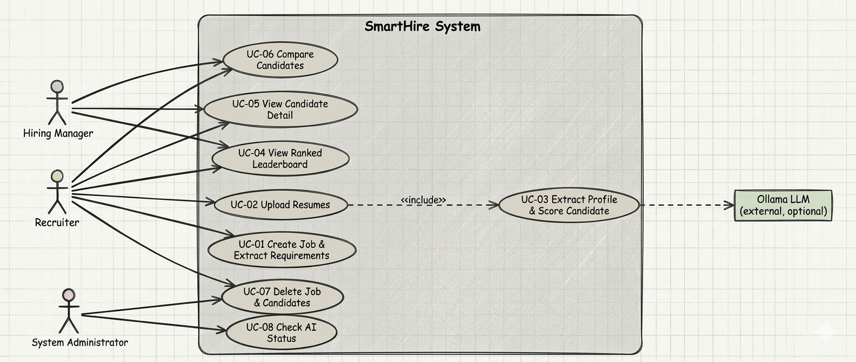
Figure 6.1: Use case diagram
Table 6.1: Use case specification
UC ID | Use Case | Actors | Summary (related requirements)
UC-01 | Create Job | Recruiter | Enter title and description; the system extracts required skills and stores the job (FR-1.1 to FR-1.3).
UC-02 | Upload Resumes | Recruiter | Select files for the active job; each file is processed and new candidates are returned (FR-2.1 to FR-2.3).
UC-03 | Extract Profile and Score | System, Ollama (optional) | Included in UC-02: extract the profile by LLM or fallback, compute scores, persist (FR-2.4 to FR-2.7).
UC-04 | View Ranked Leaderboard | Recruiter, Hiring Manager | Sort, search and filter candidates ranked by overall score (FR-3.1 to FR-3.4).
UC-05 | View Candidate Detail | Recruiter, Hiring Manager | Open the profile panel with score-breakdown chart (FR-3.5).
UC-06 | Compare Candidates | Recruiter, Hiring Manager | Select 2 to 3 candidates and open the side-by-side matrix (FR-3.6).
UC-07 | Delete Job | Recruiter, Administrator | Delete a job and all its candidates (FR-1.5).
UC-08 | Check AI Status | Administrator | View whether Ollama is connected or the system is in fallback mode (FR-2.8).

6.2 Data Flow Model
Level 0 is shown in Figure 2.1. Level 1 decomposes the system into Manage Jobs (1.0), Parse Resume Files (2.0), Extract Candidate Profile (3.0), Score and Rank (4.0) and Present and Compare (5.0), using two data stores: D1 job_descriptions and D2 candidates.
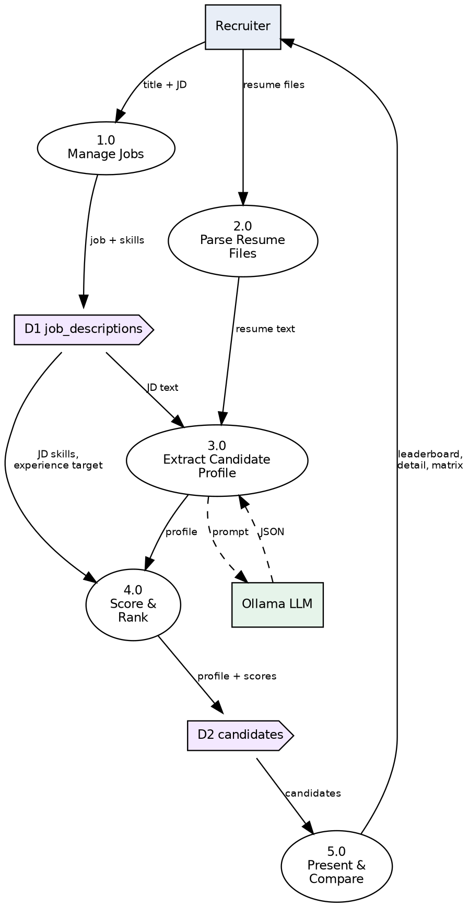
Figure 6.2: Data flow diagram, Level 1
6.3 Entity-Relationship Model
One job has many candidates; deleting a job cascades to its candidates. List-like attributes (skills, requirements) and the experience structure (years, roles, companies) are stored as JSON text for simplicity, a deliberate trade-off against strict first normal form; a production version could move skills into a separate candidate_skills table to reach full 3NF. The four score columns are derived values stored for fast ranking.
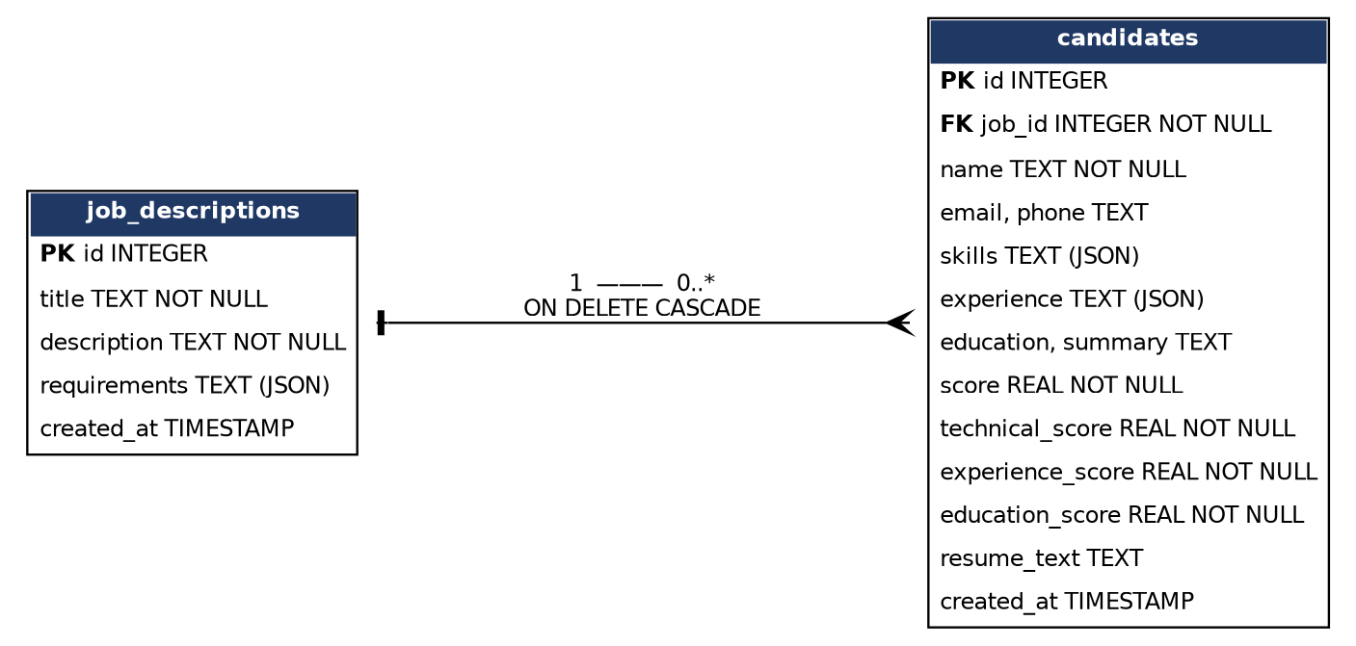
Figure 6.3: Entity-relationship diagram (crow's foot notation)
6.4 Sequence Model
The sequence below shows the happy path for resume upload. If extraction or scoring fails for a file, that file is skipped and the loop continues; if Ollama fails, step 6 falls back to rule-based extraction.
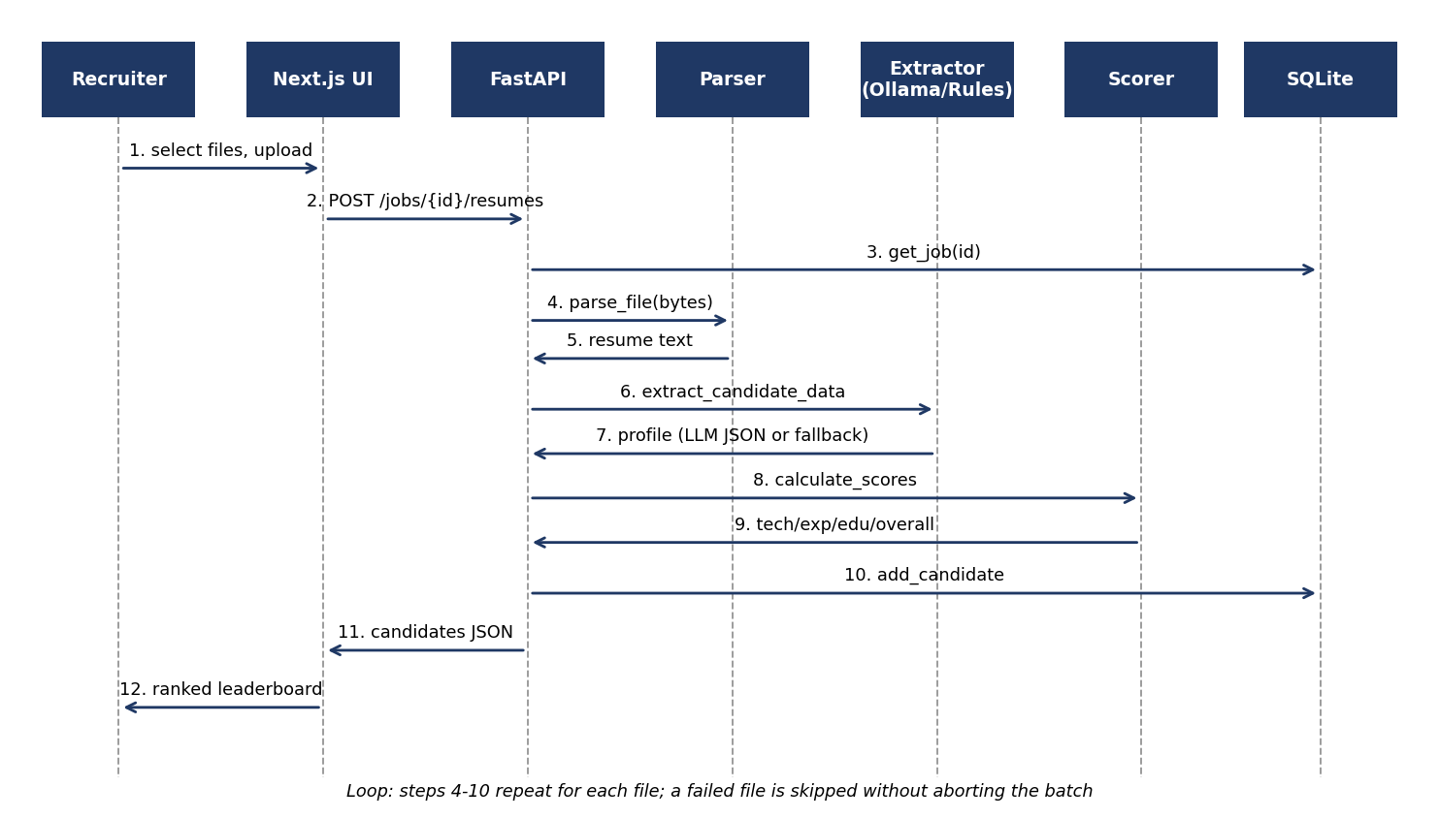
Figure 6.4: Sequence diagram, resume upload, extraction and scoring

7. Academic Review & Sign-Off
This Software Requirements Specification document has been submitted and reviewed by the academic supervisory panel:
Project Coordinator / Guide | Internal Examiner | Head of Department (HOD)
Signature: __________________  Date: __________________ | Signature: __________________  Date: __________________ | Signature: __________________  Date: __________________

