Youtube Comments Analyzer

Submitted By:

Name - Atul Mor

Section - S:40M71

Registration No. - 12323724

Project Overview:

The YouTube Comments Analyzer is an AI-powered automation system developed using n8n workflows, Ollama LLM, MySQL database, and a frontend dashboard. The system automatically fetches YouTube comments, analyzes audience sentiment and insights using AI, stores structured data into a database, and displays meaningful analytics on a dashboard.

The project is designed to:

Automate YouTube comment analysis

Detect audience sentiment

Identify complaints and requests

Extract useful keywords and categories

Generate insights for creators and businesses

Technologies Used

Technology | Purpose
n8n | Workflow Automation
Ollama | Local LLM Processing
MySQL | Data Storage
YouTube Data API v3 | Fetching Comments
React.js | Dashboard Frontend
JavaScript | Data Processing
Webhooks | API Communication

Environment Variables Used

Variable | Purpose
YOUTUBE_API_KEY | Access YouTube Data API
DB_HOST | MySQL database host
DB_USER | MySQL username
DB_PASSWORD | MySQL password
DB_NAME | Database name
OLLAMA_BASE_URL | Ollama local server URL

APIs Used

1. YouTube Data API v3
Used to:
- Fetch YouTube comments
- Retrieve paginated comment threads
- Access video-related metadata
Endpoint Used:
https://www.googleapis.com/youtube/v3/commentThreads

2. Ollama Local API
Used for:
- Sentiment analysis
- Complaint detection
- Request identification
- Keyword extraction
- Category classification
Local Endpoint:
http://localhost:11434

Comments Table
The comments table stores raw YouTube comments fetched using the YouTube Data API.

Column Name | Data Type | Description
id | varchar | Unique YouTube comment ID
videoId | varchar(90) | YouTube video identifier
authorDisplayName | text | Name of comment author
textDisplay | text | Original comment text
likeCount | int | Number of likes on comment
totalReplyCount | int | Total replies on comment
publishedAt | datetime | Comment publish timestamp
processed | tinyint(1) | Analysis status flag (0 = pending, 1 = processed)

Analysis Table
The analysis table stores AI-generated structured insights from comments.

Column Name | Data Type | Description
commentId | varchar | Foreign key referencing comment ID
sentiment_label | varchar | Sentiment classification
is_complaint | tinyint(1) | Complaint detection flag
is_request | tinyint(1) | Request detection flag
category | varchar | Main comment category
subtopic | text | Specific discussion topic
keywords | json | Extracted keywords array
videoId | varchar(90) | Related YouTube video ID

1st Workflow Fetch and Store Comments:
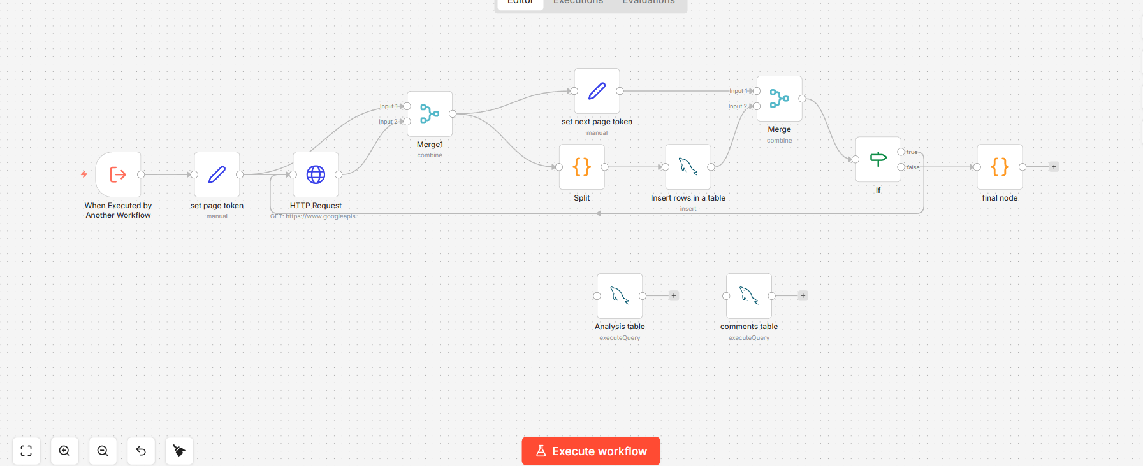

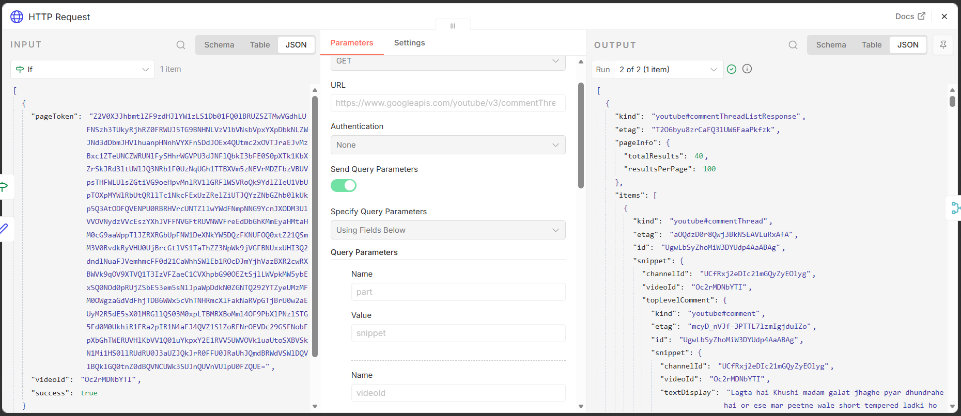
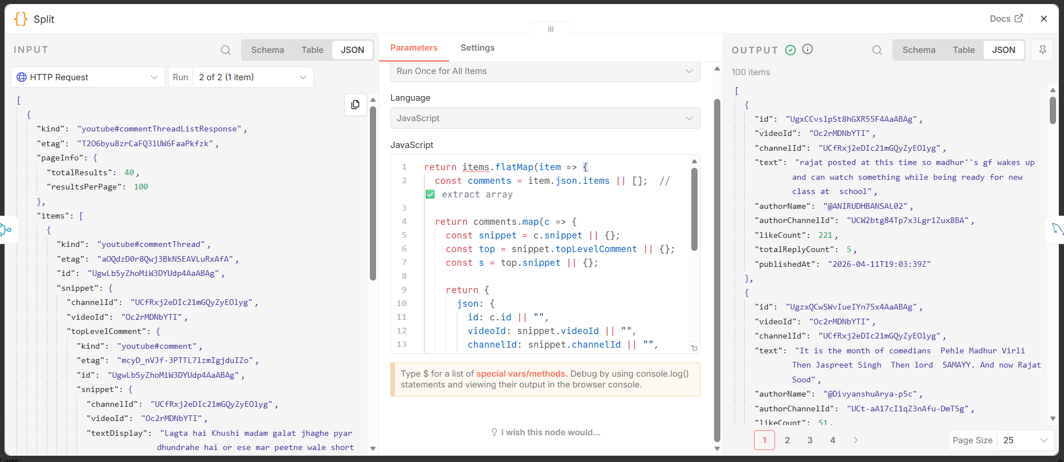
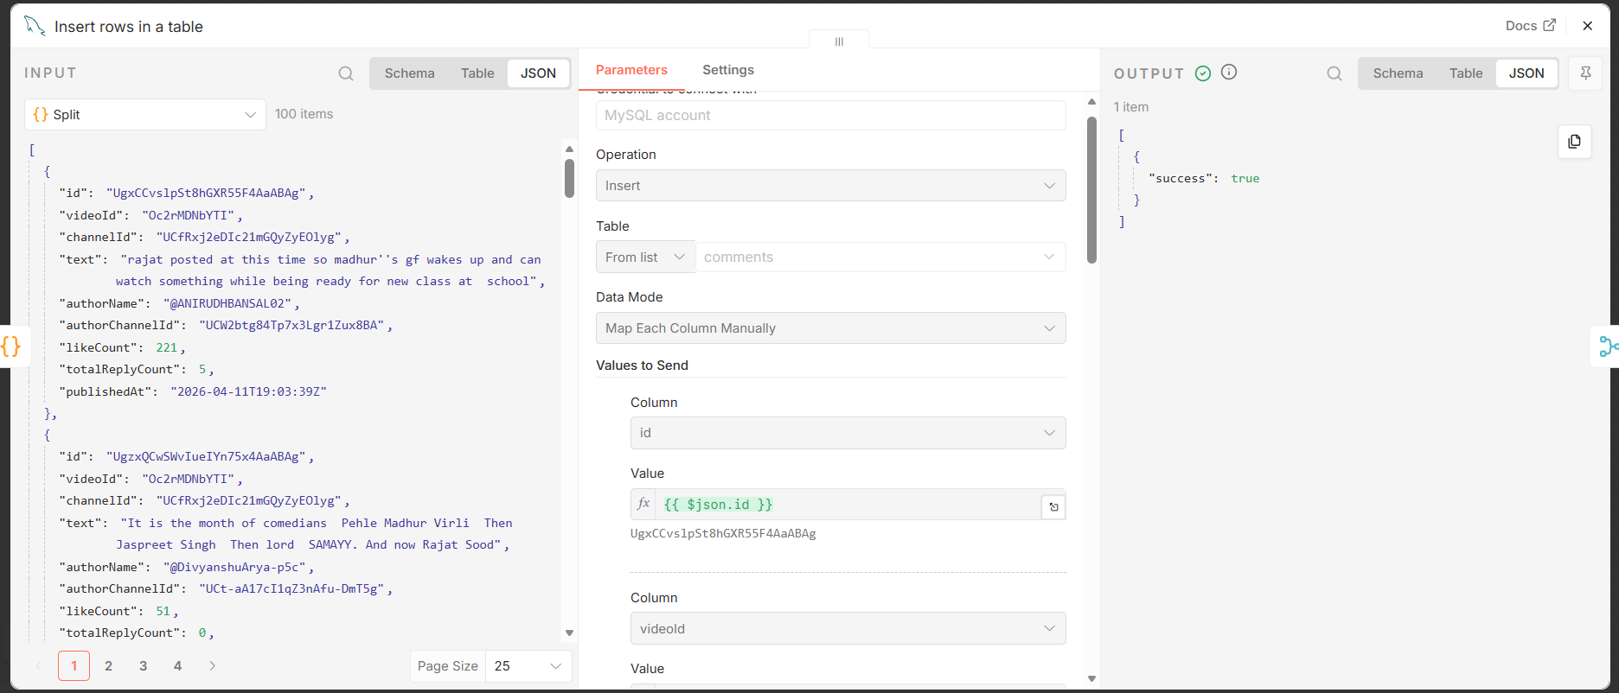
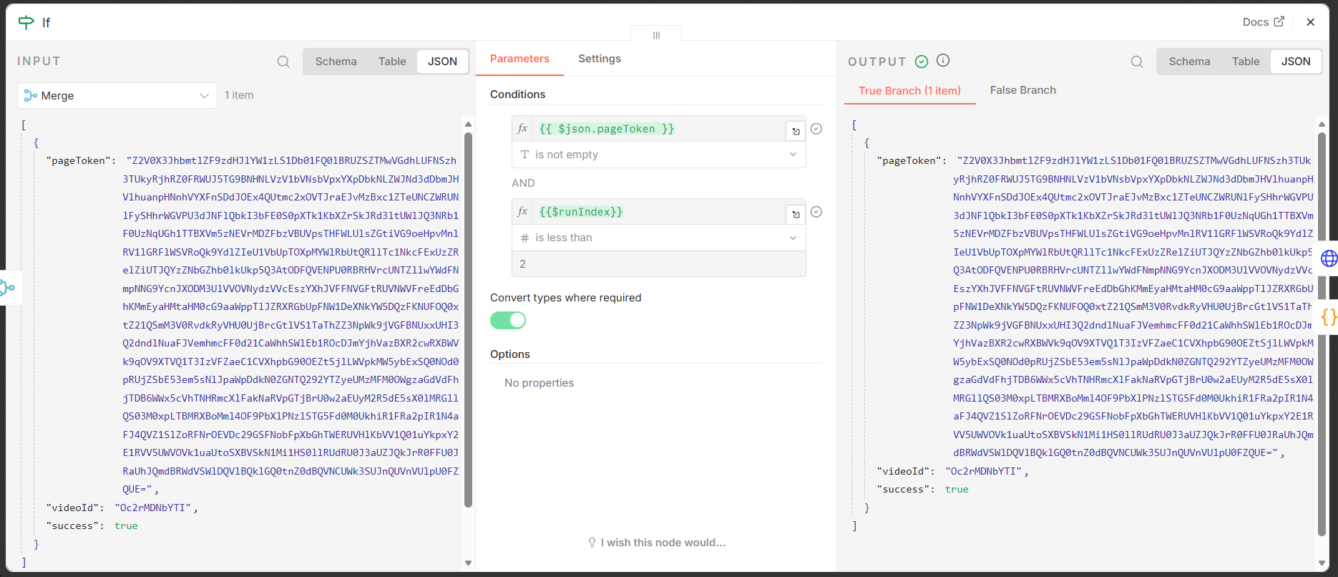
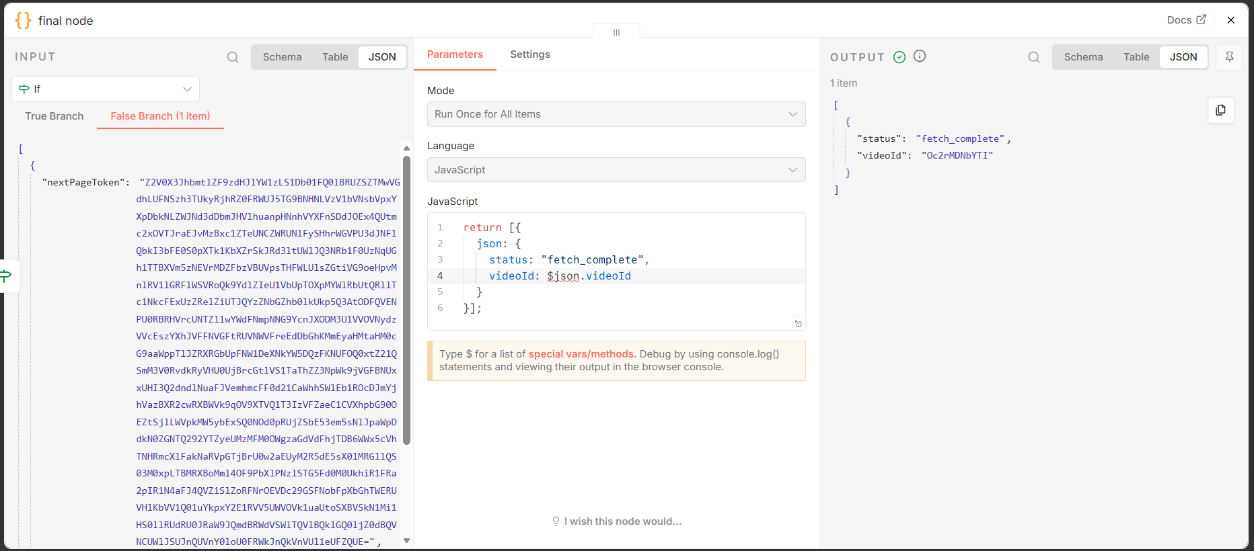

2st Workflow Analyze Comments:
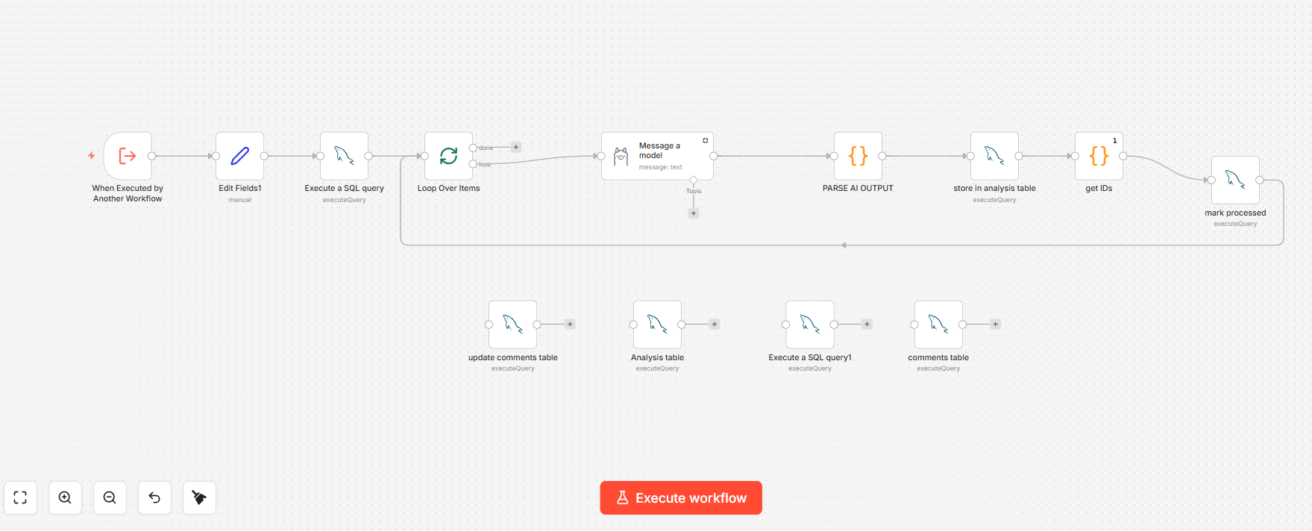
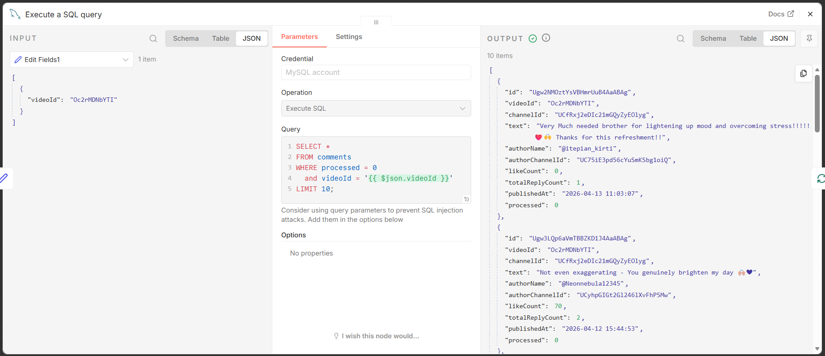
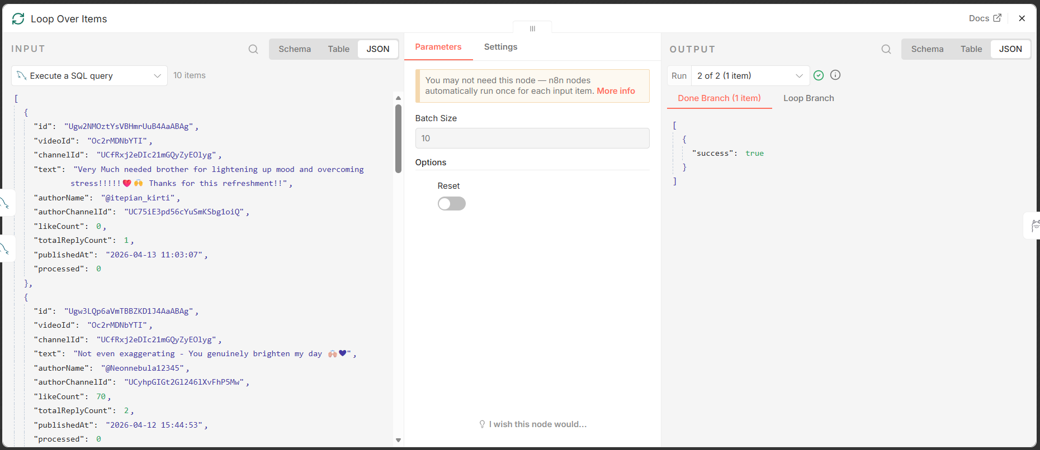
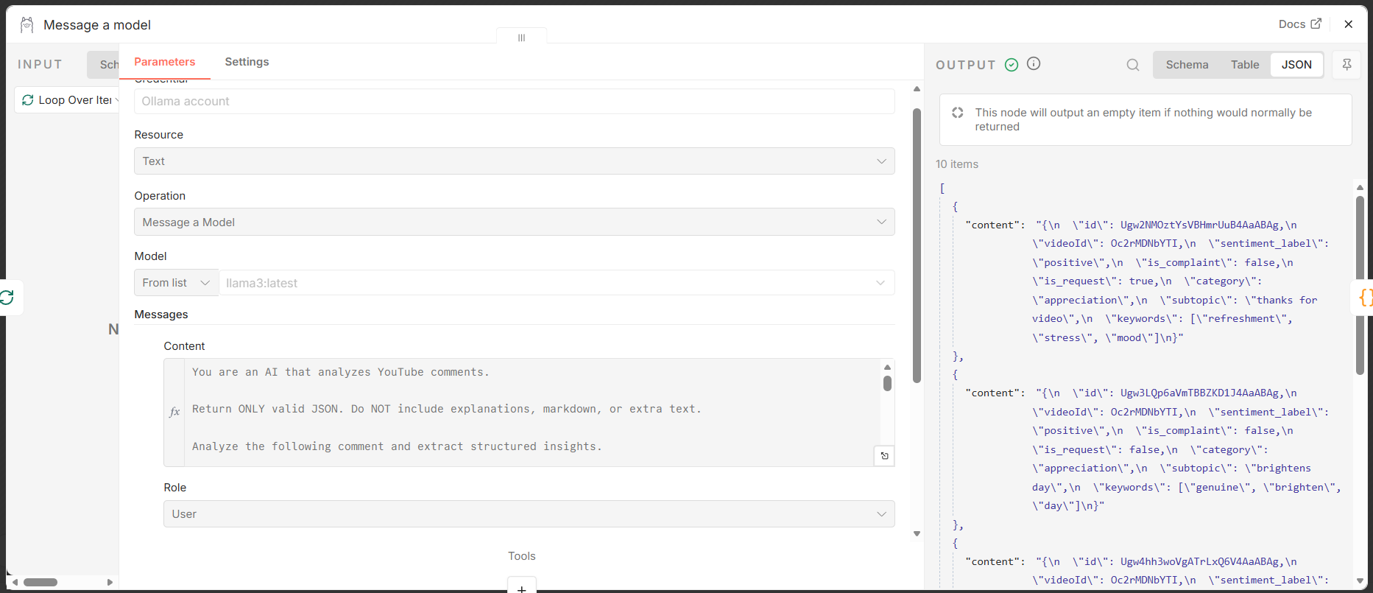
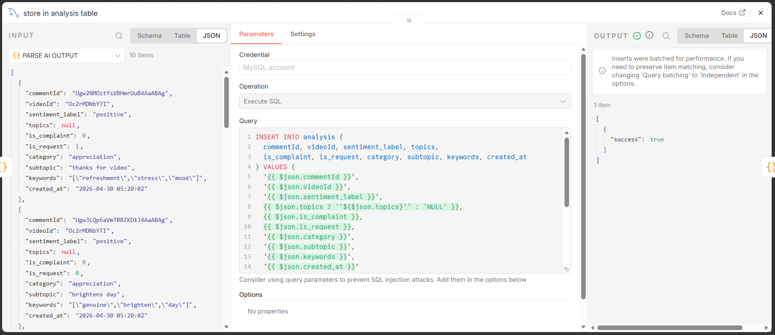
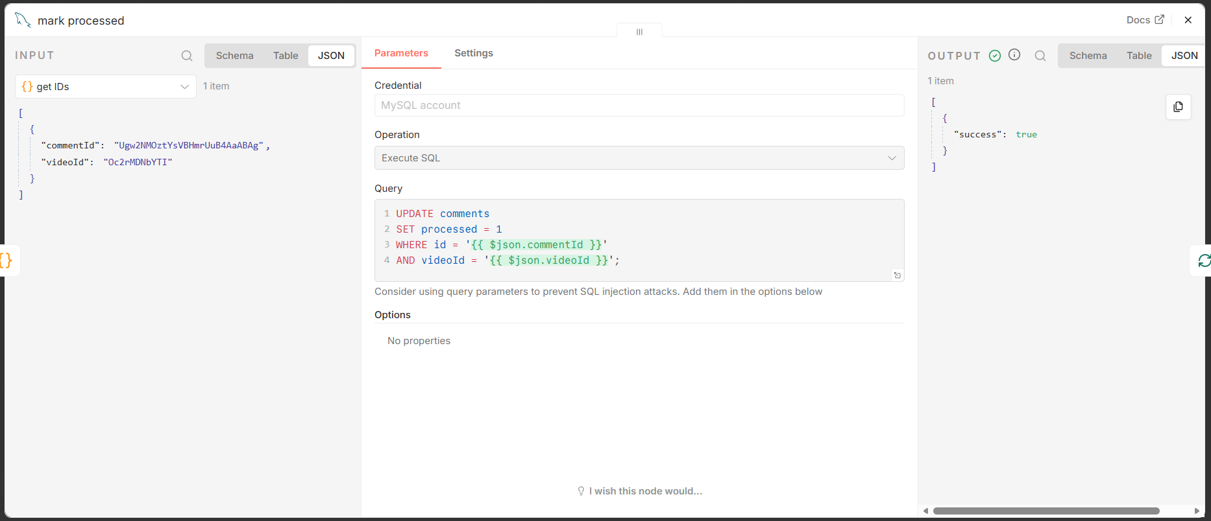3rd Workflow Fetch Insights:
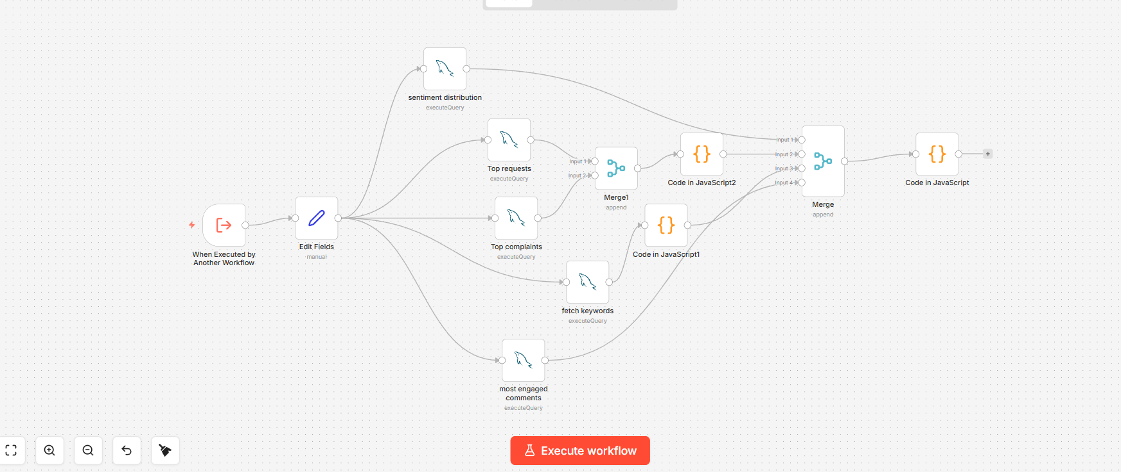

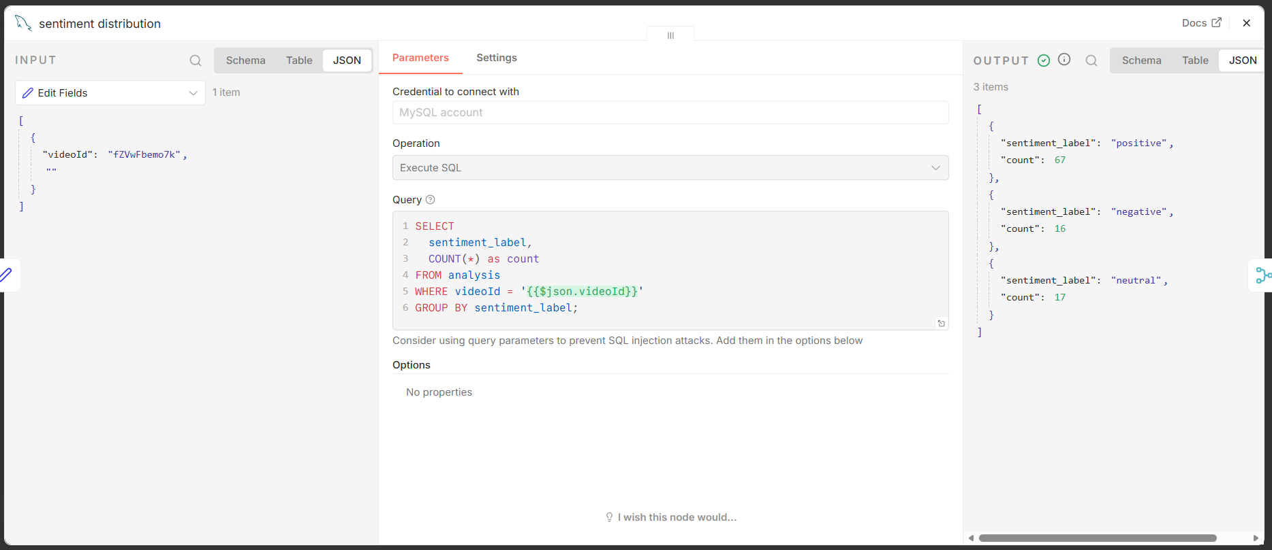
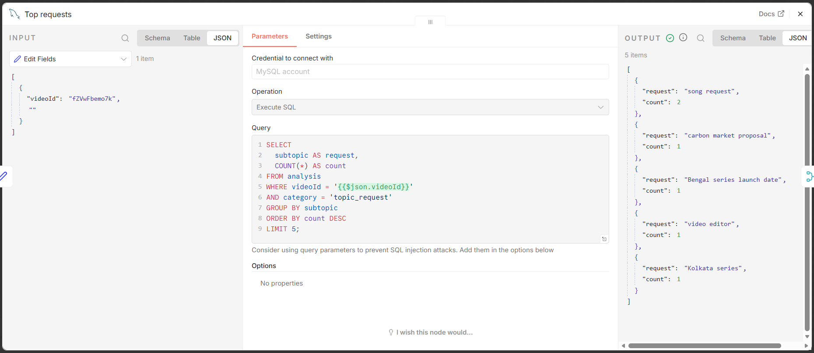
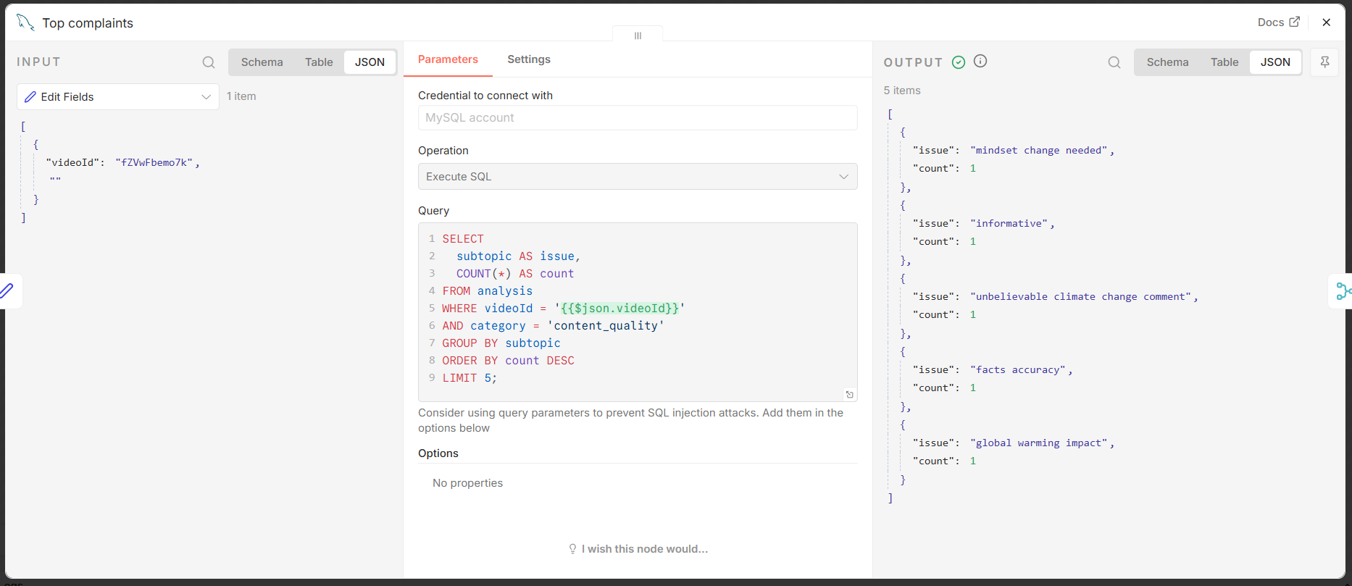
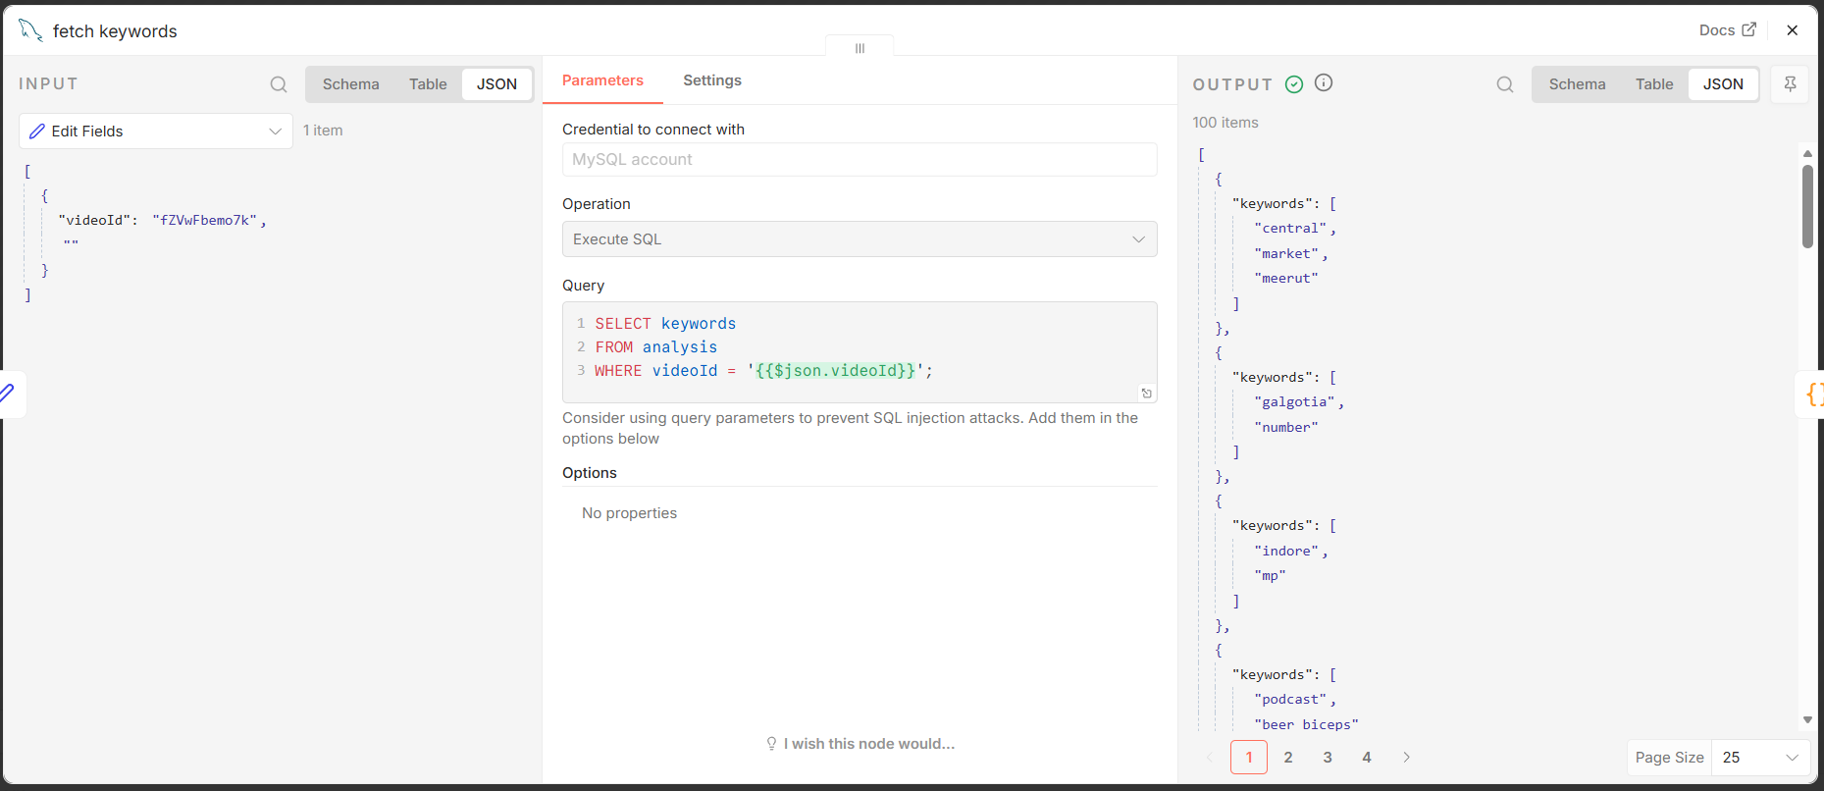

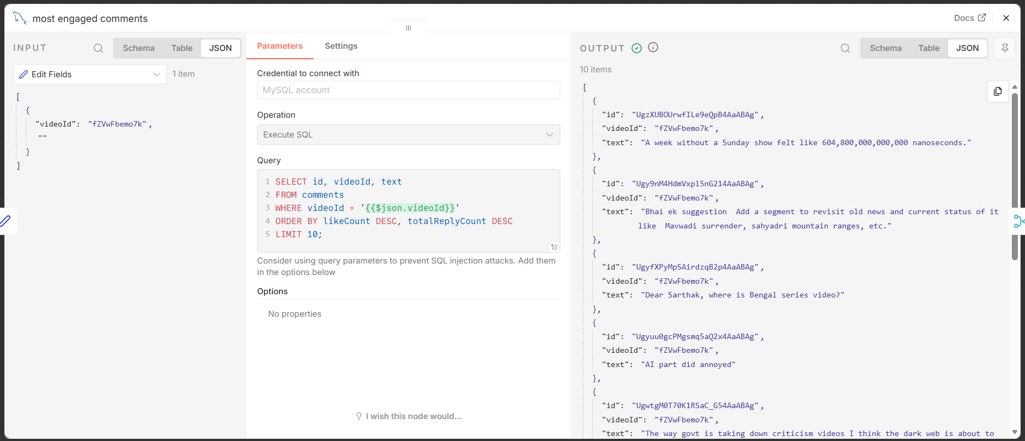
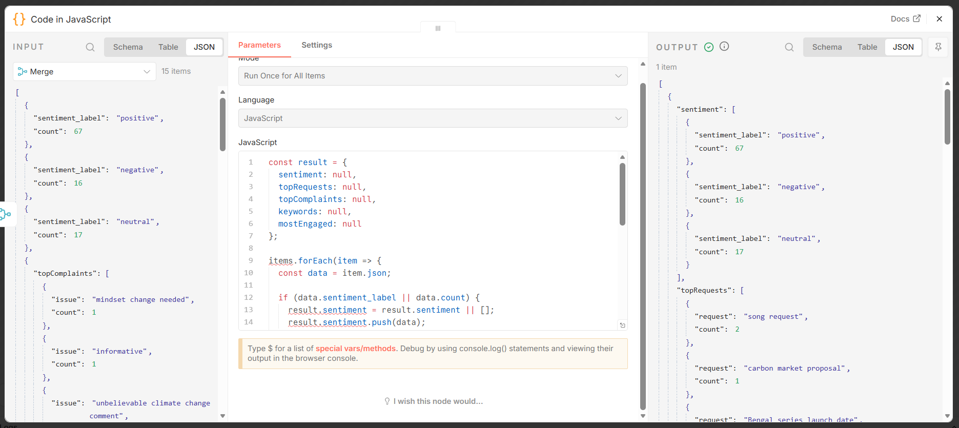

Final Workflow - Dashboard
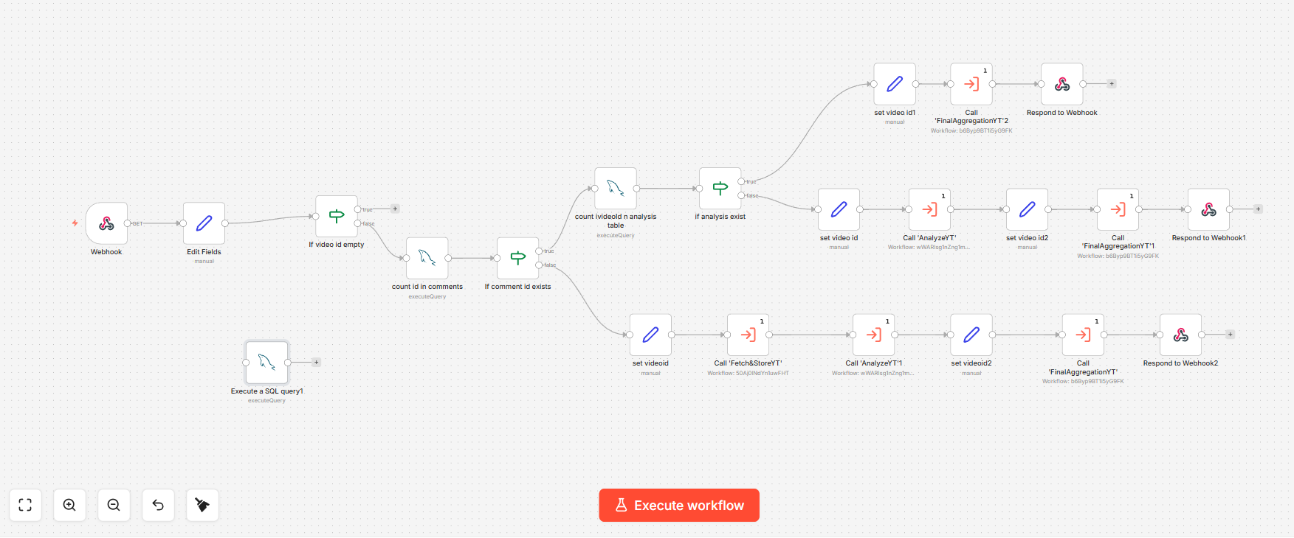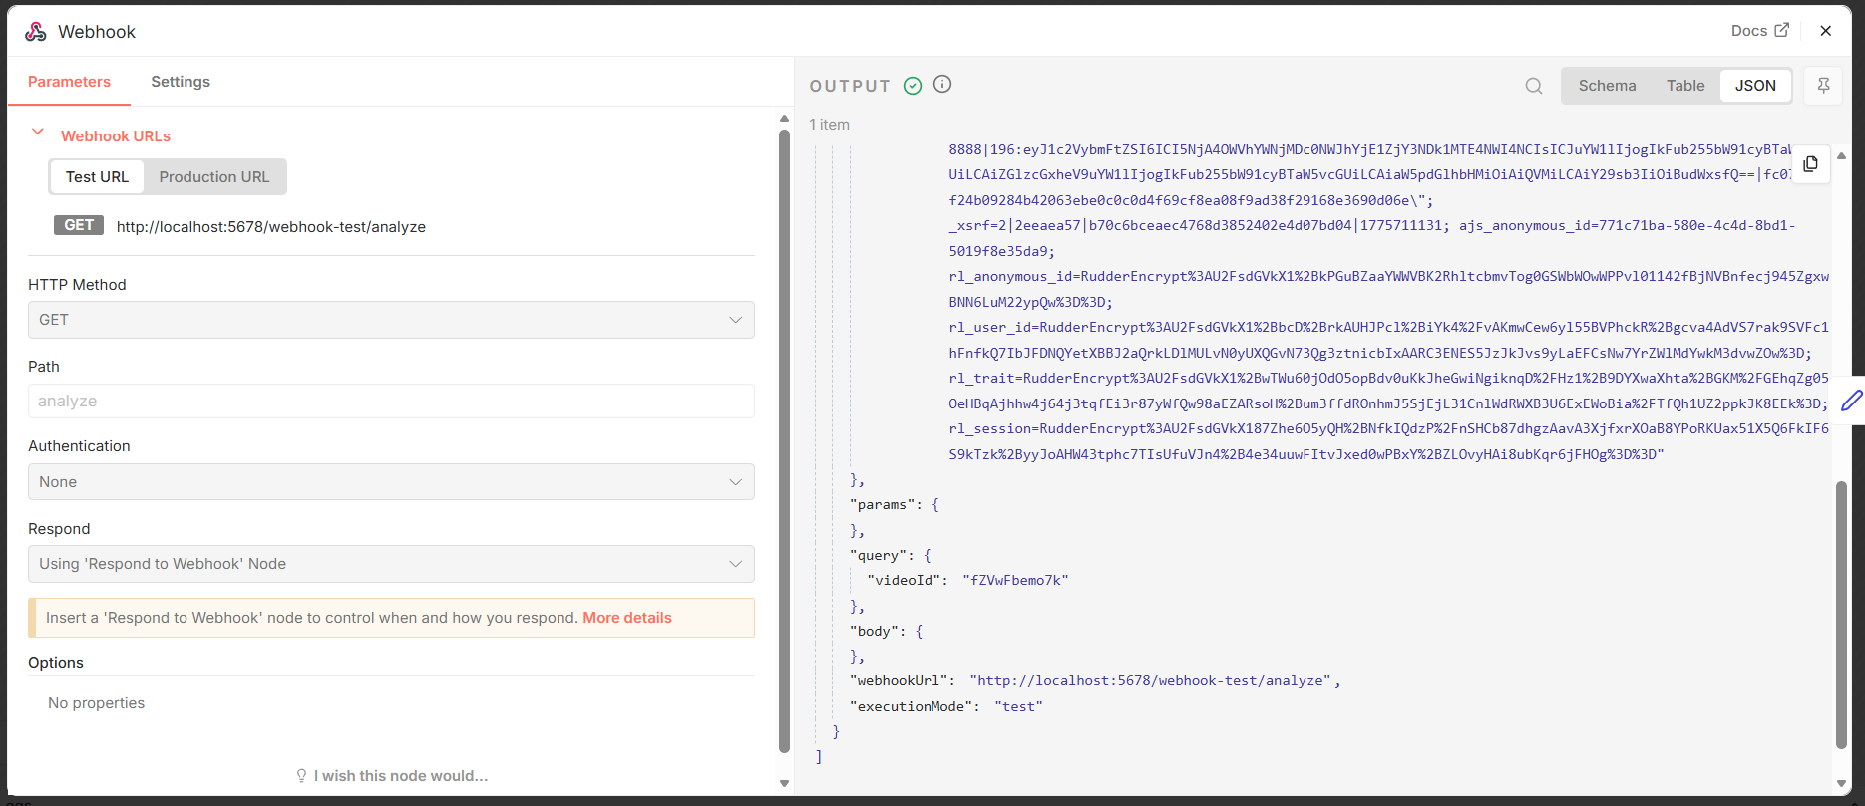
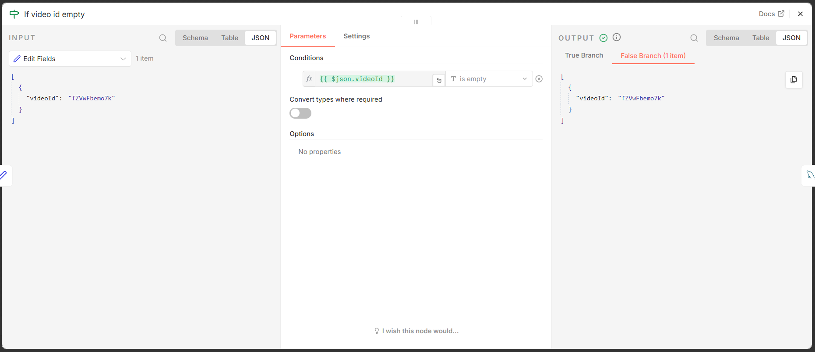
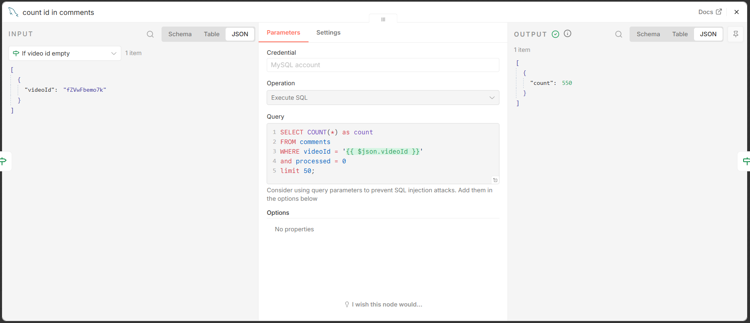
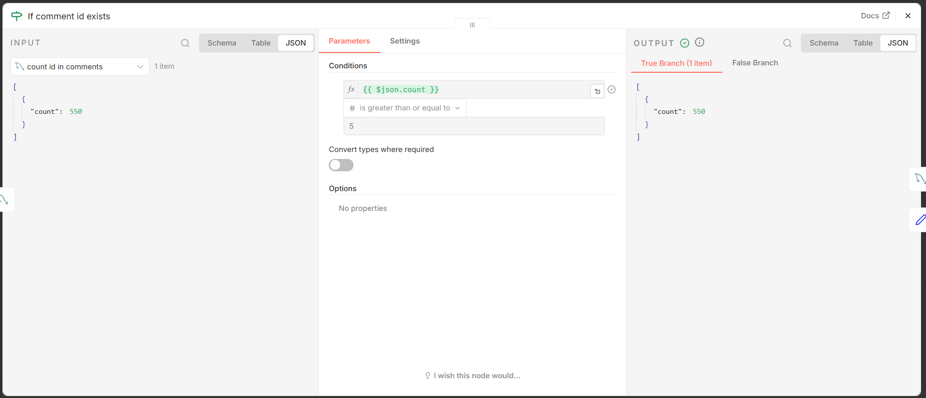
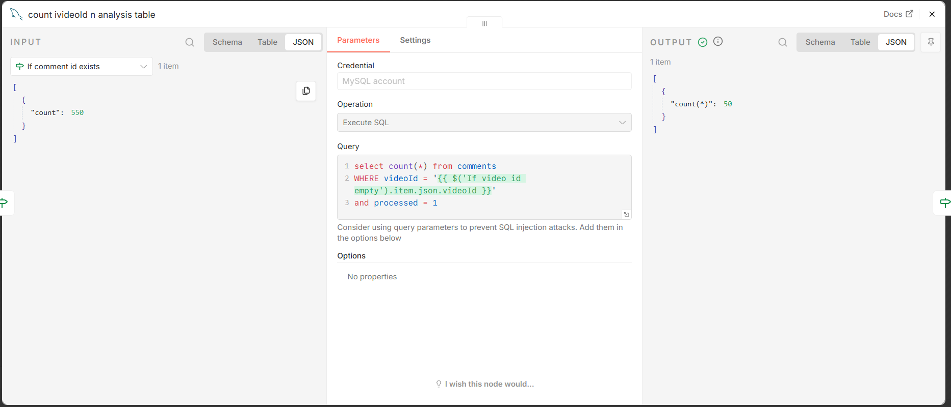
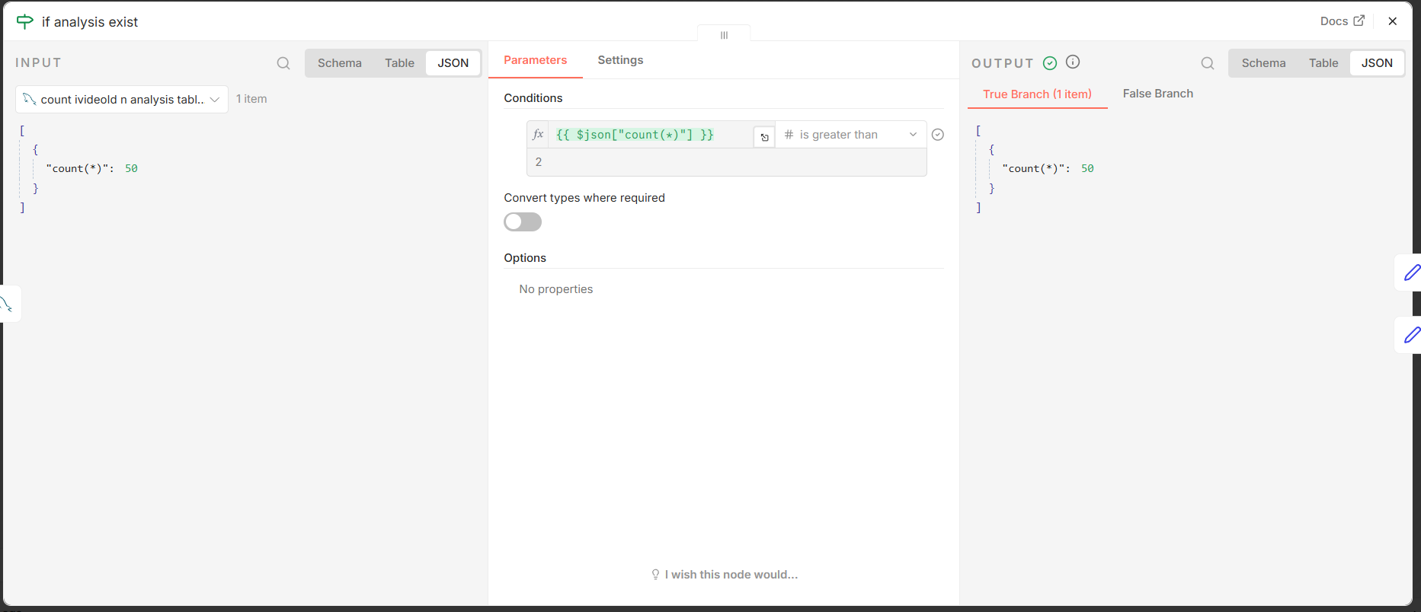
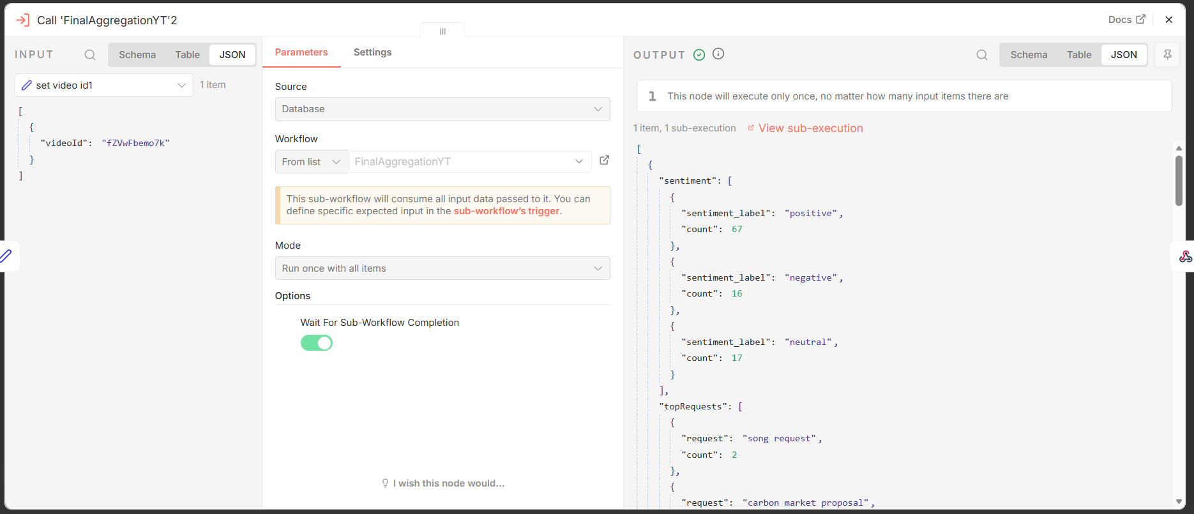
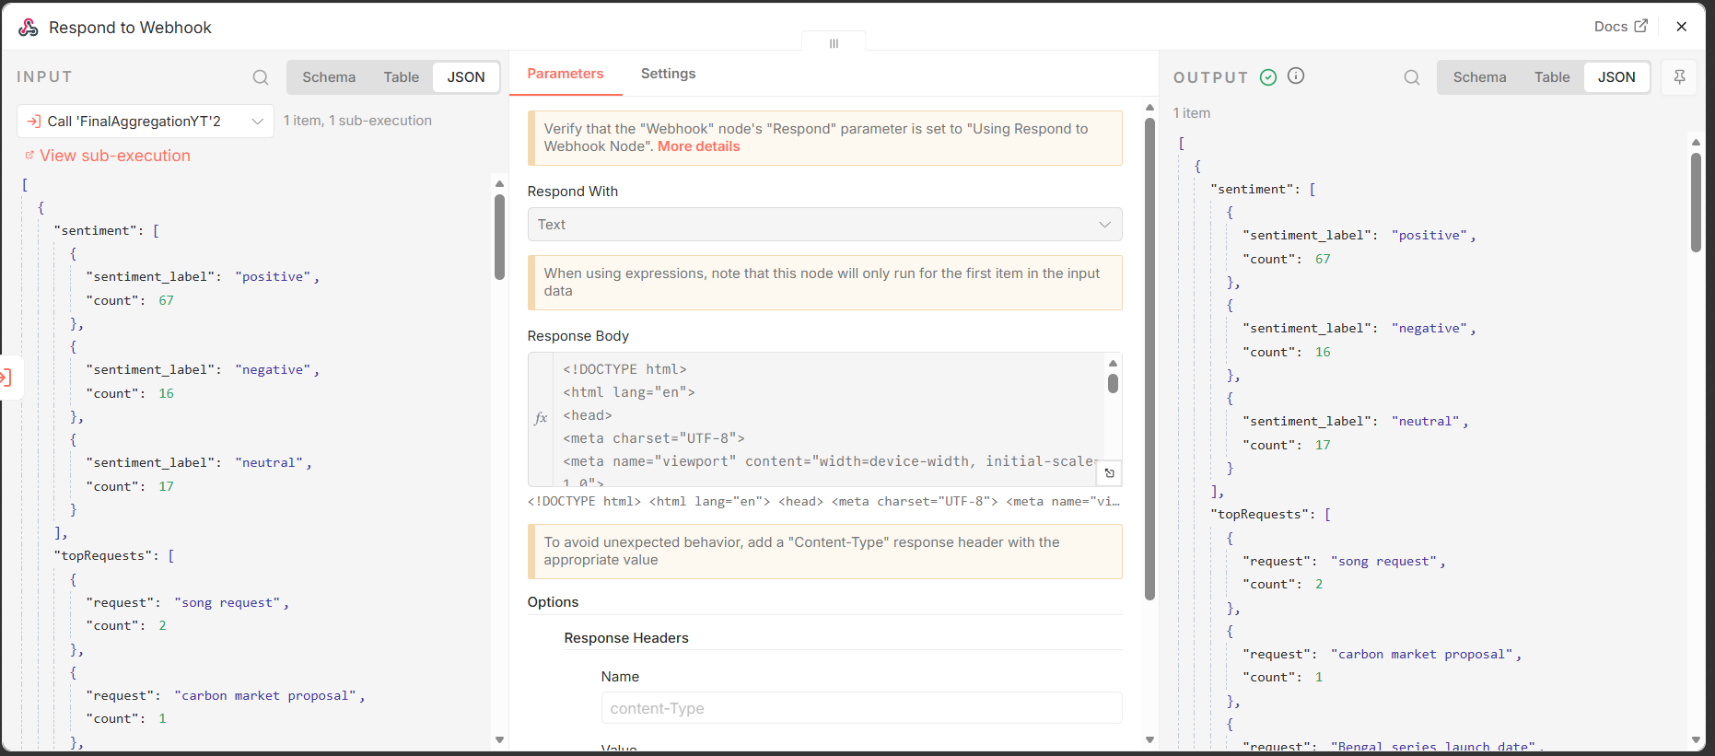

WebPage
