7COM1079-0901-2025
Team Research and Development Project

Report Title: Is there a difference in mean happiness scores between countries with higher income levels and countries with lower income levels?

Group ID: Group-A23

Dataset number: DS087

Prepared by: [Prajwol Raj Dhungel -24158874]
[Denil Gohil - 21068447],
[Atul Thapaliya- - 24155790]
[Simon Roshan Chanayil Joseph-24175410]
[Gaurav Jayesh Mali-]

University of Hertfordshire
Hatfield, 2025

Contents
1. Introduction 3
1.1 Problem statement and research motivation (100 words) 3
1.2 The data set (75 words) 3
1.3 Research question (50 words). 3
1.4 Null hypothesis and alternative hypothesis (H0/H1) (100 words) 3
2 Background research 4
2.1 Research papers (at least 3 relevant to your topic / DS) (200 words) 4
Paper 1:The World Happiness Report 4
Paper 2:Our World in Data 4
Paper 3: High Income Improves Evaluation of Life But Not Emotional Well-Being 4
2.2 Why RQ is of interest (research gap and future directions according to the literature) (100 words) 4
3 Visualisation 5
3.1 Appropriate graphs for the RQ (50 words) 5
3.2 Additional information relating to understanding the data (optional) (50 words) 5
3.3 Useful information for the data understanding (50 words) 6
4. Analysis 6
4.1 Statistical test used to test the hypotheses and output (75 words) 6
4.2 The null hypothesis is rejected /not rejected based on the p-value (100 words) 7
5. Evaluation – group’s experience at 7COM1079 7
5.1 What went well (75 words) 7
5.2 Points for improvement (75 words) 7
5.3 Group’s time management (50 words) 7
5.4 Project’s overall judgement (50 words) 7
5.5 Note any changes to group since original allocation if applicable. Add new or amended GitHub Ids for new members (75 words, write only if applies to your group arrangements) 8
5.6 Comment on the GitHub log output (50 words) 8
6. Conclusions 8
6.1 Results explained (75 words) 8
6.2 Interpretation of the results (75 words) 8
6.3 Reasons and/or implications for future work, limitations of your study (50 words) 9

1. Introduction

1.1 Problem statement and research motivation (100 words)
Politics worldwide now goes beyond GDP alone. The World Happiness Report measures how people in over 140 countries rate their lives and links these ratings to income, health, and social support, showing that people in richer nations are not always happier than those in poorer ones. Inequality and social relationships play major roles. Building on the Easterlin paradox, your 2022 study of 146 countries examines happiness differences across income groups to better understand how income relates to happiness and informs debates on inequality and progress.

1.2 The data set (75 words)
The dataset ds087-hapiness_report_2022.csv is drawn from the 2022 World Happiness Report and includes information from 146 countries. It measures average life satisfaction on a 0–10 scale using the happiness_score. Each country is also classified by its World Bank income group, allowing comparisons of happiness across different economic levels. This dataset is useful for analyzing how income categories relate to overall happiness worldwide.

1.3 Research question (50 words).
Is there a difference in the mean happiness score between countries with higher income levels (MaxIncome) and countries with lower income levels (MinIncome)?
This question examines whether countries at the highest income level report significantly greater average happiness than those at the lowest income level, highlighting the relationship between extreme income differences and life satisfaction.

1.4 Null hypothesis and alternative hypothesis (H0/H1) (100 words)
For this study, the null hypothesis (H₀) states that there is no significant difference in the mean happiness score between countries with the highest income levels (MaxIncome) and those with the lowest income levels (MinIncome). This implies that income level alone does not affect average national happiness.
In contrast, the alternative hypothesis (H₁) proposes that there is a significant difference in the mean happiness scores between MaxIncome and MinIncome countries, suggesting that higher national income is associated with different levels of life satisfaction. Testing these hypotheses will help determine whether income extremes truly influence happiness across countries.

2 Background research

2.1 Research papers (at least 3 relevant to your topic / DS) (200 words)

Paper 1:The World Happiness Report
Helliwell, Layard, Sachs, De Neve, Aknin, and Wang (2022)
It is a key source for global happiness analysis and underpins this study. Using Gallup World Poll data from over 140 countries, it measures life satisfaction with the Cantril Ladder (0–10). The report shows that higher-income countries generally have higher life evaluations, with social support, freedom, low corruption, and generosity also contributing. Our dataset follows this framework, including 146 countries, happiness scores, and World Bank income classifications.

Paper 2:Our World in Data
Ortiz-Ospina,Roser(2017)
Data examine how income relates to life satisfaction across countries. They find that large differences in happiness between nations are largely explained by income per person.They emphasize that income is not the only determinant; health, education, and social relationships also play vital roles. Our study is similar but focuses on comparing happiness across income groups rather than changes over time.

Paper 3: High Income Improves Evaluation of Life But Not Emotional Well-Being

Kahneman,Deaton(2010)
The relationship between income and well-being remains debated. One view holds that higher income improves overall life evaluation but has limited effects on daily emotional experience once basic needs are met.The happiness income paradox suggests that although wealthier individuals and nations report greater happiness, rising income over time does not reliably increase it, reflecting adaptation, expectations, and social comparison.

2.2 Why RQ is of interest (research gap and future directions according to the literature) (100 words)
Our research question examines whether mean happiness differs between countries with higher and lower income levels. This matters because prior studies show income relates to life satisfaction, yet they disagree on how strong or lasting the association is. Evidence from the World Happiness Report and Our World in Data indicates that richer countries tend to be happier, while the Easterlin paradox argues that rising income over time does not always increase happiness. Most research uses GDP continuously, but our study contrasts the highest and lowest income groups using 2022 data to assess persistent gaps and guide future policy-focused work efforts.

3 Visualisation

3.1 Appropriate graphs for the RQ (50 words)
A boxplot was chosen because the research question compares mean happiness scores between two independent income groups, making it suitable for visualising differences in central tendency and spread.
A histogram is also included to examine the overall distribution of Happiness Scores, helping confirm whether the data is approximately normal before running the t-test.
R-code for Boxplot R-code for Histogram

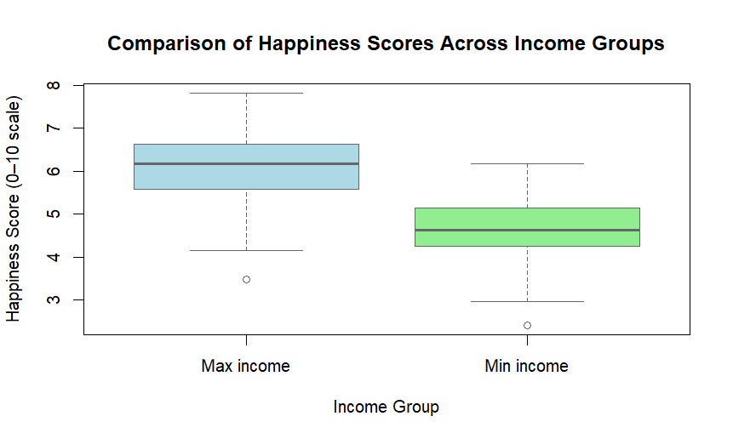

Figure 1 Boxplot

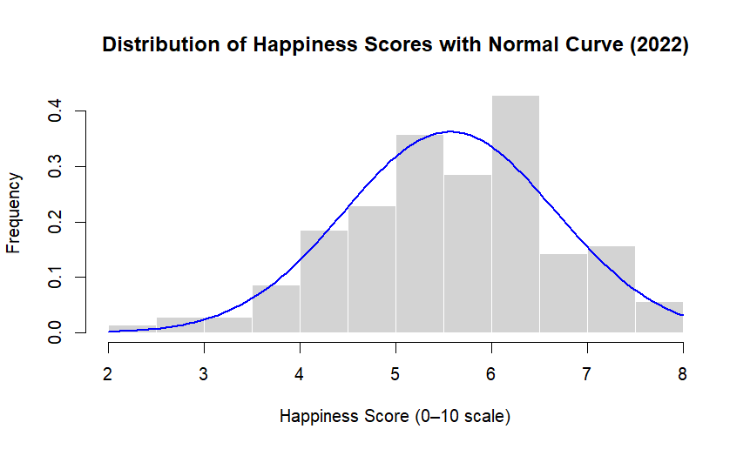
Figure 2 Histogram

3.2 Additional information relating to understanding the data (optional) (50 words)
The histogram provides insight into the distribution of Happiness Scores, showing a unimodal shape with no severe skew, supporting the use of parametric methods. The boxplot visually highlights differences between the income groups, showing higher median values for Max income countries and a wider spread for Min income countries.

3.3 Useful information for the data understanding (50 words)
The plots reveal that Max income countries consistently report higher happiness levels, with their scores clustering around the upper range. Min income countries show lower central values and greater variability. Together, the visualisations help confirm both the suitability of the t-test and the presence of meaningful differences between the two groups.

4. Analysis

4.1 Statistical test used to test the hypotheses and output (75 words)

An independent samples t-test was selected because the research question focuses on determining whether there is a difference in mean happiness scores between two independent income groups. The dependent variable, Happiness Score, is continuous and measured on an interval scale, while the independent variable is categorical with two levels. The histogram showed an approximately normal distribution, and the sample size was sufficiently large, making the t-test an appropriate and statistically robust choice for this analysis.

4.2 The null hypothesis is rejected /not rejected based on the p-value (100 words)

The results of the independent samples t-test indicate a significant difference in happiness scores between the two income groups, t(117.87) = 10.40, p < 0.001. Since the p-value is far below the 0.05 significance threshold, the null hypothesis stating that both groups have equal mean happiness scores is rejected. The Max income group reported a higher mean score (M = 6.16) compared to the Min income group (M = 4.67). This suggests that countries with higher income levels tend to experience greater happiness on average, providing strong statistical evidence for income-related differences in national well-being.

5. Evaluation – group’s experience at 7COM1079

5.1 What went well (75 words)
Our group worked well together throughout the module. Everyone successfully set up GitHub and maintained the repository with the dataset, analysis script, and documentation. We did a strong job cleaning the data, creating boxplots and histograms, and running the statistical tests. Tasks were shared efficiently, with one member focusing on R, another on the literature, and another on writing. We also solved technical problems together, including fixing the GitHub Actions process and resolving merge conflicts.

5.2 Points for improvement (75 words)
One area for improvement is that we could have started the background research and data analysis earlier to reduce last minute pressure. Communication could also be improved by meeting more often or using platforms like Teams or WhatsApp more consistently. Some of our Git commit messages could have been more descriptive. In addition, better coordination is needed before editing the same file at the same time to avoid merge conflicts like the one we encountered in analysis.R.

5.3 Group’s time management (50 words)
We managed our time mainly through after class planning and regular communication on a WhatsApp group chat. Short online meetings were used to monitor progress. The workload was divided into data preparation, R analysis, and report writing so that each member could complete their tasks efficiently before the deadlines.

5.4 Project’s overall judgement (50 words)

Overall, the project was successful because it helped us apply RStudio and GitHub in a real research context. We were able to answer our research question on happiness across income groups and develop reusable code. The project increased our confidence in data analysis and strengthened our teamwork skills for future modules.

5.5 Note any changes to group since original allocation if applicable. Add new or amended GitHub Ids for new members (75 words, write only if applies to your group arrangements)

(N/A)
There have been no changes to the group membership or GitHub IDs since the original allocation.

5.6 Comment on the GitHub log output (50 words)
The GitHub log (Appendix 8.4) demonstrates steady collaborative progress throughout the project. It shows meaningful contributions, integration of completed sections, and clear version control practices.

1. Commit Message: Part 5 & 6 done except 5.6
This commit added major report sections, significantly progressing the project toward completion and reducing remaining workload for the team.

2. Commit Message: vis and analysis done
This commit completed the visualisation and statistical analysis, providing the essential analytical backbone required for answering the research question.

3. Commit Message: Merge branch 'master'
This merge ensured all team contributions were combined into a unified version, preventing conflicts and keeping the project consistent across collaborators.

6. Conclusions

6.1 Results explained (75 words)
The independent samples t-test showed a statistically significant difference in happiness scores between Max income and Min income countries. Higher-income countries reported a substantially greater mean happiness score, indicating a clear upward relationship between national income level and subjective well-being. The difference of around 1.5 points on a 0–10 scale is meaningful and suggests that economic conditions may play an important role in shaping national happiness averages.

6.2 Interpretation of the results (75 words)
These findings support the research question by demonstrating that income level is associated with notable differences in national well-being. Countries with stronger economic capacity tend to have higher happiness levels, possibly due to greater access to healthcare, education, public services, and social stability. For the population in this dataset, income grouping appears to be a key factor influencing quality of life. More broadly, the results suggest that economic inequality may contribute to global disparities in happiness.

6.3 Reasons and/or implications for future work, limitations of your study (50 words)
This study is limited by the use of a single year of data and broad income categories, which may oversimplify complex socioeconomic conditions. Future work could include multi-year trends, additional variables such as GDP or health indicators, and more detailed income classifications to better understand the factors of national happiness.

7. Reference list

Cleveland, W.S. and McGill, R. (1984) ‘Graphical perception: Theory, experimentation, and application to the development of graphical methods’, Journal of the American Statistical Association, 79(387), pp. 531–554.

Easterlin, R.A., McVey, L.A., Switek, M., Sawangfa, O. and Zweig, J.S. (2010) ‘The happiness–income paradox revisited’, Proceedings of the National Academy of Sciences, 107(52), pp. 22463–22468.

Helliwell, J.F., Layard, R., Sachs, J.D., De Neve, J.-E., Aknin, L.B. and Wang, S. (eds) (2022) World Happiness Report 2022. New York: Sustainable Development Solutions Network.

Helliwell, J.F., Layard, R., Sachs, J.D., De Neve, J.-E., Aknin, L.B. and Wang, S. (eds) (2024) World Happiness Report 2024. Oxford: Wellbeing Research Centre, University of Oxford.

Kahneman, D. and Deaton, A. (2010) ‘High income improves evaluation of life but not emotional well-being’, Proceedings of the National Academy of Sciences, 107(38), pp. 16489–16493.

Ortiz-Ospina, E. and Roser, M. (2017) ‘Happiness and life satisfaction’.

Wickham, H. (2016) ggplot2: Elegant Graphics for Data Analysis. New York: Springer.

8.Appendix

8.1 R-studio Code Boxplot
boxplot(hapiness_report_2022$`Hapiness Score` ~ hapiness_report_2022$group_income,
xlab = "Income Group",
ylab = "Happiness Score (0–10 scale)",
main = "Comparison of Happiness Scores Across Income Groups",
col = c("lightblue", "lightgreen"),
border = "gray40")

8.2 R-studio Code for Histogram
# Create histogram with proper labels and title
hist(hapiness_report_2022$`Hapiness Score`,
main = "Distribution of Happiness Scores with Normal Curve (2022)",
xlab = "Happiness Score (0–10 scale)",
ylab = "Frequency",
col = "lightgray",
border = "white",
freq = FALSE)

# Overlay bell curve
curve(dnorm(x,
mean = mean(hapiness_report_2022$`Hapiness Score`),
sd = sd(hapiness_report_2022$`Hapiness Score`)),
col = "blue",
lwd = 2,
add = TRUE)

8.3 T-test
t.test(hapiness_report_2022$`Hapiness Score` ~ hapiness_report_2022$group_income)

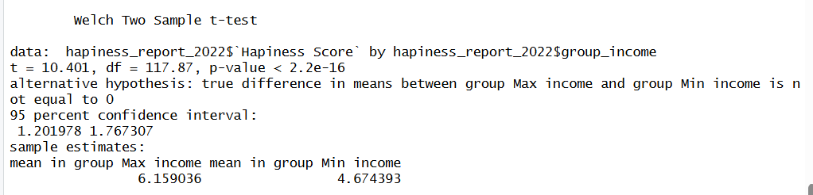

8.4 Github Log Output
commit 02f4c2d1bb9dc858ab7fbf4f594ecb2f8f39a038 (HEAD -> master, origin/master, origin/HEAD)
Author: Prajwol Raj Dhungel <pd25aaj@herts.ac.uk>
Date: Wed Dec 10 09:44:51 2025 +0000

This is the formatted Main Report

commit 0c785beef8ca456f6e212eba6d40dea255945ec9
Author: Prajwol Raj Dhungel <pd25aaj@herts.ac.uk>
Date: Tue Dec 9 20:31:59 2025 +0000

Part 5 & 6 done except 5.6

commit da286c3cf255209a2842170d53af9e7557a2d2e3
Author: Prajwol Raj Dhungel <pd25aaj@herts.ac.uk>
Date: Tue Dec 9 09:30:14 2025 +0000

Background Research

commit 21e1e84ab74b98ae70e99978a9159deec9eb8c95
Merge: f65d043 3cdb657
Author: Prajwol Raj Dhungel <pd25aaj@herts.ac.uk>
Date: Mon Dec 8 21:43:36 2025 +0000

Finish merge and add new files

commit f65d043990b1366c05a6acebdcd5f54ed7df9f3d
Author: Prajwol Raj Dhungel <pd25aaj@herts.ac.uk>
Date: Mon Dec 8 21:35:06 2025 +0000

Report First Part

commit 3cdb65745ee436d623c62118fabe571c72811539
Author: Atul24155790 <at25abw@herts.ac.uk>
Date: Mon Dec 8 16:31:04 2025 +0000

t-test and box plot

commit 4966c4054eb89aa70ad9004aa05920a8fc5314a8
Author: Atul24155790 <at25abw@herts.ac.uk>
Date: Mon Dec 8 15:49:44 2025 +0000

Histogram updated

commit 59ca08574a44a6c7e589643a13f482f1d586e677
Author: Atul24155790 <at25abw@herts.ac.uk>
Date: Mon Dec 8 12:59:44 2025 +0000

For research question

commit 5fc0a71c28b13e9ef613ccfe1f760316fcb54458
Merge: 6166042 4d306a8
Author: Denil Gohil <167923026+Gohil01@users.noreply.github.com>
Date: Sat Dec 6 21:05:40 2025 +0000

Finish merge: update report and add histogram plot

commit 61660426149fb76e2fcd5fb9974fce6daca9a65c
Author: Denil Gohil <167923026+Gohil01@users.noreply.github.com>
Date: Sat Dec 6 19:56:15 2025 +0000

Add boxplot_happiness_income image for report visualisation

commit feead25595042b979c2a646532535506f2003952
Author: Denil Gohil <167923026+Gohil01@users.noreply.github.com>
Date: Sat Dec 6 18:53:11 2025 +0000

Update report template and add boxplot image

commit ff973cd86d56cec27ccaf427e475611d8ba54aa3
Author: Denil Gohil <167923026+Gohil01@users.noreply.github.com>
Date: Sat Dec 6 18:50:30 2025 +0000

Update report template and add boxplot image

commit 4d306a840c8d8ade41c2256c59f488d417041a5a
Author: Simon Roshan <sc25adj@herts.ac.uk>
Date: Sat Dec 6 00:08:03 2025 +0000

Fix GitHub Actions workflow (resolved merge conflicts)

commit 0ece96260e61c4a624729d35a4f27f390dd9e623
Author: Simon Roshan <sc25adj@herts.ac.uk>
Date: Thu Dec 4 19:26:22 2025 +0000

Commit 5: another tiny change

commit bcfdbd67be8e2b33689985c7d294743c2f5a2b15
Author: Simon Roshan <sc25adj@herts.ac.uk>
Date: Thu Dec 4 19:25:57 2025 +0000

Commit 4: tiny change for Git

commit 40713a0268a3702613856e7288006dece6faaf2f
Author: Simon Roshan <sc25adj@herts.ac.uk>
Date: Thu Dec 4 19:25:31 2025 +0000

Commit 3: add third comment

commit 33b3c5c10581042f0814a4590795877c346a1756
Author: Simon Roshan <sc25adj@herts.ac.uk>
Date: Thu Dec 4 19:24:59 2025 +0000

Commit 2: add another tiny comment

commit 55259914fa765bc25555a5dac4b2f0eb8df6e90f
Author: Simon Roshan <sc25adj@herts.ac.uk>
Date: Thu Dec 4 19:23:31 2025 +0000

Commit 1: add comment for Git

commit 5958351903ae9a40d8dbe2965540d6110dbb62eb
Merge: a9f1aee bb8062d
Author: Simon Roshan <sc25adj@herts.ac.uk>
Date: Thu Dec 4 19:12:32 2025 +0000

Resolve merge conflicts in .gitignore and workflow

commit a9f1aeec0d02db09ebf2abd713bd23dc5a1b8929
Author: Simon Roshan <sc25adj@herts.ac.uk>
Date: Thu Dec 4 19:01:14 2025 +0000

Update script to combine income groups

commit bb8062d688b496a9f1e16024ee69025401369852
Author: Prajwol Raj Dhungel <pd25aaj@herts.ac.uk>
Date: Tue Dec 2 14:19:18 2025 +0000

Group ID

commit 9396711e4a9e27bf58c18388cb4606cb88c85657
Merge: 3a787a9 b628801
Author: Denil Gohil <167923026+Gohil01@users.noreply.github.com>
Date: Sun Nov 30 02:03:06 2025 +0000

.gitignore

commit 3a787a9a8a99088cd823715f0b1f496d6cf16699
Author: Denil Gohil <167923026+Gohil01@users.noreply.github.com>
Date: Sun Nov 30 02:01:32 2025 +0000

Updated Analysis

commit b628801aa34c7519d5f14f436db34acb9d610979
Merge: d02d419 11b5931
Author: Denil Gohil <167923026+Gohil01@users.noreply.github.com>
Date: Sun Nov 30 01:55:12 2025 +0000

Resolve merge conflict in analysis.R using final analysis script

commit d02d41994b7509b65334d12372abd49b0445c191
Author: Denil Gohil <167923026+Gohil01@users.noreply.github.com>
Date: Sun Nov 30 01:51:18 2025 +0000

Ignore RStudio workspace and history files

commit 11b5931a9ad125279c81f2d53fd9726d72d69628
Merge: bbbdc1e 02f0f6d
Author: Denil Gohil <167923026+Gohil01@users.noreply.github.com>
Date: Sun Nov 30 01:30:56 2025 +0000

Merge branch 'master' of https://github.com/Atul24155790/Group-A23

commit bbbdc1e8b4fee73a403cc9afc32733677cb07f01
Author: Denil Gohil <167923026+Gohil01@users.noreply.github.com>
Date: Sun Nov 30 01:29:55 2025 +0000

Update first 5 row.R

add step 8 and 9

commit 02f0f6d35f53778d6039b93ef77aa62b7c8fe40c
Author: Denil Gohil <167923026+Gohil01@users.noreply.github.com>
Date: Sun Nov 30 01:27:32 2025 +0000

Update r.yml

commit 3531213a70f6a59ac0dcf15545ade1742507bac1
Author: Denil Gohil <167923026+Gohil01@users.noreply.github.com>
Date: Sun Nov 30 01:14:16 2025 +0000

updated r code

commit d97e110f0ecd921facccd2f438f27a3718c0cf17
Author: Simon Roshan <sc25adj@herts.ac.uk>
Date: Thu Nov 27 23:21:36 2025 +0000

Add box plot script, dataset, and combined income groups

commit bb56dc9d6cbe9375d0e30f2334f6b3a8323cf1b2
Author: Simon Roshan <sc25adj@herts.ac.uk>
Date: Thu Nov 27 23:13:06 2025 +0000

Add box plot script, dataset, and combined income groups

commit c511f0aa375376385bf2b1b0d68e5cea87610fec
Author: Simon Roshan <sc25adj@herts.ac.uk>
Date: Thu Nov 27 22:47:59 2025 +0000

library(ggplot2)

commit cafaf978be13057810519301357f2aa0db95efd7
Merge: 51b70e7 fdeae51
Author: Simon Roshan <sc25adj@herts.ac.uk>
Date: Thu Nov 27 22:00:33 2025 +0000

Initial commit

commit 51b70e79777c88d5ac7d9983f765a98a4d5f345e
Author: Simon Roshan <sc25adj@herts.ac.uk>
Date: Thu Nov 27 21:51:17 2025 +0000

Initial commit

commit bbd0fbf2d21afa88f7b6b5075becac6afcdab51f
Author: Simon Roshan <sc25adj@herts.ac.uk>
Date: Thu Nov 27 21:34:43 2025 +0000

Test

commit fdeae518f8de7e387891006218f573b1e654e926
Author: Denil Gohil <167923026+Gohil01@users.noreply.github.com>
Date: Thu Nov 27 17:41:29 2025 +0000

Update r.yml

commit 1b2273f37e7d12e7a71a0116433b4b25a2a0f9b5
Author: Denil Gohil <167923026+Gohil01@users.noreply.github.com>
Date: Thu Nov 27 17:34:39 2025 +0000

Update r.yml

commit 87331cf99a70535e0dd4baf5245aad46c1853fcc
Author: Denil Gohil <167923026+Gohil01@users.noreply.github.com>
Date: Thu Nov 27 17:22:30 2025 +0000

Update r.yml

commit eb9f3c068d1ba08da3491a383272bba9dc53272a
Author: Denil Gohil <167923026+Gohil01@users.noreply.github.com>
Date: Thu Nov 27 17:04:06 2025 +0000

Boxplot of happiness score by income group

commit 772c9c2dfc8f9063e21b741cecd97d3949e616fe
Author: Denil Gohil <167923026+Gohil01@users.noreply.github.com>
Date: Thu Nov 27 16:36:00 2025 +0000

Histogram of overall happiness scores

commit c6c7888e5572440057553a95438e88a3cd956618
Author: Atul24155790 <at25abw@herts.ac.uk>
Date: Thu Nov 27 16:30:27 2025 +0000

Boxplot of happiness score by income group

commit aba135e6900327a1f095759bf7a2263b90cf55d8
Author: Denil Gohil <167923026+Gohil01@users.noreply.github.com>
Date: Thu Nov 27 16:07:14 2025 +0000

Descriptive stats by income group

commit 756657d7af21f31c2651c25f8238ef6d926e14a2
Author: Denil Gohil <167923026+Gohil01@users.noreply.github.com>
Date: Thu Nov 27 15:15:54 2025 +0000

Add data loading and cleaning steps up to Step 3

commit 8b32bace6e1cf022067ac26930ca61d58fcfae97
Author: Denil Gohil <167923026+Gohil01@users.noreply.github.com>
Date: Thu Nov 27 14:54:27 2025 +0000

Add 7COM1079 final report Word template

commit dea19df851247fc2462bd52afe63c950007221bd
Author: Denil Gohil <167923026+Gohil01@users.noreply.github.com>
Date: Thu Nov 27 14:42:57 2025 +0000

Add n_countries calculation to R script

commit 7743d2a11417b7733a342c5d6b01e95aa188f993
Author: SimonRoshan17 <sc25adj@herts.ac.uk>
Date: Wed Nov 26 21:09:09 2025 +0000

Create r.yml

commit ce09cf7a0aad09f335fbcdf9cffdbd7ca5f026d2
Author: AT24155790 <at25abw@herts.ac.uk>
Date: Mon Nov 24 21:35:00 2025 +0000

Add R script
(END)

