#t-test
t.test(hapiness_report_2022$`Hapiness Score` ~ hapiness_report_2022$group_income)
Welch Two Sample t-test
data: hapiness_report_2022$`Hapiness Score` by hapiness_report_2022$group_income
t = 10.401, df = 117.87, p-value < 2.2e-16
p < 0.05 → Statistically significant difference
We reject the null hypothesis (H₀) and accept the alternative hypothesis (H₁)
alternative hypothesis: true difference in means between group Max income and group Min income countries and is not equal to 0.
95 percent confidence interval:
1.201978 1.767307
sample estimates:
Mean in group Max income: 6.159036 which means Max-income countries are happier. Mean in group Min income: 4.674393 which means Min-income countries have lower happiness scores.
This fits global expectations.
Conclusion:
The independent samples t-test showed a statistically significant difference in happiness scores between Max Income and Min Income countries, t(117.87) = 10.40, p < .001. Countries in the Max Income group had significantly higher mean happiness (M = 6.16) compared to the Min Income group (M = 4.67). Therefore, the null hypothesis is rejected.

#Box plot

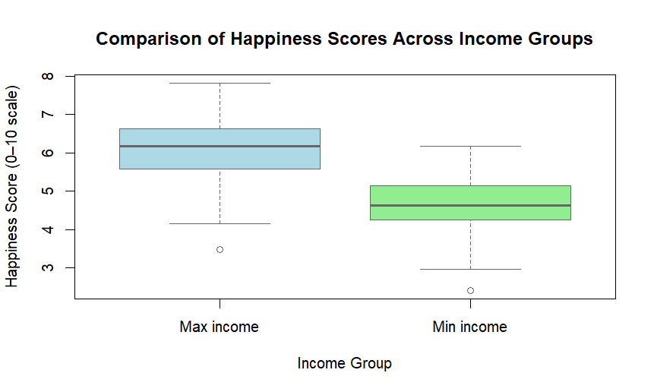
The boxplot shows that countries in the Max income group consistently report higher happiness scores compared to those in the Min income group. The spread of values also indicates that lower-income countries experience more variability and generally lower levels of happiness. Overall, the visual supports the conclusion that income level is associated with notable differences in national happiness.

