**ACKNOWLEDGEMENT**

The mini-project report on “Cricket Quiz” is the outcome of guidance, moral support and faith bestowed on me throughout my work. For this I acknowledge and express my profound sense of gratitude and thanks to everybody who have been a source of inspiration during the project preparation.

I take this opportunity to express my gratefulness to everyone who has extended their support for helping me complete this project report.

First and foremost I thank **Dr. Thomas P John,** Chairman, T. John Group of Institutions and **Dr. Thippeswamy H. N.** Principal, T. John Institute of Technology for giving me an opportunity to study in this prestigious institute and also providing me with the best of facilities.

I would like to show my greatest appreciation to **Dr. Mahesh T. R.,** HOD, Dept of CSE and **Ms. Vandana Jha,** Project Coordinator, Dept of CSE and all the staff members for lendingme their constant support.

I would also like to thank all other teaching and non-teaching staffs of computer science department who have directly or indirectly helped me in this completion of this project work.

And lastly I would hereby acknowledge and thank my parents who have been a source of inspiration and also instrumental in successful completion of this project work.

Atul Chandran

(1TJ15CS009)

**TABLE OF CONTENTS**

|  |  |  |
| --- | --- | --- |
| Chapter No. | Description | Page Number |
|  | Acknowledgement | I |
| Chapter 1 | Introduction | 1-2 |
| Chapter 2 | ER and Schema Diagram | 3-4 |
| Chapter 3 | Design | 5-8 |
| Chapter 4 | Implementation | 9-12 |
| Chapter 5 | Result | 13-20 |
|  | Conclusion | 21 |
|  | References | 22 |

**Chapter-1**

**INTRODUCTION**

* 1. **About Cricket Quiz**

Cricket Quiz is a PHP-MySQL based application designed for the user to check their cricket knowledge.

There are 4 levels in this application; each level consists of 5 questions. On answering at least 3 questions correctly from each level, the user passes a level. Moreover, a total of 5wrong answers are allowed throughout the whole quiz.

* 1. **Existing System and Its Limitations**

The current cricket quiz application includes triggering a PHP page when the user has lost all of his chances and updates the score and number of right answers accordingly with sufficient user interfaces.

The limitation of the existing quiz application is that the quiz is not based on a timer. Therefore, the user has enough time to think for each question instead of evaluating score by time.

* 1. **Proposed System**

In order to expand the ideas of existing quiz applications, I have proposed the Cricket Quiz Application with new additional features such as Introduction of sixes and wickets in terms of right and wrong answers, triggering the page if the user has lost all of his chances, etc.

With the help of these features in Cricket Quiz, the idea of a simple quiz application has given a new edge to it.

**Chapter-2**

***ER* DIAGRAM *AND SCHEMA DIAGRAM***

* 1. 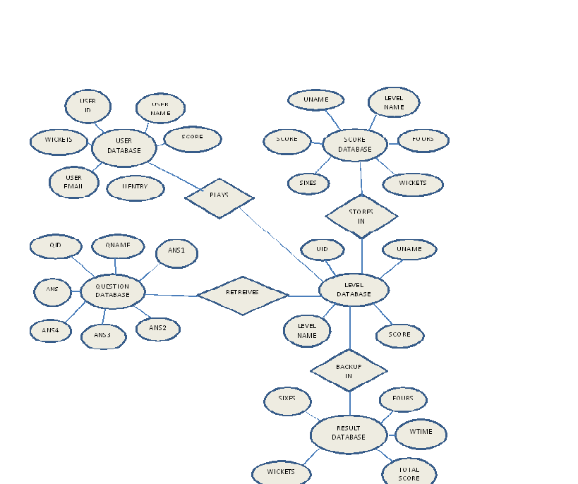**ER Diagram**

The ER diagram of the Cricket Quiz application is as follows:-

* 1. **Schema Diagram**

The Schema diagram of the Cricket Quiz application is as follows:-

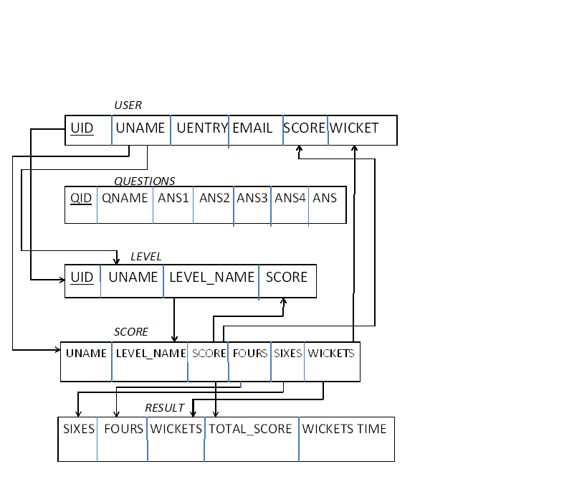

**Chapter-3**

**DESIGN**

System design is the most important phase of the implementation of any system. It basically covers the functional aspects of the system. Designing any system includes formality and design details are developed with constant backfiring.

**3.1 Input Design**

In the input design, user-oriented inputs are converted into a computer based system format. It also includes determining the method of input, speed of capture and entry on to the screen. Commands and data are accepted through keyboard. The major approach to input design is the menu and the prompt design. In each alternative, the user’s options are predefined. The data flow diagram indicates logical data flow, data stores, source and destination. Input data are collected and organized into a group of similar data. Once identified input media are selected for processing.

In this application, importance is given to develop Graphical User Interface (GUI), which is an important factor in developing efficient and user-friendly software.

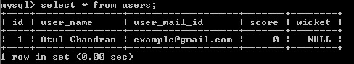

The above snapshot represents addition of a user onto the database along with user entries.

**3.2 Output Design**

In the output design, the emphasis is mainly on displaying the information requested by the user in a predetermined format. In order to carry out this activity two of the commonly used media are speakers and the screen. Users get to view their output based on the actions performed. Computer’s output is the most important and direct source of information to the user, efficient, logical, output design should improve the systems relations with the user and help in decision making.

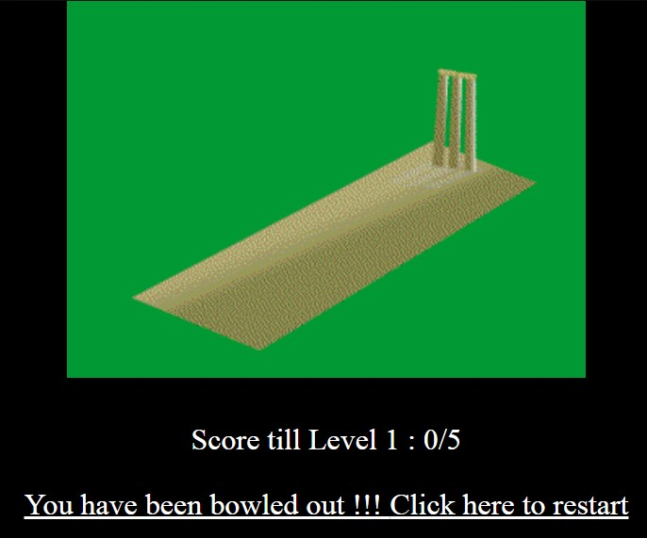

The above snapshot represents the PHP trigger when the user has lost all of his chances, i.e. 5 wrong answers.

**3.3 Database Design**

Database design is the process of producing a detailed data model of a database. This logical data model contains all the needed logical and physical design choices and physical storage parameters needed to generate a design in a Data Definition Language, which can then be used to create a database.

**3.3.1 Table**

1) USERS

|  |  |  |  |
| --- | --- | --- | --- |
| **Column** | **Type** | **Null** | **Default** |
| **Id** | int(11) | No |  |
| user_name | varchar(50) | No |  |
| user_entry_time | varchar(20) | Yes | NULL |
| user_mail_id | varchar(40) | No |  |
| Score | int(11) | No |  |
| Wicket | int(10) | Yes | NULL |

2) QUESTIONS

|  |  |  |  |
| --- | --- | --- | --- |
| **Column** | **Type** | **Null** | **Default** |
| **Id** | int(11) | No |  |
| question_name | text | No |  |
| answer1 | varchar(250) | No |  |
| answer2 | varchar(250) | No |  |
| answer3 | varchar(250) | No |  |
| answer4 | varchar(250) | No |  |
| Answer | varchar(250) | No |  |

3) LEVEL

|  |  |  |  |
| --- | --- | --- | --- |
| **Column** | **Type** | **Null** | **Default** |
| user_id | int(11) | No |  |
| user_name | varchar(20) | No |  |
| level_name | varchar(20) | Yes | NULL |
| Score | int(11) | No |  |

|  |  |  |  |
| --- | --- | --- | --- |
|  |  |  |  |
| 4) SCORE   |  |  |  |  | | --- | --- | --- | --- | | **Column** | **Type** | **Null** | **Default** | | user_name | varchar(20) | No |  | | level_name | varchar(20) | No |  | | Score | int(10) | No |  | | Fours | int(5) | Yes | NULL | | Sixes | int(5) | Yes | NULL | | Wickets | int(5) | Yes | NULL |   5)RESULT   |  |  |  |  | | --- | --- | --- | --- | | **Column** | **Type** | **Null** | **Default** | | Sixes | int(5) | No |  | | Fours | int(5) | Yes | NULL | | Wickets | int(5) | No |  | | Wickets_entry | text | Yes | NULL | | tot_score | int(5) | No |  | |  |  |  |
|  |  |  |  |
|  |  |  |  |
|  |  |  |  |

**Chapter-4**

**IMPLEMENTATION**

Implementation is the stage, which is crucial in the life cycle of the new system designed. Planning, training and system testing are the main stages in the implementation. Converting a new or revised system into an operational one is called implementation.

Implementation includes all those activities involving the conversion of an old system into a new system. The new system may be in a totally new concept or a revision of the old one. A proper implementation is required for reliable system, but still does not guarantee a successful system. Chances are there that if implementation is not proper the whole system may become a failure.

Conversion an important aspect of implementation is the process of change from the old system to the new one. A review is conducted once implementations are over. Information required for maintenance is collected during this phase. The basic review method is data collection methods of interview, observation, sampling and record inspection.

* Operating of the equipment
* Data coding
* Methods on form transaction
* Decision support activities
* Data handling activities

**4.1 Code Design**

First phase of implementation is coding. Coding can be done in two ways. One by automatic program code and other by programmer’s manually written code. A code generator is a suite of programs that matches the input to an appropriate code template and from these produces modules of code. The code is made simple in such a way that another programmer can easily understand and work on that in future. Consider an example code for inserting a new record into the database.

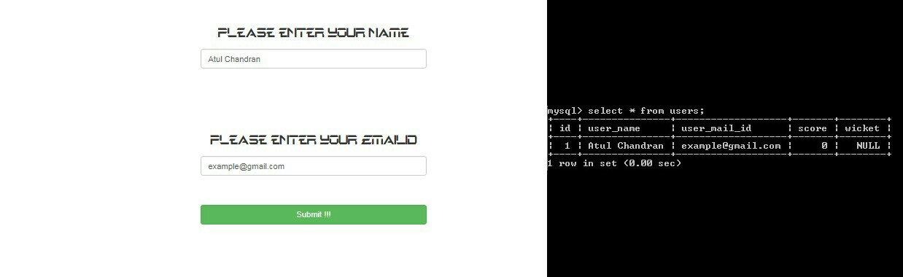

if( isset( $_POST['name'] ) && !empty($_POST['name'])){

$name = $_POST['name'];

$mail=$_POST['MailAddress'];

mysqli_query($con, "INSERT INTO users (id, user_name,user_mail_id,score) VALUES (id,'$name','$mail',0)") or die(mysqli_error( $con ));

$_SESSION['name']= $name;

$_SESSION['mail']=$mail;

$_SESSION['user_id'] = mysqli_insert_id($con);

}

Here is a code which is used to insert the user name and user mail id into the user database. To insert the data into the database, a SQL query is written specifying the data to be added. The query is executed and the data is added to the database.

**4.2 Trigger**

The trigger applied in this application is given as follows:-

CREATE TRIGGER `trigger_name` AFTER INSERT ON `users`

FOR EACH ROW delete from score;

This statements truncates data from score table when a user entry is been made to the application.

**4.3 Stored Procedure**

The stored procedure in this application is given as follows:-

DELIMITER $$

CREATE DEFINER=`root`@`localhost` PROCEDURE `routine_name`(IN `name` VARCHAR(20))

NO SQL

BEGIN

update users set user_entry_time= CURRENT_TIMESTAMP where user_name=name;

end$$

DELIMITER ;

The above stored procedure generates the timestamp when the user has entered his details

DELIMITER $$

CREATE DEFINER=`root`@`localhost` PROCEDURE `result_routine`()

NO SQL

BEGIN

update result set wickets_time= CURRENT_TIMESTAMP where wickets=5;

end$$

DELIMITER ;

The above stored procedure generates the timestamp when the user has lost all of his wickets of a particular level.

**Chapter-5**

***SYSTEM* TESTINGAND *RESULT***

Testing is a process to show the correctness of the program. Testing is needed to show completeness, it improves the quality of the software and to provide the maintenance aid. Some testing standards are therefore necessary reduce the testing costs and operation time. In order to carry out the testing process, the concept of Verification and Validation (V&V) was adopted.

V&V techniques can be broadly classified under the following categories:-

1. ***Static V&V techniques***: Used to analyze and check requirements document,design diagrams and program source code.
2. ***Dynamic V&V techniques***: Requires test data to examine the output.

The goal of V&V techniques is to make system ‘fit for purpose’ that fit for its intended use.

**Testing Process:**

The project “Cricket Quiz” has gone through various stages of testing and then integrated into a complete application. Testing steps involved are:

1. **Unit Testing**

Each module in the project was tested independently and errors were rectified. In this way, we were able to locate for errors and logic contained in a particular module.

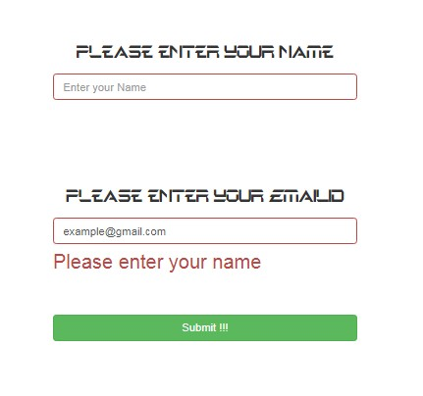

**PHP code**

<p class="text-center">

Please enter your name

</p>

<?php if(empty($_SESSION['name'])){?>

<form class="form-signin" method="post" id='signin' name="signin" action="questions.php">

<div class="form-group">

<input type="text" id='name' name='name' class="form-control" placeholder="Enter your Name" autocomplete="off"/>

<br><br><br>

<p class="text-center">

Please enter your EmailID

</p>

<input type="text" id='emailid' name='MailAddress' class="form-control" placeholder="Enter your Email address" autocomplete="off"/>

<span class="help-block"></span>

</div>

<br>

<button class="btn btn-success btn-block" type="submit"> Submit </button></form>

**Javascript code**

$(document).ready(function() {

$("#signin").validate({

submitHandler : function() {

console.log(form.valid());

if (form.valid()) {

alert("sf");

return true;

} else {

return false;

}

},

rules : {

name : {

required : true,

minlength : 3,

remote : {

url : "check_name.php",

type : "post",

data : {

username : function() {

return $("#name").val();

}

}

}

},

},

messages : {

name : {

required : "Please enter your name",

remote : "Name is already taken, Please choose some other name"

},

},

errorPlacement : function(error, element) {

$(element).closest('.form-group').find('.help-block').html(error.html());

},

highlight : function(element) {

$(element).closest('.form-group').removeClass('has-success').addClass('has-error');

},

});

});

The above code is a unit from the module ‘Check_Name’ which deals with restrictions applied on the user name entered by the user.

In the above set of code, we are checking the validity of the user name. If the entered name is less than 3 characters, a message is displayed to the user saying that the name entered is invalid and prompts the user to enter a valid name.

1. **Module Testing**

A module is a collection of department components. A module encapsulates related components so can be tested without other system modules.

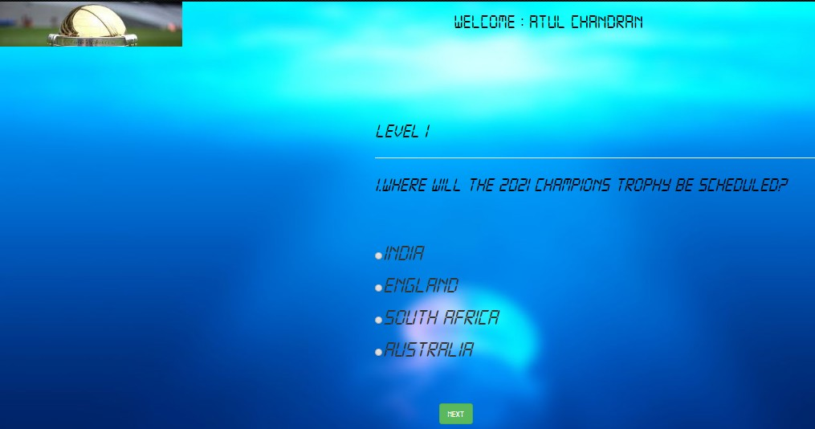

The module in the above picture describes successful user login entry and proceeds towards Level 1.

1. **Sub-System Testing**

This phase involves testing collections of modules which have been integrated into sub-systems. Sub-systems may be independently designed and implemented

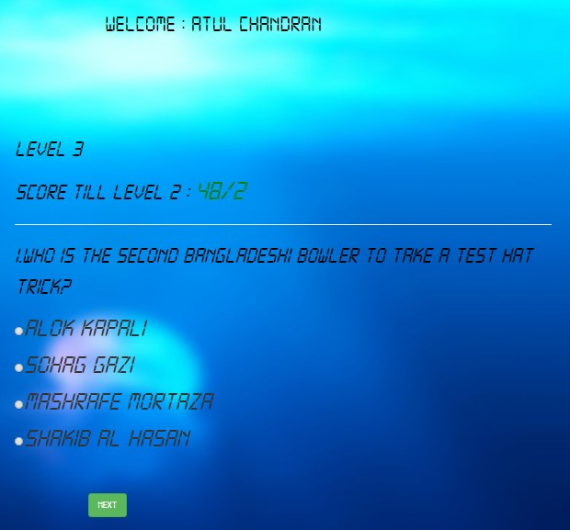

This is the sample of the sub-system module used in the Cricket Quiz application. Here, this module is an integration of several other modules and executed independently from other sub-system modules.

1. **System Testing**

The sub-systems are integrated to make up the entire system. The testing process is concerned with finding errors which result from unanticipated interactions between sub-systems and system components.

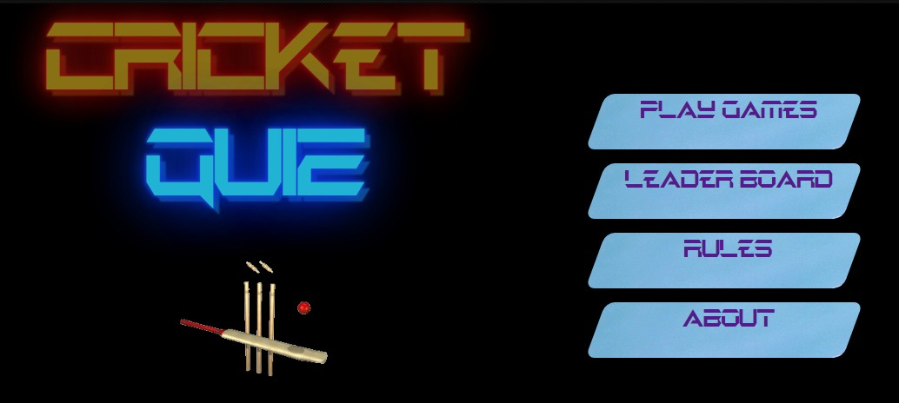

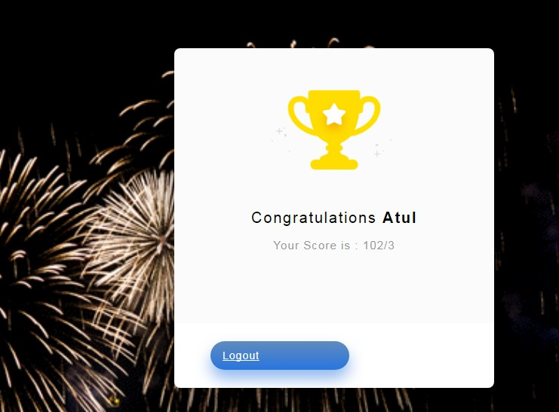

The final system is tested integrating various other sub-systems containing many other modules and sub-modules.

1. **Acceptance Testing**

Final stage in the testing process before the system is accepted for operational use. This stage may reveal errors and omissions in this system requirement definitions because the real data exercises the system in different ways from the test data.

Hence the whole system was tested and desirable results were found.

**CONCLUSIONS**

After our research on various existing quiz applications, I have found that these applications mainly focused on promoting cricket knowledge to the public and associating each question as a run scored in a match.

The proposed system is the package for entertainment and challenges users on their cricket knowledge.

**REFERENCES**

1. Database systems Models,Languages,Design and Application Programming,Ramez Elmasri and Shamkant B. Navathe,6th Edition,Pearson
2. <https://stackoverflow.com>
3. <https://www.w3schools.com>
4. https://www.sitepoint.com