IOT based Smart Homes using Android

Dr. D Ramya Dorai [1], Prof. Srinivasa H P [2], Atul Chandran [3]

[1] Associate Professor & Head, Department of Computer Science & Engineering, T John Institute of Technology, Bangalore, India

[2] Assistant Professor, Department of Computer Science & Engineering, T John Institute of Technology,

Bangalore, India

[3] B.E Student, Department of Computer Science & Engineering, T John Institute of Technology,

Bangalore, India

E-mail: [atulchandran05@gmail.com](mailto:atulchandran05@gmail.com)

**Abstract**

The objective of this work is to propose a machine learning-based methodology system architecture and algorithms to find patterns of learning, interaction, and relationship and effective assessment for a complex system involving massive data that could be obtained from a proposed collaborative learning environment (CLE). Collaborative learning may take place between dyads or larger team members to find solutions for real- time events or problems, and to discuss concepts or interactions during situational judgment tasks (SJT). Modeling a collaborative, networked system that involves multimodal data presents many challenges. This paper focuses on proposing a Machine Learning - (ML)-based system architecture to promote understanding of the behaviors, group dynamics, and interactions in the CLE. Our framework integrates techniques from computational psychometrics (CP) and deep learning models that include the utilization of convolutional neural networks (CNNs) for feature extraction, skill identification, and pattern recognition. Our framework also identifies the behavioral components at a micro level, and can help us model behaviors of a group involved in learning.

Keywords: Home Automation, Smart Homes, Android Mobile Phone and Arduino

—————————— ◆ ——————————

# Introduction

Due to tremendous growth in the present-day technologies, humans are adapted to these technologies in numerous ways. Wireless communication or wired serial communication are two its types. Bluetooth technology stands on the top among the different wireless technologies as it is able to provide a communication between devices and users in a simple and efficient manner. In everyday life, there are many types of Bluetooth devices that are being used. To control various appliances, several types of Bluetooth modules are designed. The modules are based on several specifications based on which they perform the operations that are related to it. These Bluetooth modules, operate at 2.4 GHz frequency and work within a range of 45 meters.

With the help of this Bluetooth technology, we are designing a home automation system. The HC-05 Bluetooth module is used here. Some issues are needed to be considered before designing, the user should be able to connect to that Bluetooth module from any device he would wish to. He should also be able to change the host from one device to another and that module should work accordingly. If any fault occurs it should be able to detect it and the system should work immediately towards its solution when an instruction is given to improve the nature of wireless technology.

The main objective of this project is to develop a simple and cost-efficient home automation system with an Android application which would act as a remote and make at most use of all the appliances that can be connected which would help to simplify daily life. Modern houses are gradually shifting to centralized control system, involving wireless controlled switches. Every single appliance in the house can be controlled using a remote device.

IOT based E-home using Android is an application of embedded system which integrates Android operating system, Arduino controller and the Bluetooth for the implementation of Smart Home. Provide improved convenience, comfort, energy, efficiency and security.

It also provides a user-friendly environment through the android app and also a cost efficient, long range solution for the implementation of a smart home using fewer complex circuits.

# Materials and methods

## A. The system has the following hardware components:

1. Android Mobile Phone

A mobile smart device running Android application which is a Bluetooth controller, an Arduino and a Bluetooth module hc05 which will connect the respective android device with the connected appliance.

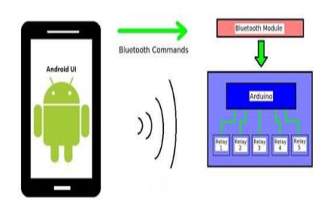

Fig. 1 Android Mobile Phone

1. Arduino UNO

Arduino is an easy-to-use hardware and software based on open-source electronics platform. Inputs like - light on a sensor, a finger on a button, or online can be read by the Arduino boards. By sending a set of instructions to the microcontroller on the board, you can tell your board what to do. The Arduino Software (IDE), based on Processing and the Arduino programming language (based on Wiring), help us to do send instructions.

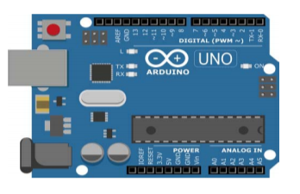

Fig. 2 Arduino UNO

1. HC-05 (Bluetooth Module)

A HC-05 is a Bluetooth serial port protocol module which is very easy to use and function which uses transparent serial wireless setup connection. Master / Slave configuration can be used by HC-05 Bluetooth module which is an effective solution for all types of wireless communication. It has number of hardware features in it such as having sensitivity of around 80dBm in which radio frequency can transmit power up to +4dBm. It also has programmable input and output control with UART interface.

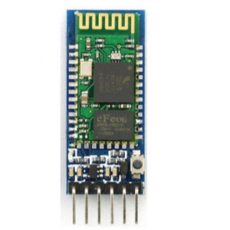

Fig. 3 HC-05 (Bluetooth Module)

1. 5V Relay with Optocoupler

A relay is an electrically operated device. It has a controlled system and a control system. Automatic control circuit uses a relay frequently. It is an automatic switch with a low-current signal for controlling a high-current circuit, in simple terms. Long-term reliability, lower inertia of the moving, small volume and stability are few of its advantages. Automation technology, power protection, remote control, sport, reconnaissance and communication, as well as in devices of electro mechanics and power electronics, a relay is widely used. Generally speaking, a relay consists of an induction part which reflects input variable like power, current, voltage, temperature, resistance, pressure, frequency, speed and light etc.

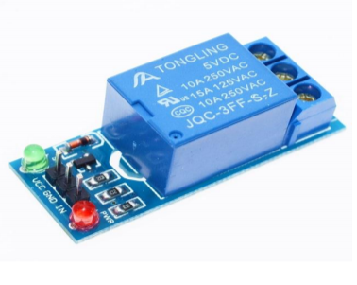

Fig. 4 5V Relay with Optocoupler

1. Motors and Sensors

For the mechanical part of an electromechanical switch a stepper motor is used. When the electrical (Bluetooth app switch) sends a signal to turn ON / OFF to this switch the motor will rotate in clockwise direction for switching ON and anti-clockwise for switching OFF. For security purposes an IR Sensor has been installed at the door of the house. This sensor basically detects if something has passed over it. If any object cuts the path of IR then it will detect that movement and report it to the system. By using this sensor, we can show that whether the door is closed or open. To sense whether it is closed or open we will need 2 IR sensors near the door.

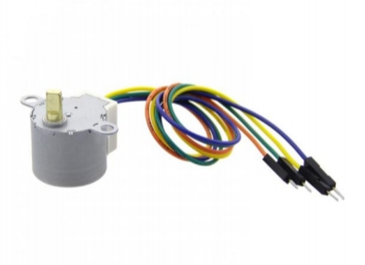

Fig. 5 Motors and Sensors

## B. System Architecture:

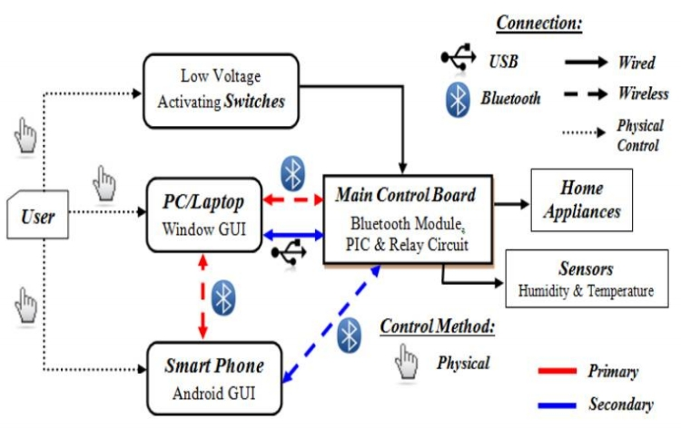

Fig. 6 Architecture for Home automation system

The hardware of the system was designed in such a way that can make the circuit compact and as efficient as possible. A simple architecture that uses to construct this home automation system is shown below. There can be multiple output components used in this system say for an example Tube light, fan, Charger, Television, blinds etc. In the proposed system we have used a LED, Fan, Motorized blinds and a Door lock as the appliance connected.

* LED

It turns ON/OFF by sending a command through the app. Also, its intensity can be varied.

* Fan

It can be turned ON/OFF by sending the respective command and also its speed can be varied through the app.

* Blinds

It is connected by a stepper motor and can be controlled to pull down or pull up the blinds.

* Door Lock

The door can be locked or unlocked through the app. The motor is connected to the throw bolts of the lock and basically rotates bolts to lock or unlock the door.

The block diagram which is shown in Figure 6 displays the architecture of the proposed system. The android device is used on the respective user’s phone on which an android app is developed. A signal is sent on the Bluetooth module via the developed android app which is connected to it via Bluetooth. The signal is then being processed by the microcontroller. In this case it is Arduino UNO which consists of Atmega 328 chip. In the further stage the micro controller which is connected to the relay sends the respected signal to it. The relay in this case acts as a switch and as soon as a high signal arrives it turns ON and similarly if a low signal arrives it gets switched OFF. We are using a 5V relay which has an optocoupler included in it and according to our required appliances we can use n such channels. The relay is connected to multiple appliances and depending on the no. of appliances relay should be included. Depending on the input coded through the microcontroller and the signal passed via the android device the relay will switch ON and switch OFF the appliance. Multiplexing of the devices is possible as well.

## C. Flowchart:

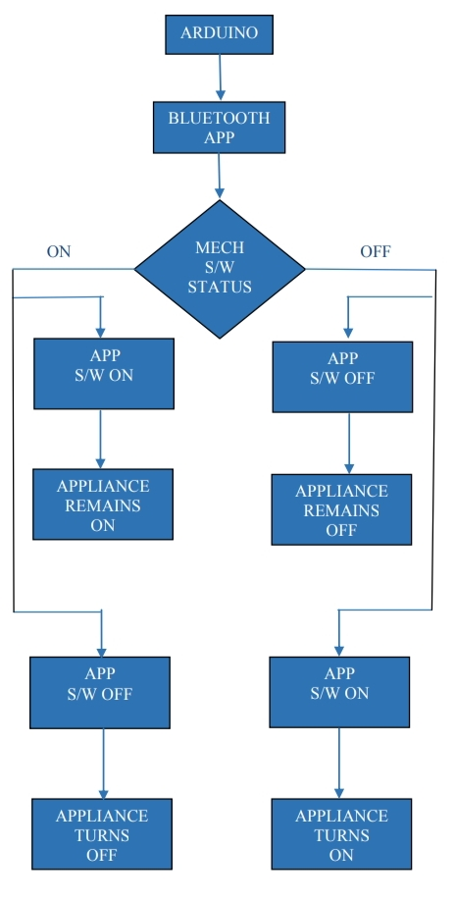

Fig. 7 Flowchart

The block diagram shown in figure 7 explains the working of the designed system. It shows the case when we take the status of mechanical switch into the consideration. Similarly, if we consider the case when we check the status of Bluetooth App switch first the block diagram in Figure 7 will change accordingly. The figure 7 Is a typical flowchart which shows the working of the entire system. The Arduino is connected to the Bluetooth application developed using android. It relates the application of the software with the mechanical switches present at the place. For example if we consider initially the mechanical switch is off and the application switch is also off then the following appliance will be switched off only but if the mechanical switch is switched off and the application is turned on by the user then the appliance will turn on and similarly it will happen in the other case that is if the mechanical switch is kept on with the application switch on the following appliance will remain in On status but if the application switch is turned off keeping the appliance switch on then the appliance will turn off.

# Literature Review

Previous Research on existing Home Automation Systems:

N. Sriskanthan and Tan Karand in their work have presented an application of Bluetooth Technology for Home Automation. The Bluetooth technology which emerged in late 1990's is used for implementing the wireless home automation system. Various appliances such as air conditioners, home theatres, cellular phones etc., are interconnected, thus creating a Personal Area Network in Home Environment. The communication between several client modules and the host server takes place through the Bluetooth module. A Home Automation Protocol has been developed to enhance communication between the host server and the client modules. The system also allows integration or removal of devices to the network which makes the system scalable. The wireless system aims at reducing the cost of Home Automation. But the system does not use the trending mobile technology. [1]

A. Z. Alkar and U. Buhur have developed an internet based wireless home automation system for multifunctional devices. A flexible, low cost, wireless solution to the home automation is introduced. The transformation of the initial simple functionality control mechanism of devices to more complex devices has been discussed. The home appliances are connected through a server to a central node. The system is secured from unauthorized users by using SSL algorithm. During tests, the wireless communication was found to be limited to <100 meters in a concrete building. [2]

Muhammad Izhar Ramli, Mohd Helmy Abd Wahab, Nabihah developed a prototype electrical device control system using Web. They have developed a web-based controller, for controlling electrical devices. Whenever the condition of server is down, they also set their server with auto restart. The system does not use mobile technology. Being a web-based system; this application is less effective since the use of headphones and Smart phones is increasing rapidly. [3]

E. Yavuz, B. Hasan, I. Serkan and K. Duygu have designed and implemented a telephone and PIC remote-controlled device for controlling the home electrical devices. In this Pin check algorithm has been introduced where it was with cable network and not wireless communication. The system ensures safety as it cannot be used by unauthorized users as the system uses Pin-check system. The architecture is very complex, but it gives an idea of remote handling of home automation system. [4]

Shahriyar, E. Hoque, M. M. Akbar, S. Sohan, I. Naim, and M. K. Khan presented a GSM based communication and control for home appliances. Different AT commands are sent to the Home Mobile for controlling different appliances. The drawback of this system is that a Graphical User Interface (GUI) is not provided to the user. Different AT commands have to be remembered by the users to control the connected devices. Also, the system supports Java enabled mobile phones. The system thus becomes less functional as now-a-days the use of Java enables phones are reducing and the use of Android phones are increasing tremendously. [5]

Jitendra Rajendra Rana and Sunil N.Pawar in their paper have implemented a zigbee based home automation system. Zigbee is a high-level communication protocol used to create personal area network. It supports any kind of microcontroller. The system eliminates the complication of wiring in case of wired automation. Considerable amount of power saving is also possible. Operating range is more than Bluetooth. But the system does not allow remote monitoring and controlling of appliances. [6]

R. Piyare and M. Tazil have presented the design and implementation of a low cost, flexible and wireless solution to the home automation. The system uses Bluetooth technology where the cell phone is used for interaction between the host server and the client modules. This system can be used by any appliances that require On-off switching applications without any internet connection. The drawback of this system was that the wireless communication system was found to be limited to a range less than 50m in a concreted building and maximum of 100m range in an open range. The system supports only the symbian OS cell phones. [7]

Amul Jadhav, S. Anand, Nilesh Dhangare, K.S. Wagh developed a system which uses one of the operating systems for implementation of the Home Automation System. An XML document is created and placed over the server, which can be used by any other mobile device without any platform issue. The layout of the screen is controlled by a common XML format. Downloading of XML file from the server and its parsing needs to be coded on every platform. As the design part is coded only once, a lot of coding effort is reduced. The same file is used by every other platform. The main objective of the paper was to develop a system without operating system platform limitations for Universal Mobile Applications. [8]

# Results

In order to operate the Arduino, a separate android app has been developed in order to provide the user with a sleek, modern and easy to use interface so that the user won’t have to go through the nitty-gritty details on how the Arduino circuit actually works. In order to develop the Android app, the Android Studio IDE was used and the code has been written in pure Java while the design elements have been written in pure XML. The app basically acts as a remote control which sends signals to the Arduino circuit via Bluetooth. The app has been designed keeping a minimal approach in mind such that the user can easily figure out how the remote control actually works.

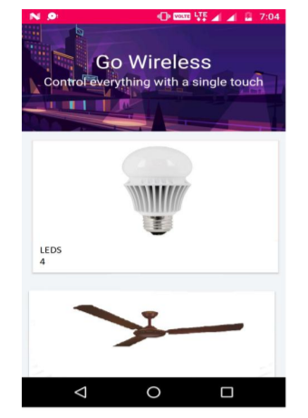

Fig. 8 Appliance Screen

On starting up the app, the user is greeted with a splash screen in which the logo of the app along with the name has been displayed after which the user is taken to the main screen. Recycler view and card view navigation allows smooth scrolling all over the main screen. Here in each card, the number of appliances as well as the name of the appliance, which is basically its type, is displayed. On clicking any of the cards, the user is taken to the appliance screen. The appliance screen is a simple page with a number of toggle buttons corresponding to the various relays of the Arduino as well as the intensity part in whichever appliance it is required.

Whenever the user toggles the given appliance from one state to the next, the toggle button changes its colour to pink, which is the thematic colour of our app, indicating that the appliance is currently working. The states of the toggle button are stored in a shared preferences file such that even when the user quits the app and restarts it, the toggle buttons will stay in their respective on/off states. The shared preferences file is edited each time the app is started and each time the user moves out of the appliance screen in any manner.

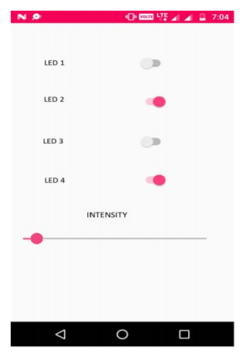

Fig. 9 Toggle Screen for LED

Thus, we have a smooth and a polished app with an easy to use UI which is used to communicate with the Arduino device Via Bluetooth. The Smart home system proposed above and the smart home app, both of them are developed and been tested successfully which had a fruitful result. The demonstration of the appliances makes the system feasible, easy to use and efficient. Features such as low cost, automatic control through the self-developed app which can be changed according to personal usage which makes it unique. Also, security plays an important role in a smart home.

For the purpose of security, an electromechanical door lock can be used which can controlled manually as well as by Bluetooth switch. The motor connected to the lock rotates to lock or unlock the door when a command is given via android app. The sensor connected near the door will detect whether the door is open or closed.

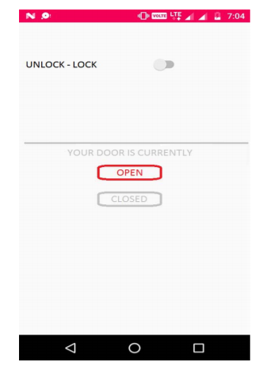

Fig. 10 Toggle Screen for Door

# conclusion

The system will facilitate users to pair any sort of Android devices with Bluetooth Sensor integrated on board with the respective appliances present in the room of the house, office or any place where it can be applied. The designed system is useful for the physically disabled people, people having a bed rest and also old people for whom getting up from the chair or bed just to switch on the appliance is not possible, so it can be useful for this purpose since it is reliable and fast. This low-cost system is designed to improve the standard living in home. Thus, the Internet of Things based Home Automation System is better than all traditional existing Home Automation Systems.

# Future enhancements

The scalability of these can extended at the user end to various type of inputs. The user can send the command by gestures, voice, buttons, eyes, etc. The transmitter end i.e. the user end has to be designed or coded accordingly to detect a gesture drawn, eye movement, button pressed, voices received, etc. For a further advanced version of smart home, sensors like temperature, smoke, PIR, IR, etc. can be installed in the houses. The project of a smart home is not restricted to a single model in it, multiple models can be taken into picture. Running many such models at a time aids to the security of the residents. Also, there are various type of appliances in a house, the code can be changed accordingly to access the various features of it. As home automation technology is evolving, there are several factors which can play a crucial role. Factors like the Internet of Things, open source automation, Wi-fi module, Z wave, Zigbee, Xteon, Insteon and Li-Fi can modify or enhance the working of the concept of automated homes.

# references

[1] Vaishnavi S. Gunge, Pratibha S. Yalagi, “Smart Home Automation: A Literature Review”, IJCA, RTDM 2016

[2] Salma Nasrin, P J Radcliffe, "Novel protocol enables DIY home automation", Telecommunication Networks and Applications Conference (ATNAC) 2014 Australasian, pp. 212-216, 2014.

[3] M. R. Kamarudin, M. A. F., and M. Yusof, "Low Cost Smart Home Automation via Microsoft Speech Recognition," International Journal of Engineering & Computer Science, vol. 13, pp. 6-11, June 2013.

[4] Rajeev Piyare and Tazil M. (2011) “Bluetooth Based Home Automation System using Cell Phone,” 2011 IEEE International Symposium on Consumer Electron-ics, pp.192-195

[5] A. Alheraish, “Design and Implementation of Home Automation System,” IEEE Transactions on Consumer Electronics, vol. 50, no. 4, pp.1087-1092, Nov. 2004

[6] N. Sriskanthan and Tan Karande, “Bluetooth Based Home Automation Systems,” Journal of Microprocessors and Microsystems, 2002, Vol. 26, pp. 281-289

[7] E.M.C Wong, “A Phone-Based Remote Controller for Home and Office Automation,” IEEE Transactions on Consumer Electronics, vol. 40, no. 1, pp.28-34, Feb. 1994.

[8] H. Brooke Stauffer “Smart Enabling System for Home automation”, 1991, IEEE Transactions on Consumer Electronics, Vol. 37(2), pp. 29-35.

[9] Bluetooth Remote Home Automation System Using Android Application. http://www.theijes.com/papers/v2-i1/X021014 901 53. Pdf

[10] Arduino Home Automation Projects by Marco Schwartz

[11]Various Electric Motors and comparison <https://www.slideshare.net/etawahup/variouselectric-motors-and-comparison>

[12] Zigbee Technology and its application in wireless home automation system.

[13] Different Types of Sensors with their Applications https://www.edgefx.in/different-types-of-sensorswith-applications.