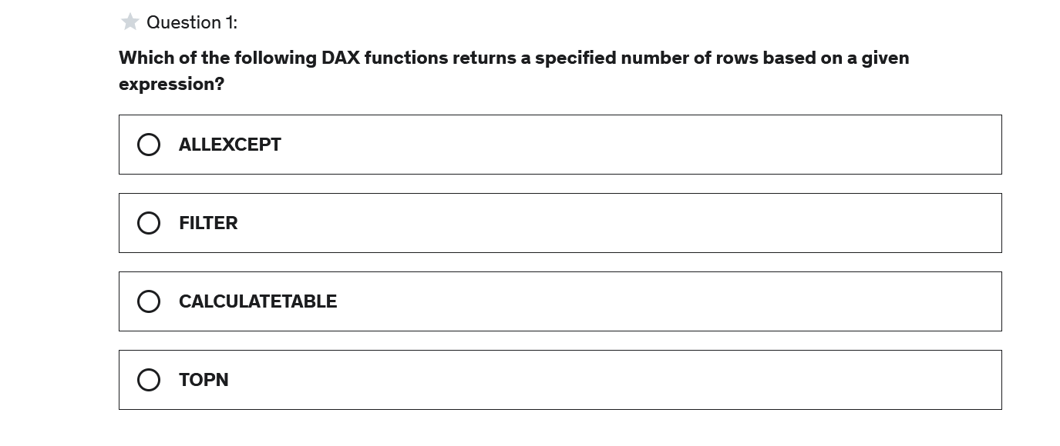

Answer : D

#### Explanation

TOPN can be used to create both tables and measures and will return a subset of customers based on the N_Value

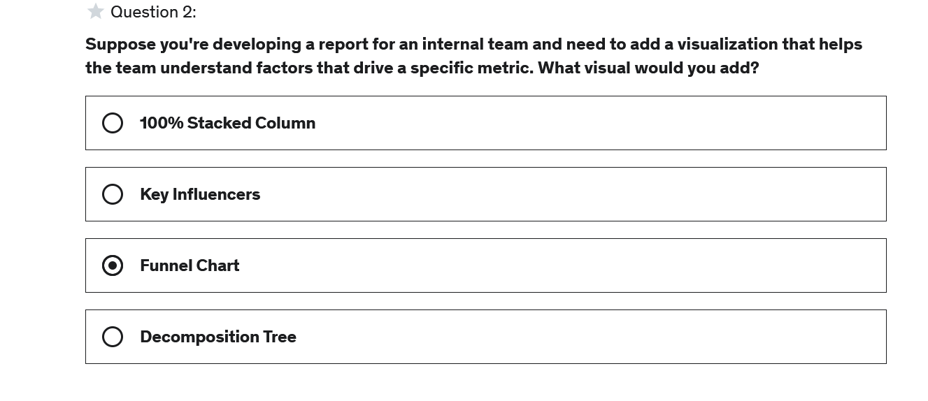

Answer : B

Explanation

The key influencers visual shows the most important factors based on the fields provided

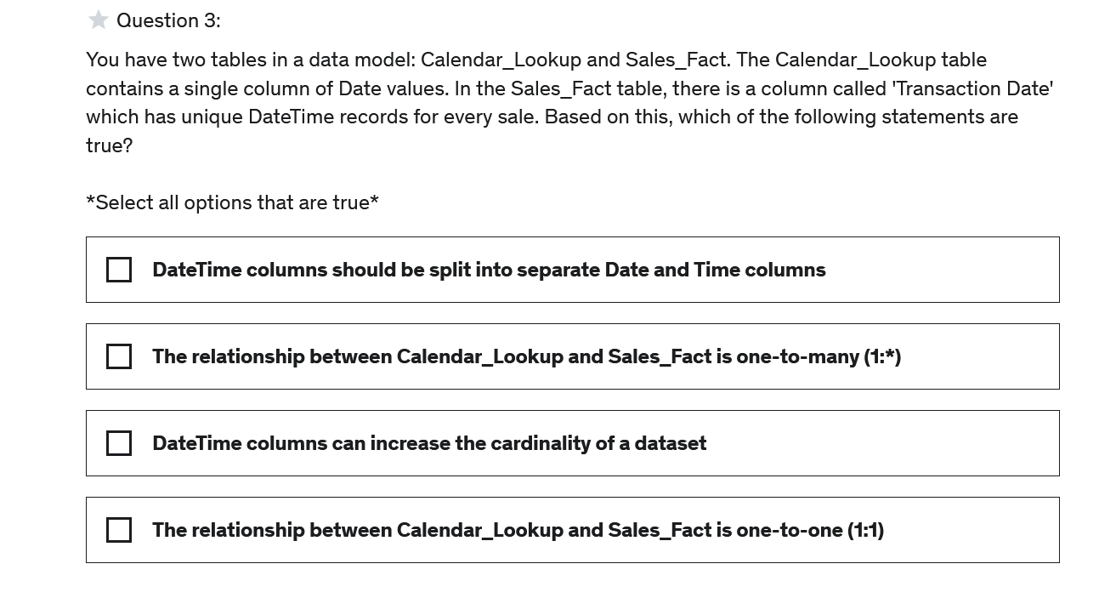

Answer : A,B, C

#### Explanation

In a large dataset (1 million + rows) with a date/time column that contains unique values, the cardinality of that column is very large and leads to performance issues. Splitting out the time component from the date helps reduce the model size. Additionally, because the lookup table contains a single column of Date values and all DateTime values in the Sales_Fact table are unique, the relationship between Lookup and Fact table is one-to-many

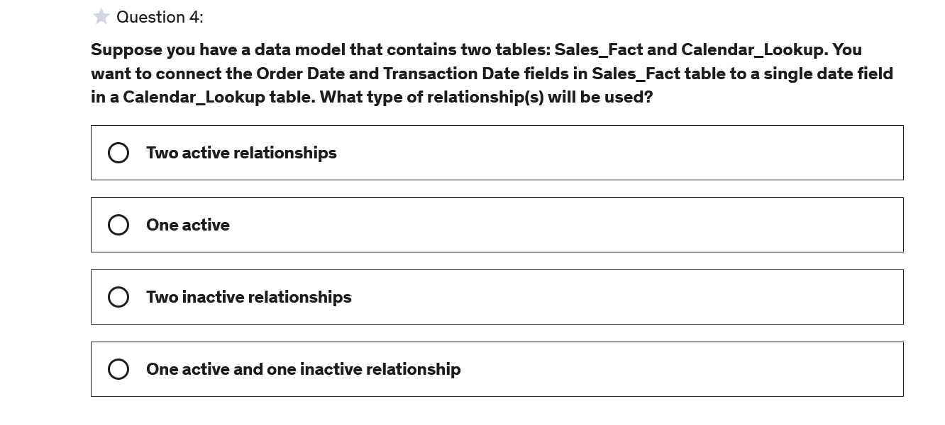

Answer : D

**Explanation**

When creating relationships, you can only have one active relationship between the same column in a lookup table and a fact table. The first relationship created will default to active.

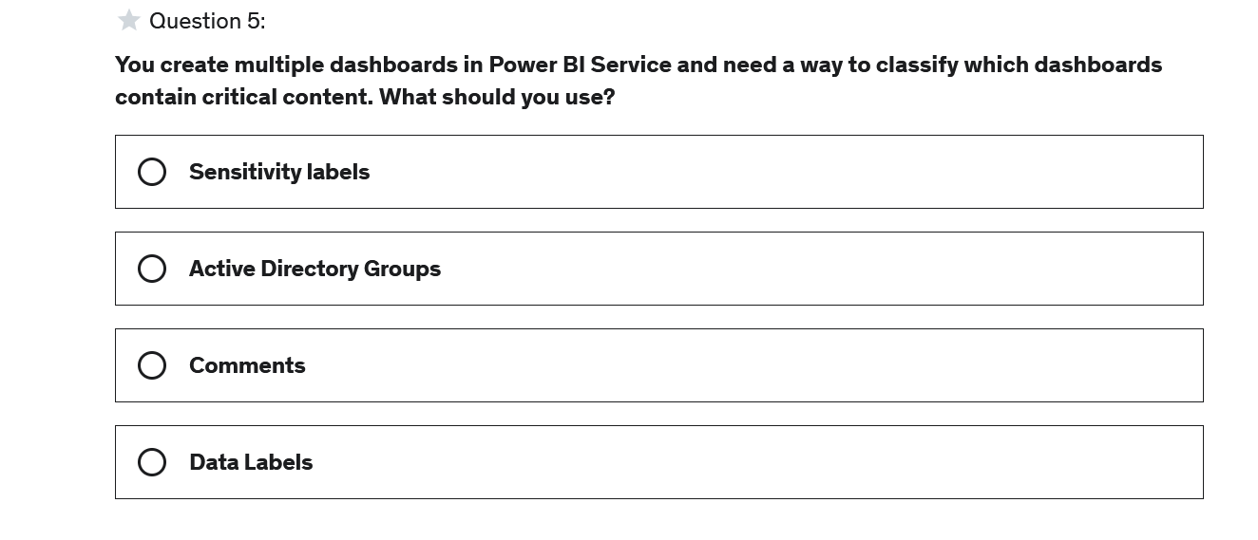

Answer : A

**Explanation**

Sensitivity labels provide a simple way for users to classify content in Power BI Service

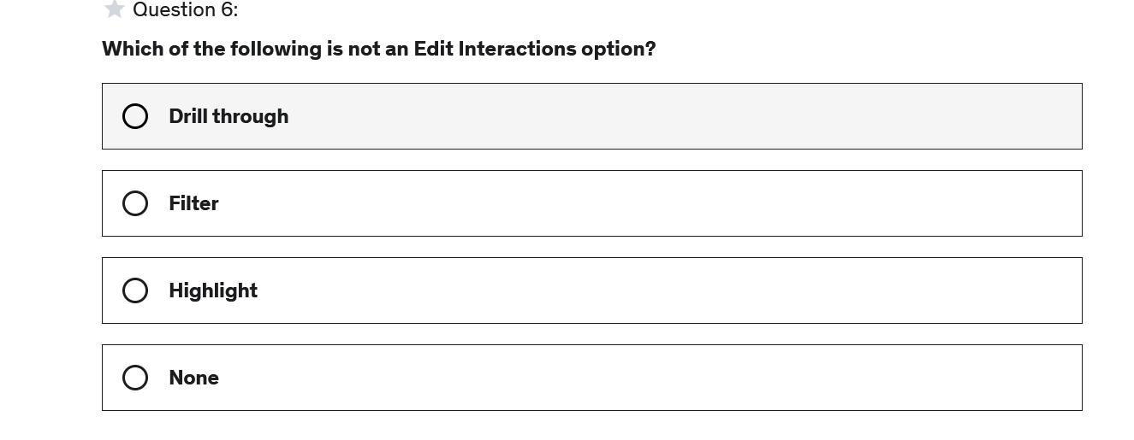

Answer : A

**Explanation**

Filter, Highlight, or none (no interaction) are all options available when setting interactions between visuals

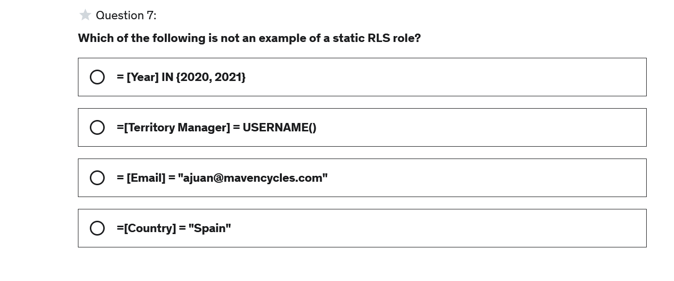

Answer :B

**Explanation**

RLS roles that use the DAX functions USERNAME and USERPRINCIPALNAME are examples of dynamic RLS roles

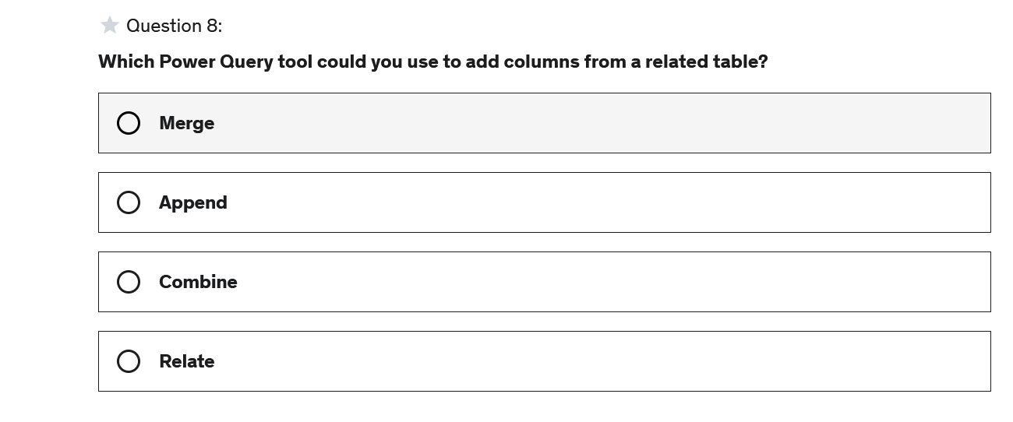

Ans : A

**Explanation**

There are two primary ways of combining queries: merging and appending. When you have one or more columns that you'd like to add to another query, you merge the queries.

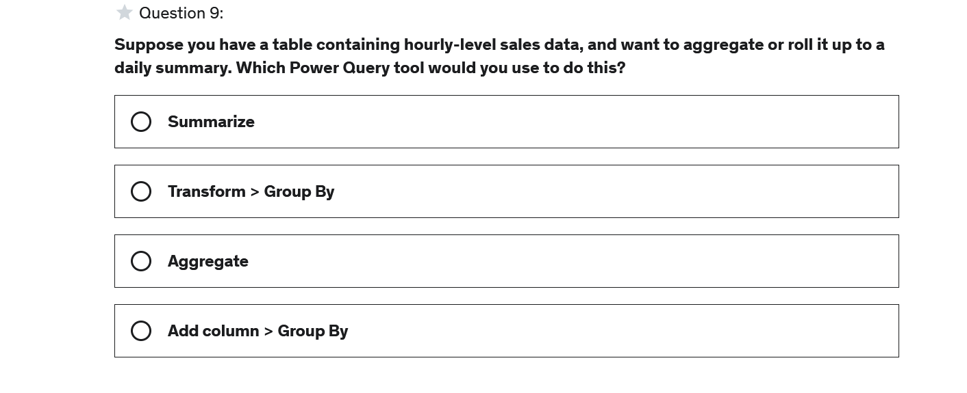

Answer : B

**Explanation**

Group By, available in the Transform tab, is used when you want create a summary view or group various values in many rows into a single value

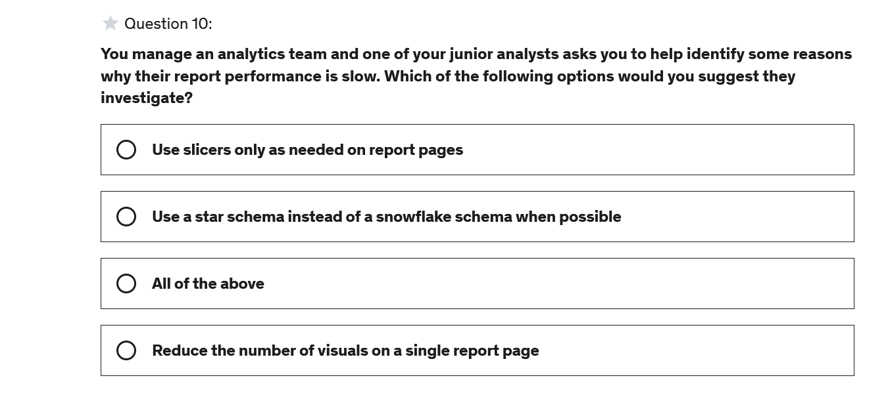

Answer : C

**Explanation**

There are many reasons why a Power BI may perform slowly. Some areas that can impact performance are when complex snowflake schemas are used to model data, many slicers are used within a report page, and when there is a large number of visuals on a single report page.

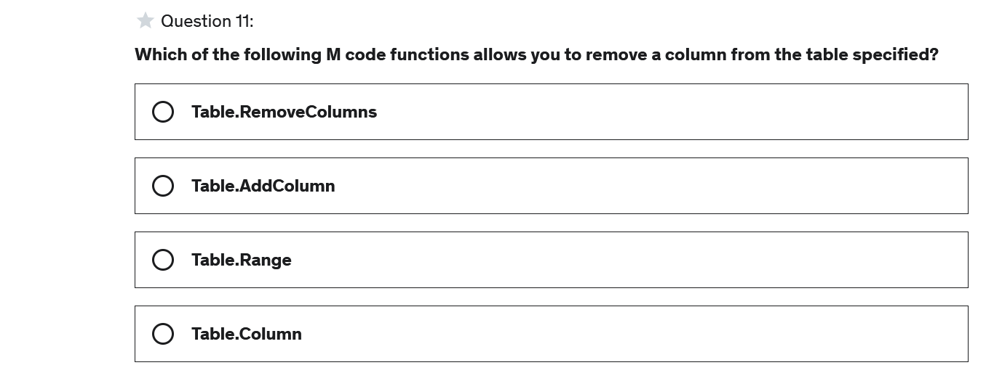

Answer : A

#### Explanation

The Table.RemoveColumns function allows you to remove the specified columns from the table provided. If the column doesn't exist, an exception is thrown unless the optional parameter missingField specifies an alternative table

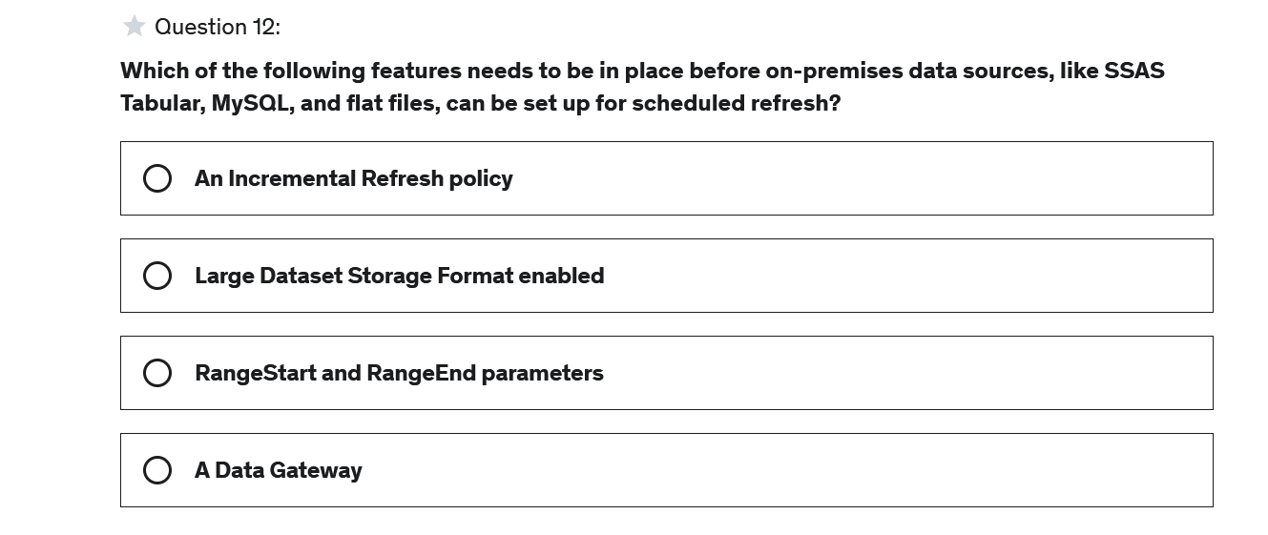

Answer :D

**Explanation**

On-premises data sources, like SSAS Tabular, MySQL, flat files, Oracle, etc., require a data gateway to refresh

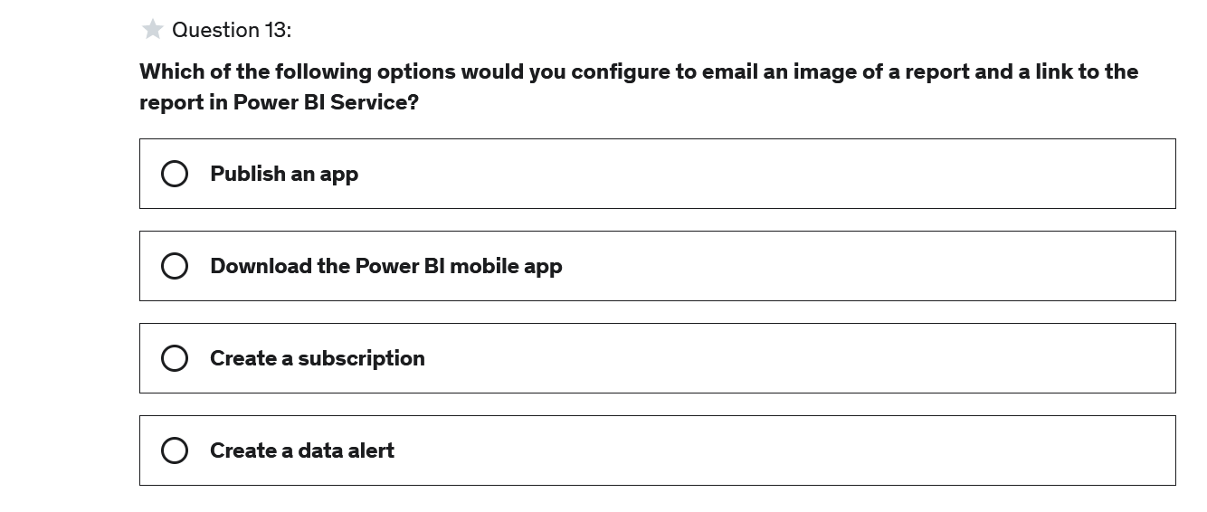

Answer :C

**Explanation**

Subscriptions allow you to send daily emails with snapshots of metrics and visuals

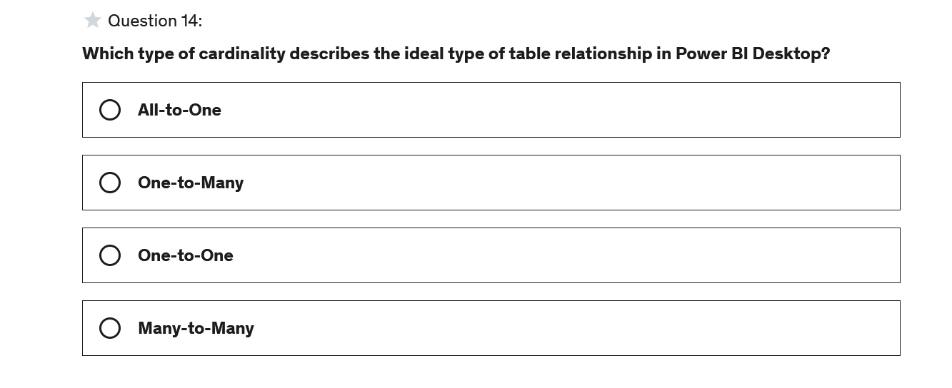

Answer: B

**Explanation**

With few exceptions, tables within a Power BI Desktop data model should be related via one-to-many relationships, between primary and foreign keys.

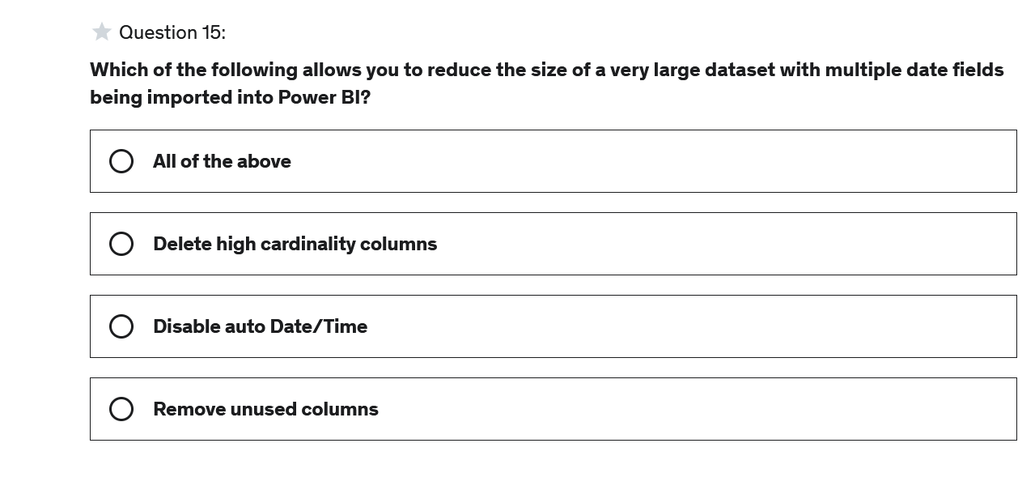

Answer : A

#### Explanation

All of these options can be used to reduce the size of a dataset

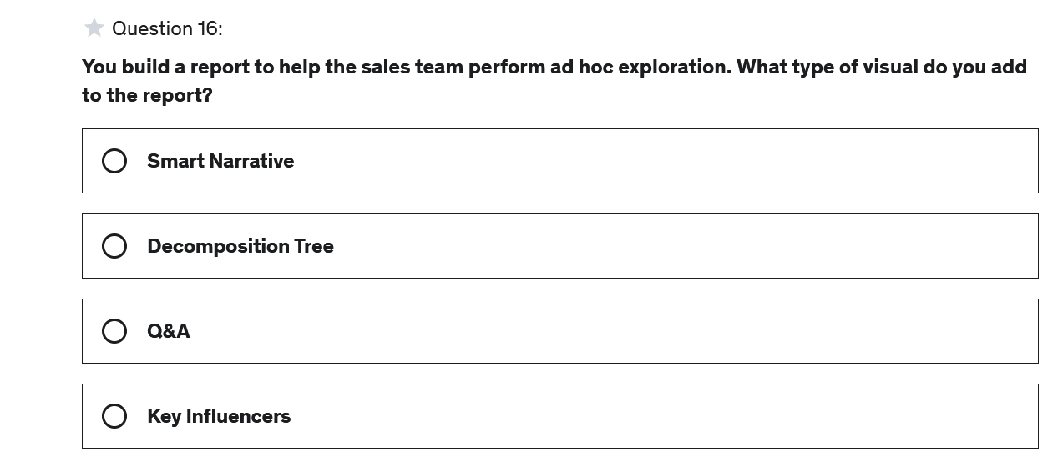

**Answer : B**

**Explanation**

Decomposition trees allow you to perform exploratory and root cause analysis

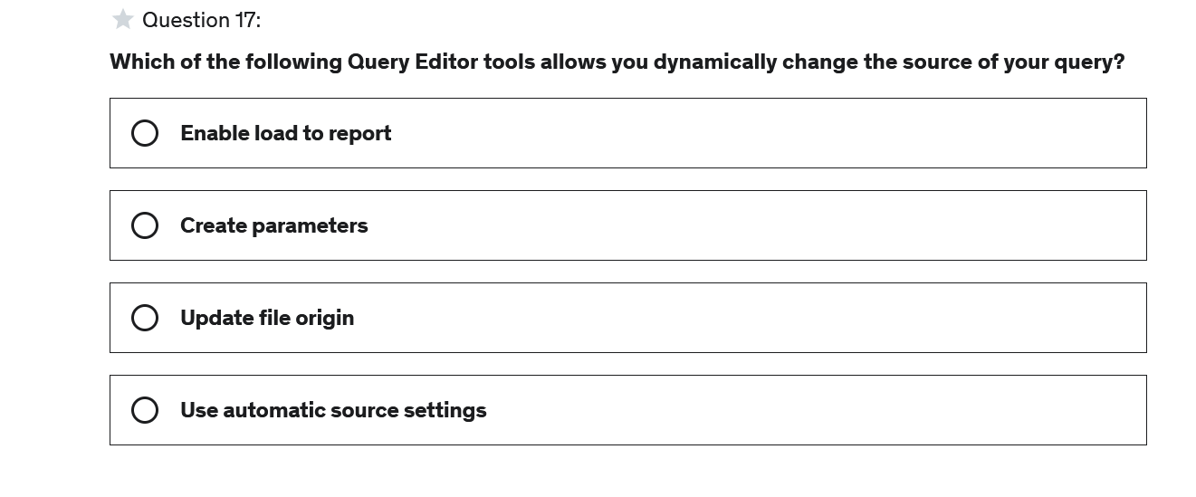

Answer : B

**Explanation**

Using parameters allows you to easily switch between different tables and schemas in a data source or database

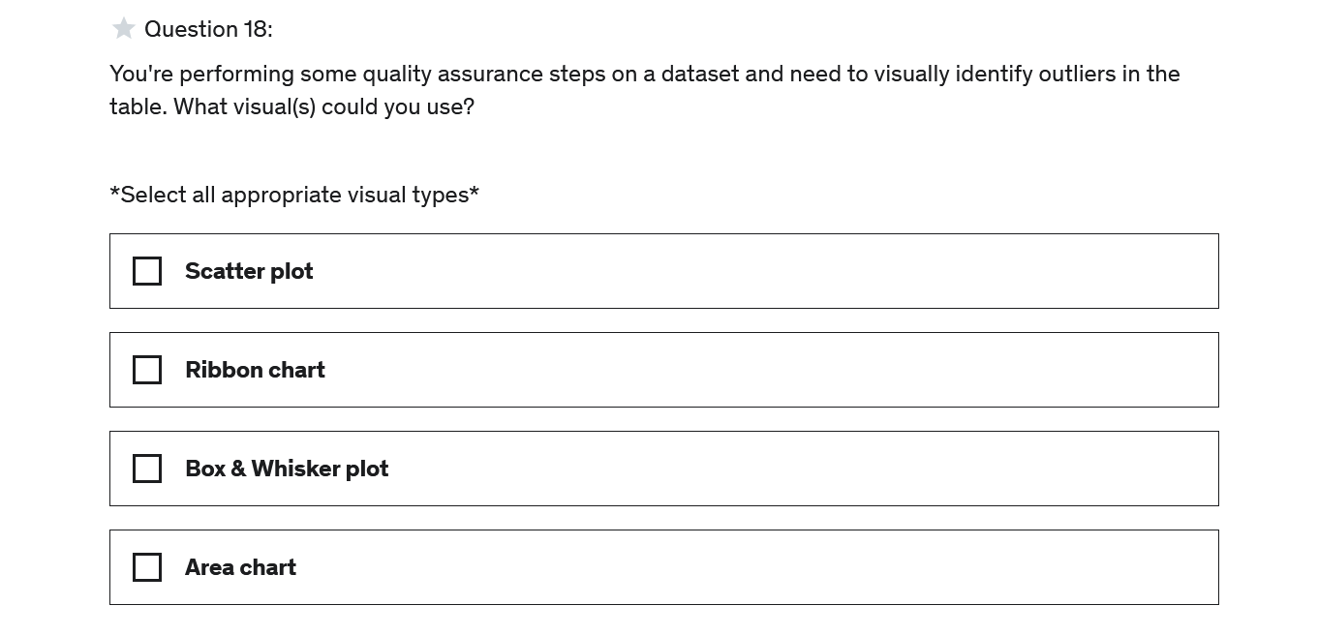

Answer : A, C

**Explanation**

Scatter plots and box plots help identify data points that are outside of an expected distribution

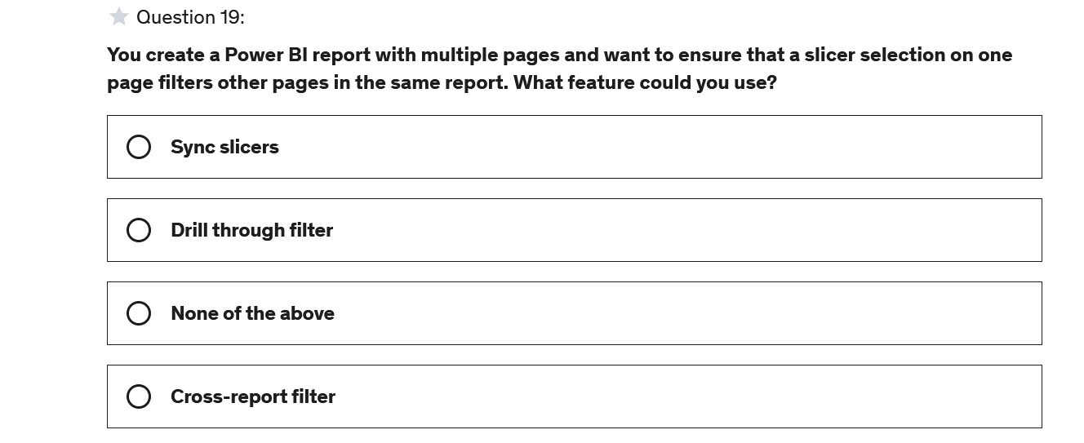

Answer: A

**Explanation**

The sync slicer option ensures that a slicer selection on one page propagates to other pages within the same report

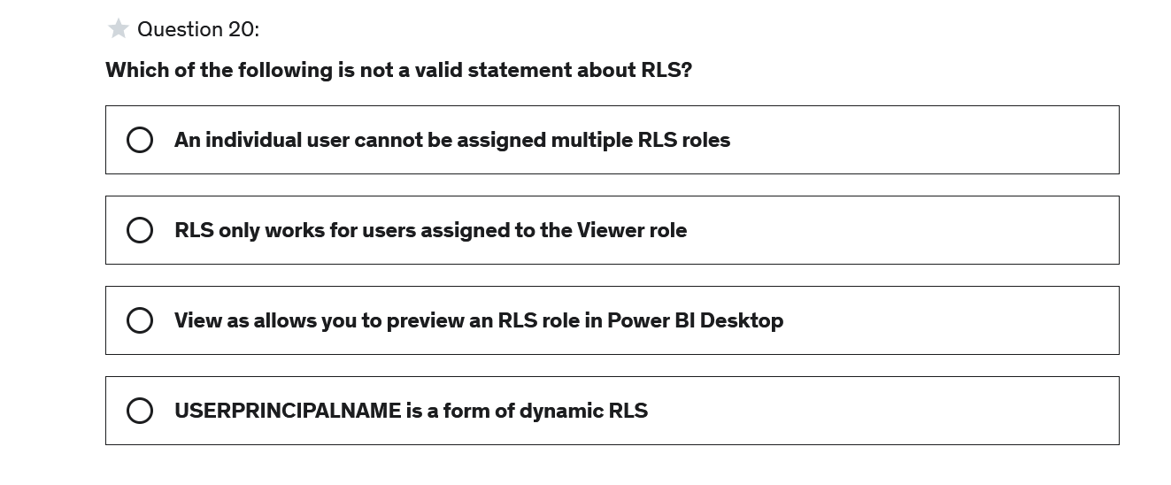

Answer: A

**Explanation**

When a user is assigned to multiple roles, the RLS filters become additive and create a union between the filters

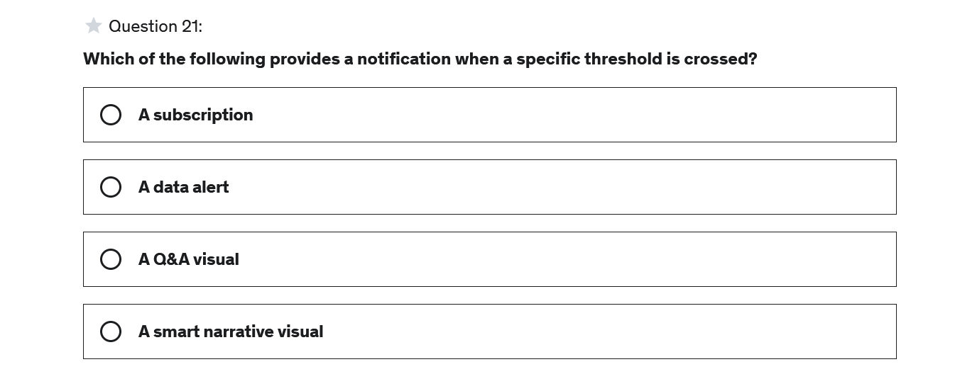

Answer : B

**Explanation**

Data alerts let you trigger a notification when a threshold is crossed

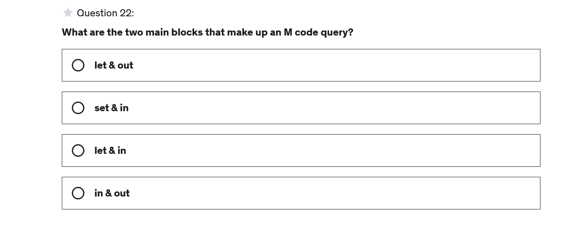

Answer :C

**Explanation**

M code typically consists of two blocks: let & in. The let block contains the definition of all variables in the query and the in block is the output of the query

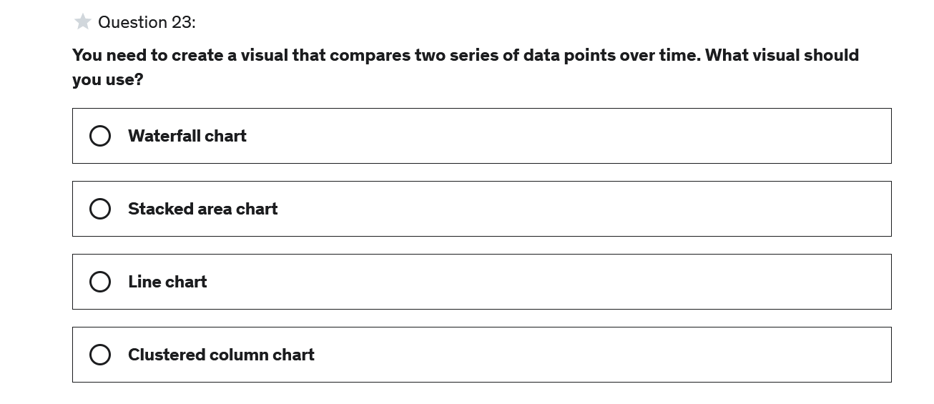

Answer : C

**Explanation**

Line charts are used to visualize change over time

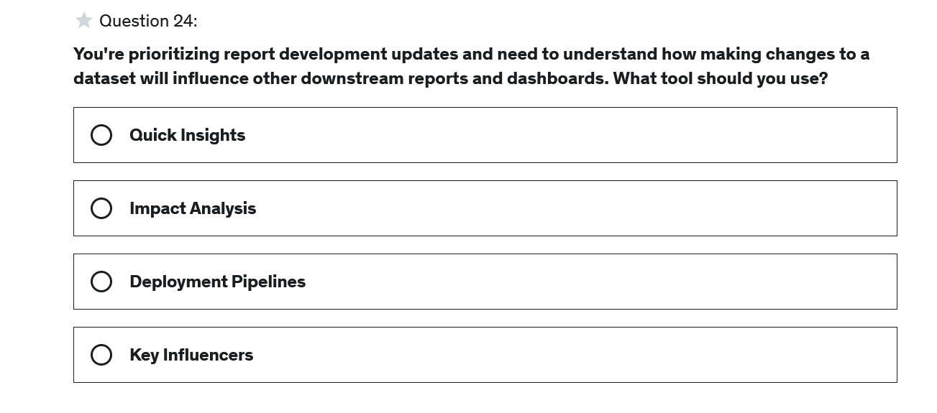

Answer : B

**Explanation**

Impact analysis provides you the tools to understand how making changes to a dataset will impact downstream reports and dashboards

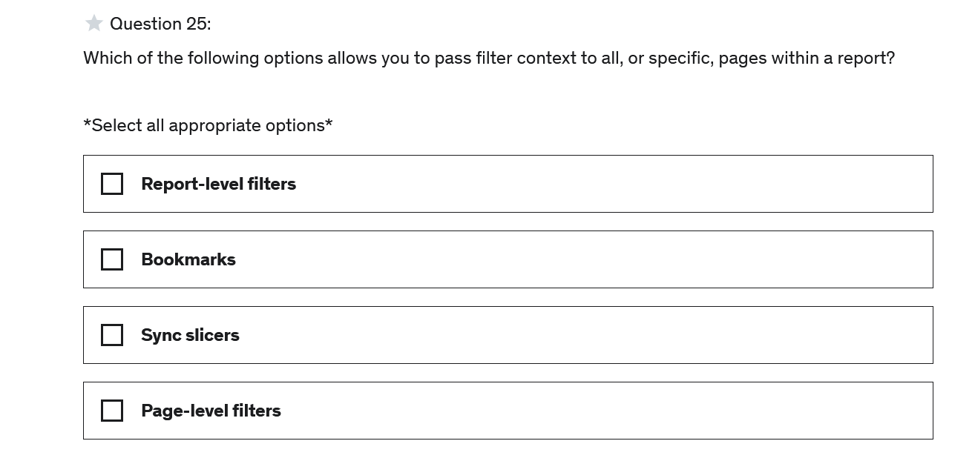

Answer A, C

**Explanation**

Using report-level filters & syncing slicers across report pages allows users to select a single value to filter the results on all pages

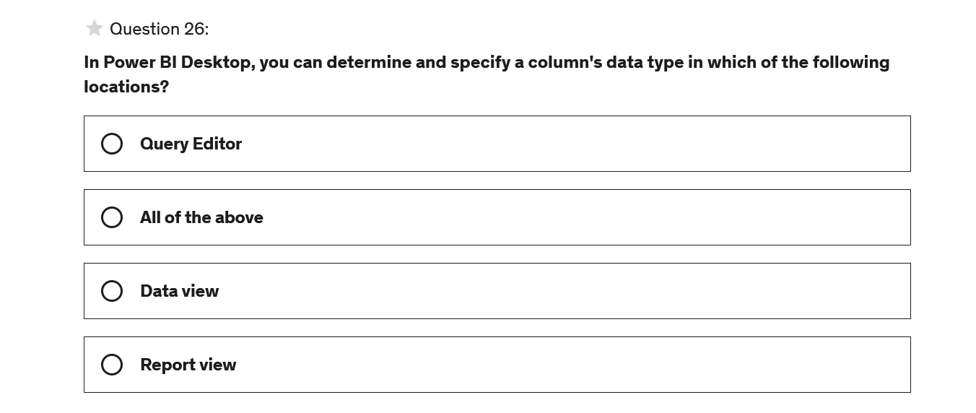

Answer : B

**Explanation**

The data type of a column can be set or adjusted from three locations: the Query Editor, Report view (column tools), and the Data view (column tools)

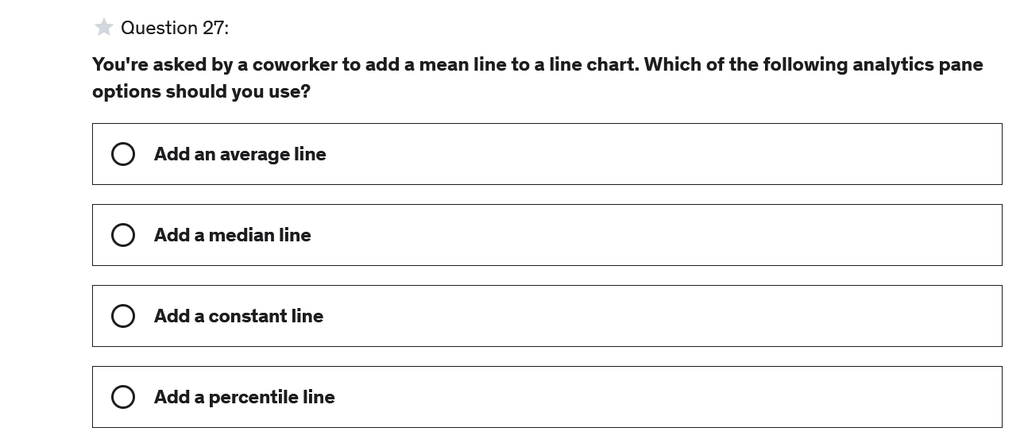

Answer :A

**Explanation**

The analytics pane options change by chart type but for a line chart you can add an average line (mean)

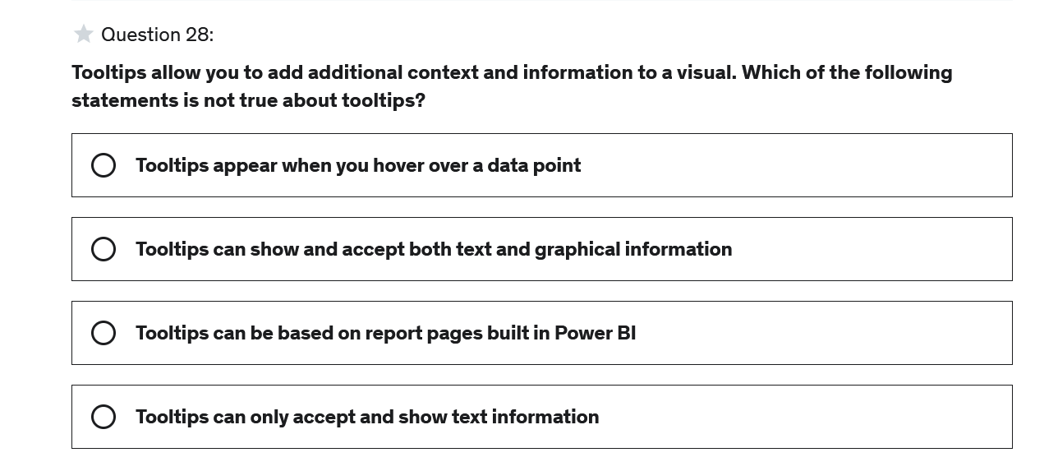

Answer :D

**Explanation**

Tooltips appear when you hover over a data point in a visual, can display both text and graphical information, can be either of type default or report page. When set to report page, a tooltip can be fully customized and include many metrics, other charts & visuals, have a custom background, etc.

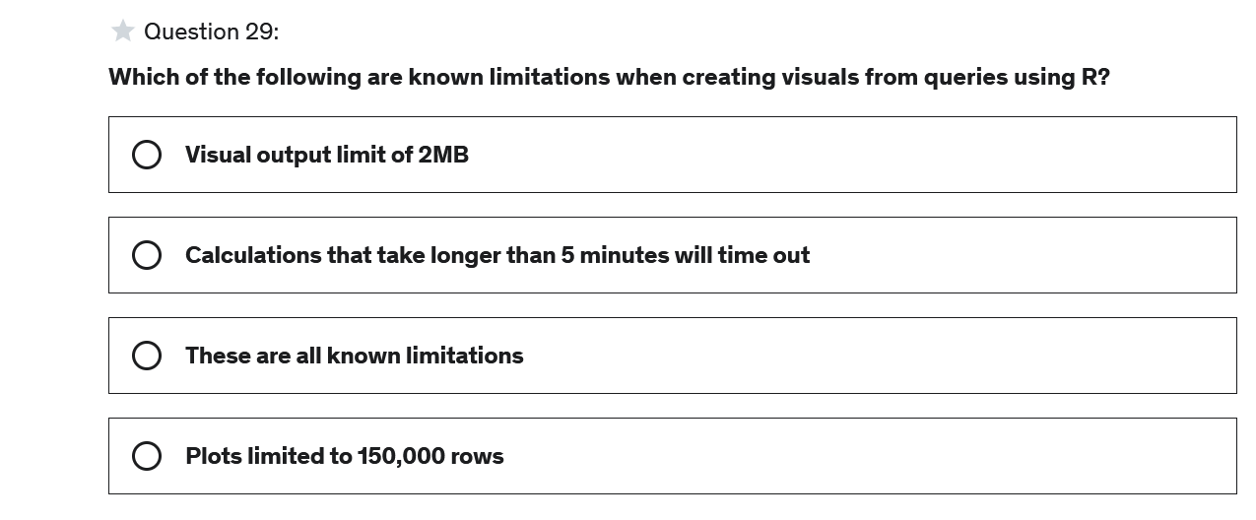

Answer : C

**Explanation**

Plots limited to 150,000 rows, visual output limit of 2MB, visual resolution of 72 DPI, and calculations > 5 minutes timing out are all known limitations when using datasets generate in R

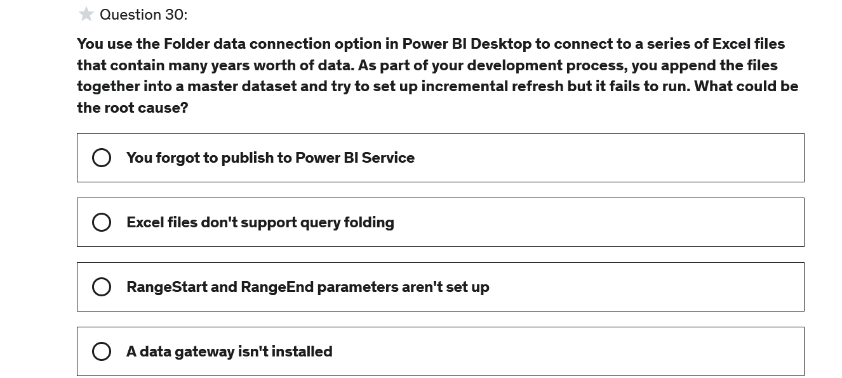

Answer :B

**Explanation**

Queries using Excel, CSV, blob storage, and other flat files don't support query folding and therefore cannot take advantage of incremental refresh

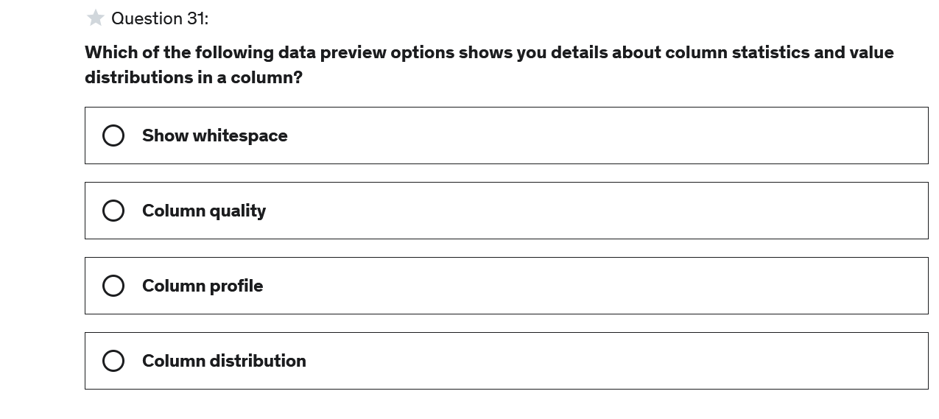

Answer :C

#### Explanation

Column profile shows the detailed column statistics (count, error, empty, distinct, etc.) and value distribution based on a selected column

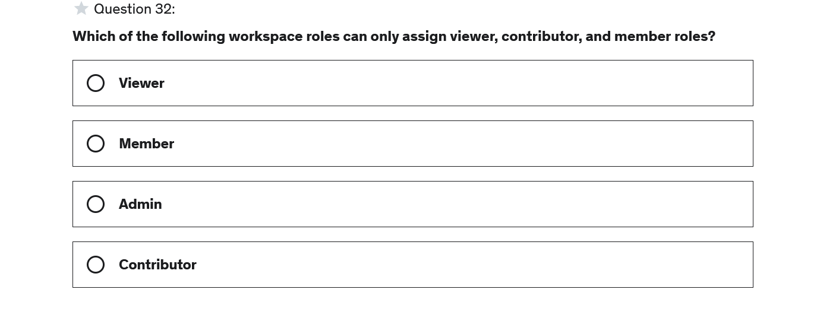

Answer : B

**Explanation**

Members can assign member roles and below

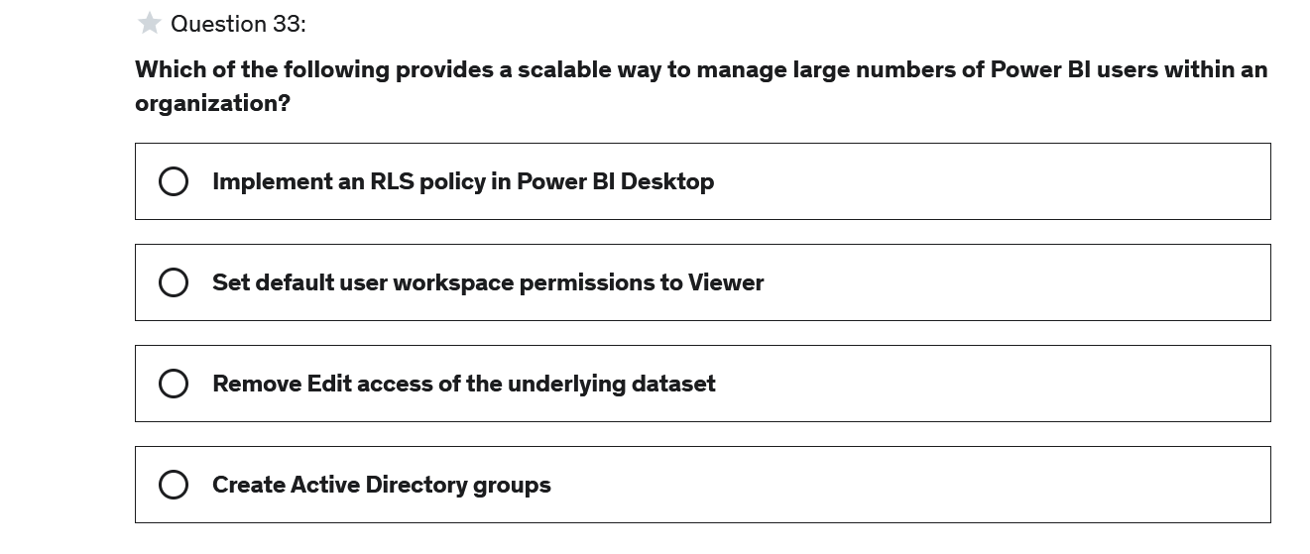

Answer : D

**Explanation**

When using Active Directory groups, you no longer need to maintain lists of individual users

=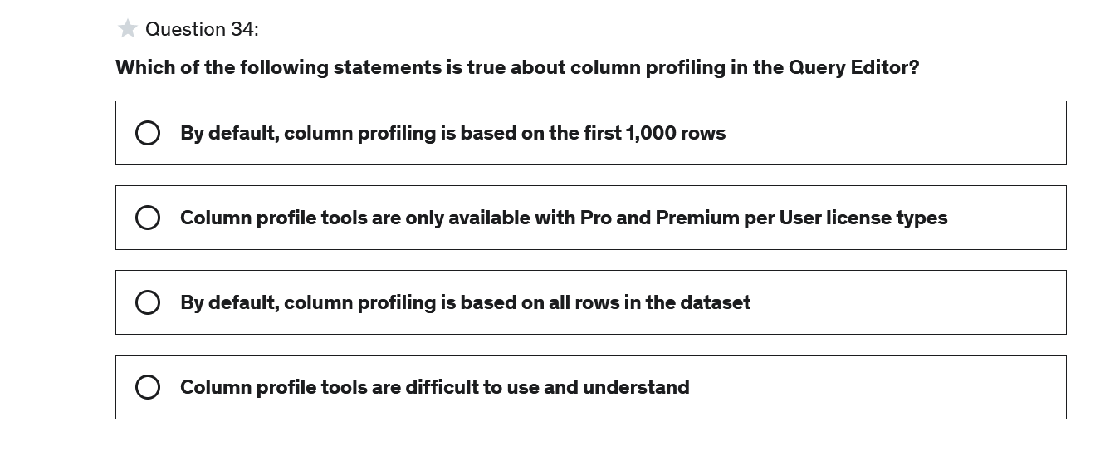

Answer : A

**Explanation**

By default, column profiling is only based on the first 1,000 rows within a table. In order to see all of the rows (records) in a table, you need to select column profile based on entire dataset

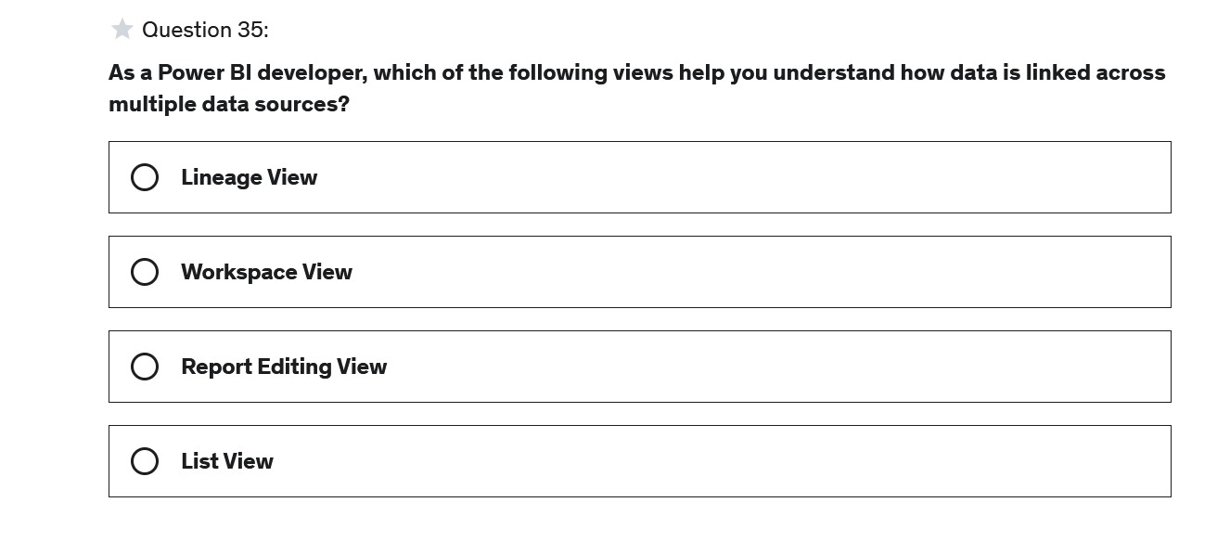

**Answer :A**

**Explanation**

The data lineage view shows you how data is connected across multiple data sources and how it flows to create data sources, reports, dashboards, and apps.

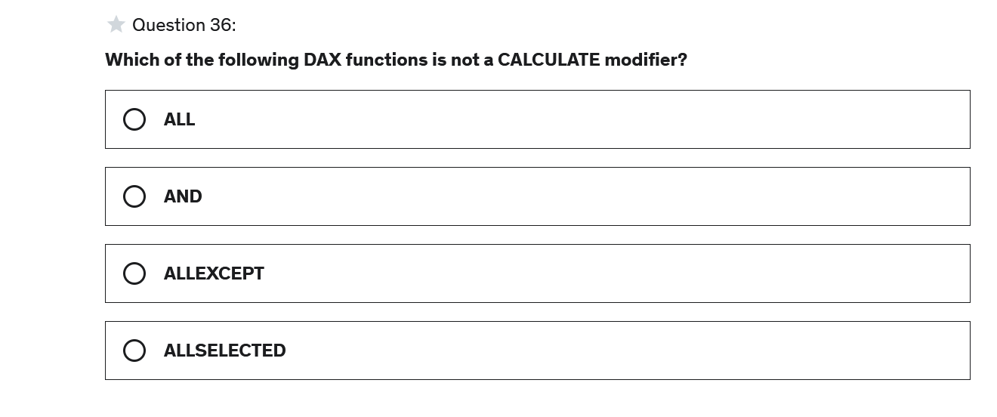

**Answer: B**

**Explanation**

AND is the only function listed that is not a CALCULATE modifier

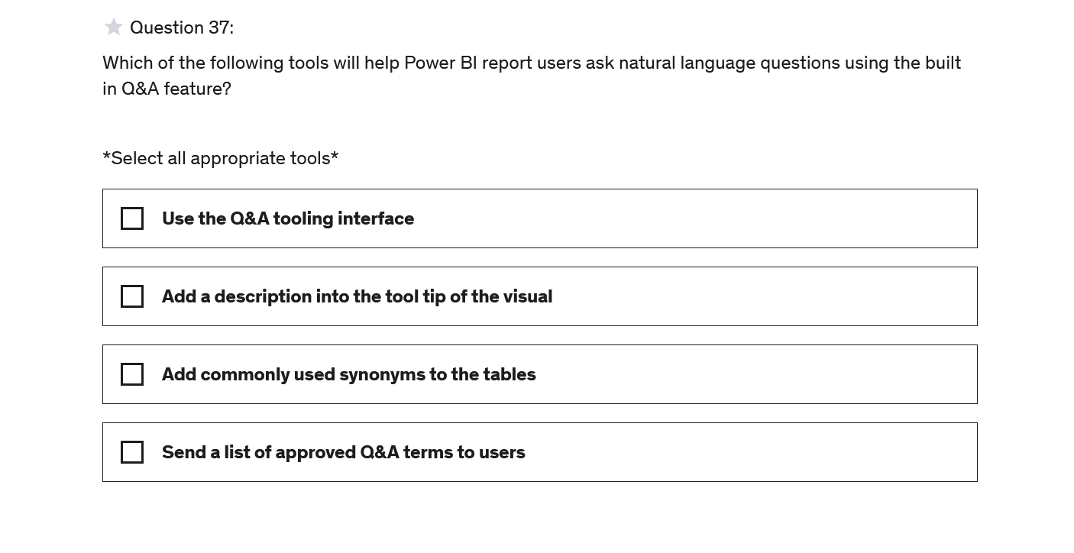

Answer : A,C

**Explanation**

Adding synonyms to tables from the data model view and using the Q&A tooling interface to manage Q&A are both best practices

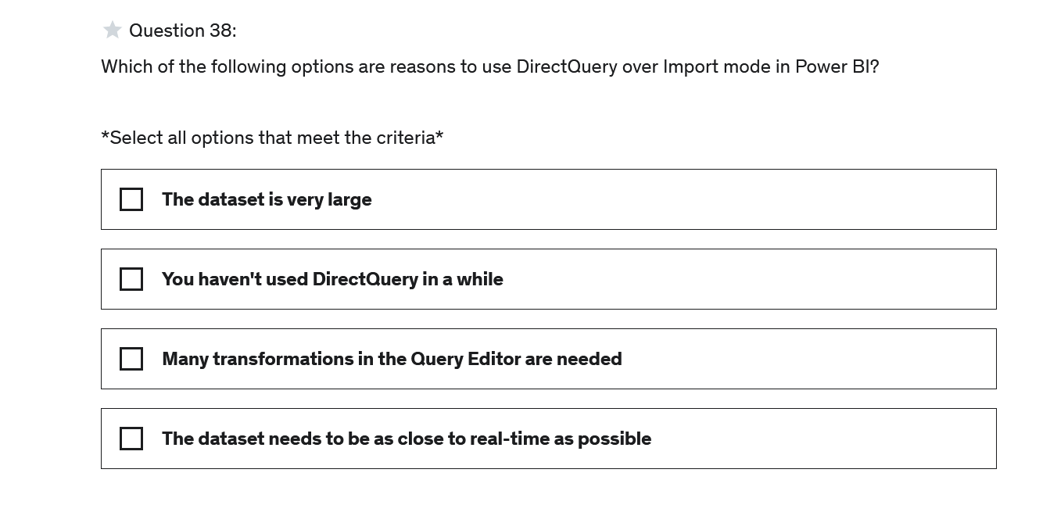

Answer : A,D

**Explanation**

DirectQuery is best used when the report requirements are near real-time data and/or the dataset is very large

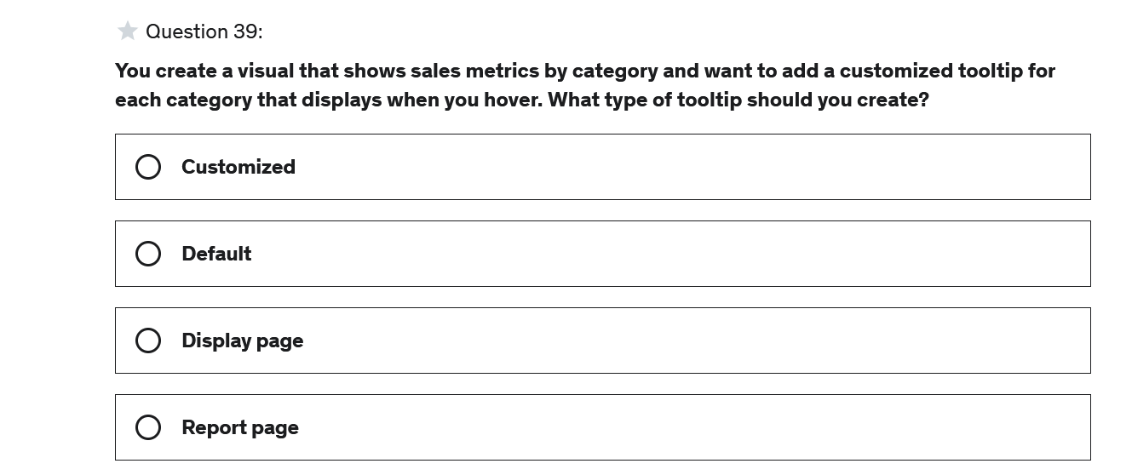

Answer :D

**Explanation**

Tooltips in Power BI have two types, default and report page. You can create a report page that is customized to your report format and contains more details and metrics than are available from the default view

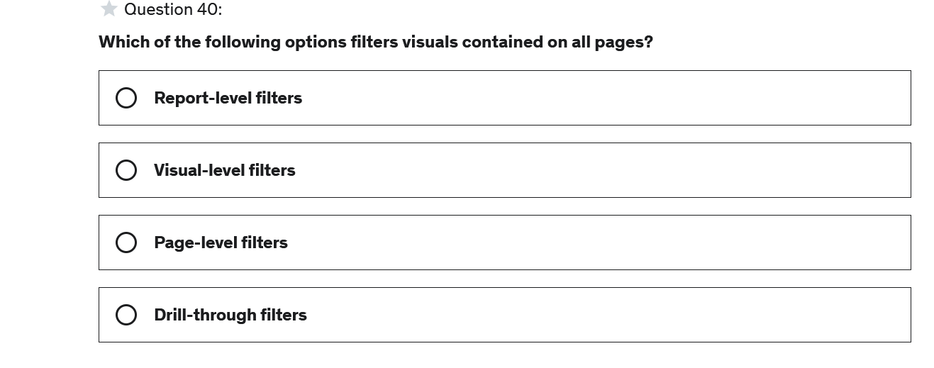

Answer : A

**Explanation**

Report-level filters are applied to all pages of a report

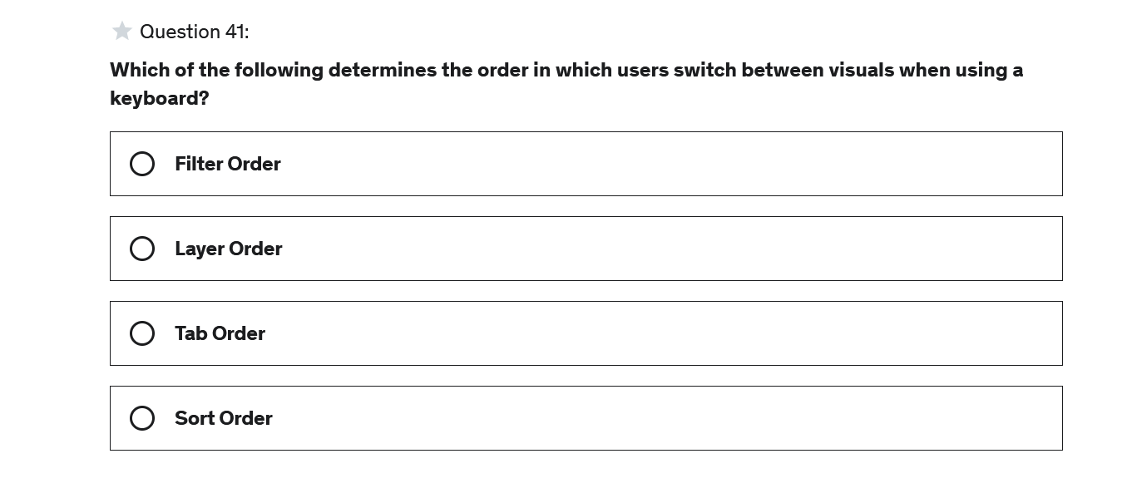

Answer :C

**Explanation**

Tab order determines the order in which users switch between visuals when using a keyboard

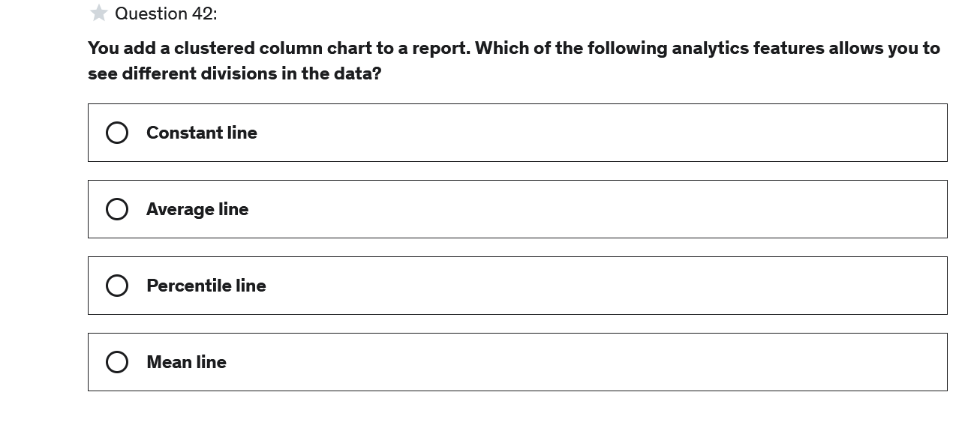

Answer :C

**Explanation**

A percentile line allows you to add a dynamic line to a visual that will visually indicate values that fall below the specified percentile. For example, adding a 75th percentile line would show you the value below which 75% of the observations are found

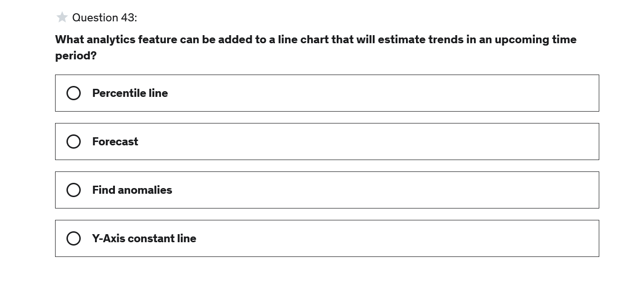

Answer:B

**Explanation**

Line charts with a single line have a forecasting analytics option that can be enabled

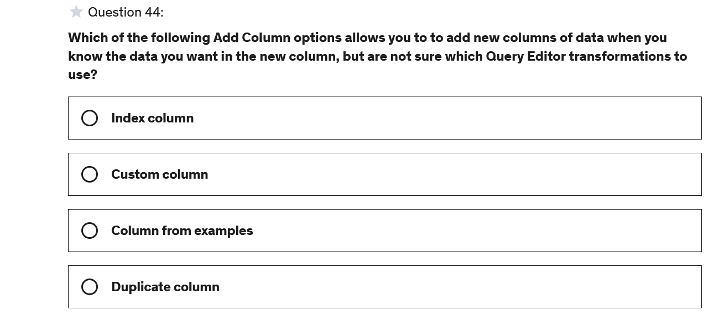

Answer :C

**Explanation**

Column from examples allows you to add in new columns to your data model by providing examples from an existing column. The Query Editor will do its best to write a transformation formula based on the examples provided.

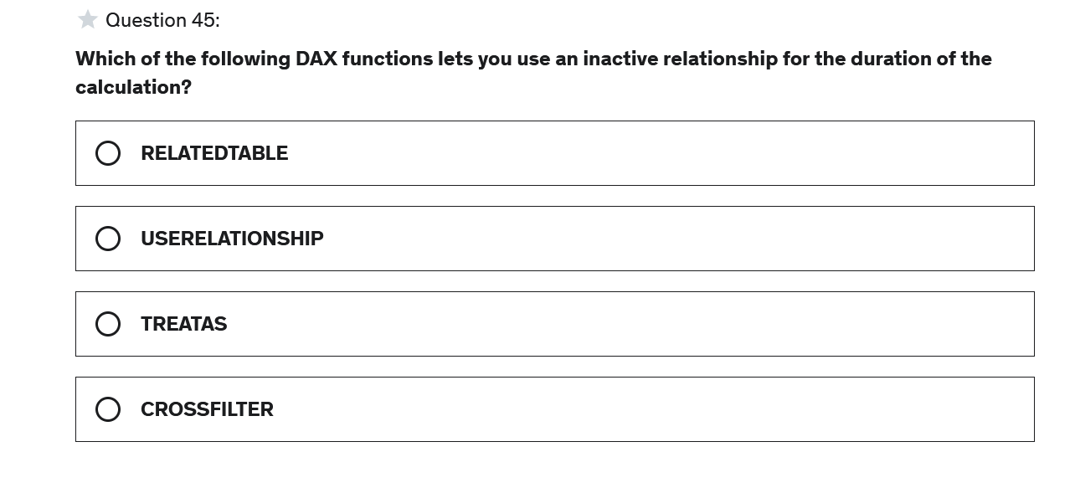

Answer :B

**Explanation**

USERELATIONSHIP let's you traverse inactive relationships in your data model

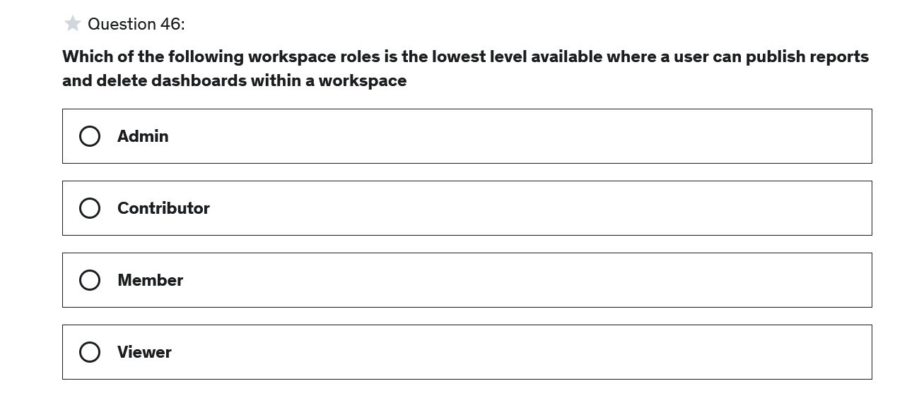

Answer :B

**Explanation**

Contributors can create, edit, and delete content in a workspace and publish reports to the workspace

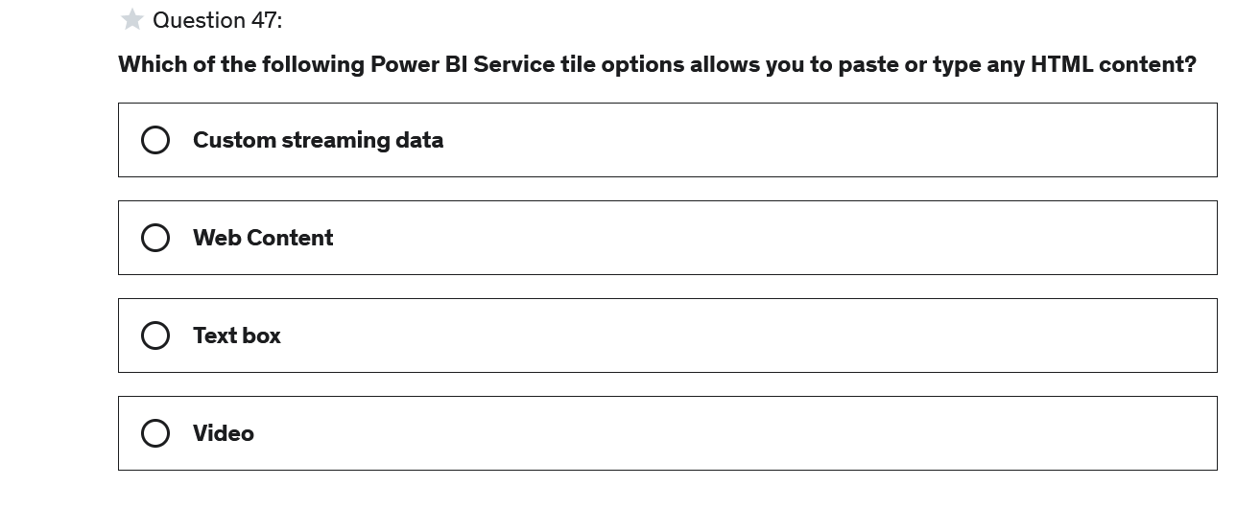

Answer :B

**Explanation**

The web content tile allows you to add and customize any HTML content, like websites. Web content tiles preserve the functionality of the page so you can access other videos on the site. The video tile only allows you to post a single video

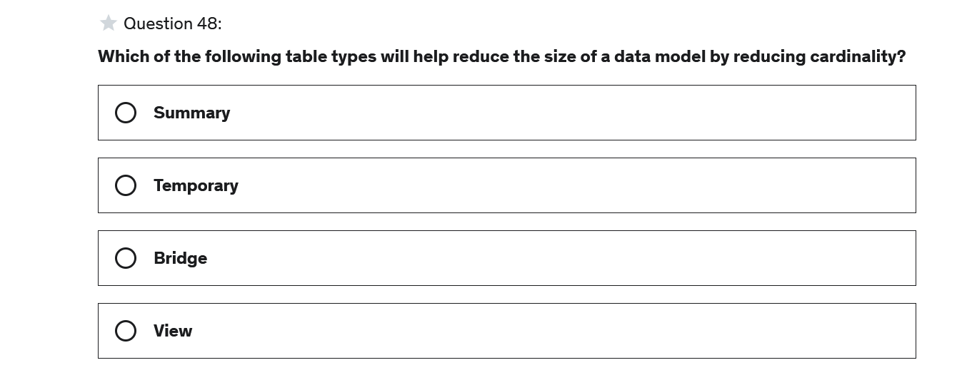

Answer : A

**Explanation**

A summary data table is an effective way to reduce the size of a data model because summary tables group data together, which reduces the cardinality (number of unique values in a column) of columns

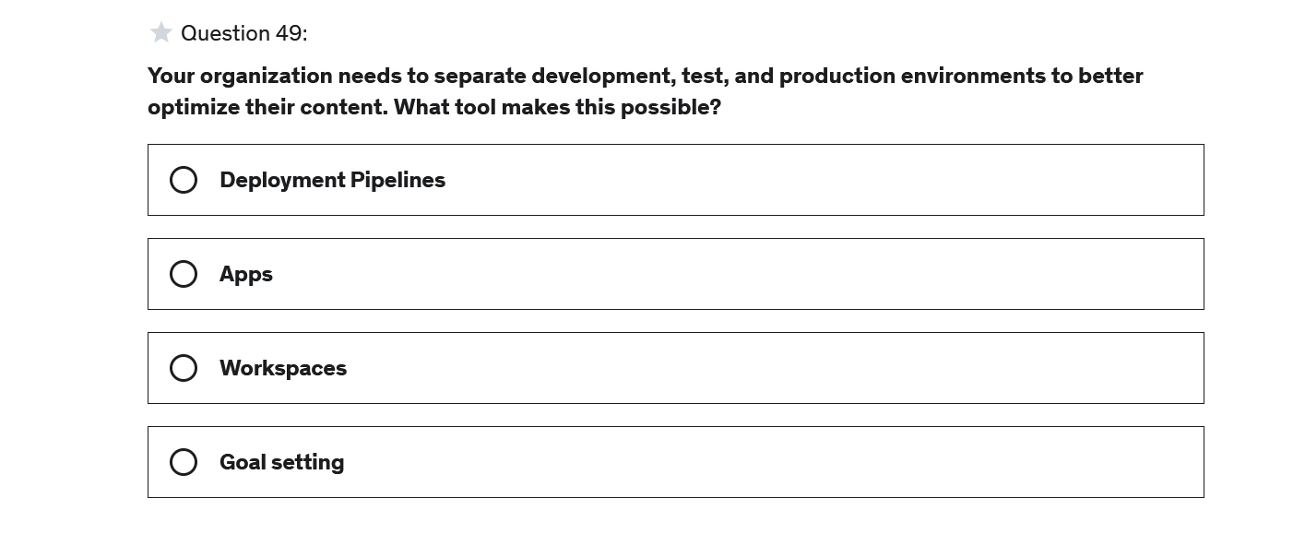

Answer :A

**Explanation**

Deployment pipelines allow you to manage the lifecycle of your organizations content

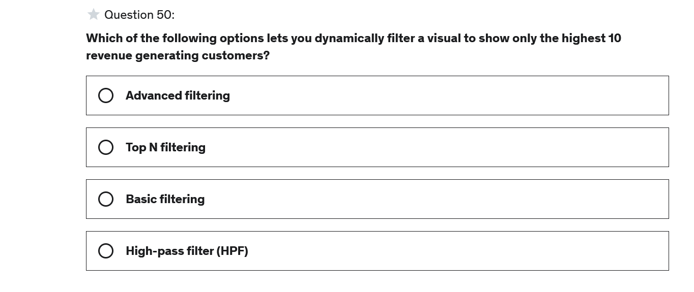

Answer :B

**Explanation**

Top N visual-level filters are used to only display the top performing records