**A] Create Model:**

1. Create Model based on “AmazingMartEU2_Combined.xlsx” and give it name as “Amazing Mart_Model”
2. First take “COMBINEDDATA” from the excel to create.
3. Combine the data of other sheet “AllCountries_Long_Lat” in the existing sheet based on the COUNTRY Column as:

COMBINEDDATA.COUNTRY= AllCountries_Long_Lat.COUNTRYNAME

1. Create Coordinates with Location column for Geo map enrich:

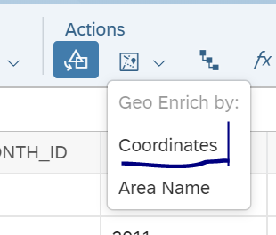

1. Location column will be created with the latitude and Longitude automatically.
2. Save the Model and Close it.

**B] Create a Story:**

1. From Home screen, create a story using below option:

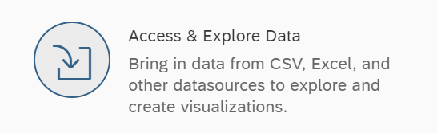

1. Choose the model you created above “Amazing Mart_Model”
2. Add different dimensions in the upper panel and below see what is the difference in the results.

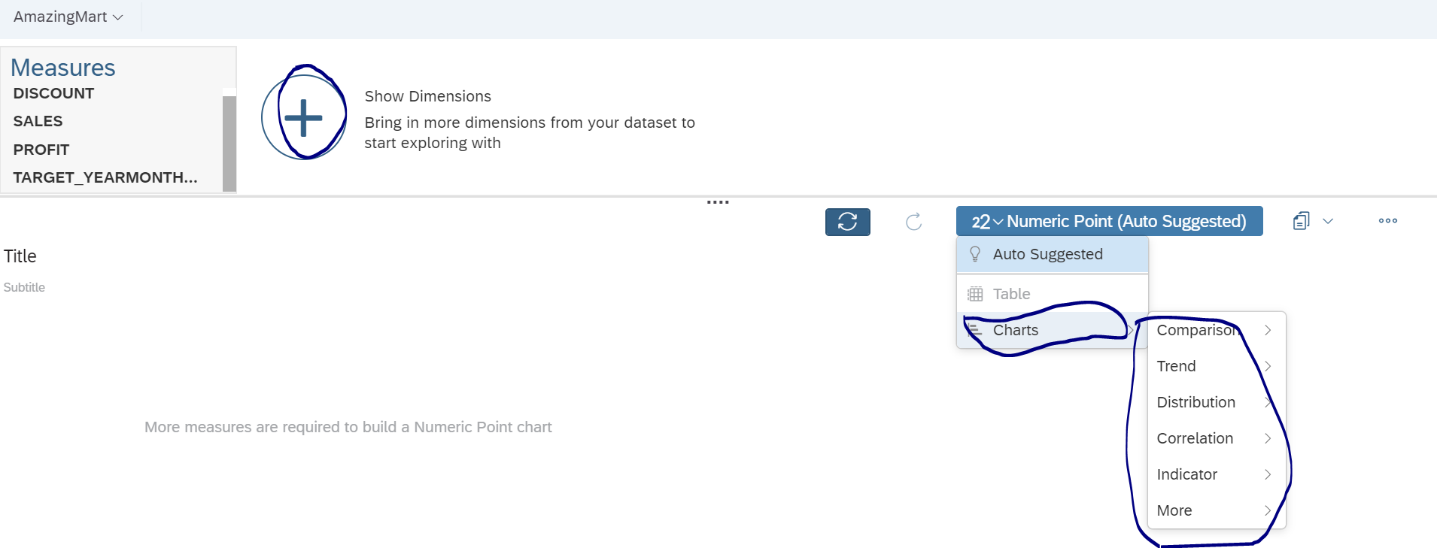

1. Also create different charts from the list given and try to understand difference between it.

Following different types of Stories should be built :

1)

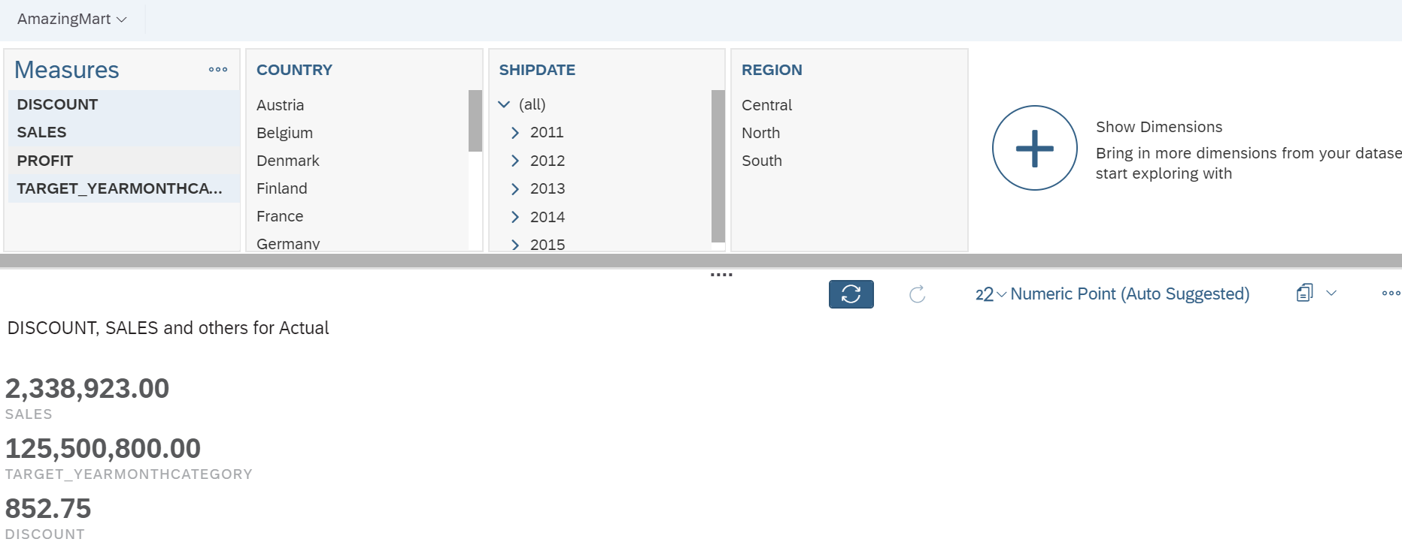

**C] Dashboard Creation:**

1. Create new story and select Dashbaord template to create the same:

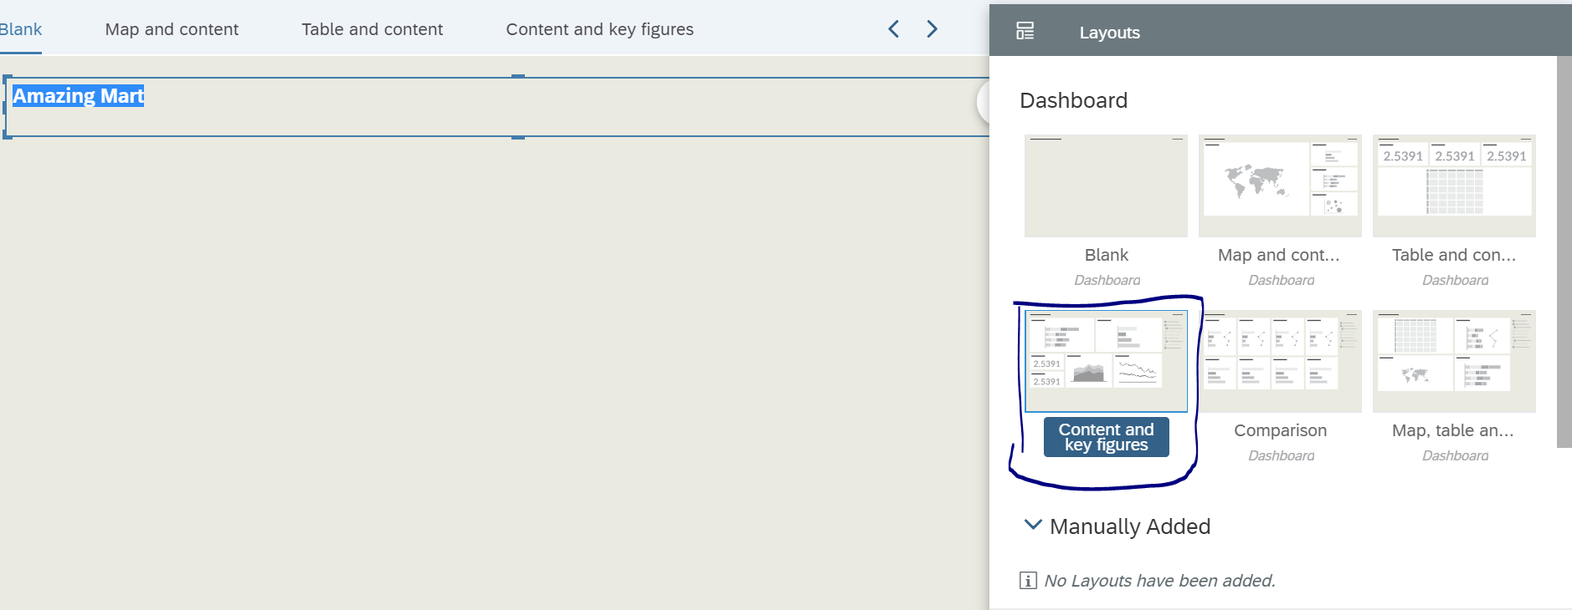

1. Build following Dashboards one by one in each:
2. Give title to Dashboard “Amazing Sales Dashboard”
3. Create first tab : Map and Content” as Location wise Sales and it should display like below:

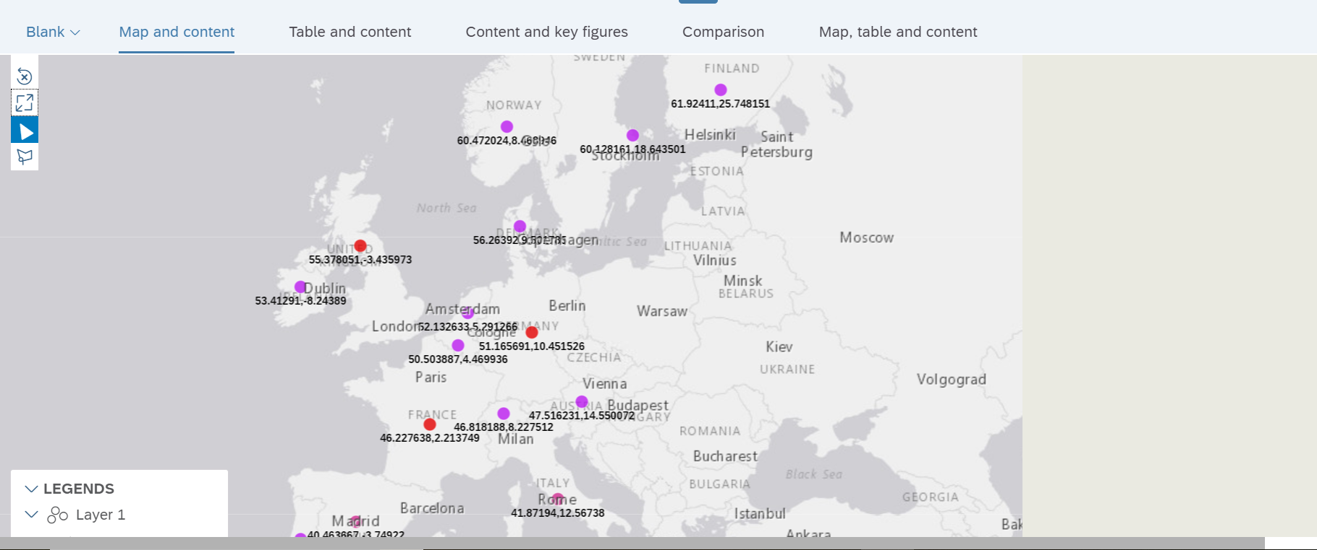

1. Create second tab “ Table and Content” and it should look like below:

* Discount, Profit and Sales in the first box
* Sales per Country and Order Date
* Table displaying City, Category, Country and Shipdate columns as:

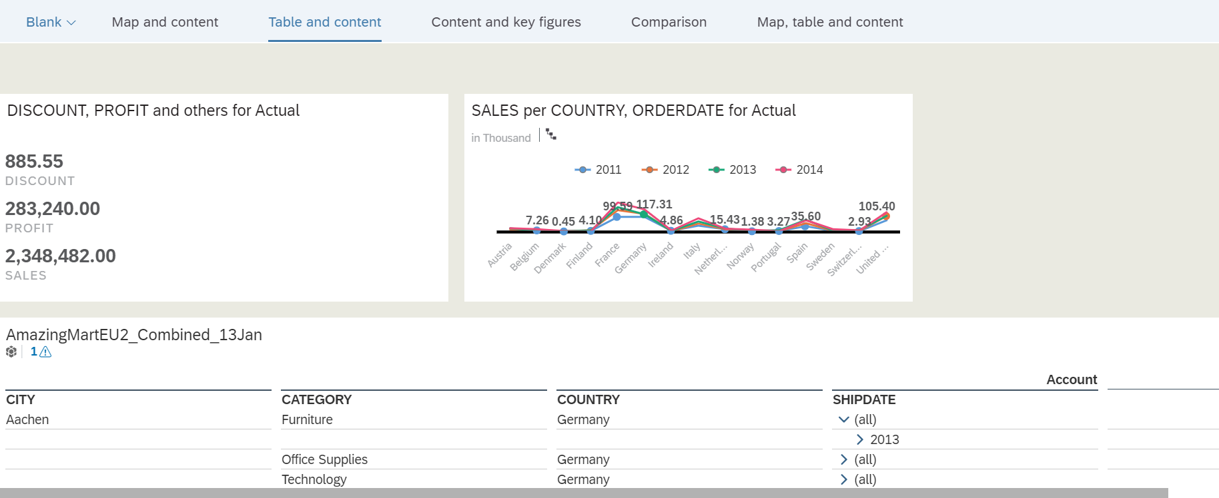

1. Create third tab as “Comparision” which gives different data on comparative basis

* Profit and Sales comparision over a period of time (ShipDate)
* Sales and Target Comparision over a period of time(ShipDate)
* Sales% per customer in all regions
* Discount and Sales per Category.

It should look like below:

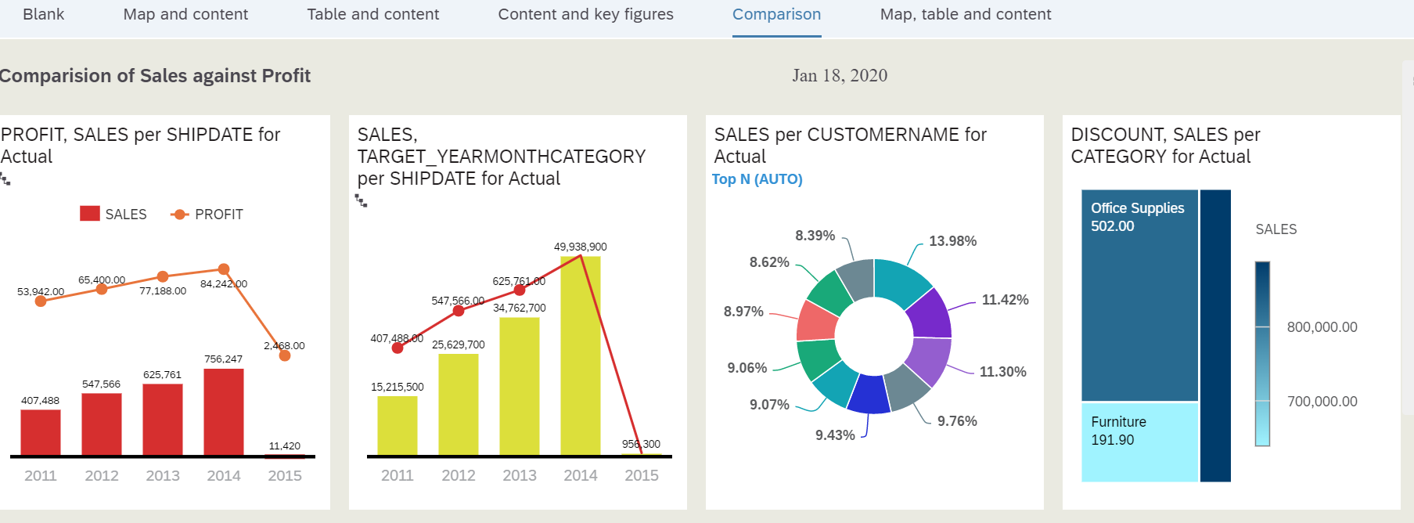

In All above wherever ship date has been used, you should be able to drill down on it, as Hierarchy has been already applied and if we click on suppose year, it should drill like below:

Quarter Wise:

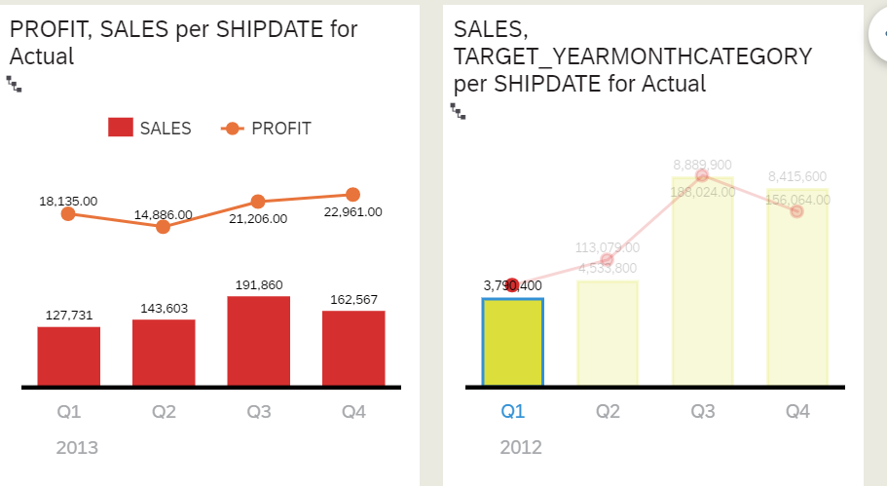

**Month Wise**

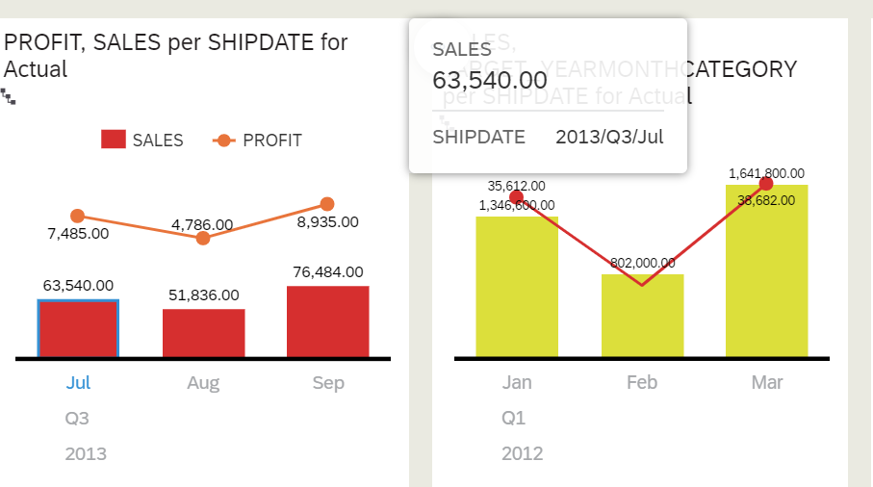

Day Wise

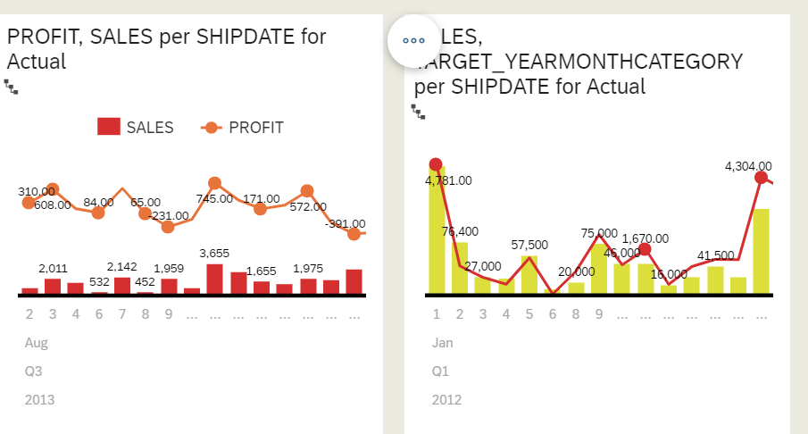

That’s it….

Other things to try out:

1. Editing the existing Model and rebuild it.