Introduction
Hibernate 5.2 and later require Java 8 and JDBC 4.2

SessionFactory
interface
thread safe
immutable
it is a heavy weight object as it encapsulates many services hibernate uses like cache , connection pools, transaction systems etc.

Session
interface
it wraps connection ,statement and transaction objects
it maintains first level cache
one session object is one connection to database
not thread safe

Transaction
used to make changes made by application permanent on database

@Entity → make class eligible for mapping (compulsory annotation)
@Table(name=”table_name”) → optional used for giving table name
@Id → primary key (compulsory annotation)
@GeneratedValue(strategy=) strategy for generating id
@Column(name=”column_name”,length=10,nullable=false,unique=true) can be used with variable or public getter
hibernate.hbm2ddl.auto = create → table will be dropped everytime and recreated
hibernate.show_sql=true → display generated queries
hibernate.format_sql=true → display generated queries in formatted fashion

if

<property name="hibernate.hbm2ddl.auto">create</property>

does not work then use below

<property name="hibernate.dialect">org.hibernate.dialect.MySQL5Dialect</property>

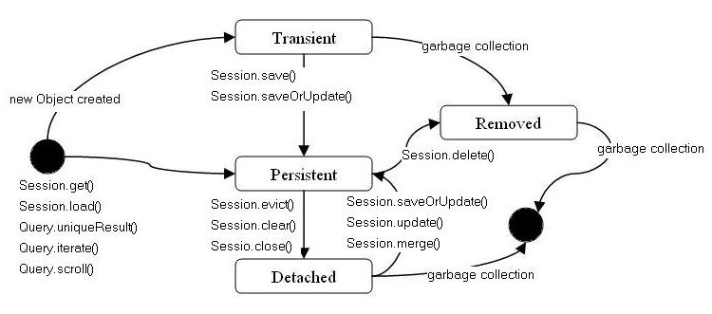

Transient State

When an object is instantiated (with new operator), it’s not persistent immediately.
It’s first goes to the transient state which is in memory.
In this state it’s not related to any database table row.

When that object is de-referenced it loses its state and goes to detached state which will be eligible to garbage collected.

The objects that are in transient state are not considered as transactional objects.
Any modification made on those object can not be part of transaction.

If a transient object need to be persist or in other words if an object need to changes its state from transient to persistent, then the save () method should be called to persistent manager or
that object should refer to one which was created from already persisted.

Here, an object is not associated with the Session. So, the transient state is not related to any database.
Hence, modifications in the data don't affect any changes in the database.
The transient objects exist in the heap memory. They are independent of Hibernate.

Persistent State

As soon as the object associated with the Session, it entered in the persistent state.

Persistent instance is which has a valid database entry set with a primary key identifier. In other words, it should refer a valid database table row.

Persistent object can be instantiated with a call of save () method of the persistent manager then it’s associated to that persistent manager. Or alternatively it can be instantiated with a persistent object which is already associated with that persistent manager.

Persistent object participated in a transaction will be synchronized with the database when the transaction manager commits the transaction which executes the SQL query.

When the transaction ends, all the persistent object will not be updated to the database. Hibernate checks the objects and finds which are modified then only it’ll update the database. This process is called dirty checking.

Dirty objects are which has had modified and not synchronized with database.
This process gains performance with some databases and loose performance with some databases.
So hibernate allows user to set this with dynamic-update="true" in class mapping so it would generate SQL dynamically to update only the columns that are modified.

Detached State

No longer guaranteed to be synchronized with database state
As an object is no more associated with the Session, modifications in the data don't affect any changes in the database.

However, the detached object still has a representation in the database.

If we want to persist the changes made to a detached object, it is required to reattach the application to a valid Hibernate session.

Hibernate methods

get()
used to retrieve an object from database
to be used if we are not sure whether object exists in database
will return null if unique id is not found in database
it hits database immediately and loads data(eager loading)

load()
used to retrieve object from database
we must be sure object exists in database
throws exception if id is not found in database
it return a proxy object by default with given id and hits database when we use getters on proxy object
it follows lazy loading

use get when we want to load an object
use load when we want a reference to the object to be used for eg in a has a relation without invoking extra queries

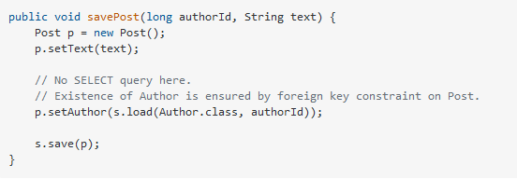

load should be used if we are sure value exists in database and we dont want ot execute extra queries and when the object is used in a relationship

calling get and load object will be directly in persistent state

save()
return id of value inserted
when called on detached object it creates a new instance with new id and it results to duplicate

persist()
The persist method is intended for adding a new entity instance to the persistence context, i.e. transitioning an instance from transient to persistent state.
We usually call it when we want to add a record to the database (persist an entity instance)
does not return anything
cannot be called on detached object leads to exception

saveOrUpdate()
it is similar to update but when passed a transient object it calls save functionality
the transient object will be moved to persistent state
the detached object will be moved to persistent state

update()
it transitions detached object to persistent state
update operation takes place on same object itself no new object is returned like merge method
if passed transient object it throws an exception

evict()
it removes persistent object from session puts it to detached state
any change to object will not be persisted

merge()
merge is used to transition detached object to persistent state
merge(passedObject)
finds an entity instance by id taken from the passed object (either an existing entity instance from the persistence context is retrieved, or a new instance loaded from the database)
copies fields from the passed object to this instance;
returns newly updated instance.
merge takes place on a new object unlike update
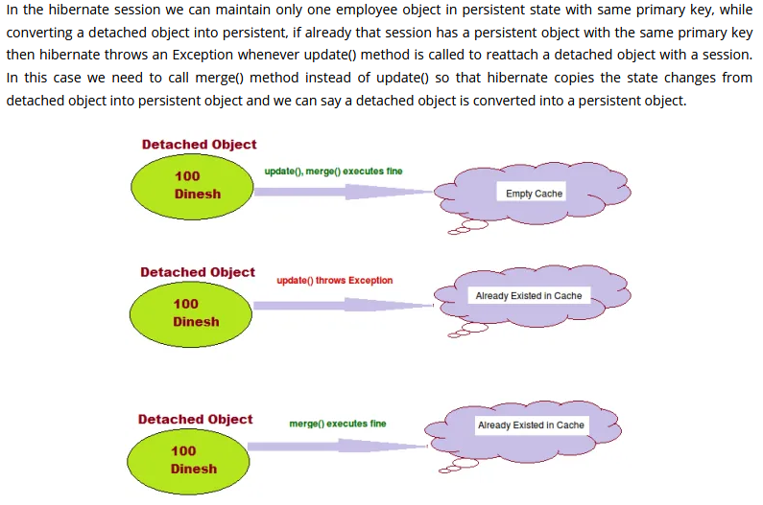
clear()
all persistent objects of the session will be detached and available for garbage collection

close()
ending the session and closing database session
flush()
writes changes made to persistent objects to database
but the changes will be visible only to the current user
on commit the changes are visible to all users

commit()
the changes made to persistent objects are visible to all users

delete()
delete a record from database
then the object is also removed from session and available for garbage collection
can be called on transient or persistent object

Dirty checking
it prevents unnecessary write operations to database only values that are modified are update to database automatically at the time of commit

@DynamicUpdate
class level annotation
only value that has changed will be updated
over writing values that has not been changed will be avoided

Hibernate dialect is used to generate database native query

Hibernate hbm2ddl values
create create the database everytime and previous data is lost
update update if any change
create-drop create everytime and drop before closing sessionFactory
validate validate make no changes
if schema not exist will throw an error

on production database update is not used
it is dangerous
instead manually a db script is created

Hibernate ID Generation Algorithms

AUTO
IDENTITY
SEQUENCE
TABLE

AUTO
default if we do not specify
lets persistence provider choose id generation strategy
creates a table hibernate_sequence and uses it to generate and store id
AUTO can choose any 3 from below
single hibernate_sequence table will be used for all db tables

IDENTITY
relies on database autoincrement column
it performs insert in database immediately so that it receives an id

SEQUENCE
it uses database sequence
@GeneratedValue(strategy=GenerationType.SEQUENCE,generator=”myGenerator”)
@SequenceGenerator(name=”myGenerator”,sequenceName=”emp_sequence”,
allocationSize=1)

TABLE
@GeneratedValue(strategy=GenerationType.TABLE,generator=”empid_generator”)
@TableGenerator(name=”empid_generator”,table=”empid_generator”,schema=”empd_db”)
for table generator use dialect class MySQL55Dialect

Value Object

@Entity
class Employee → owner class
{
@Embedded
Address address; → value object
}

@Embeddable
class Address
{

}
All properties of address class will be added in Employee entity table

Value Object Attribute Override
@Entity
class Employee → owner class
{
@Embedded
Address homeAddress; → value object

@Embedded
Address officeAddress;→ value object
}

@Embeddable
class Address
{
private String city;
private String country;
private String state;
}
in owner class if use value object twice chances are value object columns will get repeated
to avoid this we can use attribute override

Saving Collections (Embeddable)
just like one to many relation
class Employee
{
@ElementCollection
@JoinTable(name=”address_table”,joinColumns=@JoinColumn(name=”emp_id”))
Collection<Address> addressList;
}

@JoinTable → name of table who addressList variable is referring to
@JoinColumn → foreign key of table where @JoinTable is referring

Configuring collections and adding separate primary key for embeddable (Embeddable)

class Employee
{
@ElementCollection
@JoinTable(name = "address",joinColumns = {@JoinColumn(name="emp_id")})
@GenericGenerator(name = "generator",strategy = "sequence")
@CollectionId(generator = "generator",columns = {@Column(name = "address_id")}, type = @Type(type = "int"))
private Collection<Address> addressList;
}

@JoinTable → generates name of address table which is joined to employee
@JoinColumn → generates name of foreign key of address table that points to employee

Eager loading and Lazy loading

We have many entities with relation between them
eg as above Person and Address
We have 2 options of loading collections
Eager loading
loading collection values with other values at the time of object creation
Lazy loading
not loading collection values with other values at the time of object creation
instead loading values of collection when user accesses them using getter

All collections are lazily loaded

Embeddable can be used if at db side data exists in one table but at Hibernate side data exists in 2 classes
1 class is entity
1 class is non entity
@Entity
class Employee
{
Address address;
}

@Embeddable
class Address
{

}

Cascade → all operations on parent are carried on to child

One to one mapping
Both classes must be entity classes
@OneToOne annotation is used for mapping

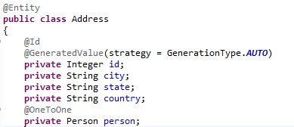



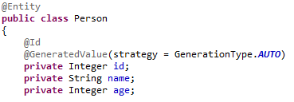

address class will refer to person class by creating foreign key in address class that points to person class id

to change foreign key column name we can use

@JoinColumn(name=”p_id”)
@OneToOne
private Person person;

One to One bidirectional mapping

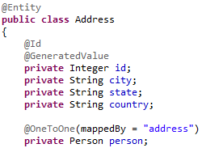

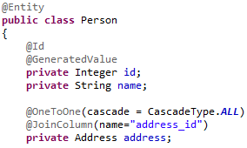

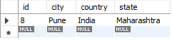

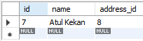

Here JoinColumn attribute is used on entity whose table has foreign key
mappedBy is used on entity whose table does not have foreign key but is referred by other table
mappedBy is used for bidirectional relationship

One to many relationship
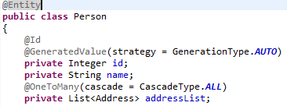

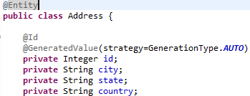

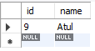

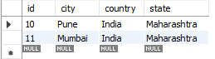

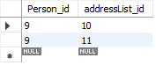

A third table is created by default called as join table

we can optimize above by foll @JoinTable annotation

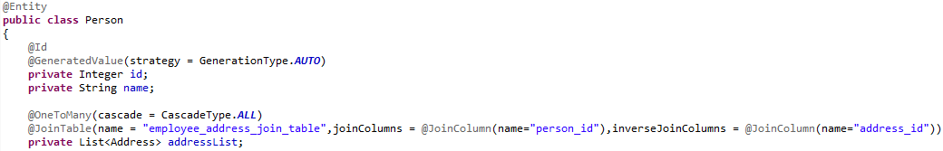

we can provide join table and join column name(person foreign key) and inverse join column (address foreign key) as above

To avoid join table we need to add foreign key in address table which points to person
This can be achieved by Many to one relationship as follows

Many to one relationship

@JoinColumn means Foreign Key
mappedBy must be used in bidirectional relationship in entity which is being referred by foreign key
eg in above scenario mappedBy must be present in Person and @JoinColumn in Address

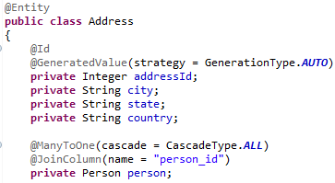

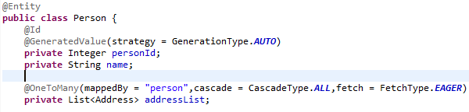

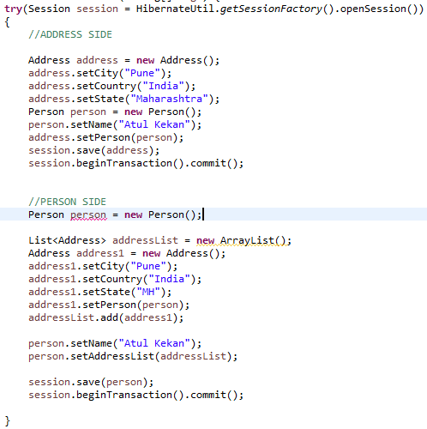

Many to many mapping
always we will have a join table
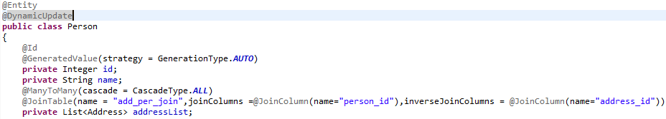
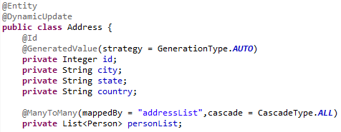

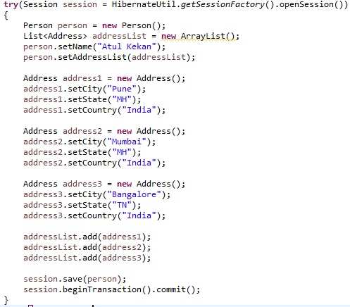

CascaseType.PERSIST
If we do not specify CascaseType.PERSIST then we need to save owner and dependent objects individually by calling session.persist(obj)
if we specify CascaseType.PERSIST then we just need to call persist on parent , child objects will be saved automatically
if we call save then it will not work

CascaseType.MERGE same as above child parent relation
CascaseType.REMOVE same as above child parent relation
CascaseType.REFRESH same as above child parent relation
CascaseType.DETACH same as above child parent relation

REFRESH
It is possible to re-load an object and all its collections at any time, using the refresh() method. This is useful when database triggers are used to initialize some of the properties of the object.
sess.save(cat);
sess.flush(); //force the SQL INSERT
sess.refresh(cat); //re-read the state (after the trigger executes)
DETACH
similar to evict
we call detach and evict so that first level cache gets free

Difference between merge and update
Merge and update are both used to insert changes done on detached object on a persistent object
At a time in session only one persistent object of a given id can exist

if a object of same id already exist in session and if we call update we will get exception but if we call merge we will not get exception

we use merge if we want to add changes done to detached object in persistent object without knowing the current state of session , whether object with same id exists or not in session

merge
Copy the state of the given object onto the persistent object with the same identifier. If there is no persistent instance currently associated with the session, it will be loaded. Return the persistent instance. If the given instance is unsaved, save a copy of and return it as a newly persistent instance. The given instance does not become associated with the session. This operation cascades to associated instances if the association is mapped with cascade="merge"

update
updates persistent instance with the identifier of given instance
if already present the exception is thrown
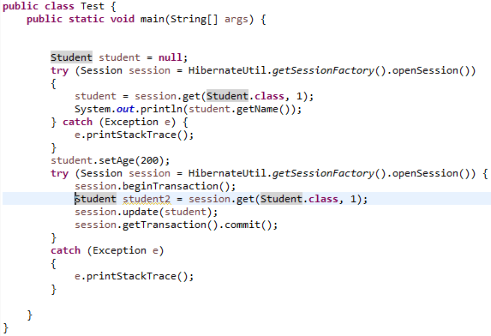

here above we will get error as student2 id is 1 and update student id is also 1
same id already exists so we will get error

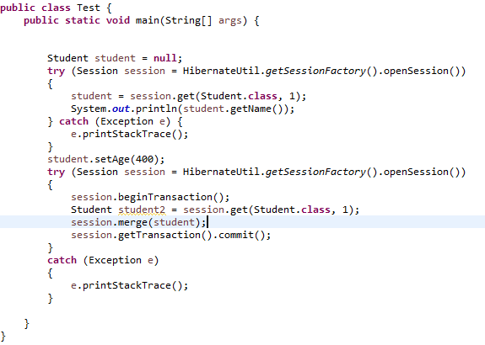

same program will work with merge

Default table inheritance strategy

if we do not specify any inheritance strategy then hibernate follows default strategy where single table is created for all child and parent classes
it creates a column DTYPE which specifies the name of class to whom the object belongs to
also if for a particular class values are not present then column is left null
normalization is not followed
table gets parent class name

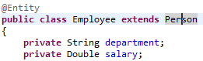

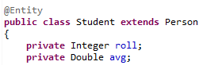

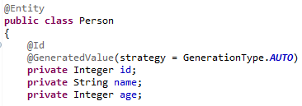

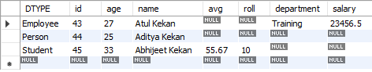

Single table inheritance strategy
by default hibernate follows this strategy

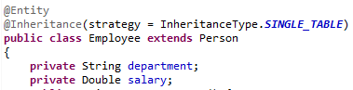

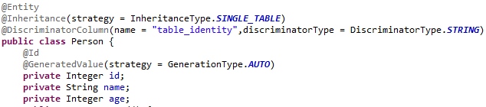
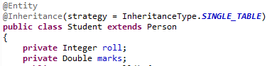

@DiscriminatorValue(value=”class_name”)
The name that must be inserted in DTYPE column / discriminator column

Table per class inheritance strategy

Here separate table is created per class and parent class variables are included as columns of table

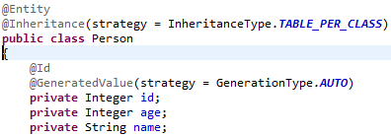

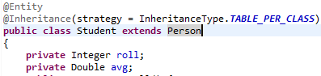

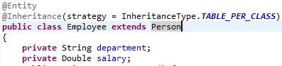

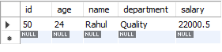

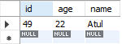

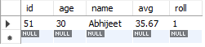

Here drawback is column names are getting repeated in every table
Here database normalization is not being followed

Joined inheritance strategy

Separate tables will be created for every class
Common values will be present in parent table and child tables will refer from there using foreign key
Follows normalization strategy

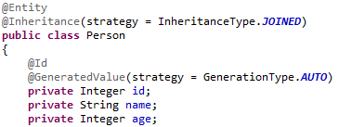

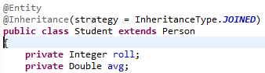

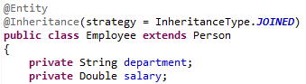

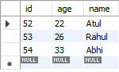

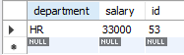

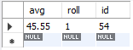

Hibernate entities lifecycle

Entity objects participate in lifecycle

Transient
Newly created objects
Do not represent any record in database
Id is not set
Non transactional

Persistent
tracked by hibernate
represent record in table

Detached
Remove from session
Not tracked by session
Represent record in database
Can be reattached or merged with persistent layer
evict() , clear() , close() → detach object
update() , merge() , saveOrUpdate() → rettach
lock() → reattach but not saved

Removed
persistent object is deleted
delete()
out of session

we require lifecycle methods because entity objects can be passed from one session to another session and their values can be modified because of any operation

HQL
OOP way of writing SQL
Similar to SQL but instead of table name we use entity class name and for columns we use entity class variable names

There are 2 types
Positional parameter
Named query

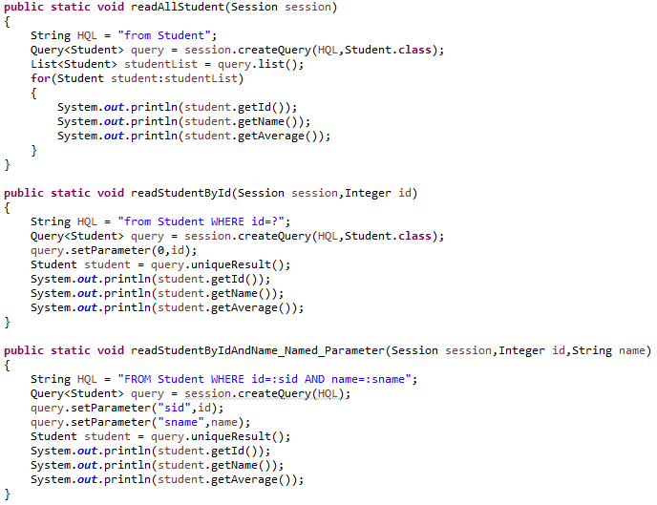
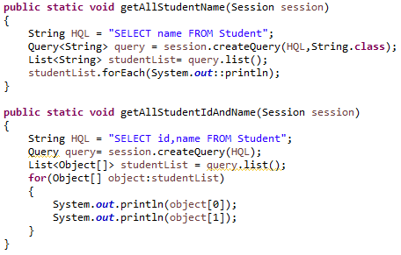

HQL read → query.uniqueResult() , query.list()

HQL insert → can be done by object mapping or native SQL

in object mapping insert into select methodology is used as hibernate HQL only supports insert from another table because we have session.save() method

we require source and target table and also entity class

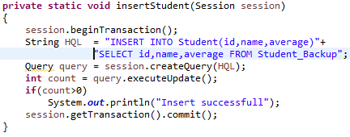

query.executeUpdate() → insert

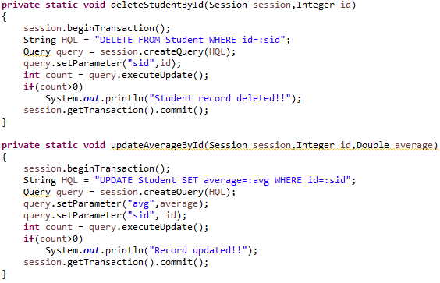

Hibernate one to one mapping
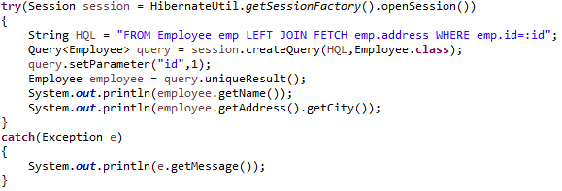

HQL One to one Join Partial Select

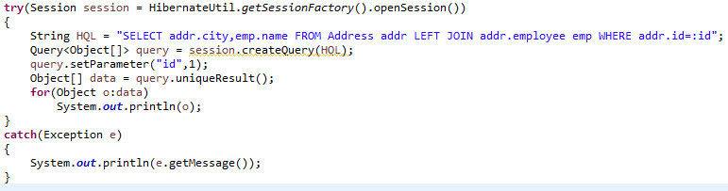
For performance purposes we need to return few values in that case we need to write join query

HQL One to many join

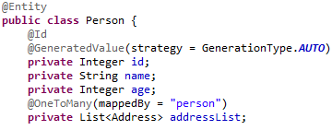

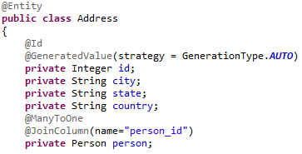

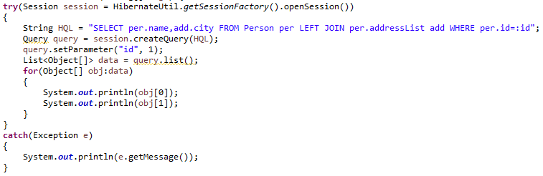
HQL Aggregate functions
count,min,max,avg

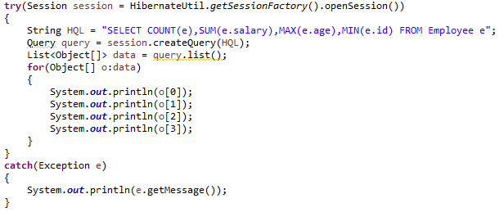

Group by using HQL

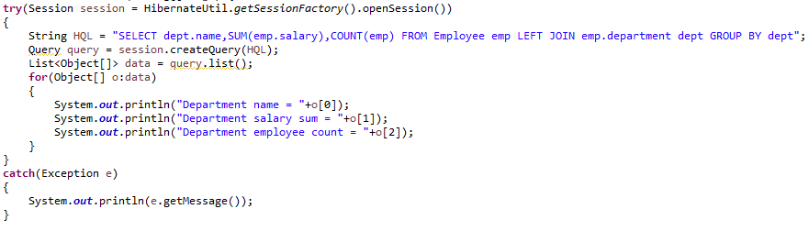

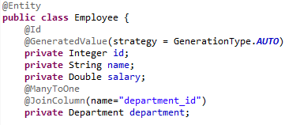

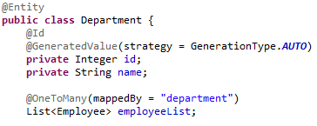

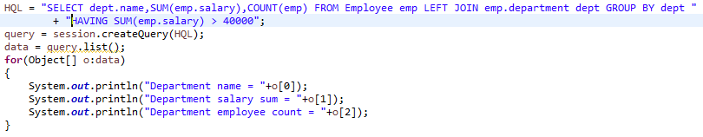
Named queries

Named query can be defined for Native and HQL query
Can be defined in configuration file and using annotations

@NamedQuery
@NamedQueries

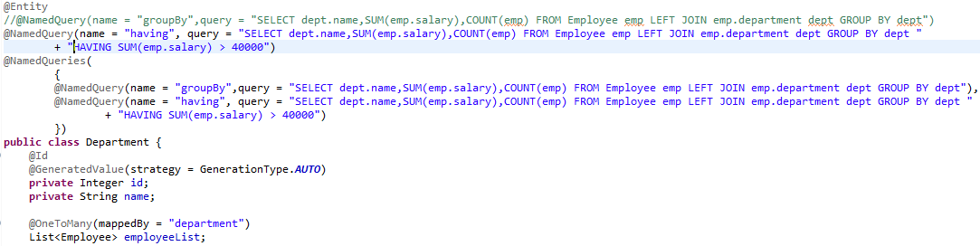

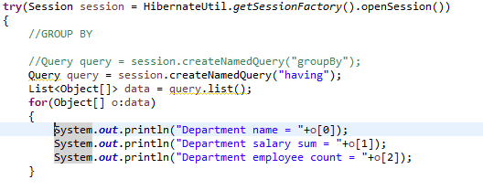

@NamedNativeQuery
@namedNativeQueries
→ native database queries

Native SQL Queries

native sql queries are database dependent queries that need to be changed if database changes
it is used to utilize db specific functionalities

session.createNativeQuery(String query);

Scalar queries
Query for partial select
we get a list of Object[]
session.createNativeQuery(“Select * from Employee”).addScalar(“id”,LongType.INSTANCE);
here even though we have written select * we will get value of only one column

Entity queries
session.createNativeQuery(“Select * from Employee”).addEntity(Person.class);

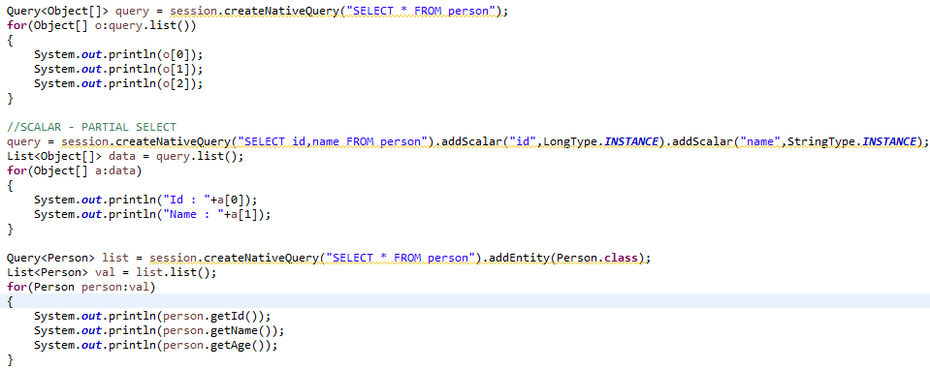
Native queries associations and collections

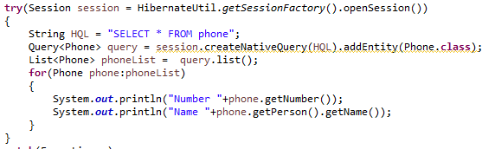

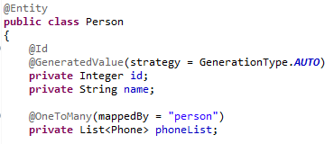

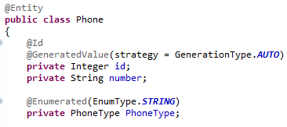

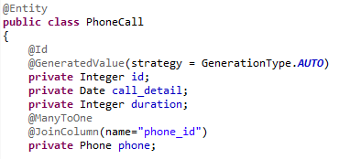

Call stored procedure

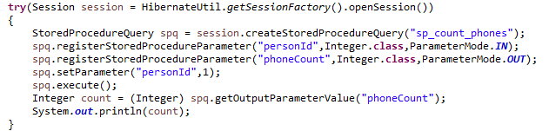

Criteria query
They are an alternative to HQL and NativeQueries
Using criteria api we can get all values , apply where clause , select partial

Selecting an entity
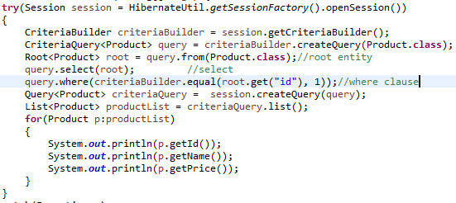

criteriaBuilder.createQuery() → input depends on type of expected output

Select partial

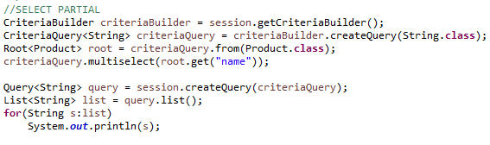

Select partial with multiple columns

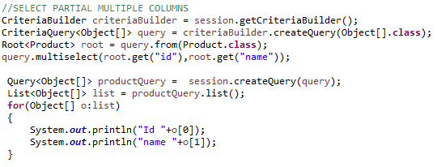

Select values in DTO (Data transfer object)

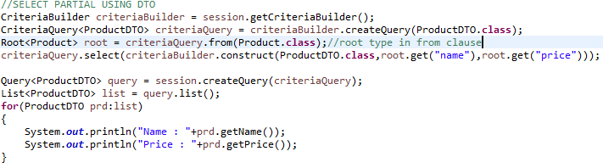
Select Value in a Tuple
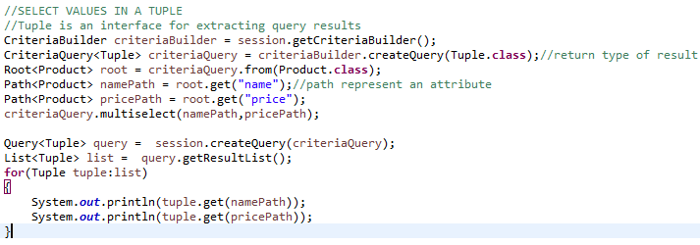
Selecting values from multiple roots
