https://www.javatpoint.com/git-interview-questions
https://www.javatpoint.com/git

Git is a modern and widely used distributed version control system
The version control system allows us to monitor and work together with our team members at the same workspace.
Git Bash → allows execution of linux commands
It is a terminal
pwd → print working directory
cd /C → change directory

Git three stage architecture
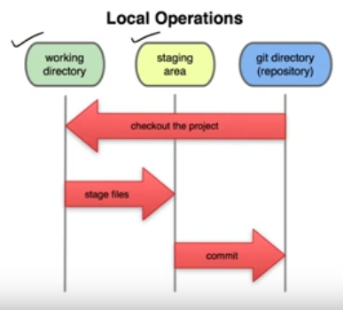

working directory contains files we are working on (adding editing)

staging area includes files that we want to add to git repository when we commit. The files we want to omit from repository should not be present in staging area

git repository is a .git folder which is hidden and contains files in compressed form

staging area is like a storage before transfering files in repository

we can directly transfer files from working to repo but it is a good practise to use staging area

Staging & Commits

git config –global user.name “Atul Kekan” (add entry in global configuration)
git config –global user.email “developer.atul.java@gmail.com” (add entry in global configuration)
git config –list → list of values set in git

git config --global --unset user.name (remove entry in global configuration)
git config --global --unset user.email (remove entry in global configuration)
git init → initialise a new git repository , create .git folder with metadata an initialise head pointer for master branch
git init foldername → new repo and folder together
git clone link newFolderName → download and clone online repository
git clone -b branchname url → clone specific branch
git add filename → add file to staging area

git add -a → add all files to staging area
git add .→ add all files to staging area
git commit -m “initial commit” → commit files to repository from staging area
git commit -a -m “Direct commit” → Skip staging area commit working directory files directly

cannot direct commit untracked files
Commits are the snapshots of the project
commit-id is a cryptographic number created by SHA (Secure Hash Algorithm) algorithm.
git status → used to check git directory status ,will give error if directory is not a git working directory
it shows modified files,staged files,untracked files.

git push origin branchname → to push local repository commits and files to remote repository

git push --all → push all branches to server repository

git pull → downloads remote repository changes to local repository and updates working directory

git branch → list out all branches in local repository

git merge branchname → name of branch to merge in current branch

git log → history of commit is displayed author date time etc..

if git goes in edit mode use esc to escape editing and :wq command to save & exit editor

git remote add short-nme https://github.com/AtulKekan-developer/CodeWithHarry.git

origin is the name given to link mentoined after origin keyword it can be anything

git remote → if remote is configured willl show its link

git remote -v → shows links of repositories to fetch and pull

git restore filename → to undo changes done to file in working directory

git restore –staged filename → to unstage file present in staging area

git commit –ammend -m “new message”
edit latest commit → new changes/files in staging area or message will be added in the latest commit

git stash → allows to switch branch without commiting current branch changes so we can ccess them later

Git stash save -m → save stash with message
Git stash list → list of stash with id
Git stash apply → reapply changes to working directory
Git stash changes → show file stashed and changes made on them
Git stash pop → apply on working directory and delete from stash
Git stash drop → delete
Git stash clear → delete all
Git stash branch → stash on a separate branch
git fork → create a copy of repository to test and debug without affecting original owner repository and then submit pull request to owner
Fork is used to
Propose changes to someone else's project.
Use an existing project as a starting point.

Git flow(set of standards to be followed)

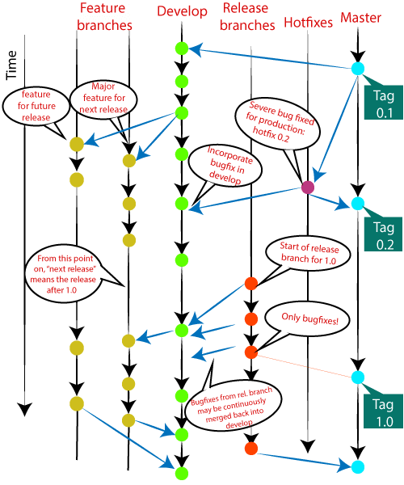

Master
Develop
Hotfixes
Release
Branches

Feature branches

Master Branch
The master branch is the main branch of the project that contains all the history of final changes. Every developer must be used to the master branch. The master branch contains the source code of HEAD that always reflects a final version of the project.

Develop Branch
It is parallel to the master branch. It is also considered as the main branch of the project. This branch contains the latest delivered development changes for the next release. It has the final source code for the release. It is also called as a "integration branch."

Supportive Branches
The development model needs a variety of supporting branches for the parallel development, tracking of features, assist in quick fixing and release, and other problems. These branches have a limited lifetime and are removed after the uses.
The different types of supportive branches, we may use are as follows:
- Feature branches
- Release branches
- Hotfix branches

Feature Branches
Feature branches can be considered as topic branches. It is used to develop a new feature for the next version of the project. The existence of this branch is limited; it is deleted after its feature has been merged with develop branch.

Release Branches
The release branch is created for the support of a new version release. Senior developers will create a release branch. The release branch will contain the predetermined amount of the feature branch. The release branch should be deployed to a staging server for testing.

Hotfix Branches
Hotfix branches are similar to Release branches; both are created for a new production release.

Git Index
The Git index is a staging area between the working directory and repository. It is used to build up a set of changes that you want to commit together. To better understand the Git index, then first understand the working directory and repository.

Git Head
The HEAD points out the last commit in the current checkout branch. It is like a pointer to any reference. The HEAD can be understood as the "current branch." When you switch branches with 'checkout,' the HEAD is transferred to the new branch.
git show head → shows location of head which is latest commit

Git Detached Head
Detached HEAD mode allows you to discover an older state of a repository. It is a natural state in Git.
When Head doesn't point to most recent commit, such state is called detached Head. If you checkout with an older commit, it will stand the detached head condition.
Git checkout commit-id

it will checkout old commit files to your directory and head will go in detached state

Undoing Changes

git checkout

used to switch between branches but need to be careful with staged and modified files

it operates on files , commits and branches

this command can be dangerous as there is no undo option on this command

git checkout -b branchname → create branch and switch
git checkout branchname → switch to branch

.gitignore files will be ignored and remain unchanged

we can also checkout remote branch

first we need to load all branches from remote

git fetch –all
git checkout remote-branch

git revert

it is used to revert some changes

git revert will undo changes in specified commit and create a new commit

git revert commit id → removes all changes done in specified commit

Git reset

The term reset stands for undoing changes. The git reset command is used to reset the changes. The git reset command has three core forms of invocation. These forms are as follows.
- Soft
- Mixed
- Hard
If we say in terms of Git, then Git is a tool that resets the current state of HEAD to a specified state.
It is a sophisticated and versatile tool for undoing changes.
It acts as a time machine for Git.
You can jump up and forth between the various commits. Each of these reset variations affects specific trees that git uses to handle your file in its content.
Additionally, git reset can operate on whole commits objects or at an individual file level. Each of these reset variations affects specific trees that git uses to handle your file and its contents.
Git reset –hard commitid

The --hard option changes the Commit History, and ref pointers are updated to the specified commit.
All previous commit history is lost

Git reset –mixed commitid
default option
does not update working directory
staging area files are moved to working directory
head points to mentioned commit id

Git reset –soft commitid
staging and working directory remains unchanged
it is like ammend command

git rm filename → remove file ,after removing file will be added to staging area need to commit it
rm -rf .git → delete .git folder from project which will remove versioning history

If a file was initially being tracked but now it is added to .gitignore it will still be tracked by git
To remove tracking we need to execute one command
git rm –cached filename
and then commit
The tracking will stop
file is removed from git metadata but it remains in repository as untracked file

git cherry-pick hashcode

Cherry-picking in git stands for applying some commit from one branch into another branch. In case you made a mistake and committed a change into the wrong branch, but do not want to merge the whole branch.
The main motive of a cherry-pick is to apply the changes introduced by some existing commit. A cherry-pick looks at a previous commit in the repository history and update the changes that were part of that last commit to the current working tree.

Some scenarios in which you can cherry-pick:
Scenerio1: Accidently make a commit in a wrong branch.

Scenario2: Made the changes proposed by another team member.
Suppose one of my team members made any changes in the main project and suggests it for the main project. You can cheery-pick it after review.
Inspecting Changes
git log
git log –p → modified files / location of chnges / files added removed
git log –oneline
git diff → track changes that have not been changed
git diff –staged → diff of staged files
undo rm command before commit
git reset –hard → update working and staging area with files from latest commit
git checkout filename → will update the file from latest commit

Branch
https://stackoverflow.com/questions/16408300/what-are-the-differences-between-local-branch-local-tracking-branch-remote-bra/24785777 → do read

git branch branchname → create branch
git branch
git checkout branch → switch branch
git merge branch → merge 2 branch
git merge commitid → merge specific commit

merge conflict → remove conflict markers and select one data

git rebase branchname → clear commit history it will show all commits of rebased branch in current branch one by one

merge shows only one merge commit

remote branch → branch that is available on remote repository
remote tracking branch → remote branch available on local machine that has updates from remote branch
local branch → available only on local machine not on remote
local tracking branch → is a local branch that is tracking another branch.

https://stackoverflow.com/questions/292357/what-is-the-difference-between-git-pull-and-git-fetch

git fetch → updates remote tracking branches – never changes local branches
git pull → performs fetch + merge
git push → upload local repository content to remote repository

Git file status lifecycle

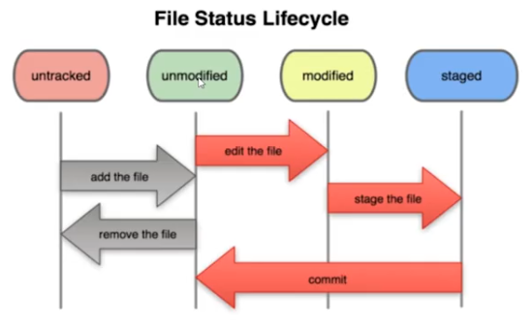

touch filename → linux command to create file

to ignore files from versioning we need to add .gitignore file and mention name of the file we want to ignore

to ignore files of particular extension we need to add *.extension in .gitignore file
to ignore a particular directory anywhere we need to add foldername/ in .gitignore file
to ignore a particular directory only in main folder we need to add /foldername/ in .gitignore file
leading / matches beginning of path name

git diff → compares files present in working directory with repository file and displays difference in lines of code

git diff –staged → compares files present in staging area with commit area and displays difference in lines of code

While commiting avoid setting messages like changed xyz file or time of commit because info like this is always stored with commit instead add messages like solved which bug or added which function

git mv filename newname → rename file ,file will be added to staging area

git log -p → view previous commits with diff

git log –stat → displays info of every commit no of additions and deletions done in every commit

git log –pretty=oneline → display oneline info

git log –pretty=short → display short info

git commit –amend → change last commit message

git checkout – filename → get file from last commit (used id file gets accidently changed or deleted)

what if above command is called accidently then our previous uncommited changes in files present in working directory will be gone

if working directory file is in staging area then above command wont work

git checkout -f → whole working directory changes will be undone

git config –global alias.st status → alias or synonym for inbuilt command instead of status we can use st

Conflict

When conflicts occur conflict resolution markers appear in file depicting changes which are conflicting with branch name

we need to manually edit the file to remove conflict resolution markers and decide which change we want to allow current or incoming and then add that file in staging area and call commit then merge will complete successfully.

Branch management

git branch → names of all branches
git branch -v → names of all branches with recent commit
git branch -d branchname → delete branch will throw error if branch not merged
git branch -D branchname → delete branch even if not merged
git branch –merged → show all merged branches
git branch –no-merged → show all non merged branches

Branching workflows

Long running branches
master
develop
proposed update

Topic branches(short term updates)
issue1
issue2

For resolving every issue create a separate branch

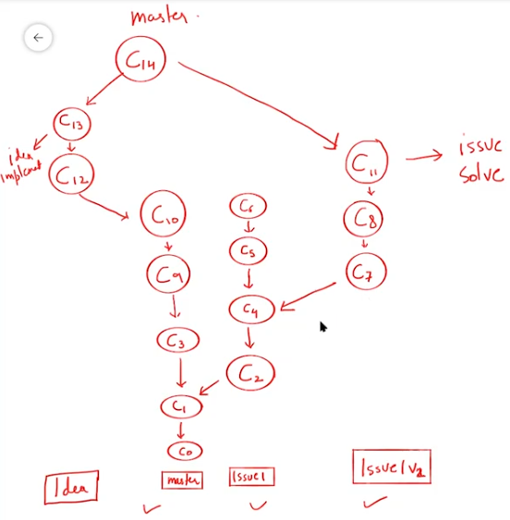

Diff between git and github ?
Git is a distributed version control system lets us manage and keep track of source code history
Git is a tool that needs to be installed locally on computer
Github is a cloud based hosting service which lets us manage repositories on cloud

.git repository consists of hooks , objects , info and refs.
It initialises HEAD pointer for master branch of the repository

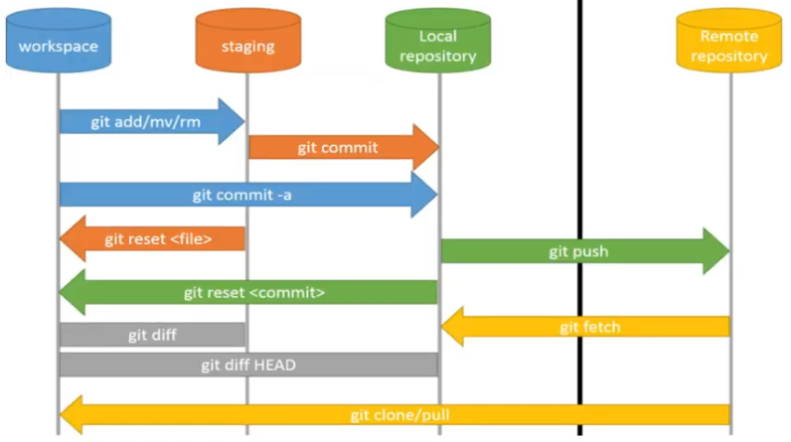

git reset → unstage files from staging area

git checkout 060c3cf65e410c778bd285048d4c80d4de81cef4 → with hashcode of commit we can checkout files from particluar commit

What is detached head state ?

Head points to current branch that is being accessed
Head is a file in .git foldername
if we checkout then our head will stop pointing to any branch but will point the checked out commit

You are in 'detached HEAD' state. You can look around, make experimental changes and commit them, and you can discard any commits you make in this state without impacting any branches by switching back to a branch.

If you want to create a new branch to retain commits you create, you may do so (now or later) by using -c with the switch command.
Example:
git switch -c <new-branch-name>
Or undo this operation with:

git switch -

How to revert a particular commit from remote branch ?
git revert hashcode → pass hashcode of remote commit

What is a tag ?

Tag is used to capture a point in history that is used for a marked version release
Tag is like a branch that never changes
Tags have no further commit history

Types of tags

Annotated
Lightweight

When to create a tag ?
To create a release point for a stable version of software
To create a reference in history to be reused in future
The release is available in releases section of remote repository

git tag tagname (lightweight)
git tag -a tagname -m message (annotated)

git tag → list of tags
git show tagname → info about tag

git push origin tagname
git push origin –tags

git tag –d tagname
git push origin –delete tagname

git checkout -b branchname tagname → create a branch from tag
git tag tagname commit-id → create tag from older commit

How to pick commit of another branch ?

git cherry-pick hashcode

Difference between git clone and fork

How to add github project to eclipse ?
Open perpective then select github
Clone remote repository

How to remove conflicts in eclipse?
After commit and push we see an error dialog of push failing
Then we need to perform pull which will show conflict error
Remove error by manually changing files
And then right click on file and add it to index and push – commit it again
In eclipse conflicts occur if we pull and if conflict is occuring commit push is prevented by eclipse

Difference between git clone and fork
Forking allows us to contribute to a project without affecting the project
We can fork only public repository
We cannot fork own repository we fork other person repository

Fork is used in github to submit changes to an existing repository
After changes are done we can submit a pull request to owner so that he accepts our changes in his repository

Clone is used in git
Clone allows us to create a local copy of repository
This clone can be directly commited to remote repository if write permission is available else
we need to fork the project push local changes to fork and then submit a pull request.

fetch vs pull
fetch downloads only latest changes in repository
downloads changes other developers have pushed to remote repository since last fetch
allows to review and merge later using git merge
it will download changes to repository and not directly in working directory
it doesnt change working directory or working area it is completely safe
git fetch → displays if any change available with commit id
git merge commitid → if if displayed change needs to be merged with

pull downloads latest changes and automatically merges them causing conflict issues and loss of working directory changes
we cannot review changes before merging
will merge in current branch only
git pull = git fetch + merge
git pull origin master

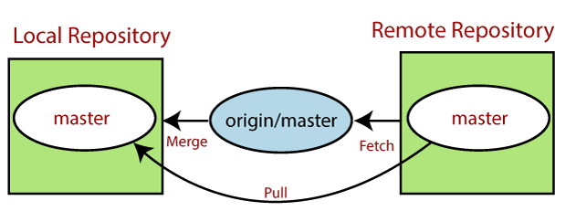

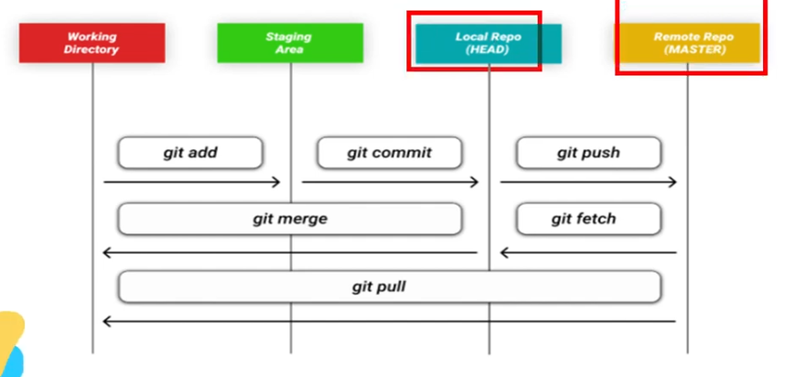

git merge vs rebase

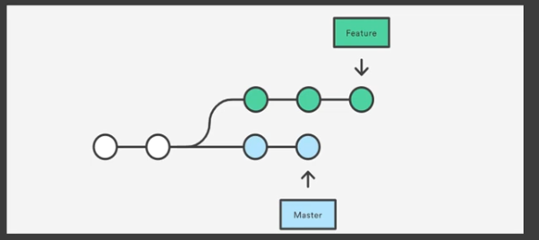

To incorporate a new feature we have branched master in feature and now 2 more commits have taken place in master
If we want to add new master commits in feature branch we have 2 options either merging or rebasing

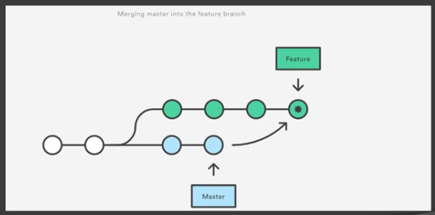

git merge

git checkout feature
git merge master

Extra commit is performed

git rebase

git checkout feature
git rebase master

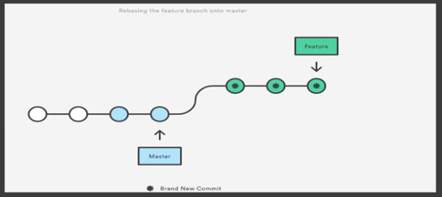

Rebase moves entire feature branch to tip of master branch
which incorporates all new commits of master branch in feature branch
rewrites project commit history
it creates much cleaner project history
we will not get extra merge commits in rebase

because of git merge we wont know how new files were added in master as only one commit is added of merge in current branch
whereas in rebase all commits of master are added in current branch and history is rewritten and is much cleaner and easier to understand

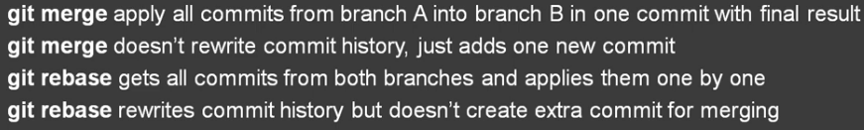

AshokIT

Github is managed by microsoft corporation
Git hub always communicates with local repository
We need to maintain code in local repository then push the code to remote repository
Github repositories will be created by administrator
We can use github using ide , gui , git bash

git help → help documentation
git help commandname → command documantation

git checkout – filename → working directory file will be replaced by repository file
git reset HEAD filename → unstage file

git stash → stash acts as a temp area for storing incomplete changes
during development before completion of ongoing task we need to switch to other tasks
but we cannot leave ongoing task as it is nor we can commit incomplete task so in such situation git stash is used , it stores ongoing code in temporary area so that we can switch to other task. It helps to keep our commit tree clean.

git stash apply → reload the stashed changes in working directory

Git branching

For every story in JIRA we will create a new branch called as feature branch
It is recommended to create branch central repository directly
branchname should be jira id

After making changes we need to push changes to branch
git push

After dev and testing completed we can merge branch changes in master
To merge one branch change to another branch we need to create pull request

To create pull request we need to select our branch and click on create pull request
The code is checked for conflicts
If no conflict is occuring then we can assign reviewer who can review our code and then click on merge pull request
After merge we can delete branch
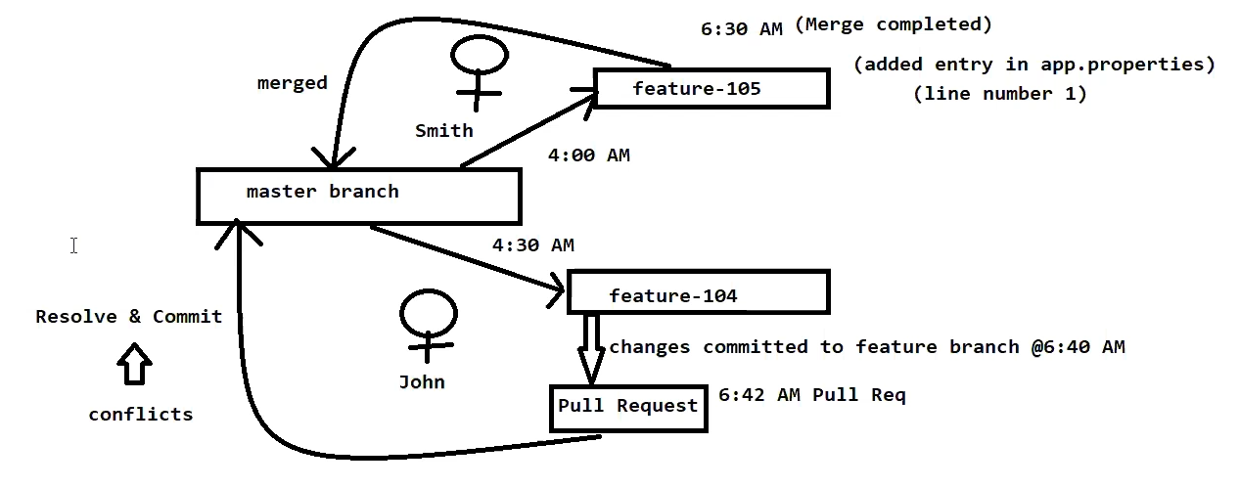

by default in a project foll branches will be created

master
develop
QA
UAT
release

Before pushing local code to remote repository we need to pull all updated files of remote and then push our code to remote repository

Also before starting to work with changes it is recommended to pull remote repository and then start working

For merging branches pull request is recommended rebase is avoided as the commit history is cleaned

_____________________________________________________________________________

git-revert
is about making a new commit that reverts the changes made by other commits.
It does not delete any data
it can be used to track bugs but to remove anything from history it is a bad option

git revert commitid

git-restore

is about restoring files in the working tree from either the index or another commit.
This command does not update your branch.
The command can also be used to restore files in the index from another commit.
The "restore" command helps to unstage or even discard uncommitted local changes.
One the one hand, the command can be used to undo the effects of git add and unstage changes you have previously added to the Staging Area.
On the other hand, the restore command can also be used to discard local changes in a file, thereby restoring its last committed state.

--staged
Removes the file from the Staging Area, but leaves its actual modifications untouched. By default, the git restore command will discard any local, uncommitted changes in the corresponding files and thereby restore their last committed state. With the --staged option, however, the file will only be removed from the Staging Area - but its actual modifications will remain untouched.

--source <ref> → ref is commit id
Restores a specific revision of the file. By default, the file will be restored to its last committed state (or simply be unstaged). The --source option, however, allows you to restore the file at a specific revision.

(using reset we can go to previous commits and commits after previous will be forgotten)

git-reset
undoing changes
three modes of invocation are soft mixed hard
it is like a time machine we can jump up and forth between various commits
Each of these reset variations affects specific trees that git uses to handle your file in its content.
Can operate on whole commit object or individual files

git reset --hard

It will remove all changes from staging and working directory to match last commit
HEAD pointer will point to last commit
changes done in working directory will be gone

git reset –mixed
it will not update working directory
it will update staging area
it will move the head pointer
the changes done in workig directory will remain

git reset –soft
it does not update working or staging area
it just updates HEAD to latest commit or commit we mention

git reset –soft commitid

it acts as git ammend command we can make changes in existing commit

