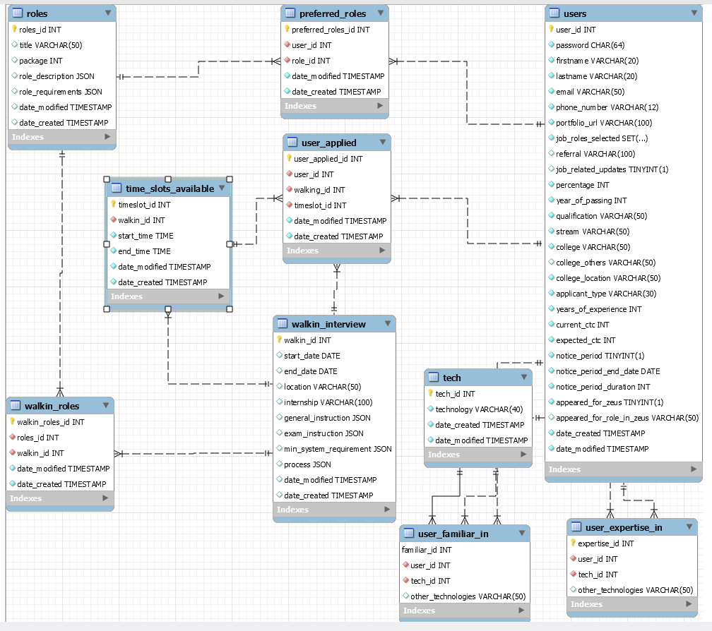

**Preferred Roles table**

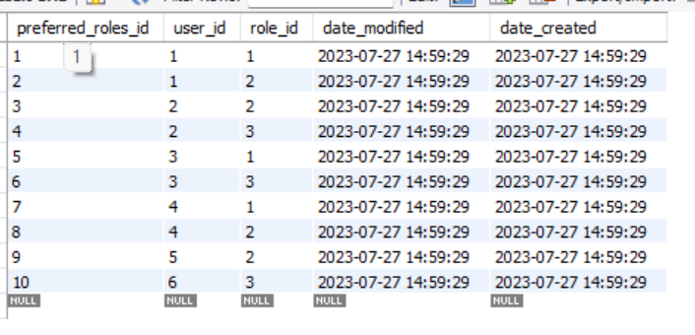

**Roles table**

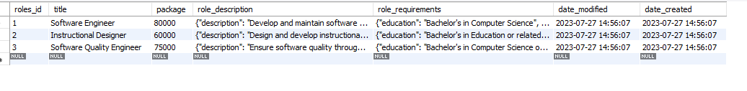

**Technologies table**

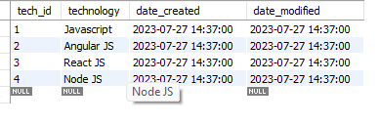

**Timeslot table**

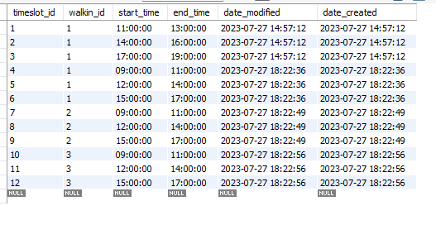

**User applied table**

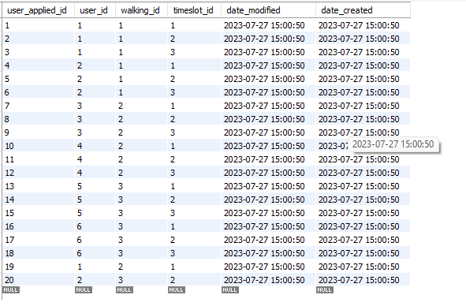

**Technologies expertise table**

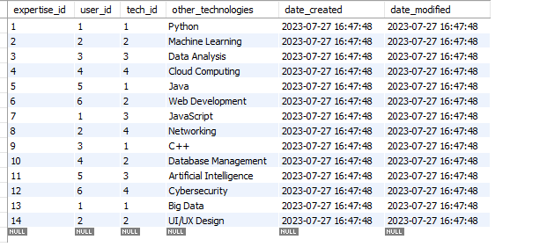

**Familiar Technologies table**

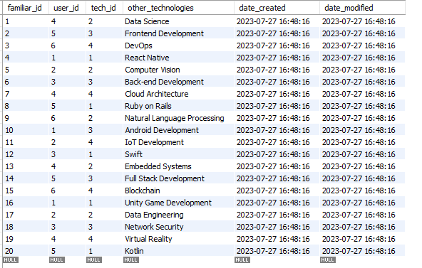

**Users table**



**Walkin offered roles table**

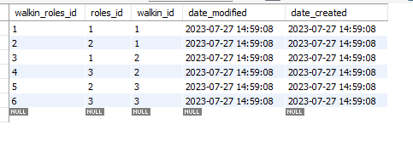

**Walkin details table**



1. It returns users who have registered for the interview more than once

*SELECT u.firstname, u.lastname*

*FROM users AS u*

*INNER JOIN user_applied AS ua*

*ON u.user_id = ua.user_id*

*GROUP BY ua.user_id*

*HAVING COUNT(ua.user_id) > 1;*

1. To get the details of a walking interview with walkin_id is 2

So we want a walk-in interview with walkin_id = 2

So first we get the time slot for that walk-in interview using timeslots table

*SELECT ts.start_time, ts.end_time, wi.start_date, wi.end_date, wi.walkin_id*

*FROM time_slots_available AS ts*

*INNER JOIN walkin_interview AS wi*

*ON ts.walkin_id = wi.walkin_id*

*WHERE ts.walkin_id = 2*

Then we get the name and the details of the roles from the roles table

*SELECT r.roles_id, r.title, r.package, r.role_description, r.role_requirements*

*FROM roles AS r*

*INNER JOIN walkin_roles AS wr*

*ON r.roles_id = wr.roles_id*

*WHERE wr.walkin_id = 2*

Then we just fetch all the details of the walk-in table using

*SELECT * FROM walkin_db.walkin_interview;*

1. To get the user details with id

To get all the details of the user we can use

*SELECT * FROM users AS u WHERE u.user_id = 2*

Now we’ll get the technologies in which the user is familiar in

*SELECT t.technology, uf.user_id, uf.other_technologies AS other_familiar_technologies*

*FROM tech AS t*

*INNER JOIN user_familiar_in AS uf*

*ON t.tech_id = uf.tech_id*

*WHERE uf.user_id = 2*

Now we’ll get the technologies in which the user is experienced in

*SELECT t.technology, ue.user_id, ue.other_technologies AS other_expertiese_technologies*

*FROM tech AS t*

*INNER JOIN user_expertise_in AS ue*

*ON t.tech_id = ue.tech_id*

*WHERE ue.user_id = 2*

1. Get username who has expertise in more than one technology

*SELECT users.firstname FROM users WHERE user_id IN (SELECT user_id*

*FROM user_expertise_in*

*GROUP BY user_id*

*HAVING COUNT(tech_id) > 1);*

1. Get user having expertise in more than one technology along with technology name

*SELECT u.firstname, u.lastname, t.technology AS expertise_technology*

*FROM users AS u*

*LEFT JOIN user_expertise_in AS ue ON u.user_id = ue.user_id*

*LEFT JOIN tech AS t ON ue.tech_id = t.tech_id;*