

*A*

*Project Report*

*On*

**LDrive**

Mini Project Report submitted to

**Masters of Computer Application (SEM-I)**

Of

**University of Mumbai**

*Submitted by*

**SOURAV SOCHAN PRAJAPATI**

*Under the guidance of*

**Prof. SHAMBHU RAI**

## bvplogofinal

Bharati Vidyapeeth’s

**Institute of Management and Information Technology**

Navi Mumbai.

**BATCH: 2020-22**



Bharati Vidyapeeth’s

**Institute of Management and Information Technology**

Navi Mumbai.

**CERTIFICATE**

This is to certify that the mini project titled  **__________**LDrive____________ is successfully done by Mr._ SOURAV SOCHAN PRAJAPATI___during the end of Semester-I in partial fulfillment of **Master’s of Computer Application** under the **University of Mumbai,** Mumbai through the Bharati Vidypeeth’s Institute of Management and Information Technology, Navi Mumbai carried out by him/her under our guidance and supervision.

**Examiner Internal Guide**

(Signature & Date) (Signature & Date)

**Declaration**

The main purpose of the LDrive it to share files with company employee and all from internet rather than an local file system in which we cannot download files which have been uploaded to the file system just because it was for within the network whereas LDrive helps you to do same but here you can also upload download from anywhere.

The user can not only upload the file but also he can share the file with certain access privileges which are public and private .public mean the every employee can download it and private mean certain employees can download it and on top of that you can also view files which you have uploaded without downloading it.

It is tried to develop the software with utmost care, but there may be some limitations, for the project is subjective to future enhancements as per the needs of the client.

**Mr. SOURAV PRAJAPATI**

(Signature & Date)

## **Acknowledgement**

I avail this opportunity to express my sincere and deep gratitude to many who are a factor in helping me gain the knowledge and experience during the project and throughout the course.

I have great pleasure in presenting this project. The completion of this project is not merely due to only my own efforts but also due to the guidance given by our professors.

I am thankful to our project guide Prof. Shambhu Rai for his support. I also thank Dr. Suhasini Vijaykumar, Principal BVIMIT and respected faculty members for their kind support and help throughout the entire course.

I express my deep gratitude to my project guide Prof. Shambhu Rai for assistance during all the phases of project and without whom my project would not have been a success. I would also like to thank him for periodically evaluating my project documentation and monitoring the progress of project completion.

Finally I express my deep regards to all of those who stretch their helping in the execution of my project.

**Mr. SOURAV PRAJAPATI**

(Signature & Date)

**Index**

|  |  |  |
| --- | --- | --- |
| **Sr. No.** | **Contents** | **Page No.** |
| 1 | ABSTRACT | 6 |
| 2 | LITERATURE SURVEY | 7 |
| 3 | DOMAIN KNOWLEDGE | 8 |
| 4 | SYSTEM STUDY | 9 |
| 5 | SYSTEM ANALYSIS | 10 |
| 6 | REQUIREMENT GATHERING | 12 |
| 7 | DESIGN APPROACH | 13 |
| 8 | IMPLEMENTATION | 26 |
| 19 | TESTING | 30 |
| 10 | FUTURE ENHANCEMENT | 31 |
| 11 | REFERENCE | 32 |
|  |  |  |

**ABSTRACT**

LDrive is a website which is used to reduce the burden of having to manually transport files and using other products such as usb cable, pendrive, etc. It used for Sending Files to server for storing it and downloading it from anywhere. This website follows mvc(model,view,controller) architecture. LDrive is a full-featured website for any kind of operating systems.

Easily send huge files from one device to another device using LDrive. Administrator and User can add different type of file types to upload and download files and can also view files at the same time. The file types normally,

• Word File

• PDF file

• Text File

• Images

• Video/Audio File

User is have to registered first. After registration admin approves users request and a mail has been sent to user along with password. A user must provide his credential like user Id and password for log into the system. For that the system maintains data for all users. Whenever a user enters his user id and password, it checks in the database for user existence. If the user exists he can be treated as a valid user. Otherwise the request will throw back. All registered user have access to upload and download any file on the website. For file uploading and downloading the system provides a good user interface for easy to use. User can save the downloading file with his desired location.

**Object of project**

The LDrive is a web based project. The Main purpose of this website will manage a file sharing site. The Company can create a employee’s database, each one with his assigned folder. Within this folder, the employee can upload its files or download the one already in the folder already uploaded by the company itself.

When the company uploads a file in a employee’s folder, the employee have to login to website using user id and password and will receive the file with a link to download it using the LDrive website. The employee can also login into the system any time and look for previously uploaded files.

**LITERATURE SURVEY**

The project LDrive is website created to reduce the burden of having to manually transport files and using other products such as usb cable, pendrive, etc and in case of internet failure the user can still access it if the Server is been hosted by the company.

This website is useful for employees of a company to upload, share, and download the files with specific user or publically and once he share the file he can also remove the access privileges of specific user.

When your company host the website the upload and download speed is around 80 MBPS which is really fast for uploading 10-20 GB of data and since admin can remove and approve users to access site it is pretty safe to upload and download and there is Economic benefit is since buying storage is getting cheaper.

**DOMAIN KNOWLEDGE**

LDrive is a website which belongs to technology domain such that this website will help employees to share files easily. Over the years technology has been growing fast and with so much information technology available that enables millions of companies and professionals to reach new levels of success, it is no wonder how much consumers spend.

There are many websites available on the web that can be different types like banking, organization etc. Each website have different type of approach and design as per the domain.

As I have some knowledge of technology domain like hardware, software and ability to use various technologies, technological tools, and associated resources. We decided to create this website to avoid unnecessary sending of mails and easy to access.

Technology domain is now developing faster and processing more and more so we need to keep ourselves updated frequently for that change all we require is to learn new skills and concepts with speed and efforts.

**SYSTEM STUDY**

**FEASIBILITY STUDY**

LDrive website is dumb project, so feasibility study is not carried out.

**Problem Definition**

When we are using company’s file system for sharing files it is been locally shared and if you need that file your either need to connect a pendrive and copy document or you need to mail it to yourself But mailing it is not always an option because the file size is limited to not more than 25mb .

When you want to share some documents to your pc you always need to have a USB cable to share and when you do so there are chances that you need to install drivers or the phone is bit old which hampers the speed of transfer and if you by mistakenly unplug it then the file share is of no use or if you doesn’t have your USB cable in that case you just need to login to LDrive and you can share the file and once done you could download it from your pc.

**SYSTEM ANALYSIS**

The system after careful analysis has been identified to be presented with the following modules:

The Modules involved are

1. Administration
2. Users
3. File Uploading and Downloading
4. File Sharing
5. Registration
6. Authentication

**Administration**

Administrator has an authentication to monitoring the complete system. He can have all the privileges. Administrator can register users, and remove the registered users.

**Users**

User is nothing but a registered user. A registered user directly uploads information into the system. Before uploading he needs to specify his credentials for authentication.

The upload files have 2 types of priorities.

• Public priority

• Private priority

The definition of Public priority means, the files which are uploaded in to the system, those are shared by all the users which are registered in the system.

Private priority means, the accessibility of the uploaded file only by the user itself. Other users don’t have any permission for downloading.

**File Uploading and Downloading**

All registered user having authority to upload any file on the website, admin can access all uploaded files. Based on the priority users can download file from the website. For file uploading and downloading the website provides a good user interface for easy to use. User can save the downloading file with his desired location.

**File Sharing**

For every uploading file user can put priority. Private means no accessibility for other users. It’s simply personal. Public means every user can access that file. Partial public means user can choose a list of other users and give accessibility.

**Registration**

The website has a process of registration. Every user need to submit his complete details in the form of registration. Whenever a user registration is completed, automatically password is provided to user. By using that password user can log into the website.

**Authentication**

Authentication is nothing but providing security to the system. Here every user must enter into the website throw login page. The login page will restrict the unauthorized users. A user must provide his credential like email Id and password for log into the system. For that the system maintains data for all users. Whenever a user enters his mail id and password, it checks in the database for user existence. If the user exists he can be treated as a valid user. Otherwise the request will throw back.

**SYSTEM REQUIREMENTS**

A System Requirements Specification is a structured collection of information that contains the requirements of a system.

**The technologies required in this project are as follows:**

* **Software**
* Windows 7 or above
* Eclipse IDE
* Google chrome
* JDK 1.8 or greater
* **Hardware**
* Intel Core i3-5005U CPU
* 1 GB RAM and Above
* 1 GB Hard Disk and Above
* **Database Server**
* MySQL Database Server

**DESIGN APPROACH**

**Fg.1 : Work Breakdown Structure (WBS)**

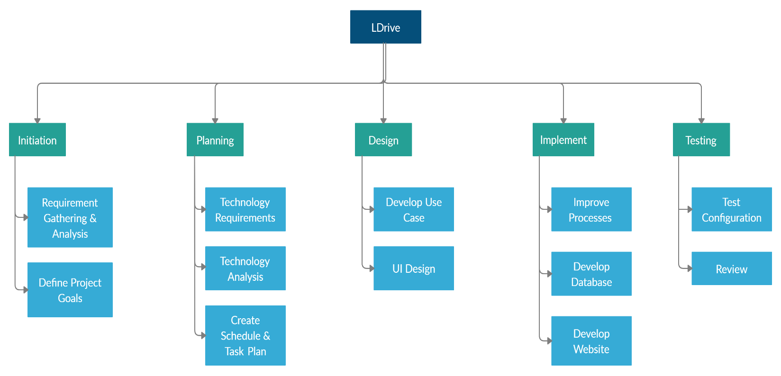

**Fg.2 : TIME LINE**



**Fg.3 : GANTT CHART**

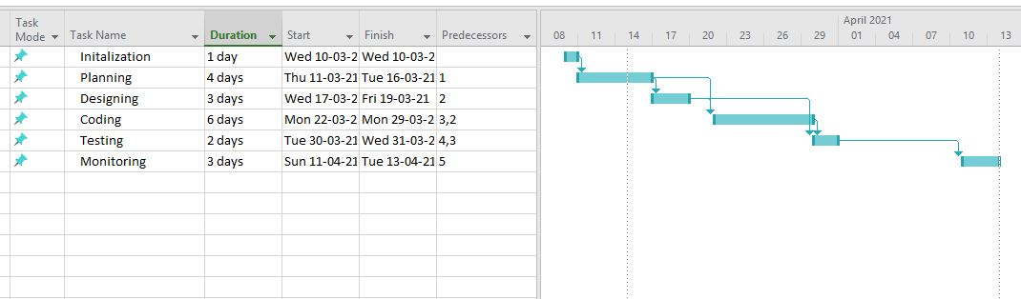

**Fg.4 : NETWORK FLOW**

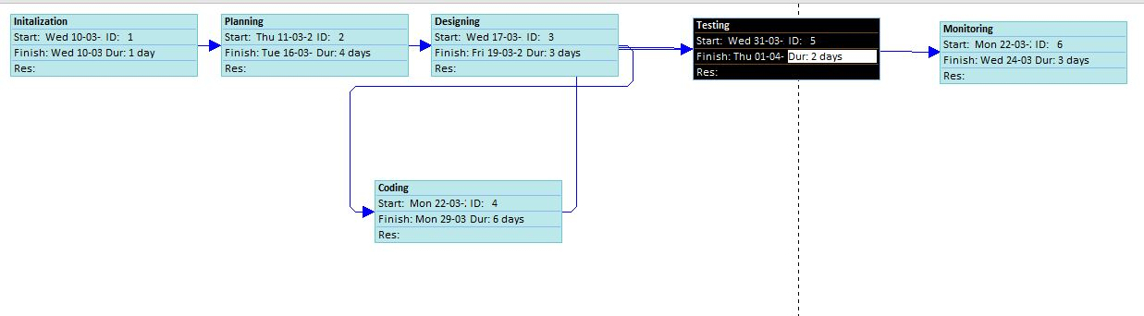

**Fg.5 : USE CASE DIAGRAM**

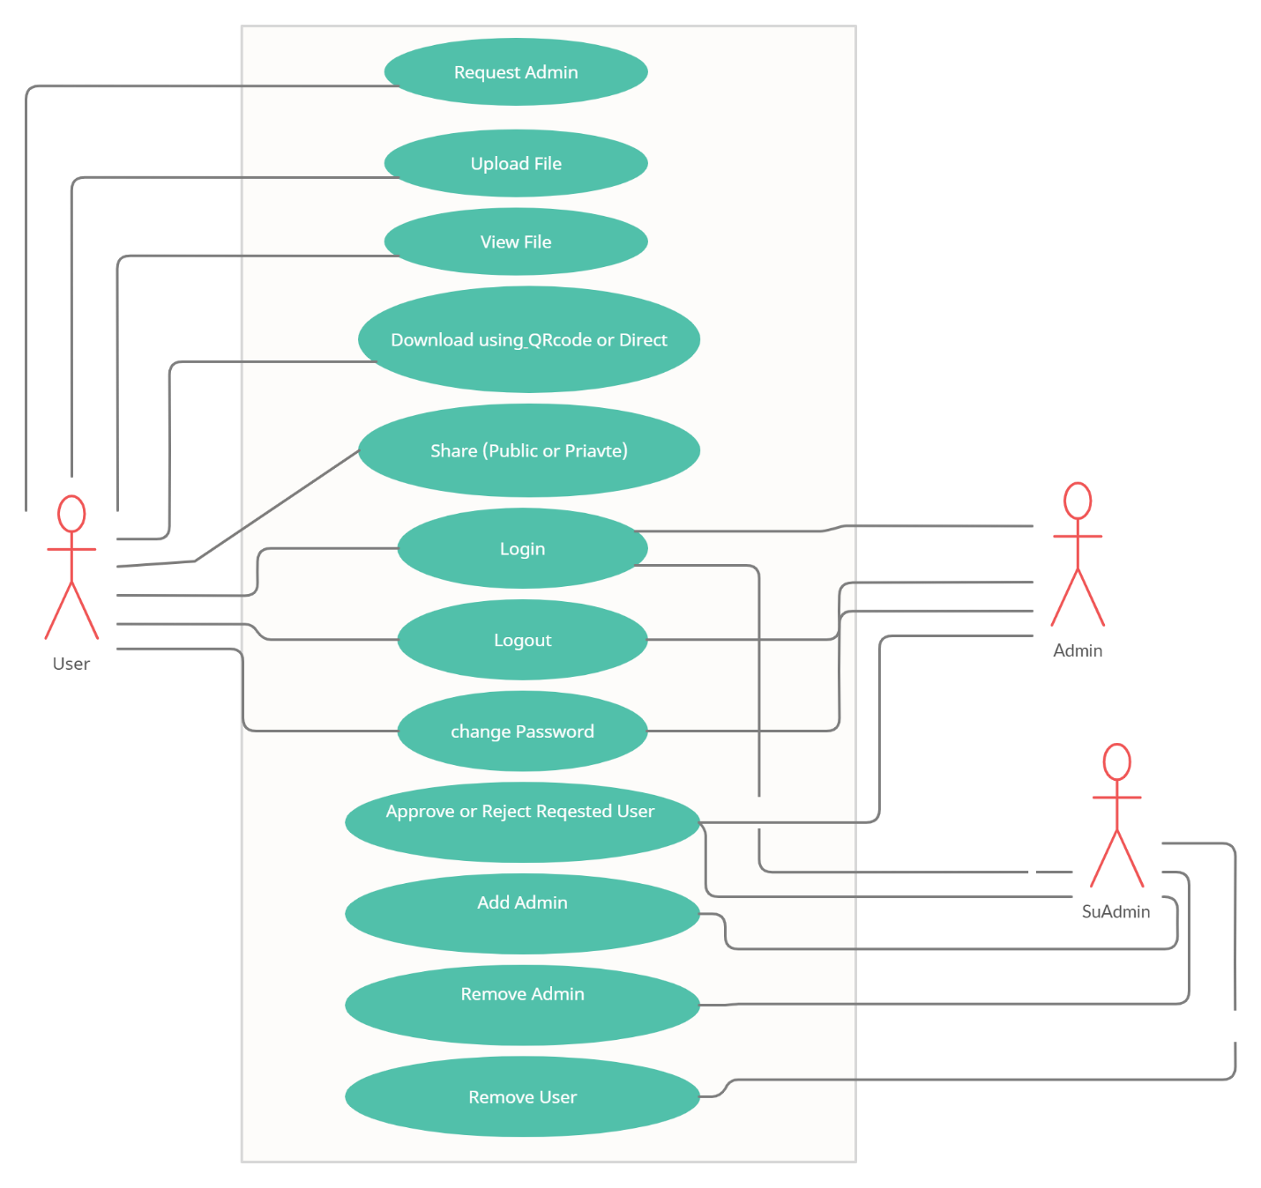

**Fg.6 : CLASS DIAGRAM**

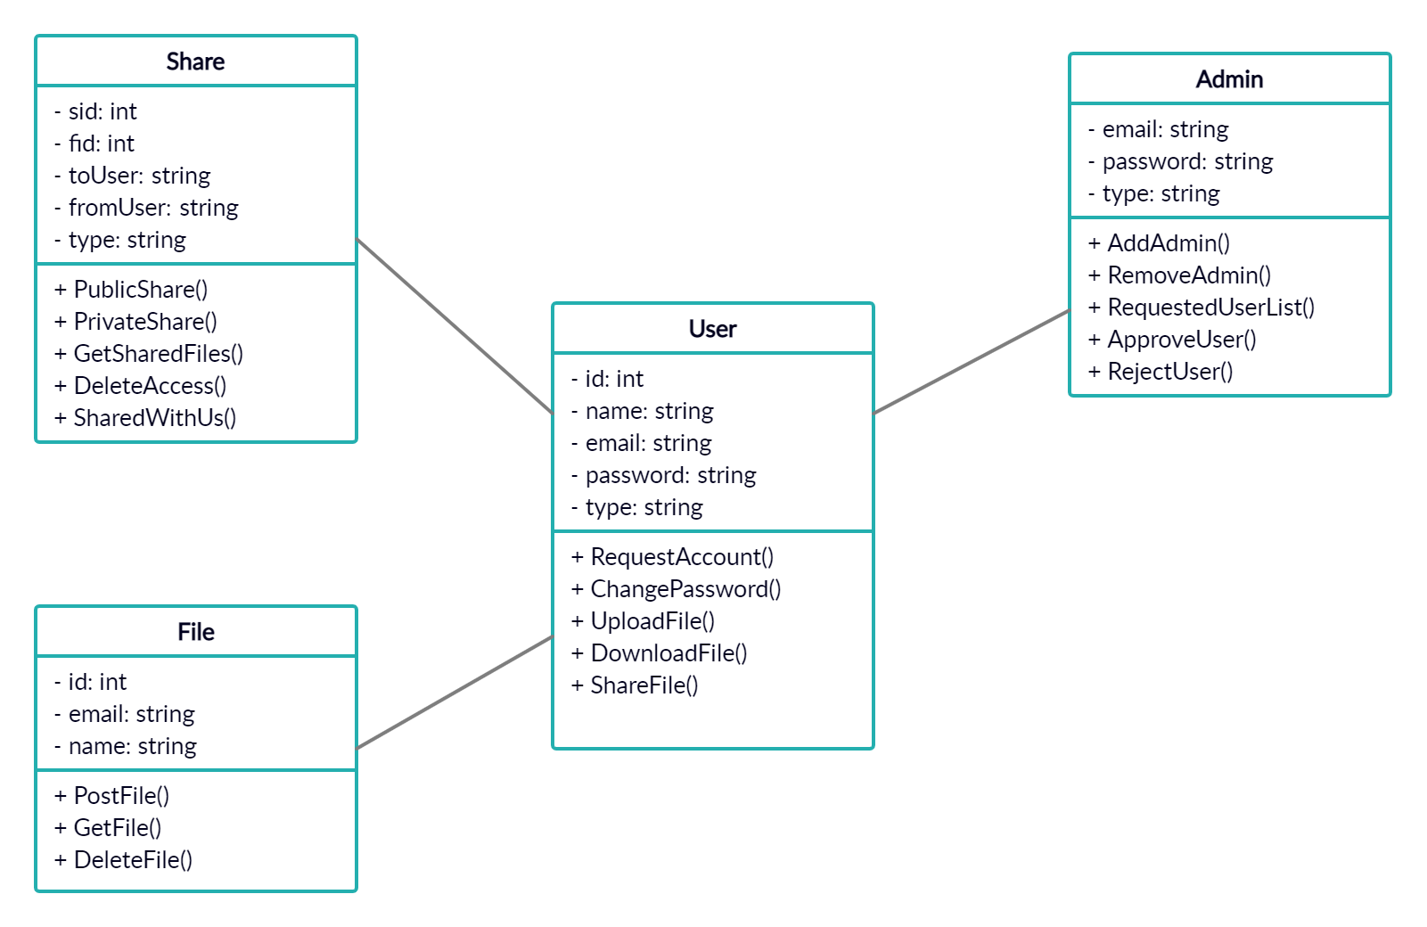

**Fg.7 : SEQUENCE DIAGRAM**

**Admin Login –**

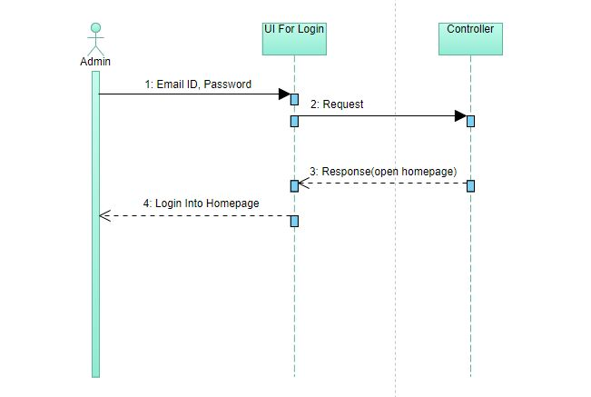

**User login –**

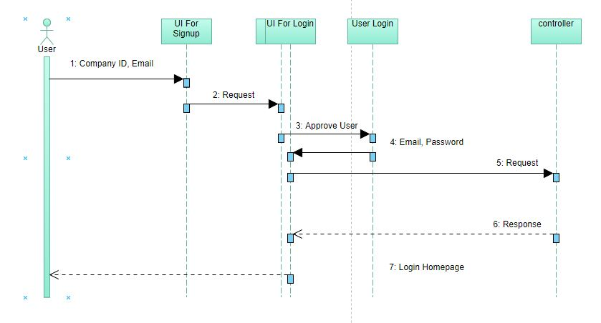

**Upload File –**

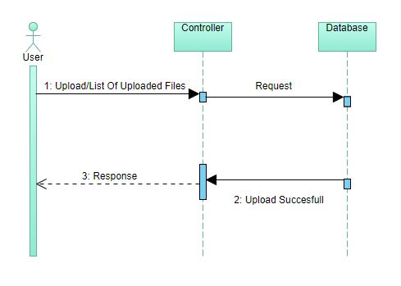

**Share File –**

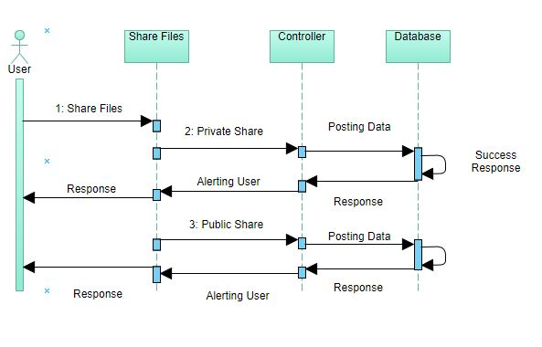

**Download File –**

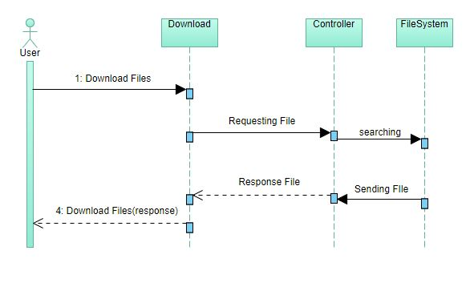

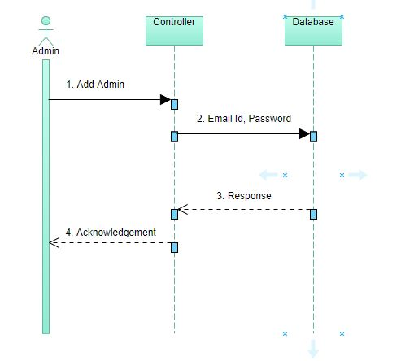**Add Admin –**

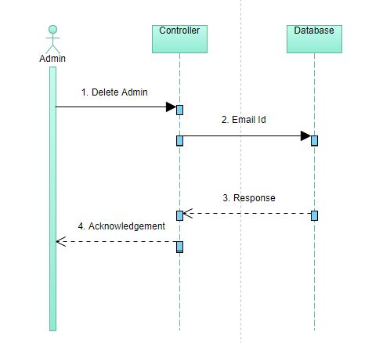**Delete Admin –**

**Get Shared Files –**

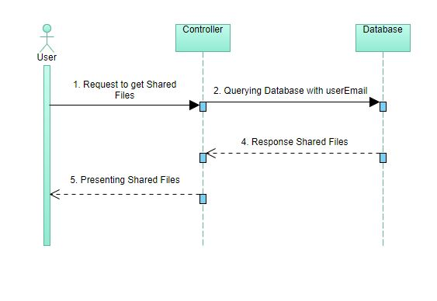

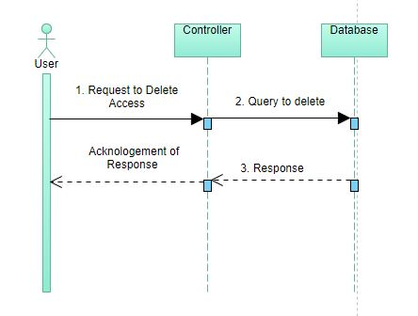**Delete Access –**

**User Change Password –**

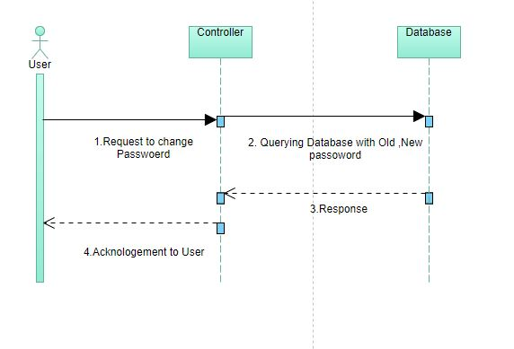

**Admin Change Password –**

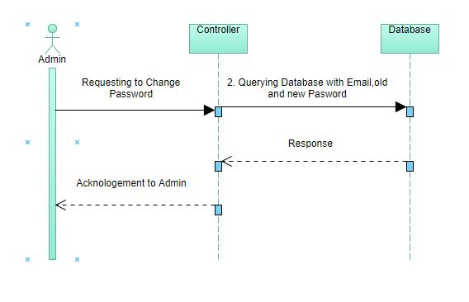

**User Logout –**

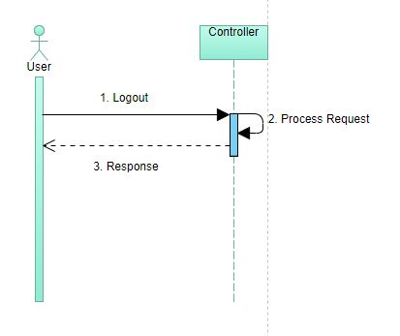

**Admin Logout –**

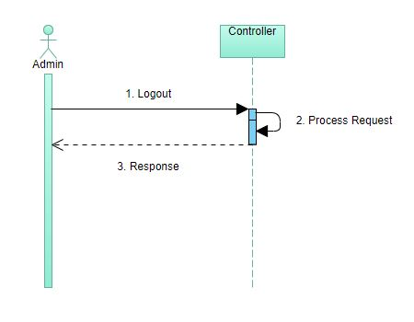

**IMPLEMENTATION**

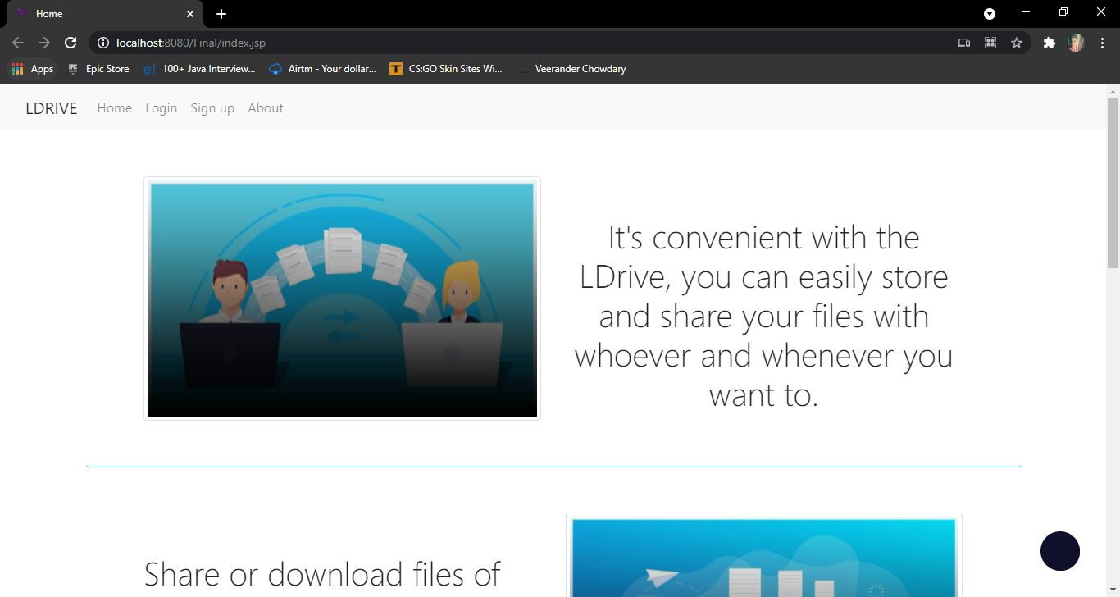**Home page(index page)**

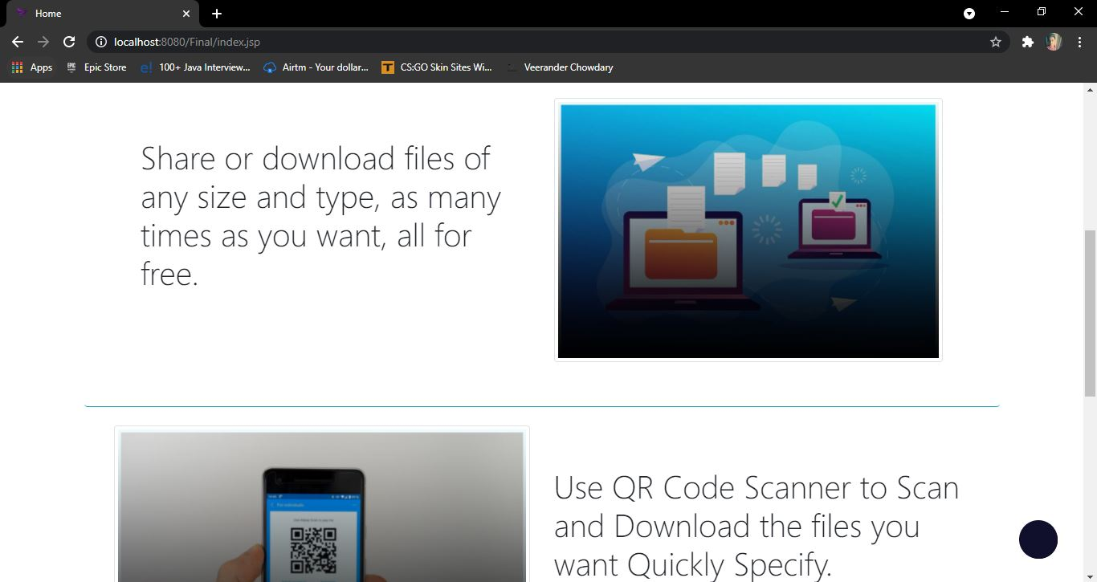

**User signup page**

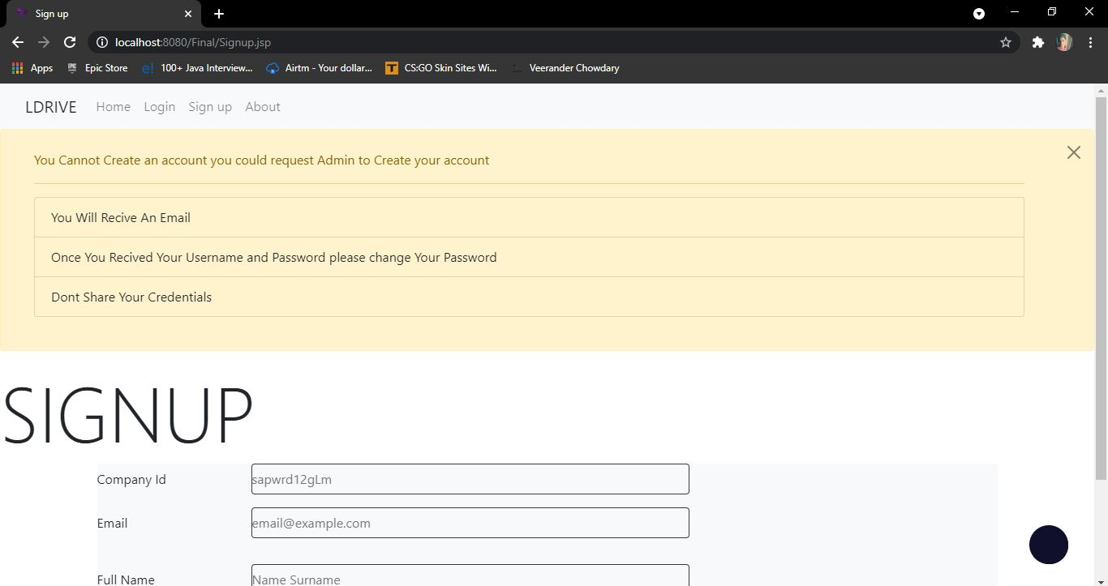

**Admin login page**

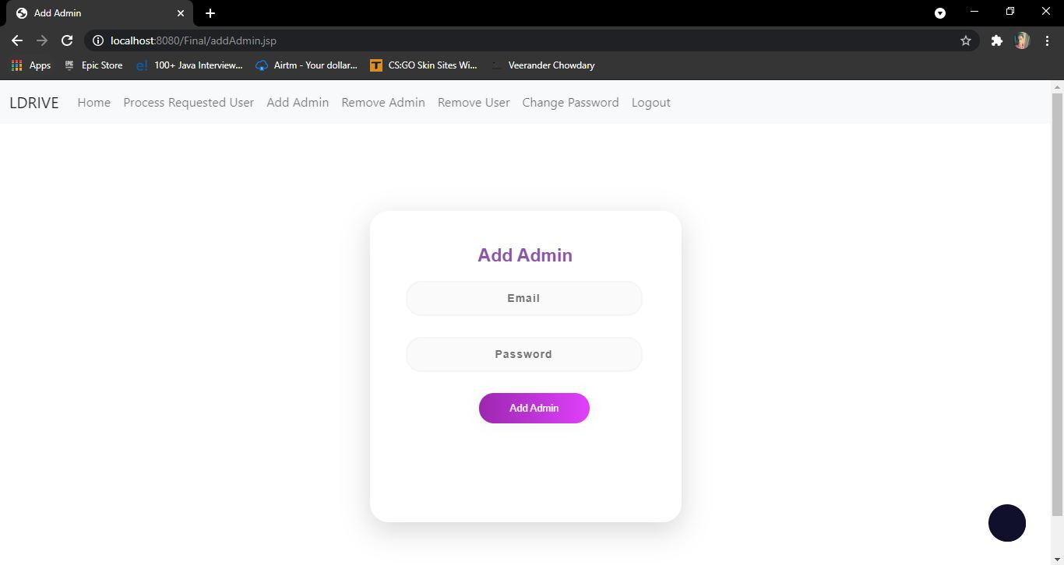

**Process requested user page**

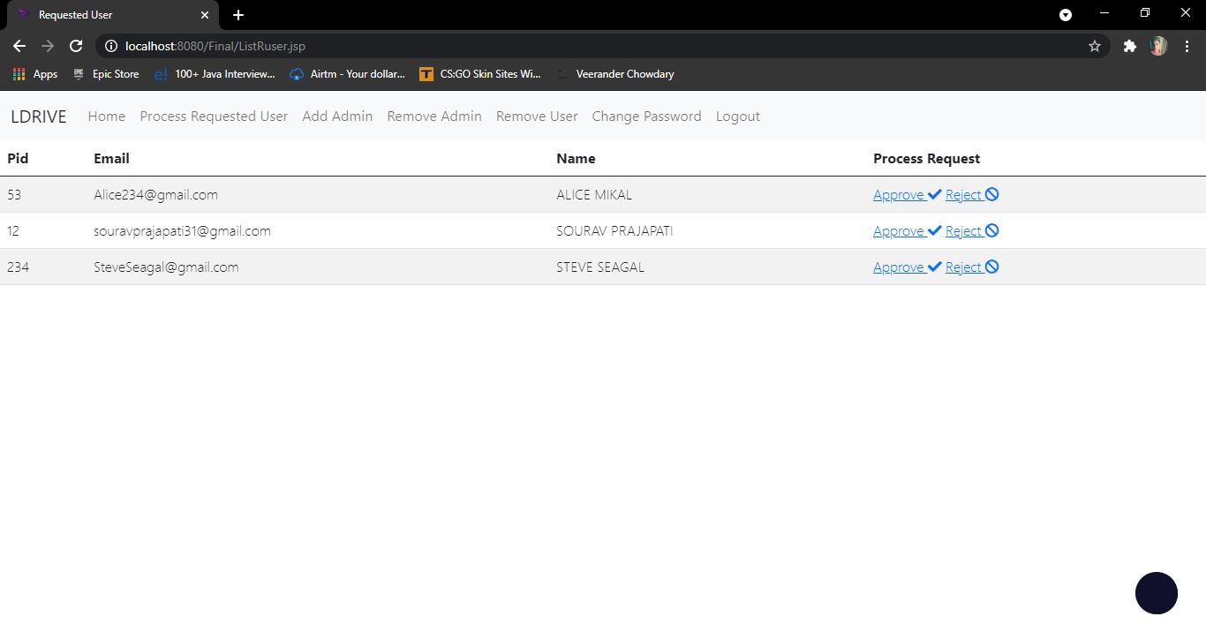

**List of files uploaded page**

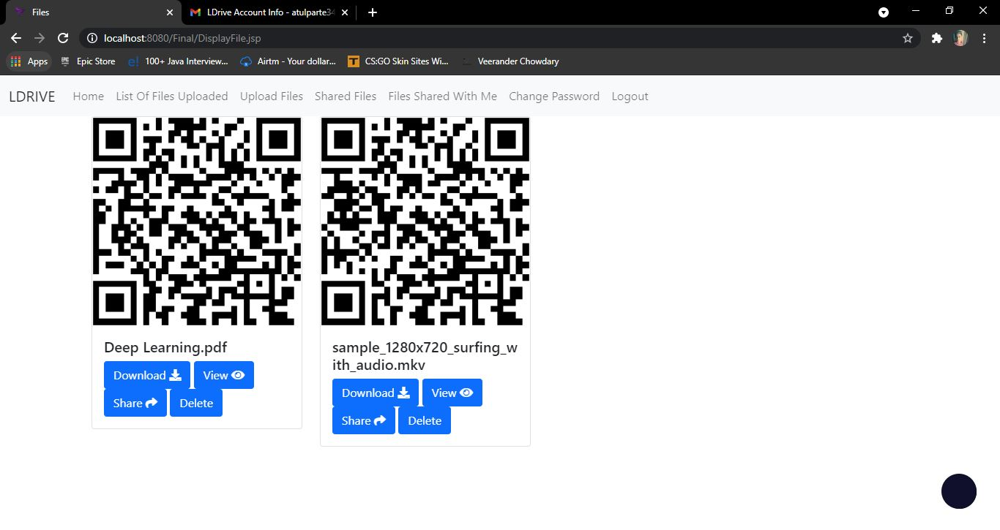

**Share files page**

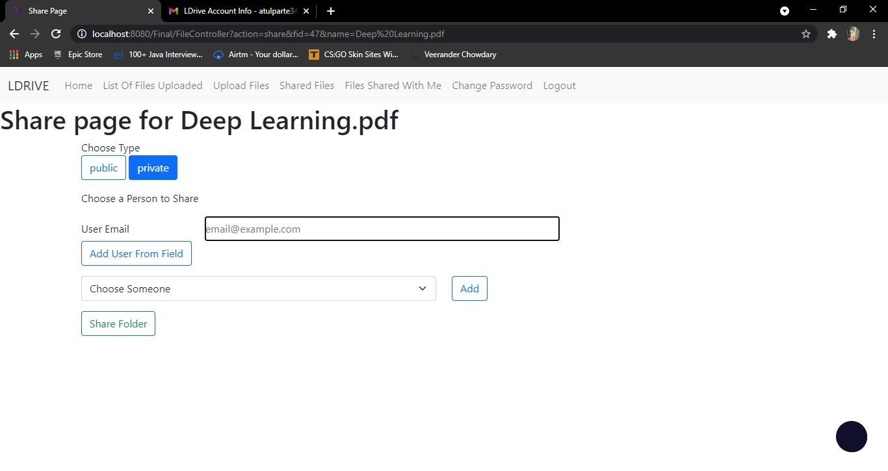

**About page**

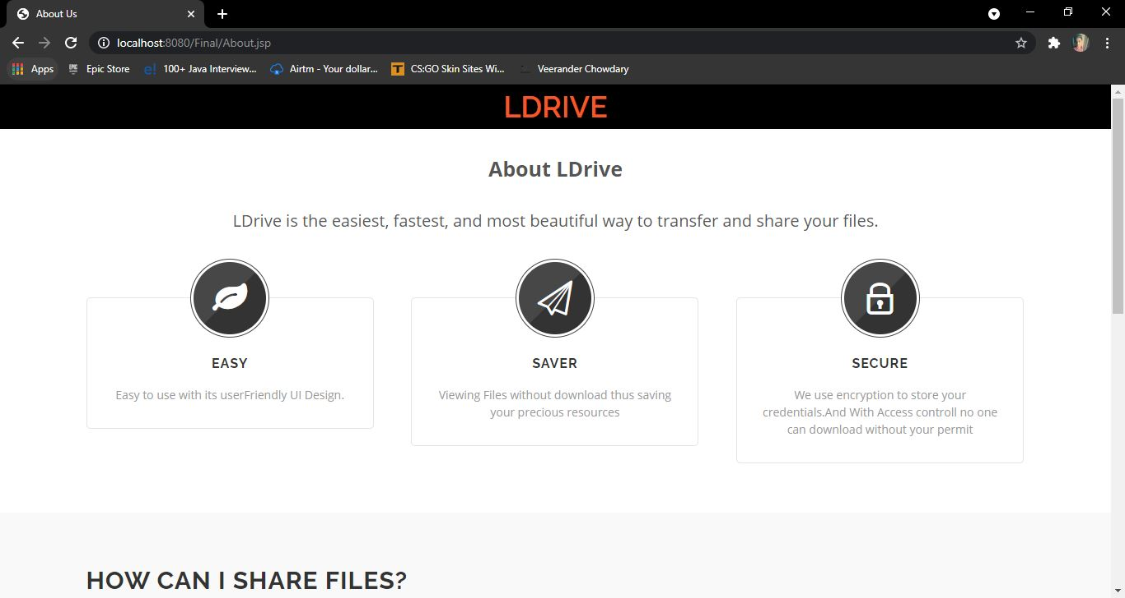

**TESTING**

**Unit Testing**

Unit testing is a software testing method by which individual units of source code—sets of one or more computer program modules together with associated control data, usage procedures, and operating procedures—are tested to determine whether they are fit for use

Unit testing involves the testing of each unit or an individual component of the software application. We have performed unit testing on every Dao (data access object) implemented class.

**Usability testing**:

Usability Testing has now become a vital part of any web based project. It can be carried out by testers like you or a small focus group similar to the target audience of the website.

Compatibility tests ensures that your website displays correctly across different devices. This would include Browser Compatibility Test: Same website in different browsers will display differently. You need to test if your website is being displayed correctly across browsers You may also check for Mobile, Browser Compatibility.

**Compatibility testing**.

Compatibility tests ensures that your website displays correctly across different devices. This would include Browser Compatibility Test: Same website in different browsers will display differently. You need to test if your website is being displayed correctly across browsers and authentication is working fine. You may also check for Mobile Browser Compatibility.

**LIMITATIION AND ENHANCEMENTS**

**Limitations –**

* It allow you to view specific formats of file eg : mkv, png, pdf, txt.
* Data send for download and upload can be intercepted by hackers.
* When you want to share files with multiple people you need to put everyone’s email id one by one.
* Anyone who has physical access to the server can see everyone’s uploaded documents.

**Enhancements –**

* Including more file formats.
* Creating groups.
* For mailing it doesn’t uses any Google API rather it uses javax.mail libray.
* Encryption for file system of server.

**REFERENCES AND BIBLIOGRAPHY**

## BOOK REFERENCES

* Effective Java.
* Java – The Complete Reference.
* Core Java Volume I – Fundamentals.
* MySQL Explained: Your Step By Step Guide to Database Design.

## INTERNET WEBSITE REFERENCES

## <https://getbootstrap.com/docs/5.0/getting-started/introduction/>

* <https://www.w3schools.com/css/>
* <https://www.atlassian.com/git/tutorials/atlassian-git-cheatsheet>
* <https://stackoverflow.com/>