A
Project Report On
Footwear Shop
Inventory Management System
Submitted in partial fulfillment of the requirements for the award of degree
Bachelor of Computer Application Final Year
From
Pt. Ravishankar Shukla University Raipur (C.G.)

Year: 2023-24

Guide Submitted by:
Dr. VARSHA THAKUR ATUL VERMA
Roll No: 4309

Submitted to
Government Nagarjuna Post Graduate College of Science, Raipur
Pt. Ravishankar Shukla University Raipur (C.G.)
- Certificate of Approval by Head of the Department.

CERTIFICATE OF APPROVAL
This is to certify that the Project work entitled “Footwear Shop Inventory Management System” is carried out by Mr. ATUL VERMA, a student of BCA – III year at Government Nagarjuna Post Graduate College of Science, Raipur is hereby approved as a credible work in the discipline of Computer Science & Information Technology for the award of degree of Bachelor of Computer Application during the year 2023-24 from Pt. Ravishankar Shukla University, Raipur (CG).

DR. KIRAN BALA DUBEY
(Head of the Department)

2. Certificate from the Guide.

CERTIFICATE
This is to certify that the Project work entitled “Footwear Shop Inventory Management System” Submitted to the Government Nagarjuna Post Graduate College of Science, Raipur by Mr. ATUL VERMA Roll No 4309, in partial fulfillment for the requirements relating to nature and standard of the award of Bachelor of Computer Application degree by, Pt. Ravishankar Shukla University, Raipur (CG) for the academic year 2023 - 2024.
This project work has been carried out under my guidance.

DR. VARSHA THAKUR
(Guide Name)

3. Certificate of evaluation.

CERTIFICATE OF EVALUATION

This is to certify that the Project work entitled “Footwear Shop Inventory Management System” is carried out by Mr. ATUL VERMA, a student of BCA – III year at Government Nagarjuna Post Graduate College of Science, Raipur, after proper evaluation and examination, is hereby approved as a credible work in the discipline of Computer Science & Information Technology and is done in a satisfactory manner for its acceptance as a requisite for the award of degree of Bachelor of Computer Application during the year 2023-24 from Pt. Ravishankar Shukla University, Raipur (CG).

Internal Examiner External Examiner

3. Declaration of Student / Self Certificate

DECLARATION

This to certify that the project report entitled “Footwear Shop Inventory Management System”, which is submitted by me in the partial fulfillment for the award of the degree of Bachelor of Computer Application, Government Nagarjuna Post Graduate College of Science, Raipur, comprises the original work carried out by me.
I further declare that the work reported in this project has not been submitted and will not be submitted, either in part or in full for the award of any other degree or diploma in this Institute or any other Institute or University.

Place: Raipur C.G. ATUL VERMA
Date: Roll No 4309

Table of Contents

1. Introduction
1.1 Purpose of this report
1.2 Scope of “Footwear Shop Inventory Management System”
1.3 Problem identification
1.4 proposed system to solve the problem
2. Feasibility Study
3. Specific Requirements
3.1 Functional Requirements
3.2 Nonfunctional Requirements
3.3 External Interface Requirements
4. Data Flow Diagram
4.1 Notations used
4.2 Level 0 DFD
4.3 Level 1 DFD
4.4 Level 2 DFD
5. Entity Relationship Diagram
5.1 Notations used
5.2 Diagram
6. Database Design
7. Graphical user interface
8. source code
9. Future Enhancement
10. Concussion
11. Bibliography and References

1 Introduction
“Footwear Shop Inventory Management System” app is a software application that helps a footwear shop owner to manage inventory and create bills (for customers). This application also gives report such as monthly profit and soled product count etc.

1.1 Purpose of this Report
The purpose of the document is to give an overview of “Footwear Shop Inventory Management System” application and helps understanding how the app actually works, Flow of data in application and its requirement. This document includes all the technical data required for use and future enhancements.

1.2 Scope of “Footwear Shop Inventory Management System”
This app solves the problem of maintaining records on pen and paper and replace it with digit counterpart. This is also a billing application for generating customer bills. This software also gives monthly reports on profit and loss and sold products in just one click.

1.3 Problem identification
Different shops have different types of requirements. This software a small size footwear shop which sells footwear and maintain record on pen and pepper but after few months and year the record are damaged it is difficult to reproduce this record.

1.4 proposed system to solve the problem
Footwear shop Inventory management system solves the problem of maintaining record using pen and pepper and digitize using an app the maintain record when operator gives user a bill it is automatically recorded and deducted from the inventory and stores the details of customer and its bought product for future safety. This app also helps to generate bills in fast manner.
2 Feasibility Study

- Technical Feasibility: - can the work for the project be done with current equipment, existing software technology, and available personnel?
Answer: - Yes
- Economic Feasibility: - Are there sufficient benefits in creating the system to make the costs acceptable?
Answer: - Yes
- Operational Feasibility: - Will the System be used if it is developed and implemented?
Answer: - Yes

3 Specific Requirements
3.1 Functional Requirements
For Operator :-
- Brief Description
An Operator can add product and its units available and when a customer purchase products operator also generates bills.
- Initial Step-By-Step Description
- First operator login with their login id and password.
- Then using product section add, edit or delete product.
- Then using inventory section add cost price, selling price and number of units have in the stock.
- Lastly sell the product and generate bill.
- He also sees report such as profit and selling details using analysis section.
For Customer
Customer of footwear shop cannot interact with this app. He can give information to the operator. The bill is generated by operator and give to the customer.

For Owner of Shop
Owner cannot interact directly with this app cooperator give following information to the owner
- List of products and its detail.
- Product availability.
- Profit according to date specified.
- Selles detail according to date specified.
3.2 Nonfunctional Requirements
The software uses the local machine to compute all operations. The app uses MySQL database running at the local machine to store the all information

3.3 External Interface Requirements
Software Requirements:
- This software only works on windows pc with windows version 10 and above.
(Tested on windows 10 and 11)
- Microsoft Dot Net Core 6 (long term support) must be installed in the system.

HardWare Requirements:

- At leat 100Mb of secondary storage is required. (Dot Net 6 take sotrage separately.)
- At least 100Mb of free RAM is required for. (Dot Net 6 take RAM separately.)

4. Data Flow Diagram
4.1 Notations used

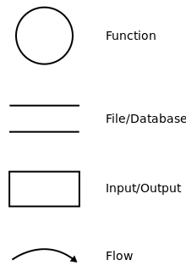

4.2 Notations used
Leverl 0 Data Flow Diagram

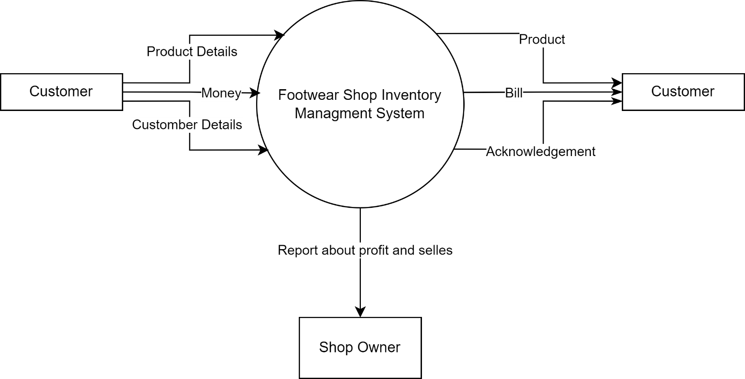

4.3 Notations used
Leverl 1 Data Flow Diagram

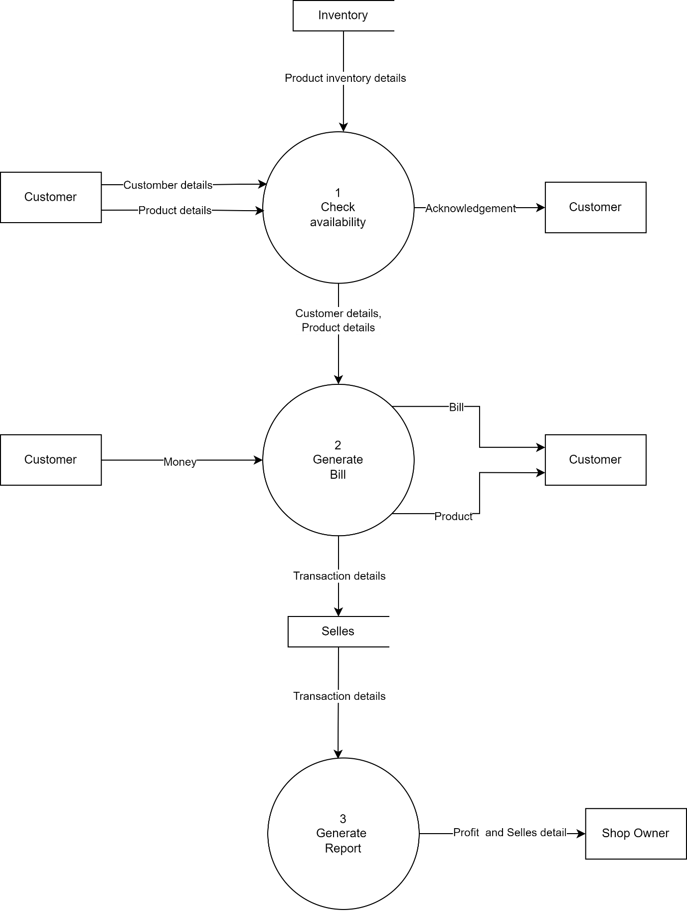

5. Entity Relationship Diagram
5.1 Notations used
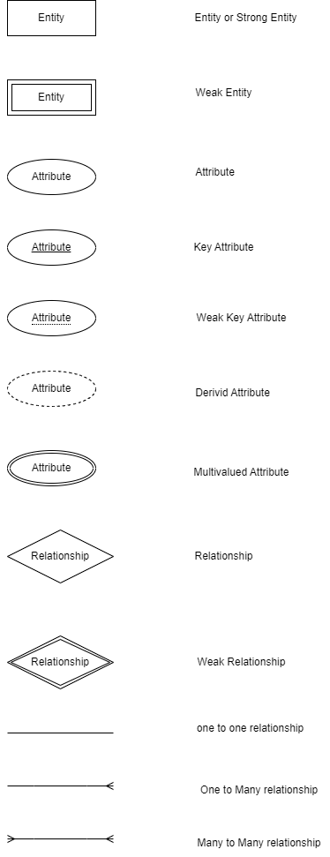

5.2 Diagram

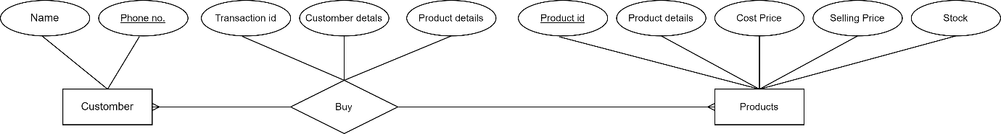

6. Database Design
Data design creates a model of data and information that is represented at a high level of abstraction. The app work on a database which have following tables
- PRODUCT_TABLE Fields of this table are :
PID
PNAME
PSIZE
PSTYLE_NAME
PBRAND
PCOLOR
USER_GROUP
PRODUCT_TYPE
HILE_TYPE
OUTER_MATERIAL
SOLE_MATERIAL
WATER_RESISTANCE_LEVEL
CLOSURE_TYPE

- SELLES_TABLE fields of this table are:
TID
PID
PUNITS
CPRICE
SPRICE
"PURCHASE_DATE
CNAME
CPHONE

7. Graphical User Interface

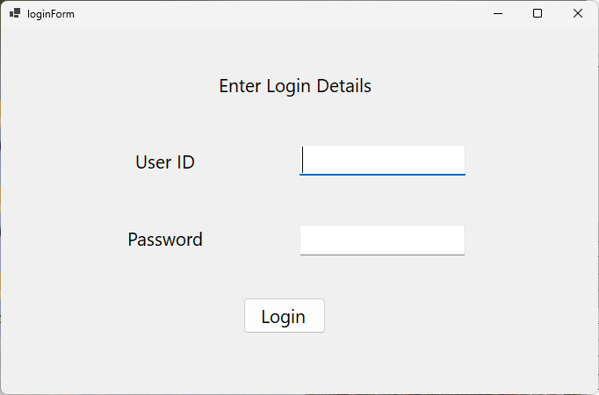

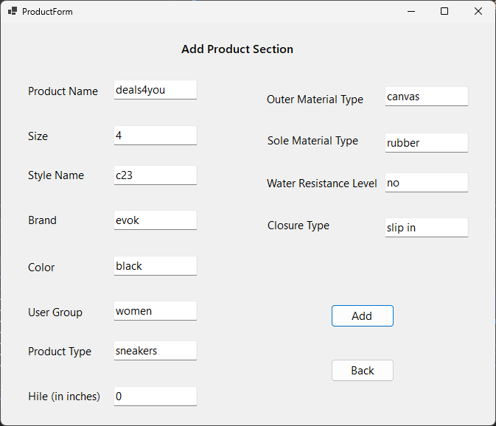

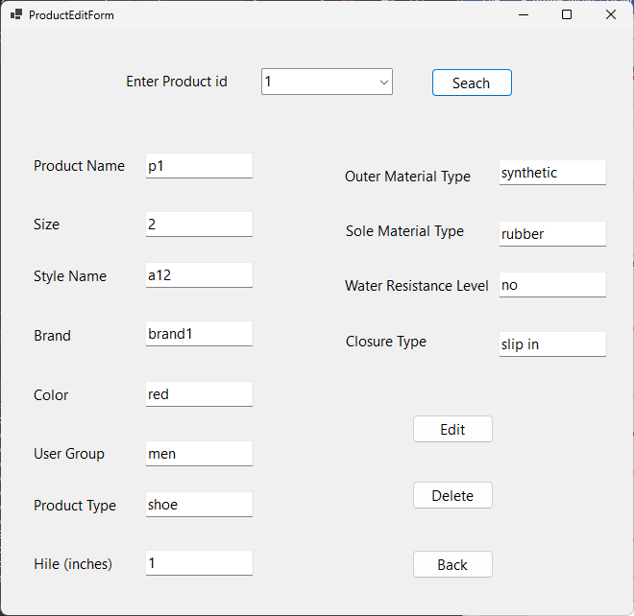

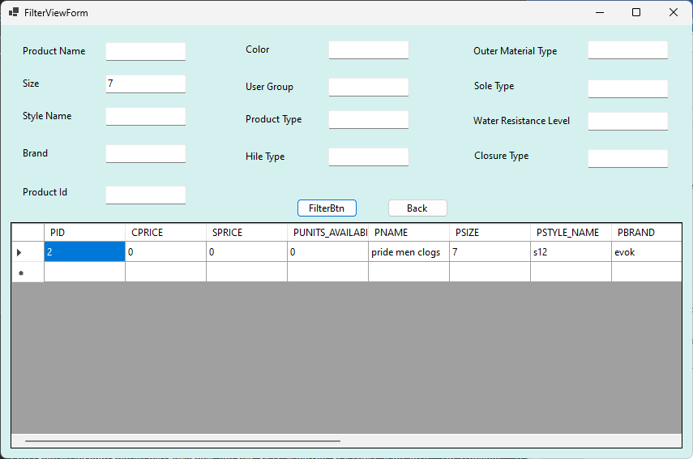

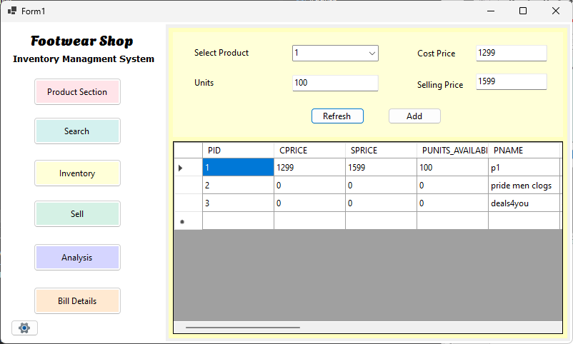

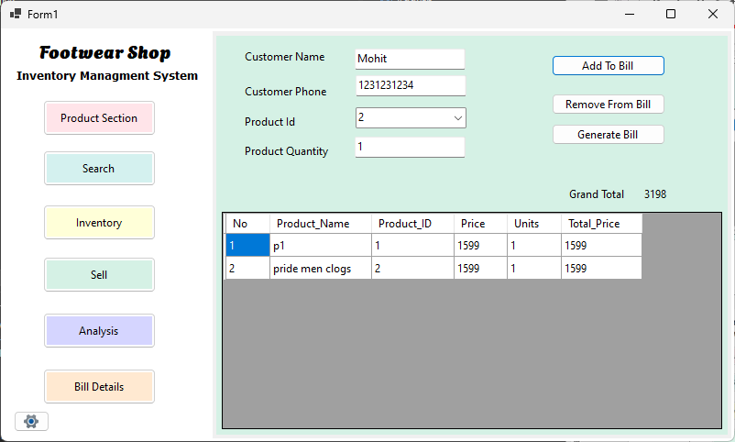

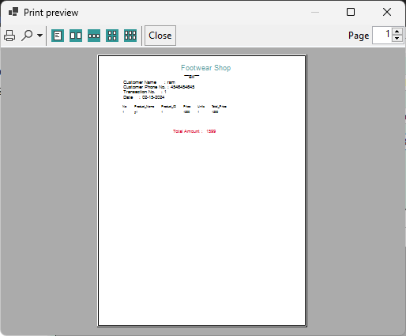

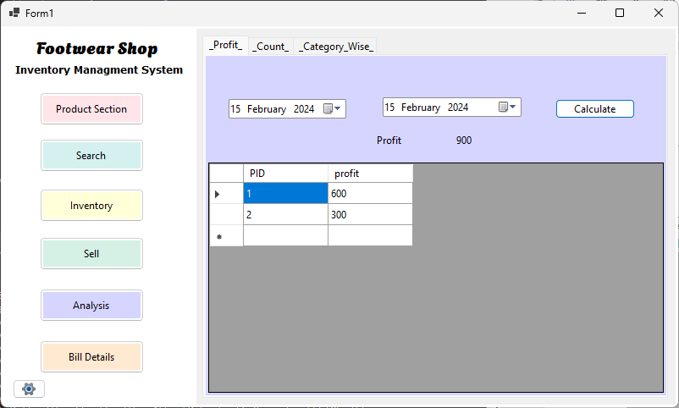

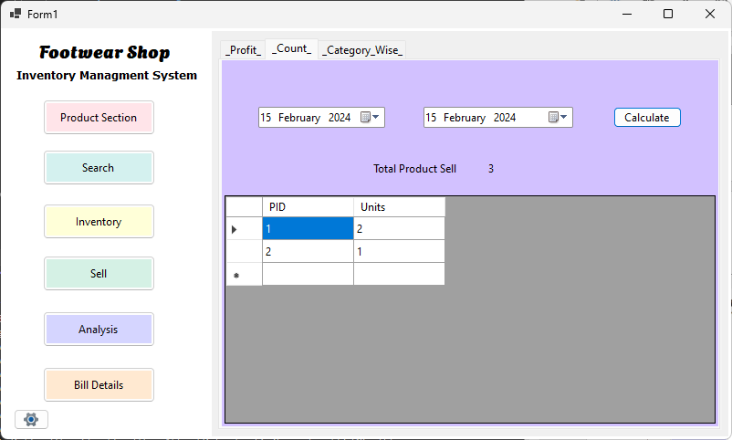

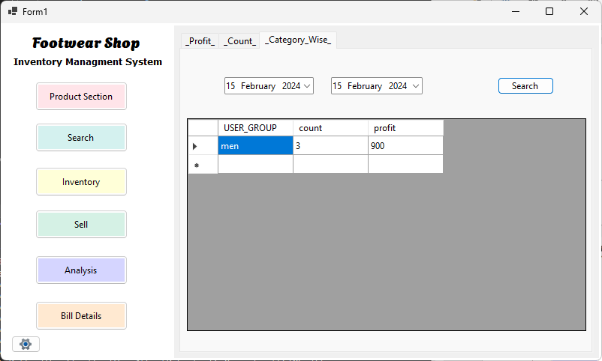

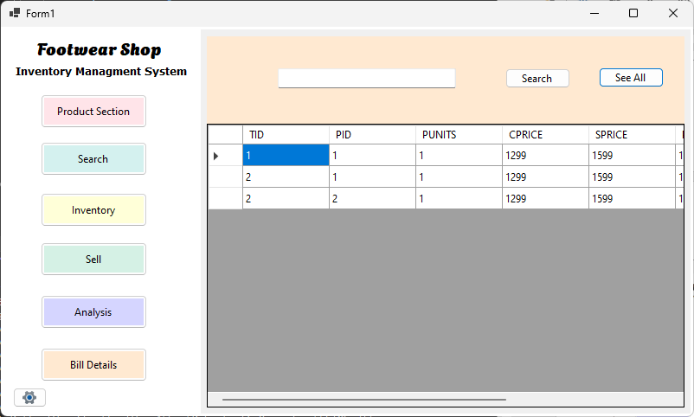

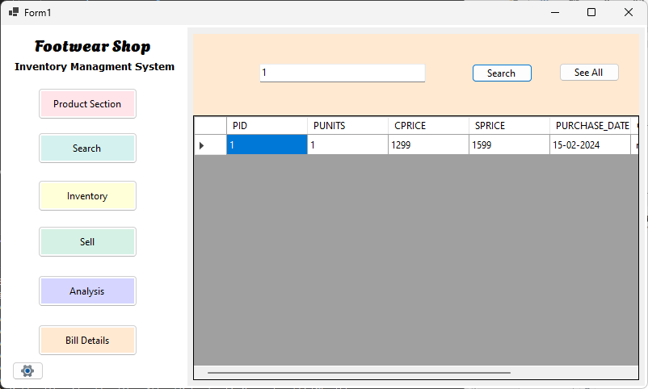

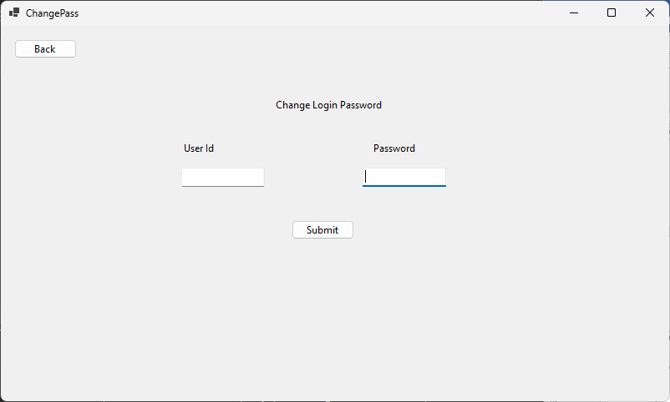

8 Source Code

CnagePass.vb
Imports System.Data.SQLite
Imports System.Text.RegularExpressions

Public Class ChangePass
Private Sub ChagnePassBtn_Click(sender As Object, e As EventArgs) Handles ChagnePassBtn.Click
conn.Open()
Dim password = pass2TBox.Text
If (password.Length >= 6 AndAlso
Regex.Match(password, "[a-z]", RegexOptions.ECMAScript).Success AndAlso
Regex.Match(password, "[A-Z]", RegexOptions.ECMAScript).Success AndAlso
Regex.Match(password, "\d", RegexOptions.ECMAScript).Success AndAlso
Regex.Match(password, "[!,@,#,$,%,^,&,*,?,_,~,-,£,(,)]", RegexOptions.ECMAScript).Success) Then

Dim sqlite_cmd As SQLiteCommand
sqlite_cmd = conn.CreateCommand()

sqlite_cmd.CommandText = "select * from login_table"
Dim reader = sqlite_cmd.ExecuteReader
If reader.HasRows Then

Dim cm As SQLiteCommand
cm = conn.CreateCommand

cm.CommandText = "update LOGIN_TABLE set uname = '" & id2TBox.Text & "', upass = '" & pass2TBox.Text & "' where constant = 'login'"
cm.ExecuteNonQuery()
conn.Close()

Else
Dim cmd As New SQLiteCommand
cmd = conn.CreateCommand
cmd.CommandText = "insert into LOGIN_TABLE (UNAME,UPASS,CONSTANT) values('" & id2TBox.Text & "','" & pass2TBox.Text & "','login')"

cmd.ExecuteNonQuery()
conn.Close()
End If

MsgBox("password change successfull")

Else
MsgBox("password must be 6 character long and contain a capital and small letter, a number and a special character")
End If

conn.Close()
End Sub

Private Sub BackBtn_Click(sender As Object, e As EventArgs) Handles BackBtn.Click
Me.Hide()
HomeForm.Show()
End Sub

Private Sub ChangePass_Closed(sender As Object, e As EventArgs) Handles MyBase.Closed
loginForm.Close()
End Sub
End Class

CommonModule.vb
'Imports Oracle.ManagedDataAccess.Client
Imports System.Data.SQLite
Module CommonModule
' Public cnn As New OracleConnection("DATA SOURCE=mydell:1521;USER ID=fsims;PASSWORD=fsims")
Public conn As SQLiteConnection = New SQLiteConnection("Data Source=database.fsims;Version=3;")

End Module

FilterViewForm.vb

Imports System.Data.SQLite

Public Class FilterViewForm
Private Sub FilterBtn_Click(sender As Object, e As EventArgs) Handles FilterBtn.Click
Dim pid As String = PIdTBox.Text
Dim pname As String = PNameTBox.Text
Dim psize As String = PSizeTBox.Text
Dim pstyle_name As String = PStyle_NameTBox.Text
Dim pbrand As String = PBrandTBox.Text
Dim pcolor As String = PColorTBox.Text
Dim user_group As String = User_GroupTBox.Text
Dim product_type As String = Product_TypeTBox.Text
Dim hile_type As String = Hile_TypeTBox.Text
Dim outer_material As String = Outer_MaterialTBox.Text
Dim sole_material As String = Sole_MaterialTBox.Text
Dim water_resistance_level As String = Water_Resistance_LevelTBox.Text
Dim closure_type As String = Closure_TypeTBox.Text

If PIdTBox.Text = "" Then
pid = "%"
End If

If pname = "" Then
pname = "%"
End If

If psize = "" Then
psize = "%"
End If

If pstyle_name = "" Then
pstyle_name = "%"
End If

If pbrand = "" Then
pbrand = "%"
End If

If pcolor = "" Then
pcolor = "%"
End If

If user_group = "" Then
user_group = "%"
End If

If product_type = "" Then
product_type = "%"
End If

If hile_type = "" Then
hile_type = "%"
End If

If outer_material = "" Then
outer_material = "%"
End If

If sole_material = "" Then
sole_material = "%"
End If

If water_resistance_level = "" Then
water_resistance_level = "%"
End If

If closure_type = "" Then
closure_type = "%"
End If

Dim Query As String

Query = "select * from inventory_table where
pid like '" & pid & "' and
pname like '" & pname & "' and
psize like '" & psize & "' and
pstyle_name like '" & pstyle_name & "' and
pbrand like '" & pbrand & "' and
pcolor like '" & pcolor & "' and
user_group like '" & user_group & "' and
product_type like '" & product_type & "' and
hile like '" & hile_type & "' and
sole_material like '" & sole_material & "' and
outer_material like '" & outer_material & "' and
water_resistance like '" & water_resistance_level & "' and
closure_type like '" & closure_type & "' "

conn.Open()
Dim cmd As New SQLiteCommand(Query, conn)
Dim reader As SQLiteDataReader = cmd.ExecuteReader
Dim dt As New DataTable
dt.Load(reader)
DataGridView1.DataSource = dt
conn.Close()
End Sub

Private Sub BackBtn_Click(sender As Object, e As EventArgs) Handles BackBtn.Click
Me.Hide()
HomeForm.Show()
End Sub
End Class

HomeForm.vb

Imports System.Data.SQLite
Imports System.Drawing.Printing
Imports System.Text.RegularExpressions
Public Class HomeForm
Private Sub AddItemsToComboBox()

conn.Open()

Dim cmd As New SQLiteCommand("select pid from inventory_table", conn)
Dim da As New SQLiteDataAdapter(cmd)
Dim db As DataTable = New DataTable
da.Fill(db)

ComboBox1.DisplayMember = "pid"
ComboBox1.ValueMember = "pid"
ComboBox1.DataSource = db
conn.Close()
End Sub

Private Sub Ref_Click(sender As Object, e As EventArgs) Handles Ref.Click
Call AddItemsToComboBox()
Call FillInvetoryToDataGrideView()
End Sub
Sub FillInvetoryToDataGrideView()
conn.Open()
Dim cmd As New SQLiteCommand("select * from inventory_table order by pid", conn)
Dim reader As SQLiteDataReader = cmd.ExecuteReader
Dim DT As New DataTable
DT.Load(reader)
DGVForInventory.DataSource = DT
conn.Close()
End Sub

Private Sub ProductBtn_Click(sender As Object, e As EventArgs) Handles ProductBtn.Click
TabControl1.SelectedTab = TabPage1
End Sub

Private Sub InventoryBtn_Click(sender As Object, e As EventArgs) Handles InventoryBtn.Click
TabControl1.SelectedTab = TabPage2
End Sub

Private Sub GoToAddProductFormBtn_Click(sender As Object, e As EventArgs) Handles GoToAddProductFormBtn.Click
Me.Hide()
ProductForm.Show()
End Sub

Private Sub GoToProductEditFormBtn_Click(sender As Object, e As EventArgs) Handles GoToProductEditFormBtn.Click, GoToProductEditFormBtn2.Click
Me.Hide()
ProductEditForm.Show()
End Sub

Private Sub AddInventoryBtn_Click(sender As Object, e As EventArgs) Handles AddInventoryBtn.Click
Dim pid As Integer = Integer.Parse(ComboBox1.SelectedValue)
Dim cprice As Integer = Integer.Parse(CPriceTBox.Text)
Dim Sprice As Integer = Integer.Parse(SPriceTBox.Text)
Dim punits_available As Integer = Integer.Parse(ProcutUnitsTBox.Text)

conn.Open()

Dim Query2 As String = "update inventory_table set cprice = " & cprice & ",sprice = " & Sprice & ", punits_available = " & punits_available & " where pid = " & pid
Dim cmd3 As SQLiteCommand
cmd3 = conn.CreateCommand
cmd3.CommandText = Query2
cmd3.ExecuteNonQuery()
conn.Close()

Call FillInvetoryToDataGrideView()
End Sub

Private Sub HomeForm_Load(sender As Object, e As EventArgs) Handles MyBase.Load
Call AddItemsToComboBox()
Call FillInvetoryToDataGrideView()
TabControl1.Appearance = TabAppearance.FlatButtons
TabControl1.ItemSize = New Size(0, 1)
TabControl1.SizeMode = TabSizeMode.Fixed
End Sub

Private Sub SellBtn_Click(sender As Object, e As EventArgs) Handles SellBtn.Click
TabControl1.SelectedTab = TabPage3

conn.Open()
Dim cmd As New SQLiteCommand("select pid from inventory_table", conn)
Dim da As New SQLiteDataAdapter(cmd)
Dim db As DataTable = New DataTable
da.Fill(db)

pid2CBox.DisplayMember = "pid"
pid2CBox.ValueMember = "pid"
pid2CBox.DataSource = db
conn.Close()
End Sub

Dim sprice As Integer
Dim i = 0
Dim GrandTotal As Long = 0
Dim punits_available As Integer
Dim punits As Integer
Dim pid As Integer
Private Sub Button5_Click(sender As Object, e As EventArgs) Handles Button5.Click

Dim cname As String = CNameTBox.Text
Dim cphone As Long

Try
pid = Integer.Parse(pid2CBox.Text)
If CPhoneTBox.Text.Length = 10 Then
cphone = Long.Parse(CPhoneTBox.Text)
Else
cphone = 0
End If

punits = Integer.Parse(pUnits2TBox.Text)

Catch ex As Exception
' MsgBox(ex.Message)

pid = -1
cphone = 0
punits = 0
End Try

Dim pname As String
Dim cprice As Integer

conn.Open()
Dim cmd As New SQLiteCommand("select pname,cprice,sprice,punits_available from inventory_table where pid=" & pid, conn)
Dim reader As SQLiteDataReader = cmd.ExecuteReader
While reader.Read

'pname = reader.GetString(4)
'cprice = Integer.Parse(reader.GetString(1))
'sprice = Integer.Parse(reader.GetString(2))
'punits_available = Integer.Parse(reader.GetString(3))

pname = reader.GetString(0)
cprice = reader.GetInt32(1)
sprice = reader.GetInt32(2)
punits_available = reader.GetInt32(3)
' MsgBox(reader.GetDataTypeName(2))

'' pname = reader.GetString(0)
'pname = "hlsfjda"
'' cprice = reader.GetInt32(1)
'cprice = 83
'' sprice = Integer.Parse(reader.GetString(2))
'sprice = 232

'MsgBox(reader.GetString(0) & " -" & reader.GetInt32(1) & " - " & reader.GetInt32(2))
'' punits_available = Integer.Parse(reader.GetString(3))
'punits_available = 212
End While
conn.Close()
If pid = -1 Then
MsgBox("Please enter product id")

ElseIf cphone = 0 Then
MsgBox("Enter correct phone number")
ElseIf punits = 0 Then
MsgBox("Enter valid product quantity")
ElseIf punits <= punits_available Then
Dim rnum As Integer = BillDGV.Rows.Add()
' Dim total = Integer.Parse(pUnits2TBox.Text) * 400

i = i + 1
BillDGV.Rows.Item(rnum).Cells("No").Value = i
BillDGV.Rows.Item(rnum).Cells("Product_Name").Value = pname
BillDGV.Rows.Item(rnum).Cells("Product_ID").Value = pid
BillDGV.Rows.Item(rnum).Cells("Price").Value = sprice
BillDGV.Rows.Item(rnum).Cells("Units").Value = punits
BillDGV.Rows.Item(rnum).Cells("Total_Price").Value = sprice * punits

GrandTotal += (sprice * punits)

Call update()
Else
MsgBox("Stock not available")
End If

GrandTotalLabel.Text = GrandTotal

End Sub

Sub update()
conn.Open()
Dim Query As String = "update inventory_table set punits_available= " & punits_available - punits & " where pid =" & pid
Dim cmd As New SQLiteCommand(Query, conn)
cmd.ExecuteNonQuery()
conn.Close()
End Sub

Dim tid
Private Sub GenerateBillBtn_Click(sender As Object, e As EventArgs) Handles GenerateBillBtn.Click

Dim rowCount As Integer = BillDGV.RowCount
Dim pid As Integer
Dim Unit As Integer
Dim Today As Date = Date.Now
Dim TodayStr As String = Format(Today, "yyyy-MM-dd")

Dim cprice As Integer
Dim sprice As Integer

Dim cname As String = CNameTBox.Text
Dim cphone As String = CPhoneTBox.Text

conn.Open()
Dim cmd As New SQLiteCommand("Select max(tid) from selles_table", conn)
Dim reader As SQLiteDataReader = cmd.ExecuteReader
While reader.Read
Try
tid = reader.GetInt32(0)
tid += 1
Catch
tid = 1
End Try
End While
conn.Close()

For j As Integer = 0 To rowCount - 1
pid = Integer.Parse(BillDGV.Item(2, j).Value)
Unit = Integer.Parse(BillDGV.Item(4, j).Value)

conn.Open()
Dim Query As String = "select * from inventory_table where pid = " & pid
Dim cmd2 As New SQLiteCommand(Query, conn)
Dim r As SQLiteDataReader = cmd2.ExecuteReader
While r.Read
cprice = r.GetInt32(1)
sprice = r.GetInt32(2)
End While

Dim Query2 = "insert into selles_table (tid,pid,punits,cprice,sprice,purchase_date,cname,cphone) values(
" & tid & ",
" & pid & ",
" & Unit & ",
" & cprice & ",
" & sprice & ",
DATE('" & TodayStr & "'),
' " & cname & "',
" & cphone & "

)"

Dim cmd3 As New SQLiteCommand(Query2, conn)
cmd3.ExecuteNonQuery()
conn.Close()
Next

'TO_DATE(' " & TodayStr & "','DD-MM-YYYY'),

ppd.Document = pd
ppd.ShowDialog()

CNameTBox.Text = ""
CPhoneTBox.Text = ""
pUnits2TBox.Text = ""
BillDGV.Rows.Clear()
GrandTotal = 0

End Sub

Private Sub HomeForm_Closed(sender As Object, e As EventArgs) Handles MyBase.Closed
loginForm.Close()

End Sub
Private Sub RemoveFromBillBtn_Click(sender As Object, e As EventArgs) Handles RemoveFromBillBtn.Click
If BillDGV.CurrentRow IsNot Nothing Then
Dim rowIndex As Integer = BillDGV.CurrentRow.Index
Dim colIndexUnit As Integer = 4
Dim colIndexpid As Integer = 2
Dim pid2 = Integer.Parse(BillDGV.Item(colIndexpid, rowIndex).Value)
Dim Unit = Integer.Parse(BillDGV.Item(colIndexUnit, rowIndex).Value)

Dim UnitAvailable
conn.Open()
Dim Query2 As String = "select punits_available from inventory_table where pid = " & pid
Dim cmd2 As New SQLiteCommand(Query2, conn)
Dim reader As SQLiteDataReader = cmd2.ExecuteReader
While reader.Read
UnitAvailable = reader.GetInt32(0)
End While

Dim sum As Integer = UnitAvailable + Unit

Dim Query As String = "update inventory_table set punits_available= " & sum & " where pid =" & pid2
Dim cmd As New SQLiteCommand(Query, conn)
cmd.ExecuteNonQuery()

conn.Close()

BillDGV.Rows.Remove(BillDGV.CurrentRow)

i = i - 1
GrandTotal = GrandTotal - (punits * sprice)
Else
MsgBox("Select a row from below to remove",, "")
End If
End Sub

Private Sub ProfitCalculateBtn_Click(sender As Object, e As EventArgs) Handles ProfitCalculateBtn.Click
conn.Open()
Dim profit
Dim D1 = DateTimePicker1.Value
Dim da1 As String = Format(D1, "yyyy-MM-dd")

Dim D2 = DateTimePicker2.Value
Dim da2 As String = Format(D2, "yyyy-MM-dd")

Dim Query As String = "select SUM((sprice - cprice)*punits) as profit from selles_table where purchase_date >= DATE('" & da1 & "') AND Purchase_date <= DATE('" & da2 & "')"
Dim cmd As New SQLiteCommand(Query, conn)
Dim r As SQLiteDataReader = cmd.ExecuteReader
Try

While r.Read
profit = r.GetInt32(0)
End While
Catch exception As Exception
' MsgBox(exception.Message & profit)

profit = 0
End Try

ProfitLabel.Text = profit

' select SUM((sprice - cprice)*punits) as profit from selles_table where purchase_date >= TO_DATE('21-01-2024','DD-MM-YYYY') AND Purchase_date <= TO_DATE('21-01-2024','DD-MM-YYYY')

Query = "select pid,SUM((sprice - cprice)*punits) as profit from selles_table where purchase_date >= DATE('" & da1 & "') AND Purchase_date <= DATE('" & da2 & "') group by pid"

cmd = New SQLiteCommand(Query, conn)
r = cmd.ExecuteReader

Dim dt As New DataTable
dt.Load(r)
PPofitDGV.DataSource = dt

conn.Close()

End Sub

Private Sub A2Btn_Click(sender As Object, e As EventArgs) Handles A2Btn.Click
conn.Open()
Dim TotalProdut
Dim D1 = DateTimePicker3.Value
Dim da1 As String = Format(D1, "yyyy-MM-dd")

Dim D2 = DateTimePicker4.Value
Dim da2 As String = Format(D2, "yyyy-MM-dd")

Dim Query As String = "select SUM(PUNITS) from selles_table where purchase_date >= DATE('" & da1 & "') AND Purchase_date <= DATE('" & da2 & "')"
Dim cmd As New SQLiteCommand(Query, conn)
Dim r As SQLiteDataReader = cmd.ExecuteReader
Try

While r.Read
TotalProdut = r.GetInt32(0)
End While
Catch
TotalProdut = 0
End Try

TotalProductLabel.Text = TotalProdut

Query = "select pid,SUM(punits) as Units from selles_table where purchase_date >= DATE('" & da1 & "') AND Purchase_date <= DATE('" & da2 & "') group by pid"
cmd = New SQLiteCommand(Query, conn)
r = cmd.ExecuteReader

Dim dt As New DataTable
dt.Load(r)
PSellDGV.DataSource = dt

conn.Close()

End Sub

Private Sub SearchBtn_Click(sender As Object, e As EventArgs) Handles SearchBtn.Click
Me.Hide()
FilterViewForm.Show()

'cnn.Open()
'Dim cmd As New OracleCommand("select pid from inventory_table", cnn)
'Dim da As New OracleDataAdapter(cmd)
'Dim db As DataTable = New DataTable
'da.Fill(db)

'FilterViewForm.ComboBoxForid.DisplayMember = "pid"
'FilterViewForm.ComboBoxForid.ValueMember = "pid"
'FilterViewForm.ComboBoxForid.DataSource = db
'cnn.Close()
End Sub

Private Sub transactionBtn_Click(sender As Object, e As EventArgs) Handles transactionBtn.Click
TabControl1.SelectedTab = TabPage5

'cnn.Open()
'Dim cmd As New OracleCommand("select tid from selles_table group by tid", cnn)
'Dim a As New OracleDataAdapter(cmd)
'Dim d As DataTable = New DataTable

'TIDCBox.DisplayMember = "tid"
'TIDCBox.ValueMember = "tid"
'a.Fill(d)
'TIDCBox.DataSource = d

'cnn.Close()

End Sub

Private Sub PRrefreshBtn_Click(sender As Object, e As EventArgs) Handles PRrefreshBtn.Click
conn.Open()

Dim cmd As New SQLiteCommand("select * from inventory_table ", conn)
Dim reader As SQLiteDataReader = cmd.ExecuteReader
Dim dt As New DataTable
dt.Load(reader)
prductDGV3.DataSource = dt

conn.Close()

End Sub

Private Sub AnalysisBtn_Click(sender As Object, e As EventArgs) Handles AnalysisBtn.Click
TabControl1.SelectedTab = TabPage4
End Sub

Dim WithEvents pd As New PrintDocument
Dim ppd As New PrintPreviewDialog

' Handle the PrintPage event of the PrintDocument
Private Sub pd_PrintPage(sender As Object, e As PrintPageEventArgs) Handles pd.PrintPage
Dim g As Graphics = e.Graphics
Dim font As New Font("Arial", 10)
Dim margin As Integer = 50
Dim colCount As Integer = BillDGV.ColumnCount
Dim rowCount As Integer = BillDGV.RowCount
Dim dgvWidth As Integer = BillDGV.Width
Dim dgvHeight As Integer = BillDGV.Height
Static curPage As Integer = 0
Static curRow As Integer = 0

' Calculate the number of pages
Dim pages As Integer = Math.Ceiling(dgvHeight / (e.MarginBounds.Height - margin * 2))

e.Graphics.DrawString("Footwear Shop", New Font("Arial", 22), Brushes.CadetBlue, 335, 35)
e.Graphics.DrawString("***Bill***", New Font("Arial", 14), Brushes.Black, 350, 75)
e.Graphics.DrawString("Customer Name : " & CNameTBox.Text, New Font("Arial", 13), Brushes.Black, e.MarginBounds.Left, 100)
e.Graphics.DrawString("Customer Phone No. : " & CPhoneTBox.Text, New Font("Arial", 13), Brushes.Black, e.MarginBounds.Left, 120)
e.Graphics.DrawString("Transaction No. : " & tid, New Font("Arial", 13), Brushes.Black, e.MarginBounds.Left, 140)
e.Graphics.DrawString("Date : " & DateString, New Font("Arial", 13), Brushes.Black, e.MarginBounds.Left, 160)

Dim x As Integer = e.MarginBounds.Left
Dim y As Integer = e.MarginBounds.Top + 100
Dim cell As Rectangle

For i As Integer = 0 To colCount - 1
cell = New Rectangle(x, y, BillDGV.Columns(i).Width, BillDGV.ColumnHeadersHeight)
g.DrawString(BillDGV.Columns(i).HeaderText, font, Brushes.Black, cell, StringFormat.GenericTypographic)
x += cell.Width
Next

' Draw the rows
y += BillDGV.ColumnHeadersHeight
For i As Integer = curRow To rowCount - 1
If y + BillDGV.Rows(i).Height > e.MarginBounds.Bottom - margin Then
' The current row does not fit in the page, so print the current page and exit
curRow = i
curPage += 1
e.HasMorePages = True
Return
End If
x = e.MarginBounds.Left
For j As Integer = 0 To colCount - 1
cell = New Rectangle(x, y, BillDGV.Columns(j).Width, BillDGV.Rows(i).Height)
g.DrawString(BillDGV(j, i).Value.ToString(), font, Brushes.Black, cell, StringFormat.GenericTypographic)
x += cell.Width
Next
y += BillDGV.Rows(i).Height
Next

e.Graphics.DrawString("Total Amount : " + GrandTotal.ToString(), New Font("Arial", 15), Brushes.Crimson, x - 250, y + 50)
' All rows have been printed, so reset the current page and the current row
curPage = 0
curRow = 0
e.HasMorePages = False
End Sub

Private Sub Button1_Click(sender As Object, e As EventArgs) Handles Button1.Click
conn.Open()

Dim D1 = DateTimePicker5.Value
Dim da1 As String = Format(D1, "yyyy-MM-dd")

Dim D2 = DateTimePicker6.Value
Dim da2 As String = Format(D2, "yyyy-MM-dd")

Dim Query As String = "select user_group,sum(punits) As count , sum((selles_table.SPRICE - selles_table.cprice)*punits) as profit from selles_table,inventory_table where purchase_date >= DATE('" & da1 & "') AND Purchase_date <= DATE('" & da2 & "') and selles_table.pid = inventory_table.pid group by USER_GROUP"

Dim cmd As New SQLiteCommand(Query, conn)
Dim reader As SQLiteDataReader = cmd.ExecuteReader
Dim DT As New DataTable
DT.Load(reader)
UserGroupGDV.DataSource = DT
conn.Close()
End Sub

Private Sub Button2_Click(sender As Object, e As EventArgs) Handles Button2.Click

If Regex.Match(TextBox1.Text, "\d", RegexOptions.ECMAScript).Success Then
conn.Open()

Dim Query As String = "select pid,punits,cprice,sprice,purchase_date,cname,cphone from selles_table where tid = " & Integer.Parse(TextBox1.Text)
Dim cmd As New SQLiteCommand(Query, conn)
Dim reader As SQLiteDataReader = cmd.ExecuteReader
Dim dt As New DataTable
dt.Load(reader)
TDGV1.DataSource = dt
conn.Close()
Else
MsgBox("Please Enter valid transaction id",, "")
End If

End Sub

Private Sub Button3_Click(sender As Object, e As EventArgs) Handles Button3.Click
conn.Open()

Dim Query As String = "select tid,pid,punits,cprice,sprice,purchase_date,cname,cphone from selles_table "
Dim cmd As New SQLiteCommand(Query, conn)
Dim reader As SQLiteDataReader = cmd.ExecuteReader
Dim dt As New DataTable
dt.Load(reader)
TDGV1.DataSource = dt
conn.Close()
End Sub

Private Sub pid2CBox_SelectedIndexChanged(sender As Object, e As EventArgs) Handles pid2CBox.SelectedIndexChanged

End Sub

Private Sub SettingBtn_Click(sender As Object, e As EventArgs) Handles SettingBtn.Click
Me.Hide()
ChangePass.Show()
End Sub
End Class

loginForm.vb
Imports System.Data.OracleClient
Imports System.Data.SQLite
Imports System.Diagnostics.Eventing.Reader
Imports System.DirectoryServices

Public Class loginForm
Private Sub Button1_Click(sender As Object, e As EventArgs) Handles Button1.Click
conn.Open()
Dim cmd As New SQLiteCommand
cmd = conn.CreateCommand
cmd.CommandText = "select * from login_table"
Dim reader As SQLiteDataReader = cmd.ExecuteReader
Dim id As String
Dim pass As String

If reader.HasRows Then
While reader.Read()
id = reader.GetString(0)
pass = reader.GetString(1)
End While

' If ((id.Equals(idTBox.Text)) And (pass.Equals(passTBox.Text))) Then
If True Then
conn.Close()
Me.Hide()
HomeForm.Show()
Else
' Dim i As String = CStr())
' MsgBox(id & pass & idTBox.Text & passTBox.Text & i)
MsgBox("Wrong Login Password")
End If
Else
conn.Close()
Me.Hide()
HomeForm.Show()

End If

conn.Close()
End Sub

Private Sub loginForm_Load(sender As Object, e As EventArgs) Handles MyBase.Load
conn.Open()

Dim sqlite_cmd As SQLiteCommand
sqlite_cmd = conn.CreateCommand()

sqlite_cmd.CommandText =
"CREATE TABLE IF NOT EXISTS INVENTORY_TABLE
( PID NUMBER(0),
CPRICE NUMBER(0),
SPRICE NUMBER(0),
PUNITS_AVAILABLE NUMBER(0),
PNAME VARCHAR2(100),
PSIZE NUMBER,
PSTYLE_NAME VARCHAR2(100),
PBRAND VARCHAR2(100),
PCOLOR VARCHAR2(100),
USER_GROUP VARCHAR2(100),
PRODUCT_TYPE VARCHAR2(100),
HILE NUMBER(0),
OUTER_MATERIAL VARCHAR2(100),
SOLE_MATERIAL VARCHAR2(100),
WATER_RESISTANCE VARCHAR2(100),
CLOSURE_TYPE VARCHAR2(100)
)"

sqlite_cmd.ExecuteNonQuery()

sqlite_cmd.CommandText = "
CREATE TABLE IF NOT EXISTS SELLES_TABLE
( TID NUMBER(0),
PID NUMBER(0),
PUNITS NUMBER(0),
CPRICE NUMBER(0),
SPRICE NUMBER(0),
PURCHASE_DATE DATE,
CNAME VARCHAR2(100),
CPHONE NUMBER(10)
)"

sqlite_cmd.ExecuteNonQuery()

sqlite_cmd.CommandText = "
CREATE TABLE IF NOT EXISTS LOGIN_TABLE
(
UNAME VARCHAR2(100),
UPASS VARCHAR2(2000),
CONSTANT VARCHAR2(12)
)"

sqlite_cmd.ExecuteNonQuery()
conn.Close()
End Sub

End Class

ProductEditForm.vb

Imports System.Data.SQLite

Public Class ProductEditForm
Private Sub ProductEditForm_Load(sender As Object, e As EventArgs) Handles MyBase.Load
Call AddItemsToComboBox()

End Sub

Private Sub AddItemsToComboBox()
conn.Open()
Dim cmd As New SQLiteCommand("select pid from inventory_table", conn)
Dim da As New SQLiteDataAdapter(cmd)
Dim db As DataTable = New DataTable
da.Fill(db)

ComboBox1.DisplayMember = "pid"
ComboBox1.ValueMember = "pid"
ComboBox1.DataSource = db
conn.Close()
End Sub

Private Sub EditBtn_Click(sender As Object, e As EventArgs) Handles EditBtn.Click
Dim re As MsgBoxResult = MsgBox("Are You Sure ? this cannot be undo ", MsgBoxStyle.OkCancel, "")
If re.Yes Then
conn.Open()

Dim pid As Integer = Integer.Parse(ComboBox1.SelectedValue)

Dim pname As String = PNameTBox.Text
Dim psize As Integer = Integer.Parse(PSizeTBox.Text)
Dim pstyle_name As String = PStyle_NameTBox.Text
Dim pbrand As String = PBrandTBox.Text
Dim pcolor As String = PColorTBox.Text
Dim user_group As String = User_GroupTBox.Text
Dim product_type As String = Product_TypeTBox.Text
Dim hile As Integer = Integer.Parse(Hile_TypeTBox.Text)
Dim outer_material As String = Outer_MaterialTBox.Text
Dim sole_material As String = Sole_MaterialTBox.Text
Dim water_resistance_level As String = Water_Resistance_LevelTBox.Text
Dim closure_type As String = Closure_TypeTBox.Text

Dim Query As String = "update inventory_table
set pname = '" & pname & "',
psize = " & psize & ",
pstyle_name = '" & pstyle_name & "',
pbrand = '" & pbrand & "',
pcolor = '" & pcolor & "',
user_group = '" & user_group & "',
product_type = '" & product_type & "',
hile = " & hile & ",
outer_material = '" & outer_material & "',
sole_material = '" & sole_material & "',
water_resistance = '" & water_resistance_level & "',
closure_type = '" & closure_type & "'

where pid = " & pid & "
"

Dim cmd As New SQLiteCommand(Query, conn)
cmd.ExecuteNonQuery()
conn.Close()

End If
End Sub

Private Sub SearchBtn_Click(sender As Object, e As EventArgs) Handles SearchBtn.Click
Dim pid As Integer = Integer.Parse(ComboBox1.SelectedValue)

conn.Open()
Dim Query As String = "select * from inventory_table where pid = " & pid
Dim cmd As New SQLiteCommand(Query, conn)
Dim reader As SQLiteDataReader = cmd.ExecuteReader
While reader.Read
PNameTBox.Text = reader.GetString(4)
PSizeTBox.Text = reader.GetInt32(5)
PStyle_NameTBox.Text = reader.GetString(6)
PBrandTBox.Text = reader.GetString(7)
PColorTBox.Text = reader.GetString(8)
User_GroupTBox.Text = reader.GetString(9)
Product_TypeTBox.Text = reader.GetString(10)
Hile_TypeTBox.Text = reader.GetInt32(11)
Outer_MaterialTBox.Text = reader.GetString(12)
Sole_MaterialTBox.Text = reader.GetString(13)
Water_Resistance_LevelTBox.Text = reader.GetString(14)
Closure_TypeTBox.Text = reader.GetString(15)
End While
conn.Close()

End Sub

Private Sub DeleteBtn_Click(sender As Object, e As EventArgs) Handles DeleteBtn.Click
Dim pid As Integer = Integer.Parse(ComboBox1.Text)
Dim re As MsgBoxResult = MsgBox("Are You Sure Delete a product which id is " & pid, MsgBoxStyle.OkCancel, "")
If re.Yes Then
conn.Open()

Dim Query As String = "delete from inventory_table where pid = " & pid
Dim cmd As SQLiteCommand
cmd = conn.CreateCommand
cmd.CommandText = Query
cmd.ExecuteNonQuery()

'Query = "delete inventory_table where pid = " & pid
'cmd = New OracleCommand(Query, cnn)
'cmd.ExecuteNonQuery()

conn.Close()

Call AddItemsToComboBox()

PNameTBox.Text = ""
PSizeTBox.Text = ""
PStyle_NameTBox.Text = ""
PBrandTBox.Text = ""
PColorTBox.Text = ""
User_GroupTBox.Text = ""
Product_TypeTBox.Text = ""
Hile_TypeTBox.Text = ""
Outer_MaterialTBox.Text = ""
Sole_MaterialTBox.Text = ""
Water_Resistance_LevelTBox.Text = ""
Closure_TypeTBox.Text = ""

End If
End Sub

Private Sub BackBtn2_Click(sender As Object, e As EventArgs) Handles BackBtn2.Click
Me.Hide()
HomeForm.Show()
End Sub

Private Sub ProductEditForm_Closed(sender As Object, e As EventArgs) Handles MyBase.Closed
loginForm.Close()

End Sub
End Class

ProductForm.vb

Imports System.Data.SQLite

Public Class ProductForm
Private Sub AddBtn_Click(sender As Object, e As EventArgs) Handles AddBtn.Click
conn.Open()

Dim pid As Integer
Dim Query As String = "select max(pid) from inventory_table"

Dim cmd As New SQLiteCommand(Query, conn)

Dim reader As SQLiteDataReader = cmd.ExecuteReader

Try
While reader.Read
pid = reader.GetInt32(0)
pid += 1
End While
Catch
pid = 1
End Try
conn.Close()

Dim pname As String = PNameTBox.Text
Dim psize As Integer = Integer.Parse(PSizeTBox.Text)
Dim pstyle_name As String = PStyle_NameTBox.Text
Dim pbrand As String = PBrandTBox.Text
Dim pcolor As String = PColorTBox.Text
Dim user_group As String = User_GroupTBox.Text
Dim product_type As String = Product_TypeTBox.Text
Dim hile As Integer = Integer.Parse(Hile_TypeTBox.Text)
Dim outer_material As String = Outer_MaterialTBox.Text
Dim sole_material As String = Sole_MaterialTBox.Text
Dim water_resistance_level As String = Water_Resistance_LevelTBox.Text
Dim closure_type As String = Closure_TypeTBox.Text

Query = "insert into inventory_table (punits_available,cprice,sprice,pid,pname,psize,pstyle_name,pbrand,pcolor,user_group,product_type,hile,outer_material,sole_material,water_resistance,closure_type) values
(
0,0,0,
" & pid & ",
'" & pname & "',
" & psize & ",
'" & pstyle_name & "',
'" & pbrand & "',
'" & pcolor & "',
'" & user_group & "',
'" & product_type & "',
" & hile & ",
'" & outer_material & "',
'" & sole_material & "',
'" & water_resistance_level & "',
'" & closure_type & "'
)"
conn.Open()
' cmd = New SQLiteCommand(Query, conn)
Dim cmd2 = conn.CreateCommand
cmd2.CommandText = Query
cmd2.ExecuteNonQuery()
conn.Close()
MsgBox("Product Added successfully",, "")
End Sub

Private Sub BackBtn1_Click(sender As Object, e As EventArgs) Handles BackBtn1.Click
Me.Hide()
HomeForm.Show()
End Sub

Private Sub ProductForm_Closed(sender As Object, e As EventArgs) Handles MyBase.Closed
loginForm.Close()

End Sub

End Class

9. Future Enhancement

- Multiuser system can be implemented.
- Improvie graphical user interface.
- Optimize for performance.
- Can be connect to central data center.

10. Conclusion

This software has completed is purpose of digitizing the maintaining the record of stocks and generate bill which can be done in manual manner user pen and pepper. But more future enhancement is required for better user experience.

11. Bibliography and References

- MSDN online by Microsoft
- The Complete Reference VB.NET by Jeffery R. Shapiro, Tata McGraw Hill.
- GeekForGeeks.com

