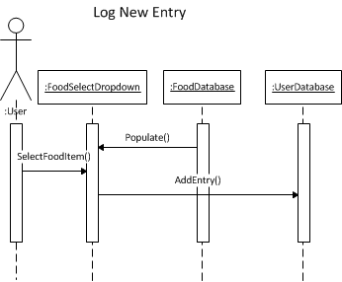

This diagram illustrates how procedure calls are fired between objects when the user logs a new entry about his meal. From the front page, user will interact with a UI feature, possibly a dropdown menu, that is populated from the FoodDatabase object to select the correct food that was consumed. After selecting the food item, user will trigger another UI feature that will fire the “SelectFoodItem” function, from which the Dropdown object will call “AddEntry” method with the parameter which is the food item selected by the user. This will update the UserDatabase object accordingly.

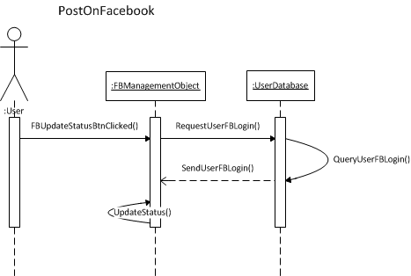

This diagram illustrates PostOnFacebook sequence of our application. User will first click the button named “FBUpdateStatusBtn” which calls the FBManagement object. This object will then request user’s FB Login information from the UserDatabase object. After the login information is received, the FBManagement object will call function “UpdateStatus” which will employ Facebook API to update user’s status on Facebook.

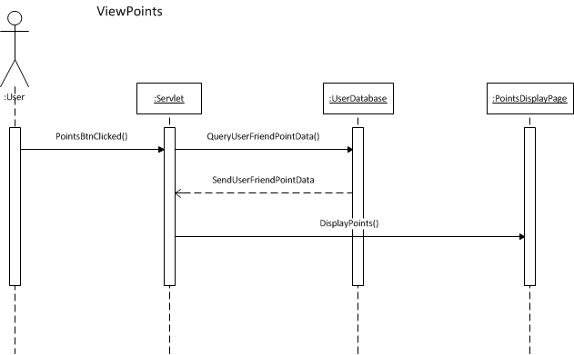

This diagram demonstrates the sequence for the user to view points that they scored. From the front page, user will click on a button named PointsBtn which will call the servlet object. Servlet will then query current user’s points information from the UserDatabase object. After the servlet receives this information, it will redirect the user to “PointsDisplayPage,” calling the function “DisplayPoints” which will paint a chart or a graph with the points information received from the database.