https://www.hackerearth.com/problem/algorithm/prime-numbers/
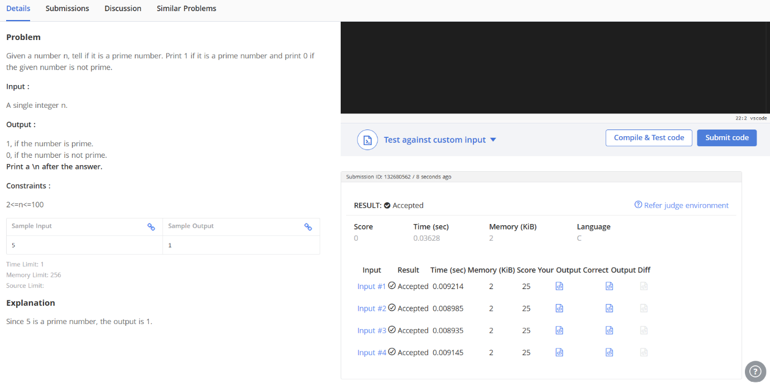

#include <stdio.h>

int main() {
int num, i, prime = 1;

scanf("%d", &num);

if (num < 2) {
prime = 0;
} else {
for (i = 2; i <= num / 2; i++) {
if (num % i == 0) {
prime = 0;
break;
}
}
}

printf("%d\n", prime);

return 0;
}

