https://www.hackerearth.com/practice/basic-programming/input-output/basics-of-input-output/practice-problems/algorithm/io-exercise/

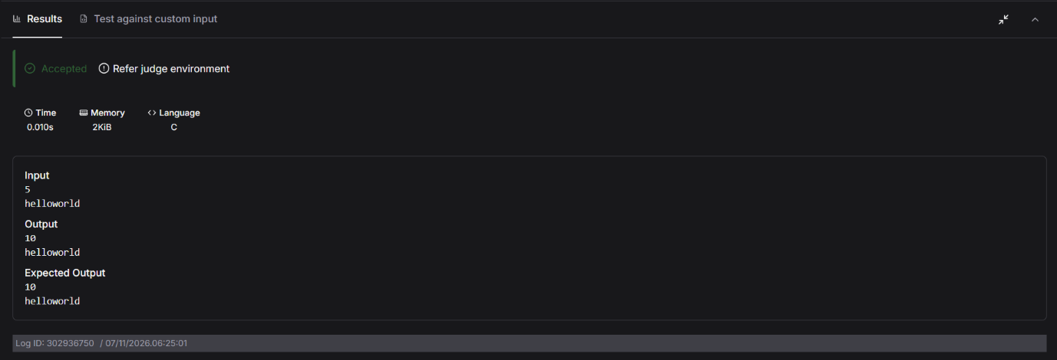

int main(){
int num;
scanf("%d", &num);

char str[20];
scanf("%s",&str) ;

printf("%d\n",num*2);
printf("%s",str);
return 0;

}

