https://www.hackerrank.com/challenges/staircase/problem?isFullScreen=true
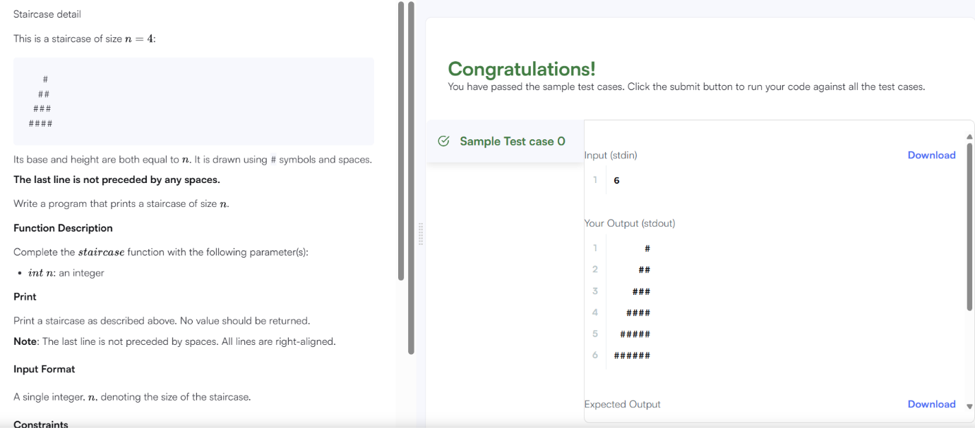

#include <stdio.h>

int main() {
int n;
scanf("%d", &n);

for (int i = 1; i <= n; i++) {

for (int j = 1; j <= n - i; j++) {
printf(" ");
}

for (int j = 1; j <= i; j++) {
printf("#");
}

printf("\n");
}

return 0;
}

