https://leetcode.com/problems/power-of-two/submissions/2191343645/
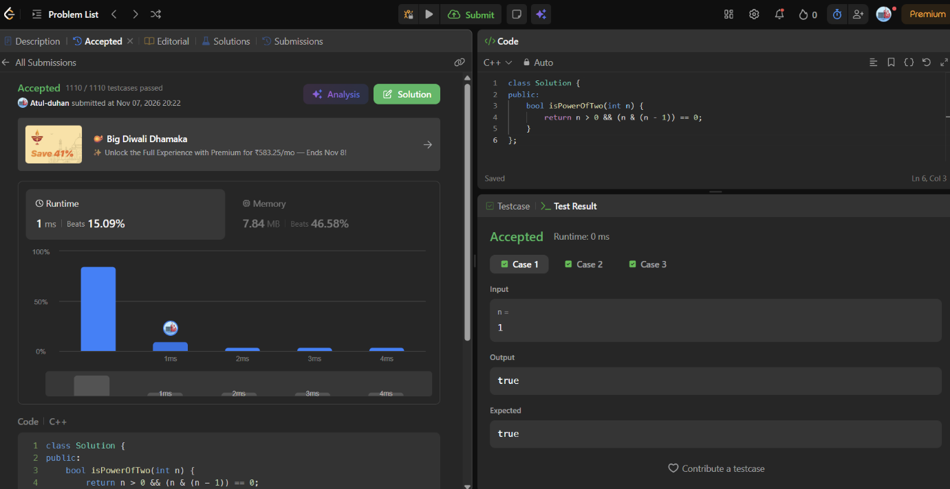
class Solution {
public:
bool isPowerOfTwo(int n) {
return n > 0 && (n & (n - 1)) == 0;
}
};

