https://leetcode.com/problems/smallest-even-multiple/
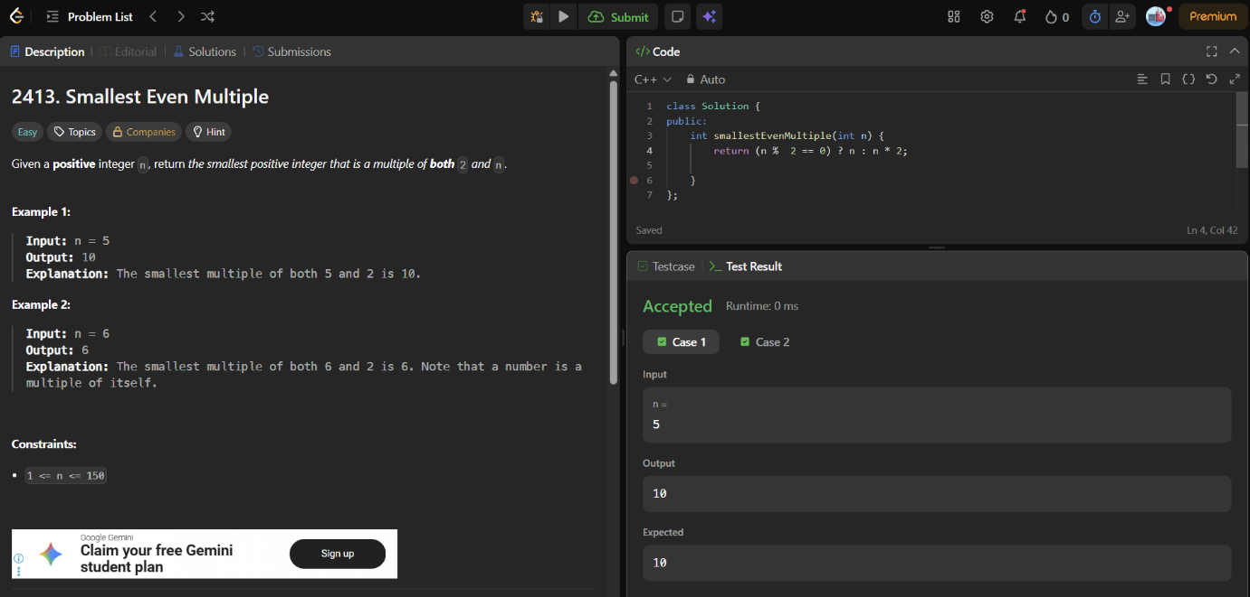
class Solution {
public:
int smallestEvenMultiple(int n) {
return (n % 2 == 0) ? n : n * 2;

}
};

