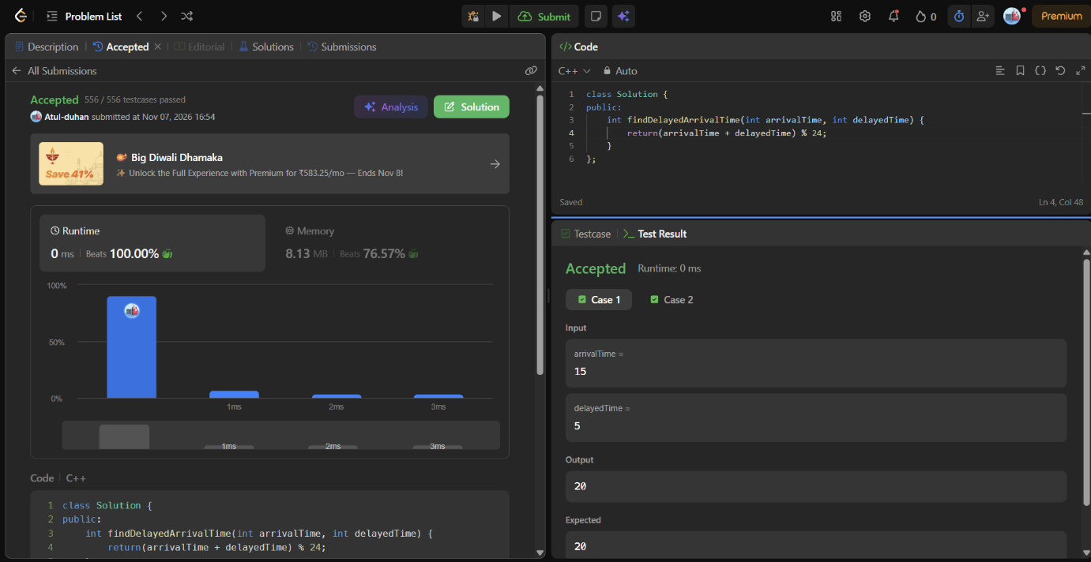

class Solution {
public:
int findDelayedArrivalTime(int arrivalTime, int delayedTime) {
return(arrivalTime + delayedTime) % 24;
}
};

