https://leetcode.com/problems/power-of-three/submissions/2191347730/
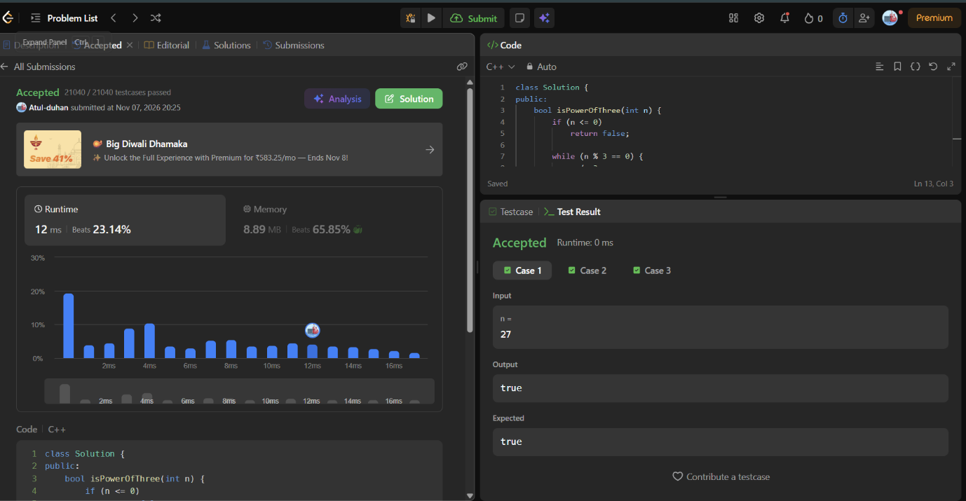
class Solution {
public:
bool isPowerOfThree(int n) {
if (n <= 0)
return false;

while (n % 3 == 0) {
n /= 3;
}

return n == 1;
}
};

