https://leetcode.com/problems/reverse-integer/submissions/2191338389/
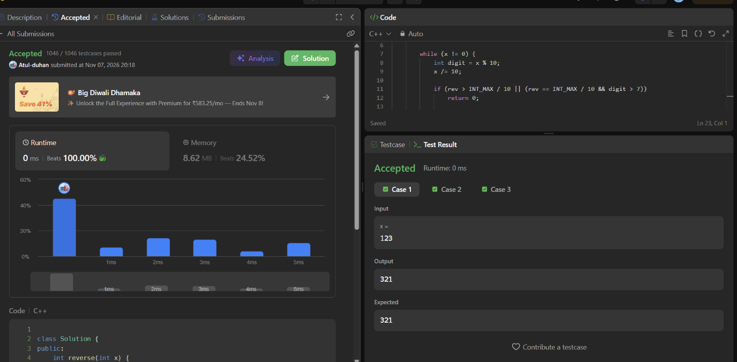

class Solution {
public:
int reverse(int x) {
int rev = 0;

while (x != 0) {
int digit = x % 10;
x /= 10;

if (rev > INT_MAX / 10 || (rev == INT_MAX / 10 && digit > 7))
return 0;

if (rev < INT_MIN / 10 || (rev == INT_MIN / 10 && digit < -8))
return 0;

rev = rev * 10 + digit;
}

return rev;
}
};

