https://leetcode.com/problems/palindrome-number/submissions/2191332549/
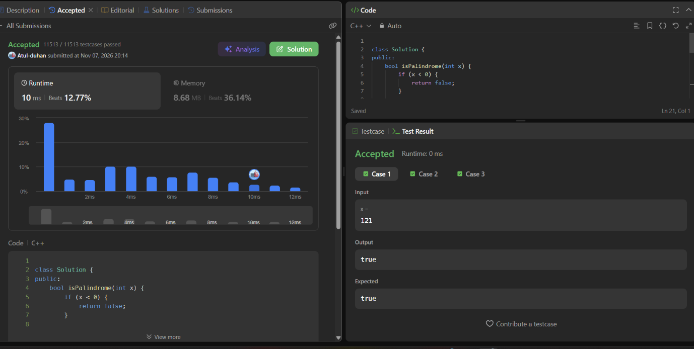

class Solution {
public:
bool isPalindrome(int x) {
if (x < 0) {
return false;
}

int original = x;
long long reverse = 0;

while (x > 0) {
int digit = x % 10;
reverse = reverse * 10 + digit;
x = x / 10;
}

return original == reverse;
}
};

