Adhoc retrieval from Legal Document(Consumer Law and Hindu Marriage & Diverse Law)

Dataset Pre-processing
Vocabulary is taken from here : http://www-01.sil.org/linguistics/wordlists/english/wordlist/wordsEn.txt.
Remove stop-words from vocab.
For each file :
- Remove non-alphabet characters.
- Tokenize and lemmatize.
- For tokens not in vocab check for words stuck together(specific issue with the dataset) and resolve it using following heuristic: find largest prefix that is in vocab and then ,if still not found, try for suffix
- Again remove tokens with len=2 and stop-words.

Dictionary creation
A seperate dictionary is created for every individual court.
Filter each of these dictionary separately by discarding words occurring in less than 5 documents and in more than 50%.
Merge all the dictionaries into one.

Models
TFIDF
Formula for unnormalized weight of term i in document j in a corpus of D documents:
weight_{i,j} = frequency_{i,j} * log_2(D / document_freq_{i})
We then normalize the whole vector to unit length.

BM25
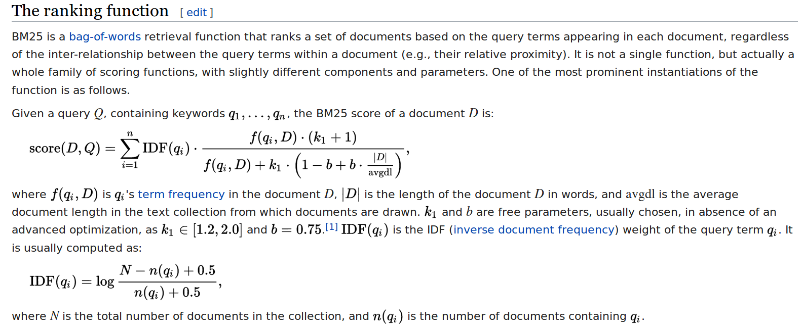Parameter chosen : K1 = 1.2, B = 0.75
Language Models
[ A Study of Smoothing Methods for LanguageModels Applied to Information Retrieval ,CHENGXIANG ZHAI and JOHN LAFFERTY, Carnegie Mellon University ]
One considers the probability of a query as being “generated” by a probabilistic model based on a document.
p(d|q) ∝ p(q|d)p(d)
p(d) is assumed to be uniform, and so does not affect document ranking.

The retrieval model reduces to the calculation of p(q|d), which is where language modeling comes in.

We use unigram model :
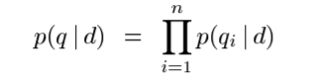

Most smoothing methods make use of two distributions, a model ps(w|d) used for “seen” words that occur in the document, and a model pu(w|d) for “unseen” words that do not. The probability of a query q can be written in terms of these models as follows, where c(w; d) denotes the count of word w in d and n is the length of the query.
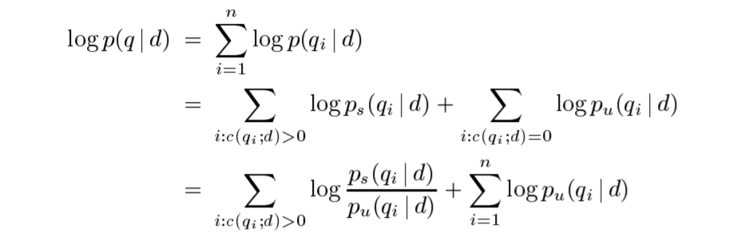
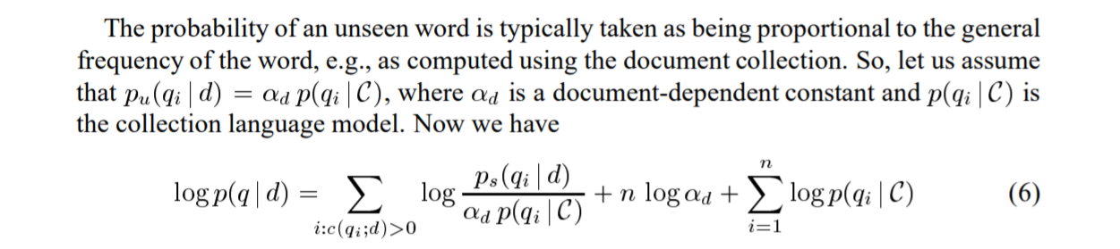
Note that the last term on the righthand side is independent of the document d, and thus can be ignored in ranking.
αd is a document-dependent constant that is related to how much probability mass will be allocated to unseen words according to the particular smoothing method used.
p(qi|C) plays a role very similar to the well-known IDF.
nlogαd can be thought of playing the role of document length normalization.

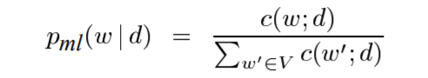
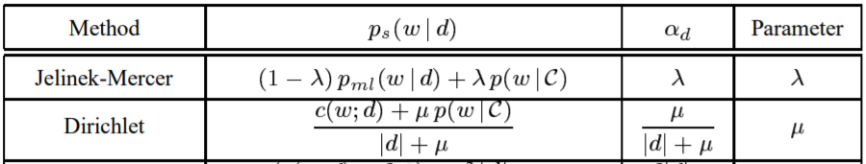

Language Model - Jelinek-Mercer Smoothing
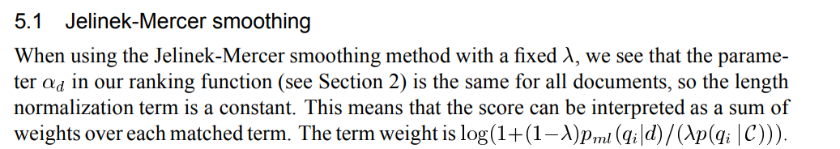

Parameter chosen : Lambda = 0.7

Language Model - Dirichlet Prior Smoothing
The term wieght is:
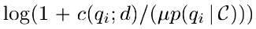
and an additional “|q| * log(MU/(|d|+ MU)” term added to the total score. |q| is the query length and |d| is the document length.
Parameter chosen : Mu = 2000

Models summary
- TFIDF
- BM25 : K1 = 1.2, B = 0.75
- Language Model - Jelinek-Mercer Smoothing : Lambda = 0.7
- Language Model - Dirichlet Prior Smoothing : Mu = 2000

Results
Fscore
Harmonic mean of precision and recall.
Average precision
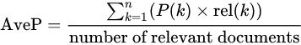

Where k is the rank in the sequence of retrieved documents, n is the number of retrieved documents, P(k) is the precision at cut-off k in the list and rel(k) is an indicator function equaling 1 if the item at rank k is a relevant document, zero otherwise.
Mean Average Precision
Mean average precision for a set of queries is the mean of the average precision scores for each query.
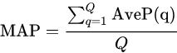

where Q is the number of queries.

Evaluations performed
k = 1, 5 ,10, 25, 50, 100, 500, 1000.
For each query
- Precision, Recall and FScore@k for Relevance = 1, 0 and 1 & 0 both.
- Average Precision@k for Relevance = 1, 0 and 1 & 0 both.
Mean Average precison@k for Relevance = 1, 0 and 1 & 0 both.

