BEHAVIOURAL DIAGRAM

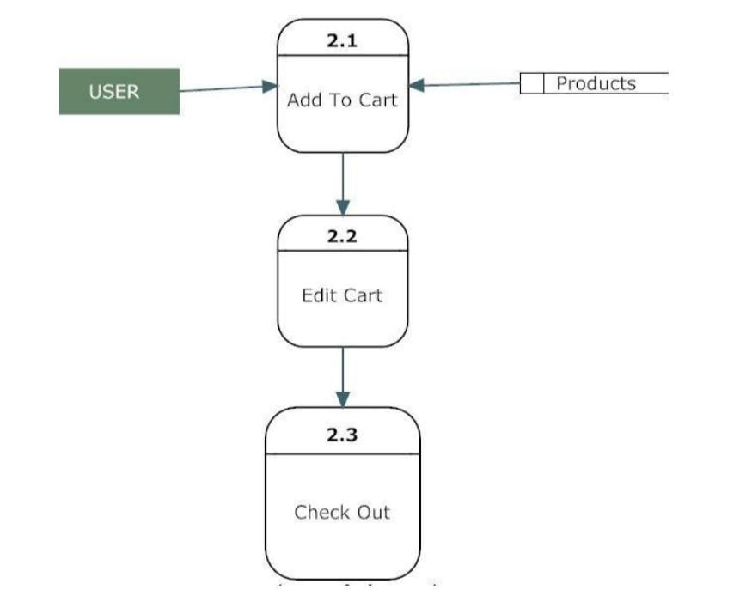

STRUCTURAL DIAGRAM

