MINI PROJECT

**EMBEDDED C (ARM BASED) PROJECT**

## TITLE

WIPER CONTROLLER

## SUBMITTED BY

ATUL SINGH

## DATE

MAY.2022

**ABSTRACT**

The automotive industry has spent the last two decades vigorously researching ways to use modern computing and electronic improvements in the development of vehicle safety, dependability, and entertainment technology. With a growing number of distractions, automated rain-sensing wiper systems become an even more tempting feature, as they attempt to reduce the amount of time the driver has take his or her hands off the wheel. Most classic systems can operate at both intermittent and variable speeds. The typical wiper system, on the other hand, necessitates constant driver attention when altering the wiper speed. Traditional windshield wiper speed changes with the passage of time and the speed of the vehicle. Because manual wiper adjustment diverts the driver's attention, it may be a direct cause of accidents.

This is review paper for automatic wier in various method and also explain the basic skeleton for adjust speed of wiper automatically cording to the amount of water on the windshield and in addition with also in advance removal of moisture inside the car while raining. The system activates the wiper to operate in full automatic mode and detect moister using CAN technology.

# INTRODUCTION

The car industry has been intensively researching ways to harness modern computing and electronic developments in the development of safety, dependability, and entertainment technologies for the past two decades. Despite this, for a variety of reasons, automatic rain-sensing wiper systems are rather uncommon in modern vehicles. In new cars, they are frequently too pricey, unattractive, or unreliable to be desirable. Many attempts have been made to develop an effective, dependable, and inexpensive rain detection and wiper control system that adjusts the vehicle's speed and intermittent interval automatically based on the amount of rain. Optical sensors are commonly used to monitor the amount of water.

The fact that the refraction angle and amount of light reflection varies when the two windshields are moist is used in this sort of sensor. Despite their widespread use, optical sensors have several drawbacks. The sensitivity to external light is one of the drawbacks. Another issue arises when driving at night, via tunnels, or even in underground parking. Many systems still engage the wiper as the automobile exits tunnels or underground parking lots for this reason. Another flaw, possibly the most serious, is that the sensing area is a small piece of the windshield. As a result, the system can only operate in a small region.

The wiper system may fail to activate when there are some raindrops on the driver’s line of sight, but not on the sensing area. They are often too expensive, too unsightly, or too unreliable to be desired in new automobiles.

# HISTORY OF WIPER CONTOLLER

## 1903: Mary Anderson patents the first windshield wiper

Mary Anderson, a real estate developer, cattle rancher, and winemaker, patented the first windshield wiper in 1903. Anderson witnessed the streetcar operator labouring with extremely poor visibility while riding a streetcar in New York City in 1902 during a thunderstorm, prompting him to open his window and thrust his head out. When Anderson saw this, he immediately started designing a windshield wiper that the driver might use to aid enhance visibility.

* **1919: The automatic windshield wiper is introduced**

Windshield wipers were not standard equipment on most vehicles until 1916, allowing for further technological developments.

In 1919, inventor William M. Folberth developed the first automatic, non-hand-driven windshield wipers. The vacuum-powered technology utilised by these automatic windshield wipers to clear the windshield became standard equipment on automobiles. Until the 1960s, when intermittent wipers became more widespread, this vacuum-powered technology was extensively utilised.

## 1969: Robert Kearns introduces the intermittent windshield wiper

Various innovators patented the notion of intermittent wipers over many decades, but it was thanks to Robert Kearns, an engineering professor at Wayne State University in Detroit, Michigan, that the concept actually took root. When Kearns proposed manufacturing the idea, he brought it to the attention of Ford Motor Company. While this concept resulted in a patent fight between the American carmaker and Kearns, it also led to the development of modern windshield wipers.

## Today: Windshield wipers everywhere!

Now, windshield wipers are commonplace on vehicles and a variety of options are available. The automotive industry has even introduced rain-sensing wipers that start themselves. With this technology, the view of the road is sure to stay clear

**OBJECTIVE OF THE PROJECT**

* Windshield wipers may be a little component of your vehicle, but they have a significant impact on your driving and overall safety.
* At the touch of a button, they remove rain, snow, dirt, pollen, frost, and other debris fast and smoothly!
* The wiper arms are moved across the windshield by the windshield wiper motor. The metal or hard plastic arms pull a thin rubber (or silicone) blade over the windshield to clean water from the lens, allowing you to see the road better.
* Wiper blades break, rip, and lose their flexibility and functionality with time. Wipers are harmed by a variety of factors, including road grit, bird droppings, severe temperatures, and UV light.

**BASIC COMPONENT OF WIPER CONTROLLER**

**HARDWARE**

* STM32F407
* LED (GREEN,RED,BLUE,ORANGE)
* SWITCH/ PUSH BUTTON

**SOFTWARE**

* STM32 SOFTWARE DEVLOPMENT TOOL
* QEMU

**COMPONENT**

1. **STM32F407**

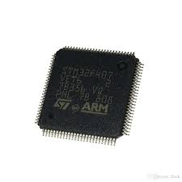

The STM32F407/417 lines are intended for medical, industrial, and consumer applications that require a high level of integration and performance, as well as integrated memories and a large peripheral set in packages as tiny as 10 × 10 mm.

The STM32F407/417 has the performance of a 168 MHz CortexTM-M4 core (with floating point unit).

**Power efficiency**: The current consumption in run mode and when operating from Flash memory is as low as 238 A/MHz at 168 MHz, thanks to ST's 90 nm technology, ART Accelerator, and dynamic power scaling.

**Integration**: In packages as tiny as 4 x 4.2 mm, the STM32F417x portfolio offers Flash memory ranging from 512 Kbytes to 1 Mbyte, 192 Kbytes of SRAM, and 64 to 144 pins.

**2. LED(**Light-Emitting Diode**)**

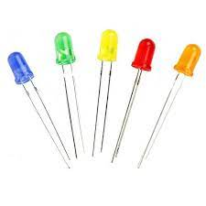

When current passes through a light-emitting diode (LED), it produces light. Electrons recombine with electron holes in the semiconductor, producing energy in the form of photons. The energy required for electrons to pass the band gap of the semiconductor determines the hue of light (equivalent to photon energy). [5] Multiple semiconductors or a coating of light-emitting phosphor on the semiconductor device are used to produce white light.

**FUNCTIONALITY**

* When the ignition is on and the button/ switch is pressed for 2 sec the system is activated
* The Red colour LED start glowing and indicate the system is in active .
* The diffrent coloue of LED i.e Green , Orange, Blue is used to indicate the speed of wiper .
* The Wiper Moving at 1 H,2Hz,3Hz.
* while the button is pressed again for 2 sec than the Red lED stop glowing and indicate that the system is off.

**SIMULATION**

Driving a vehicle is complicated in harsh weather condition without using glass wiper system. Controlling the wiper speed based on the change in weather condition is one of the research area in automotive industries now a day. Recently, the wiper speed is adjusted manually controlled by the driver. Dc motors are used to drive the wiper system based on feed forward techniques. In this paper a separately excited Dc motor is designed and controlled using robust control method to improve the feed forward wiper system performance.

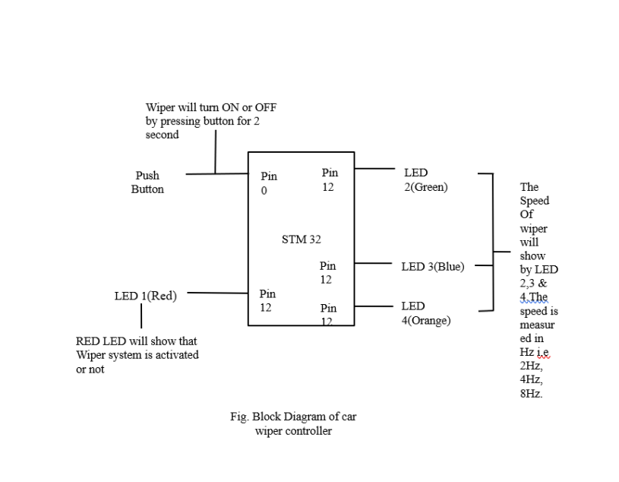**BLOCK DIAGRAM**

Fig . Block Diagram Of Wiper Controller

**FLOWCHART**

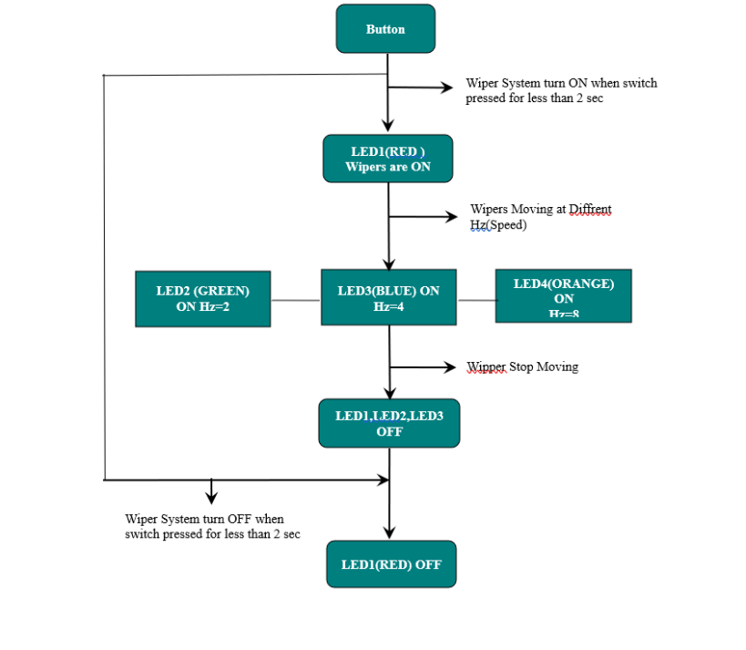

Fig. Flow Chart Of Wiper Controller

**CONCLUSION**

So I Successfully implement Car Iper Controller system by using ARM Based Microcontroller i.e STM32F407.In this Project i Explore About how the ARM work and STME32 software works.And in this project We must create an automatic wiper control system that is a better version of the intermittent wiper system. This wiper technology makes wiper operation easier and more comfortable for the driver. It will provide a new level of comfort and assistance to drivers who work at night or in congested locations, where they already have to focus on brakes and clutch. The ability to regulate the wipers during rain will be greatly simplified for children, allowing them to focus on the essential ABCs of driving (accelerator, brake, and clutch).