Atul’s Norwegian adventure.

8th European Congress on Computational Methods in Applied Sciences and Engineering (or ECCOMAS Congress 2022) is a scientific organization grouping together European associations with interests in the development and applications of computational methods in science and technology. This conference was held in Oslo, Norway from 5th to 9th June 2022, with ESR1 (Atul Singh) in attendance.

In this event, among the various presentation on myriad of engineering topics given by researchers across the world, ranging from computational solid and fluid mechanics, natural sciences, applied mathematics, right to machine learning etc, ESR1 also got an opportunity to present his work in minisymposium titled "Emerging methods for large-scale and robust multidisciplinary optimization (MDO) for industrial applications-II. The title of ESR1's talk was on "Impact of corrugated tubes on multi-disciplinary optimization of charge air coolers".

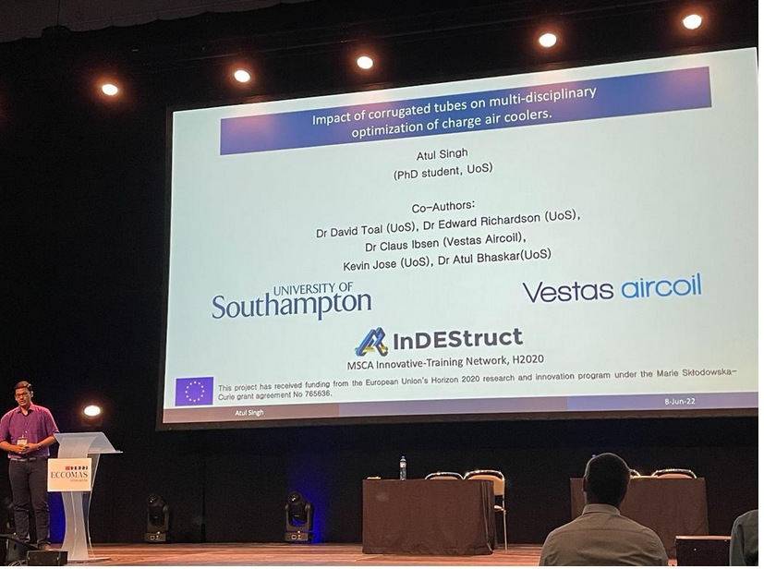  
Caption: Atul Singh (ESR1) presenting his work at the ECCOMAS conference 2022 held in Oslo, Norway.

His work on aero-thermal optimization of coolers is in collaboration with ESR2, Kevin Jose, whose research deals with characterizing the frequency and vibration response of the cooler designs. The results disseminated within this conference were a product of this multi-disciplinary collaboration between Atul (ESR1) and Kevin (ESR2).

Across a span of 1 week, along with fellow researchers, this also proved a great networking event for ESR1, over several dinners and lunches with fellow researchers from across the world. Here’s a sneak peak into the weeklong activities apart from the conference.

Caption: 1 inDEStruct-ITN Marie curie fellow, with 3 Thread-ITN Marie curie Fellows sharing anecdotes, along with food.

Caption: ESR1 feeding some Norwegian pigeons.

Caption: Atul (ESR1) snacking with fellow researchers from across the world on the eve of conference, and discussing “resource“ allocation, in the face of a fierce supply-demand problem.

Caption: Atul (ESR1) networking over dinner and discussing experiments, machine learning, culture, food, PhD things, loopholes, and politics, among other things, in no particular order!  
Caption: From Atul’s visit to Gustav Vigeland’s Sculpture park. [https://vigeland.museum.no/samlingen/fast-utstilling]. Inspired from the moods in the life of an individual. With the pillar interpreted as a kind of vision of resurrection, and our longing and striving for spirituality. [https://vigeland.museum.no/en/vigelandpark/monolith]  
Caption: This sculpture placed after a sculpture called “Circle of life”. (Get it?).