**MODULE:1**

**SE – overview of IT industry**

**Q1. What is software? What is software engineering?**

**Ans:**

* Software is a set of programs that allows the users to perform

a well-defined function or some specified tasks.

* Software is responsible for directing all computer-related

devices and instructing them regarding what and how the task is to be performed.

* Software engineering is a process of developing a software product in a well-defined systematic approach. In other words, developing a software by using scientific principles, methods, and procedures.

**Q2. Explain the types of software**

**Ans:**

1. System software
2. Application software
3. Utility software

* **System software :-** system software is a software designed to provide a platform to other software. System software control and manage the operations of computer hardware.

**Ex:-** operating system (windows, Android, Linux, etc.)

* **Application software :**- the software that helps you to do a specific type of works is called application software.

**Ex:** - Excel, vs code, MS word, etc.….

* **Utility software** :- utility software helps to manage, maintain and control computer resources.

**Ex:-** Antivirus software, Backup software, Disk tools etc.….

**Q3. What is SDLC? Explain each phase of SDLC.**

**Ans:**

* The software Development life cycle (SDLC) is a systematic process used by software engineers and development teams to design, develop, test, deploy, and maintain software systems.
* SDLC cycle represents the process of developing software.
* There are 6 stages of SDLC :-
* **Planning :-**
* Planning analysis is the most important and necessary stage in SDLC.
* Planning for the quality assurance requirements and identifications of the risks associated with the projects is also done at this stage.
* **Analysis :-**
* In this stage, all the requirements for the target software are specified.
* These requirements get approval from the customers,

Market analysis, and stockholders.

* **Designing :-**
* In this phase, the software design is created, which includes the overall architecture of the software, data structures, and interfaces.
* **Development :-**
* The design is then implemented or translated into source code and this phase is also called as development.
* **Testing :-**
* The software is thoroughly tested to ensure that it meets the requirements and works correctly.
* **Maintenance:-**
* This phase includes ongoing support, bug fixes, and updates to the software.

**Q4. What is DFD? Create a DFD diagram on Flipkart**

**Ans:**

* A DFD is the graphical representation of the flow of data from one component to another component in any information system.
* Through DFD, we can give the overview of the system without going into the deep detail of the system.

**DFD**

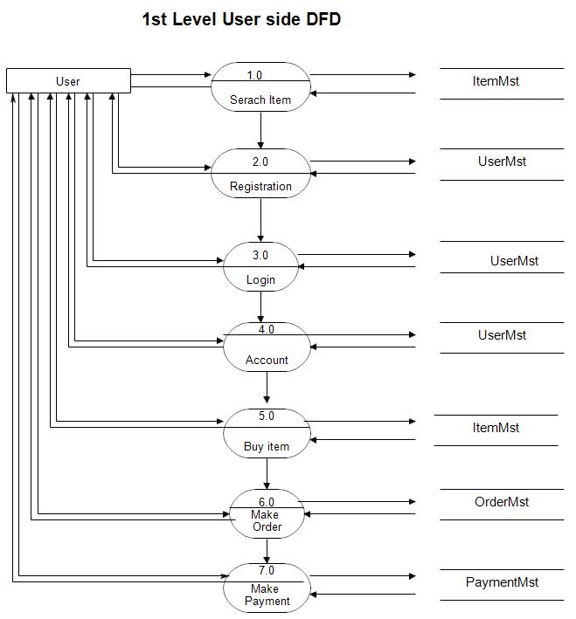

**Q5. What is flow chart? Create a flowchart to make addition of two numbers**

**Ans:**

* Flow charts are diagrams showing the exact sequence of logical steps. They use geometrical shapes and arrows to show processes, relationships and data/ process flow.
* Flowchart is a graphical representation of an algorithm. Programmers often use it as a program planning tool to solve a problem.

**Flow chart**

**End**

**Sum= num1 + num2**

**Display Sum**

**Read num1 and num2**

**Declare variables num1, num2 and sum**

**Start**

**Q6. What is use case diagram? Create a use-case on bill payment on paytm.**

**Ans:**

* Use-case diagrams model the behavior of a system.
* Used to illustrate the functional requirements of the system and its interaction with external agents(actors).
* A use case diagram gives us a high-level view of the system without going into implementation detail.