SQL Project – Retail Store

Tasks:

- Use the provided DDLs to create the following tables
  - Customers
  - Products
  - Orders
  - Order Items
  - Payments
- Use the provided DMLs to insert data into the tables created
- Construct SQL queries to answer the given business questions

TABLE STRUCTURES

Customers
Column Name | Data Type | Constraints | Description
customer_id | INT | PRIMARY KEY, AUTO_INCREMENT | Unique ID for each customer
name | VARCHAR(100) | NOT NULL | Full name of the customer
email | VARCHAR(100) | UNIQUE, NOT NULL | Unique email address
phone | VARCHAR(15) |  | Optional phone number
created_at | DATETIME | DEFAULT CURRENT_TIMESTAMP | Account creation timestamp

Products
Column Name | Data Type | Constraints | Description
product_id | INT | PRIMARY KEY, AUTO_INCREMENT | Unique product ID
name | VARCHAR(100) | NOT NULL | Name of the product
category | VARCHAR(50) | NOT NULL | Product category (e.g., Electronics)
price | DECIMAL(10,2) | NOT NULL CHECK (price > 0) | Product price
stock_quantity | INT | NOT NULL DEFAULT 0 | Units available in stock
added_on | DATE | DEFAULT CURRENT_TIMESTAMP | Date product was added

Orders
Column Name | Data Type | Constraints | Description
order_id | INT | PRIMARY KEY, AUTO_INCREMENT | Unique order ID
customer_id | INT | FOREIGN KEY REFERENCES customers(customer_id) | Who placed the order
order_date | DATETIME | DEFAULT CURRENT_TIMESTAMP | When the order was placed
status | VARCHAR(20) | DEFAULT 'Pending' | Order status (Pending, Shipped, etc)
total_amount | DECIMAL(10,2) |  | Calculated total

Order Items
Column Name | Data Type | Constraints | Description
order_item_id | INT | PRIMARY KEY, AUTO_INCREMENT | Unique ID for each line item
order_id | INT | FOREIGN KEY REFERENCES orders(order_id) | Order to which item belongs
product_id | INT | FOREIGN KEY REFERENCES products(product_id) | Which product was bought
quantity | INT | NOT NULL CHECK (quantity > 0) | Quantity ordered
item_price | DECIMAL(10,2) | NOT NULL | Snapshot of product price at order

Payments
Column Name | Data Type | Constraints | Description
payment_id | INT | PRIMARY KEY, AUTO_INCREMENT | Unique ID for payment
order_id | INT | FOREIGN KEY REFERENCES orders(order_id) | Which order was paid for
payment_date | DATETIME | DEFAULT CURRENT_TIMESTAMP | When payment was made
amount_paid | DECIMAL(10,2) | NOT NULL CHECK (amount_paid > 0) | Amount paid
method | VARCHAR(20) | NOT NULL | Method (Credit Card, UPI, etc.)

Product Reviews
Column Name | Data Type | Constraints | Description
review_id | INT | PRIMARY KEY, AUTO_INCREMENT | Unique ID for review
product_id | INT | FOREIGN KEY REFERENCES products(product_id) | Which product is reviewed
customer_id | INT | FOREIGN KEY REFERENCES customers(customer_id) | Who gave the review
rating | INT | NOT NULL CHECK (rating BETWEEN 1 AND 5) | Star rating
review_text | TEXT |  | Review message
review_date | DATE | DEFAULT CURRENT_TIMESTAMP | When the review was posted

DDL SCRIPTS

Customers
CREATE TABLE customers (
customer_id INT PRIMARY KEY AUTO_INCREMENT,
name VARCHAR(100) NOT NULL,
email VARCHAR(100) NOT NULL UNIQUE,
phone VARCHAR(15),
created_at DATETIME DEFAULT CURRENT_TIMESTAMP
);

Products
CREATE TABLE products (
product_id INT PRIMARY KEY AUTO_INCREMENT,
name VARCHAR(100) NOT NULL,
category VARCHAR(50) NOT NULL,
price DECIMAL(10,2) NOT NULL,
stock_quantity INT NOT NULL DEFAULT 0,
added_on DATETIME DEFAULT CURRENT_TIMESTAMP
);

Orders
CREATE TABLE orders (
order_id INT PRIMARY KEY AUTO_INCREMENT,
customer_id INT,
order_date DATETIME DEFAULT CURRENT_TIMESTAMP,
status VARCHAR(20) DEFAULT 'Pending',
total_amount DECIMAL(10,2),
FOREIGN KEY (customer_id) REFERENCES customers(customer_id)
);

Order Items
CREATE TABLE order_items (
order_item_id INT PRIMARY KEY AUTO_INCREMENT,
order_id INT,
product_id INT,
quantity INT NOT NULL CHECK (quantity > 0),
item_price DECIMAL(10,2) NOT NULL,
FOREIGN KEY (order_id) REFERENCES orders(order_id),
FOREIGN KEY (product_id) REFERENCES products(product_id)
);

Payments
CREATE TABLE payments (
payment_id INT PRIMARY KEY AUTO_INCREMENT,
order_id INT,
payment_date DATETIME DEFAULT CURRENT_TIMESTAMP,
amount_paid DECIMAL(10,2) NOT NULL CHECK (amount_paid > 0),
method VARCHAR(20) NOT NULL,
FOREIGN KEY (order_id) REFERENCES orders(order_id)
);
Product Reviews
CREATE TABLE product_reviews (
review_id INT PRIMARY KEY AUTO_INCREMENT,
product_id INT,
customer_id INT,
rating INT NOT NULL,
review_text TEXT,
review_date DATETIME DEFAULT CURRENT_TIMESTAMP,
FOREIGN KEY (product_id) REFERENCES products(product_id),
FOREIGN KEY (customer_id) REFERENCES customers(customer_id)
);

ER Diagram
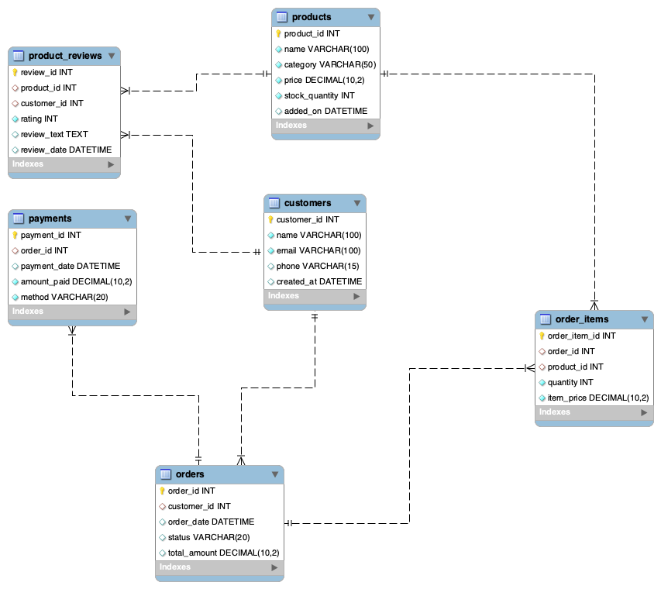

Entity Relationship

Parent Table | Child Table | Relationship Type | Foreign Key | Real-Life Meaning
customers | orders | One-to-Many | orders.customer_id → customers.customer_id | A customer can place multiple orders
orders | order_items | One-to-Many | order_items.order_id → orders.order_id | An order can contain multiple items
products | order_items | One-to-Many | order_items.product_id → products.product_id | A product can appear in many different orders
orders | payments | One-to-Many | payments.order_id → orders.order_id | One or more than one payment per order.
products | product_reviews | One-to-Many | product_reviews.product_id → products.product_id | A product can have many customer reviews
customers | product_reviews | One-to-Many | product_reviews.customer_id → customers.customer_id | A customer can write multiple reviews

Questions

Level 1: Basics

1. Retrieve customer names and emails for email marketing
This helps the marketing team extract basic customer contact details for campaigns.

Query: select name , email from customers;


2. View complete product catalog with all available details
The product manager may want to review all product listings in one go.

Query: select distinct name as "product list" from products;


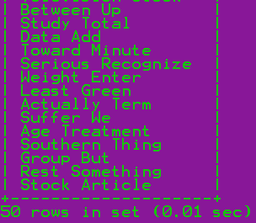

3. List all unique product categories
Useful for analyzing the range of departments or for creating filters on the website.

Query: select distinct category as "product categories list" from products;

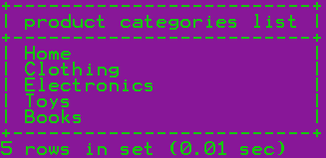

4. Show all products priced above ₹1,000
This helps identify high-value items for premium promotions or pricing strategy reviews.

Query: select distinct name as "product list" from products where price>1000;

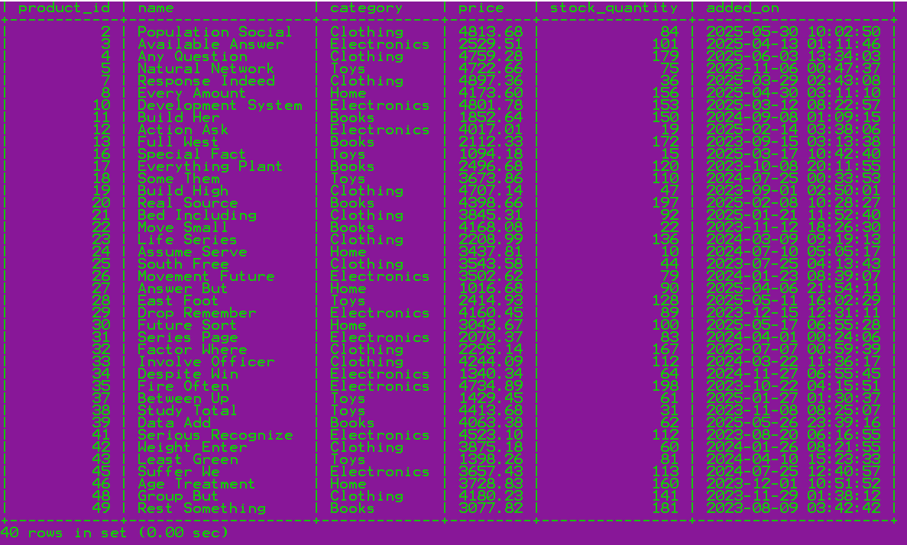

5. Display products within a mid-range price bracket (₹2,000 to ₹5,000)
A merchandising team might need this to create a mid-tier pricing campaign.

Query: select distinct * from products where price between 2000 and 5000;

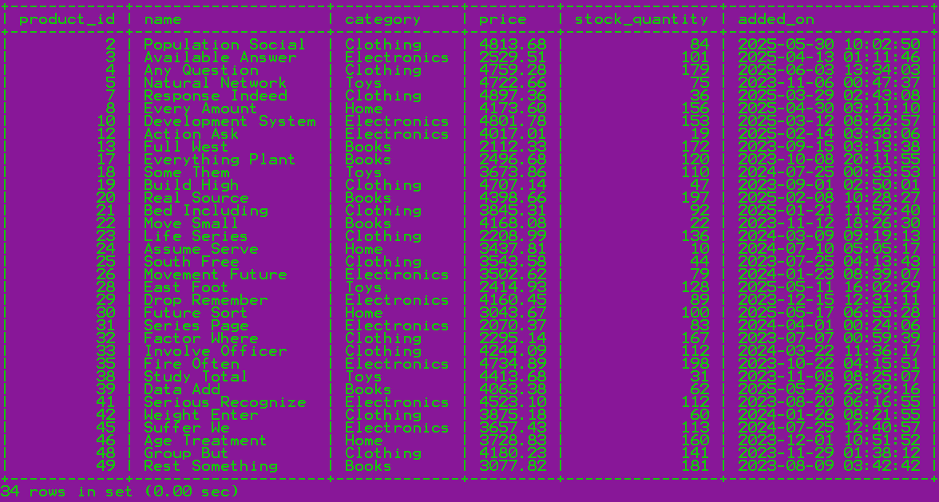

6. Fetch data for specific customer IDs (e.g., from loyalty program list)
This is used when customer IDs are pre-selected from another system.

Query: select distinct * from customers where customer_id in(2,4,7,8);

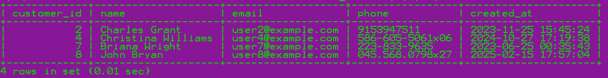

7. Identify customers whose names start with the letter ‘A’
Used for alphabetical segmentation in outreach or app display.

Query: select * from customers where name like 'A%';

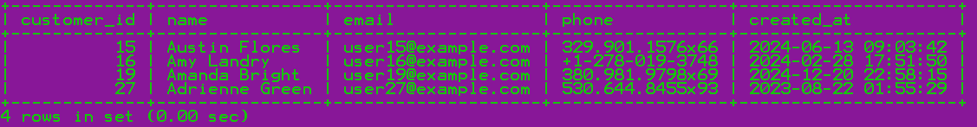

8. List electronics products priced under ₹3,000
Used by merchandising or frontend teams to showcase budget electronics.

Query: select * from products where category='Electronics' and price<=3000;

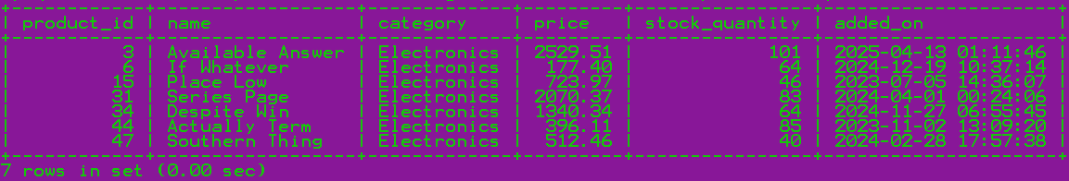

9. Display product names and prices in descending order of price
This helps teams easily view and compare top-priced items.

Query: select name, price from products order by price desc;




10. Display product names and prices, sorted by price and then by name
The merchandising or catalog team may want to list products from most expensive to cheapest. If multiple products have the same price, they should be sorted alphabetically for clarity on storefronts or printed catalogs.

Query: select name, price from products order by price desc,name;




Level 2: Filtering and Formatting

1. Retrieve orders where customer information is missing (possibly due to data migration or deletion)
Used to identify orphaned orders or test data where customer_id is not linked.

Query: select * from orders where customer_id is null;
Empty set (0.01 sec)

2. Display customer names and emails using column aliases for frontend readability
Useful for feeding into frontend displays or report headings that require user-friendly labels.

Query: select name as "Customer name", email as "Customer email" from customers;



3. Calculate total value per item ordered by multiplying quantity and item price
This can help generate per-line item bill details or invoice breakdowns.

Query: SELECT product_id, SUM(item_price * quantity) AS 'total value per item ordered'FROM order_items GROUP BY product_id;


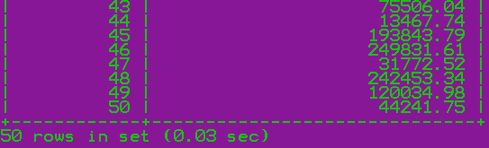

4. Combine customer name and phone number in a single column
Used to show brief customer summaries or contact lists.

Query: select concat(name,'-',phone) as 'name-phone' from customers;



5. Extract only the date part from order timestamps for date-wise reporting
Helps group or filter orders by date without considering time.

Query: select order_id,customer_id,date(order_date) as date ,status,total_amount from orders;

# order_id customer_id date status total_amount
1 20 2025-03-02 Delivered 9414.28
2 18 2024-10-09 Shipped 532.20
3 15 2025-05-08 Cancelled 5164.56
4 11 2024-09-19 Delivered 9469.78
5 12 2025-04-08 Pending 14501.86
6 29 2024-10-25 Cancelled 31050.17
7 22 2024-07-29 Shipped 3043.67
8 19 2024-07-30 Cancelled 32714.06
9 6 2025-06-10 Pending 24219.20
10 28 2025-02-16 Delivered 24342.52
11 25 2025-03-11 Cancelled 16196.13
12 28 2025-01-15 Shipped 9890.72
13 25 2025-05-12 Cancelled 9627.36
14 1 2024-09-24 Shipped 15803.34
15 29 2024-07-18 Pending 12421.88
16 5 2024-09-09 Shipped 22856.73
17 1 2024-08-19 Pending 11173.77
18 13 2024-06-15 Cancelled 32001.24
19 29 2024-07-06 Cancelled 843.46
20 20 2024-08-24 Delivered 6400.68
21 22 2025-03-12 Pending 25364.11
22 20 2025-02-21 Shipped 21281.44
23 25 2025-03-02 Delivered 18045.05
24 6 2024-06-19 Pending 22882.19
25 17 2024-07-24 Pending 23749.66
26 24 2025-02-16 Delivered 35167.92
27 17 2024-11-22 Cancelled 2955.57
28 16 2024-10-19 Delivered 639.43
29 7 2025-02-17 Delivered 26308.25
30 23 2024-10-18 Delivered 18628.74
31 14 2024-12-30 Pending 22651.79
32 15 2024-10-20 Pending 23536.35
33 8 2025-04-27 Pending 36147.09
34 29 2025-05-09 Shipped 21148.44
35 12 2024-11-27 Shipped 9469.78
36 25 2024-07-08 Cancelled 34125.89
37 12 2025-05-10 Cancelled 639.43
38 30 2024-07-05 Shipped 14681.26
39 30 2024-10-11 Shipped 15439.15
40 26 2024-09-11 Shipped 24649.49
41 20 2024-07-04 Delivered 723.97
42 3 2025-05-25 Cancelled 21622.22
43 24 2024-11-03 Shipped 19045.53
44 12 2024-11-23 Cancelled 17686.50
45 19 2024-07-21 Pending 27016.65
46 29 2025-02-24 Pending 24408.08
47 29 2025-03-24 Delivered 1016.68
48 28 2025-02-22 Shipped 28719.50
49 28 2024-11-03 Cancelled 23353.47
50 6 2024-09-04 Delivered 14204.67
51 16 2024-07-16 Shipped 24811.55
52 30 2025-01-15 Pending 30529.35
53 25 2025-02-20 Pending 7125.00
54 19 2024-10-15 Shipped 7198.10
55 24 2024-08-05 Delivered 26001.31
56 2 2024-06-23 Pending 6828.61
57 16 2025-04-16 Cancelled 2680.68
58 20 2024-09-09 Shipped 9782.58
59 9 2025-04-27 Shipped 857.85
60 8 2025-05-05 Pending 9246.62
61 1 2024-12-26 Shipped 13053.00
62 10 2025-06-13 Cancelled 35723.17
63 3 2025-02-04 Shipped 36236.03
64 16 2024-12-20 Pending 24892.90
65 26 2025-01-23 Shipped 3964.64
66 27 2024-06-19 Pending 26176.05
67 8 2025-01-15 Delivered 21146.47
68 24 2025-03-15 Delivered 36159.92
69 10 2024-12-29 Cancelled 18042.82
70 17 2024-11-21 Cancelled 8827.36
71 21 2025-05-10 Delivered 19189.46
72 7 2024-12-07 Pending 4160.45
73 28 2024-12-19 Delivered 20819.95
74 11 2024-08-25 Shipped 18915.11
75 29 2024-09-06 Delivered 15875.36
76 1 2025-01-14 Pending 23506.81
77 24 2024-11-10 Cancelled 22046.32
78 4 2025-01-05 Cancelled 20246.47
79 14 2025-03-04 Cancelled 16942.23
80 12 2025-03-28 Delivered 38656.26
81 21 2024-08-04 Shipped 21158.45
82 25 2025-04-12 Shipped 31627.15
83 5 2025-06-04 Shipped 8745.98
84 28 2024-06-19 Cancelled 19007.10
85 21 2024-06-24 Cancelled 22275.02
86 12 2024-07-05 Cancelled 5157.42
87 4 2025-03-08 Pending 14479.67
88 17 2024-07-06 Shipped 20399.23
89 8 2024-09-03 Shipped 4398.66
90 13 2025-01-18 Delivered 1970.38
91 15 2024-12-07 Pending 27466.27
92 1 2024-09-26 Shipped 834.75
93 22 2024-08-14 Delivered 16683.36
94 14 2025-03-05 Cancelled 19135.47
95 7 2024-11-09 Pending 18138.80
96 6 2025-01-10 Shipped 1537.38
97 15 2024-10-25 Pending 11891.01
98 28 2024-11-21 Delivered 29744.18
99 5 2024-10-08 Pending 1669.50
100 14 2024-09-12 Cancelled 20490.85
101 9 2024-08-12 Delivered 4590.28
102 8 2025-02-09 Shipped 10497.44
103 22 2024-07-09 Shipped 5005.51
104 30 2024-11-23 Pending 23699.22
105 14 2024-08-12 Shipped 5489.17
106 6 2024-07-16 Pending 11486.99
107 14 2025-02-01 Shipped 48042.06
108 25 2025-02-07 Cancelled 31063.66
109 1 2025-03-17 Shipped 12190.14
110 16 2025-02-21 Shipped 19306.22
111 25 2024-09-30 Pending 5388.41
112 21 2024-11-10 Delivered 15599.31
113 10 2024-10-30 Pending 20866.68
114 9 2025-01-30 Delivered 15356.31
115 22 2025-03-02 Cancelled 25414.53
116 16 2025-01-06 Pending 14440.93
117 13 2025-05-12 Shipped 8197.24
118 8 2025-04-30 Pending 10193.09
119 29 2024-10-13 Pending 2171.91
120 28 2024-08-07 Delivered 13569.30
121 16 2024-11-21 Pending 37415.67
122 23 2025-03-29 Delivered 12962.29
123 16 2024-12-07 Shipped 30071.03
124 20 2025-04-10 Cancelled 10906.44
125 20 2025-02-26 Pending 1447.94
126 5 2024-08-24 Cancelled 9995.54
127 1 2025-06-10 Pending 20160.64
128 7 2025-05-05 Pending 28589.04
129 29 2025-06-06 Delivered 30752.72
130 15 2024-09-16 Cancelled 14554.16
131 5 2024-10-09 Pending 23329.06
132 10 2025-05-22 Cancelled 13537.48
133 11 2024-11-20 Shipped 37129.82
134 3 2025-06-09 Pending 15483.53
135 1 2025-03-11 Pending 8891.79
136 17 2024-12-31 Cancelled 6291.38
137 19 2025-02-09 Cancelled 5958.51
138 23 2024-08-08 Pending 15439.86
139 18 2025-04-13 Delivered 39857.19
140 16 2024-06-23 Cancelled 33436.86
141 20 2024-08-13 Shipped 14625.43
142 17 2024-06-30 Shipped 12051.03
143 24 2025-05-28 Delivered 30951.54
144 1 2024-09-19 Shipped 12093.54
145 5 2024-08-28 Cancelled 10387.06
146 21 2025-02-18 Cancelled 19098.17
147 30 2025-03-11 Pending 22594.47
148 5 2024-09-26 Delivered 34099.39
149 4 2025-02-18 Cancelled 12420.50
150 20 2024-11-27 Shipped 22538.79
151 3 2025-04-06 Cancelled 13798.34
152 12 2025-03-08 Shipped 7750.36
153 29 2024-12-18 Delivered 12190.14
154 3 2024-08-13 Pending 6138.46
155 15 2024-08-02 Pending 421.73
156 19 2025-04-22 Delivered 4734.89
157 13 2025-02-04 Cancelled 14441.04
158 7 2024-09-27 Delivered 4021.02
159 29 2024-07-23 Cancelled 25595.89
160 18 2024-06-20 Delivered 28077.66
161 16 2025-03-07 Delivered 10254.61
162 13 2024-08-17 Shipped 1802.74
163 20 2024-12-23 Shipped 6336.99
164 18 2024-11-02 Pending 25354.04
165 24 2025-01-23 Shipped 16503.38
166 14 2025-06-09 Pending 14925.84
167 19 2025-04-07 Delivered 1537.38
168 12 2025-01-25 Cancelled 26688.78
169 2 2025-02-11 Cancelled 9426.30
170 27 2025-04-10 Delivered 18568.69
171 13 2024-10-16 Delivered 1278.86
172 6 2024-09-17 Shipped 16661.54
173 19 2025-06-13 Shipped 6875.62
174 19 2024-09-30 Cancelled 35676.00
175 30 2024-06-21 Shipped 15372.41
176 7 2025-03-15 Delivered 1429.45
177 22 2025-03-21 Cancelled 18138.37
178 5 2024-10-25 Pending 23350.80
179 5 2024-08-05 Delivered 16419.52
180 6 2024-06-21 Shipped 2680.68
181 22 2025-04-17 Shipped 4313.18
182 9 2024-08-16 Cancelled 6356.42
183 25 2024-08-18 Shipped 26833.57
184 25 2025-01-19 Delivered 25007.76
185 21 2025-05-23 Delivered 19797.69
186 23 2024-12-11 Delivered 25725.31
187 14 2024-10-13 Delivered 24962.90
188 4 2024-10-30 Pending 11186.49
189 25 2024-12-17 Shipped 40872.29
190 19 2025-03-23 Shipped 4168.08
191 28 2024-12-29 Pending 3543.58
192 17 2024-11-18 Shipped 26225.28
193 16 2025-01-15 Delivered 23707.29
194 6 2024-09-23 Shipped 296.17
195 21 2025-03-05 Cancelled 857.85
196 21 2025-02-07 Shipped 24096.64
197 30 2024-08-20 Shipped 10668.23
198 22 2024-11-11 Delivered 36504.68
199 30 2024-06-18 Delivered 4993.36
200 27 2024-10-14 Delivered 19065.76
201 23 2025-05-21 Shipped 21443.02
202 3 2024-07-12 Delivered 2529.51
203 30 2024-12-20 Cancelled 28369.14
204 20 2025-02-27 Delivered 7717.75
205 10 2024-08-24 Shipped 8126.76
206 22 2024-08-29 Delivered 21372.85
207 22 2025-02-07 Pending 5394.18
208 7 2024-06-20 Pending 9469.78
209 2 2024-10-16 Shipped 7690.62
210 24 2024-10-16 Delivered 28853.75
211 9 2025-05-30 Pending 11186.49
212 24 2025-04-13 Pending 1188.33
213 5 2024-09-23 Delivered 9046.20
214 28 2024-08-06 Pending 28031.01
215 10 2024-10-18 Delivered 28056.77
216 24 2025-03-22 Delivered 28524.05
217 14 2024-08-31 Delivered 31469.34
218 29 2024-12-22 Delivered 26218.37
219 12 2024-09-29 Cancelled 21322.74
220 9 2024-12-07 Cancelled 17287.19
221 1 2024-09-25 Pending 12437.61
222 18 2024-09-18 Delivered 23628.52
223 2 2024-11-25 Cancelled 41020.75
224 19 2024-12-12 Pending 9000.15
225 29 2024-10-04 Delivered 41885.52
226 28 2024-08-29 Delivered 4523.10
227 5 2025-03-28 Cancelled 18487.65
228 15 2024-10-14 Delivered 14405.34
229 17 2024-11-22 Delivered 21570.92
230 2 2024-07-25 Pending 22655.32
231 14 2025-06-06 Cancelled 27402.85
232 2 2025-05-02 Cancelled 9583.84
233 23 2024-10-22 Cancelled 19486.54
234 3 2024-09-03 Cancelled 18473.60
235 13 2024-12-06 Cancelled 16888.03
236 29 2025-04-09 Delivered 20296.56
237 22 2025-01-07 Shipped 21819.19
238 10 2024-07-30 Cancelled 26142.33
239 8 2025-05-15 Pending 30576.99
240 3 2025-01-18 Delivered 11267.39
241 11 2024-12-06 Cancelled 4180.23
242 22 2025-03-19 Shipped 16976.89
243 15 2024-12-19 Delivered 40510.54
244 11 2025-03-01 Cancelled 16733.86
245 30 2024-07-26 Pending 2496.68
246 8 2024-09-09 Pending 19441.36
247 17 2025-03-15 Shipped 7916.30
248 2 2025-06-06 Pending 9829.50
249 5 2025-03-28 Pending 28575.10
250 24 2025-04-08 Shipped 33000.22
251 10 2024-10-22 Delivered 20263.22
252 15 2025-05-20 Cancelled 26734.02
253 23 2024-12-30 Shipped 10872.30
254 19 2025-01-25 Shipped 9701.84
255 7 2025-01-01 Cancelled 8336.16
256 17 2025-06-08 Delivered 40944.10
257 17 2024-12-23 Delivered 11285.23
258 26 2025-04-18 Pending 38836.44
259 30 2025-04-30 Cancelled 12043.33
260 18 2025-01-30 Delivered 20012.07
261 6 2025-02-11 Delivered 1447.94
262 22 2024-07-27 Cancelled 3875.18
263 21 2024-10-05 Pending 5101.94
264 17 2024-11-10 Delivered 22179.72
265 12 2025-05-31 Cancelled 13016.70
266 5 2025-03-21 Delivered 39921.78
267 23 2024-07-03 Shipped 33419.96
268 14 2024-11-02 Cancelled 15422.53
269 26 2024-12-16 Pending 9414.28
270 13 2024-09-20 Pending 29673.12
271 6 2025-01-06 Cancelled 10972.29
272 14 2025-01-11 Shipped 24574.22
273 26 2025-05-04 Pending 20528.80
274 4 2024-09-23 Delivered 20124.38
275 30 2024-08-08 Pending 15495.63
276 24 2025-04-10 Delivered 23080.38
277 30 2025-05-06 Cancelled 18188.67
278 1 2025-02-01 Delivered 32015.16
279 20 2025-02-12 Pending 27437.94
280 5 2025-05-08 Cancelled 15619.88
281 3 2024-11-08 Shipped 41679.11
282 22 2025-04-19 Shipped 26969.05
283 2 2025-03-22 Delivered 14493.79
284 14 2024-09-18 Cancelled 27770.12
285 28 2024-09-19 Pending 30722.49
286 15 2025-06-11 Pending 26952.09
287 12 2024-09-21 Shipped 14763.96
288 7 2024-12-23 Cancelled 5295.87
289 30 2024-08-22 Cancelled 985.19
290 4 2024-11-26 Shipped 15135.69
291 26 2024-12-16 Cancelled 14646.15
292 16 2024-10-31 Cancelled 9582.36
293 27 2024-07-25 Shipped 18184.99
294 3 2025-03-17 Cancelled 13240.61
295 18 2024-11-29 Shipped 33872.19
296 9 2025-03-10 Pending 5260.77
297 21 2025-01-06 Delivered 19631.91
298 25 2025-06-06 Pending 20011.26
299 11 2025-04-02 Shipped 30321.27
300 29 2025-05-04 Delivered 41322.58
301 21 2024-07-08 Cancelled 8591.32
302 3 2024-11-19 Delivered 3282.54
303 30 2025-05-05 Cancelled 31523.38
304 20 2024-09-23 Shipped 16291.08
305 14 2025-01-09 Pending 24633.46
306 3 2025-03-03 Delivered 14702.63
307 6 2024-07-26 Shipped 8776.60
308 14 2025-06-11 Cancelled 36411.35
309 29 2024-09-13 Delivered 43867.08
310 7 2024-10-30 Shipped 20034.78
311 15 2024-11-24 Delivered 8488.18
312 18 2025-04-02 Shipped 16231.58
313 25 2025-06-09 Cancelled 24245.67
314 10 2025-03-13 Pending 7713.77
315 2 2025-01-27 Cancelled 42056.04
316 24 2024-10-04 Cancelled 27863.48
317 20 2024-10-03 Delivered 5007.28
318 3 2025-02-18 Shipped 13886.38
319 2 2025-04-22 Delivered 1024.92
320 22 2025-03-18 Shipped 7005.24
321 13 2025-04-11 Pending 23590.16
322 8 2024-08-17 Delivered 17090.84
323 29 2025-02-03 Pending 24962.31
324 19 2025-03-03 Pending 19188.81
325 20 2024-10-31 Cancelled 16090.75
326 21 2024-12-11 Cancelled 11783.59
327 20 2025-05-05 Shipped 39563.51
328 4 2025-01-29 Shipped 4017.01
329 2 2025-03-19 Delivered 31387.01
330 6 2025-01-10 Pending 39003.19
331 17 2025-02-24 Cancelled 3728.83
332 25 2025-02-24 Delivered 23648.72
333 6 2024-12-07 Delivered 30371.42
334 2 2025-01-27 Delivered 27857.86
335 2 2024-08-29 Pending 11713.56
336 20 2025-02-14 Pending 13868.44
337 13 2025-03-30 Cancelled 7768.73
338 3 2024-08-14 Shipped 2317.96
339 17 2025-05-02 Pending 20278.23
340 13 2025-04-23 Cancelled 177.40
341 8 2024-06-25 Cancelled 5963.22
342 3 2025-05-04 Cancelled 888.51
343 27 2025-04-18 Shipped 20754.96
344 15 2025-05-18 Cancelled 14093.33
345 29 2025-01-24 Shipped 30411.52
346 28 2025-03-31 Pending 9469.78
347 29 2024-09-18 Shipped 1429.45
348 9 2024-12-29 Cancelled 21414.44
349 13 2025-03-04 Pending 14938.76
350 19 2024-11-19 Delivered 11472.47
351 25 2025-03-04 Delivered 21283.02
352 4 2024-07-29 Delivered 14204.67
353 18 2025-02-27 Shipped 12257.63
354 15 2025-01-16 Delivered 14760.32
355 10 2025-03-24 Cancelled 20291.05
356 9 2025-06-11 Pending 11584.94
357 16 2024-10-23 Shipped 6050.37
358 28 2025-01-27 Shipped 4288.35
359 10 2024-06-30 Cancelled 13569.30
360 15 2025-05-20 Pending 29852.51
361 6 2024-12-15 Delivered 2573.55
362 29 2024-07-09 Pending 27540.77
363 17 2024-07-14 Shipped 1016.68
364 21 2024-10-05 Delivered 18410.90
365 10 2024-09-04 Shipped 13569.30
366 11 2024-10-15 Shipped 20054.80
367 28 2025-04-29 Pending 33025.01
368 30 2024-11-13 Delivered 34761.91
369 3 2024-09-04 Shipped 33503.41
370 16 2025-01-31 Delivered 22871.46
371 27 2025-02-07 Cancelled 532.20
372 7 2024-10-10 Shipped 18814.53
373 19 2024-09-11 Delivered 29373.72
374 16 2025-01-30 Cancelled 17291.69
375 6 2024-11-15 Shipped 6911.65
376 16 2025-02-09 Pending 1016.68
377 2 2025-03-14 Pending 13580.06
378 2 2024-11-26 Pending 10030.43
379 1 2025-03-22 Cancelled 21586.89
380 15 2024-12-25 Shipped 1669.50
381 2 2024-10-20 Shipped 7087.16
382 11 2025-04-08 Cancelled 16304.96
383 6 2024-07-05 Delivered 18148.12
384 23 2024-12-26 Delivered 9232.97
385 24 2025-02-28 Cancelled 23042.67
386 4 2024-12-18 Cancelled 25747.34
387 27 2024-07-20 Pending 6155.64
388 19 2025-03-08 Pending 17639.96
389 11 2025-01-01 Delivered 20299.18
390 7 2025-06-06 Delivered 18092.48
391 3 2024-12-28 Cancelled 4733.08
392 24 2024-11-12 Shipped 27858.02
393 28 2024-12-17 Pending 44504.56
394 2 2025-06-05 Delivered 18154.30
395 9 2025-02-11 Cancelled 12331.34
396 28 2024-07-21 Pending 35029.57
397 10 2024-11-10 Delivered 26820.10
398 17 2024-11-07 Shipped 13212.61
399 17 2025-02-08 Shipped 19557.58
400 7 2024-10-22 Shipped 5269.50

6. List products that do not have any stock left
This helps the inventory team identify out-of-stock items.

Query: SELECT
p.product_id,
p.name,
p.stock_quantity AS original_stock,
SUM(oi.quantity) AS total_sold,
(p.stock_quantity - SUM(oi.quantity)) AS remaining_stock
FROM products p
JOIN order_items oi ON p.product_id = oi.product_id
GROUP BY p.product_id, p.name, p.stock_quantity
HAVING remaining_stock = 0;
Empty set (0.02 sec)

Level 3: Aggregations

1. Count the total number of orders placed
Used by business managers to track order volume over time.

Query: select count(distinct order_id) as 'total orders placed' from orders;

+------------------------+
| total orders placed |
+------------------------+
| 400 |
+------------------------+
1 row in set (0.00 sec)

2. Calculate the total revenue collected from all orders
This gives the overall sales value.

Query: select sum(total_amount) as 'total revenue generated' from orders;
+------------------------------+
| total revenue generated |
+------------------------------+
| 6960973.66 |
+------------------------------+
1 row in set (0.00 sec)

3. Calculate the average order value
Used for understanding customer spending patterns.

Query: SELECT AVG(total_amount) FROM orders;
+--------------------------+
| AVG(total_amount) |
+--------------------------+
| 17402.434150 |
+--------------------------+
1 row in set (0.03 sec)

4. Count the number of customers who have placed at least one order
This identifies active customers.

Query: SELECT COUNT(DISTINCT customer_id) FROM orders;
+--------------------------------------------+
| COUNT(DISTINCT customer_id) |
+--------------------------------------------+
| 30 |
+--------------------------------------------+
1 row in set (0.00 sec)

5. Find the number of orders placed by each customer
Helpful for identifying top or repeat customers.

Query: SELECT customer_id, COUNT(*) FROM orders GROUP BY customer_id;

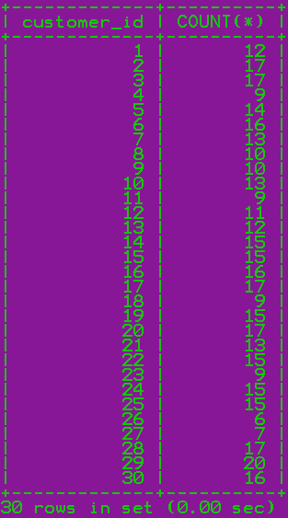

6. Find total sales amount made by each customer

Query: SELECT customer_id, SUM(total_amount) FROM orders GROUP BY customer_id;



7. List the number of products sold per category
This helps category managers assess performance by department.

Query: SELECT p.category, SUM(oi.quantity) FROM order_items oi JOIN products p ON oi.product_id=p.product_id GROUP BY p.category;

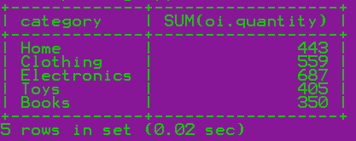

8. Find the average item price per category
Useful to compare pricing across departments.

Query: SELECT category, AVG(price) FROM products GROUP BY category;



9. Show number of orders placed per day
Used to track daily business activity and demand trends.

Query: SELECT DATE(order_date), COUNT(*) FROM orders GROUP BY DATE(order_date);






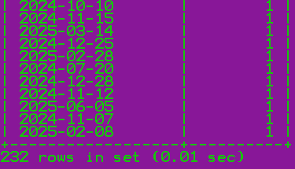

10. List total payments received per payment method
Helps the finance team understand preferred transaction modes.

Query: SELECT method, SUM(amount_paid) FROM payments GROUP BY method;

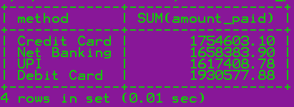

Level 4: Multi-Table Queries (JOINS)

1. Retrieve order details along with the customer name (INNER JOIN)
Used for displaying which customer placed each order.

Query: SELECT o.order_id, c.name, o.total_amount FROM orders o JOIN customers c ON o.customer_id=c.customer_id;










400 rows in set (0.01 sec)

2. Get list of products that have been sold (INNER JOIN with order_items)
Used to find which products were actually included in orders.
Query: SELECT DISTINCT p.name FROM products p JOIN order_items oi ON p.product_id=oi.product_id;




3. List all orders with their payment method (INNER JOIN)
Used by finance or audit teams to see how each order was paid for.

Query: SELECT o.order_id, pay.method FROM orders o JOIN payments pay ON o.order_id=pay.order_id;

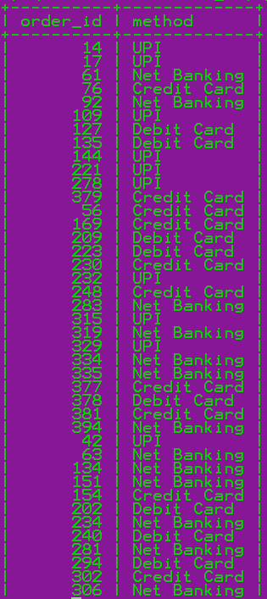
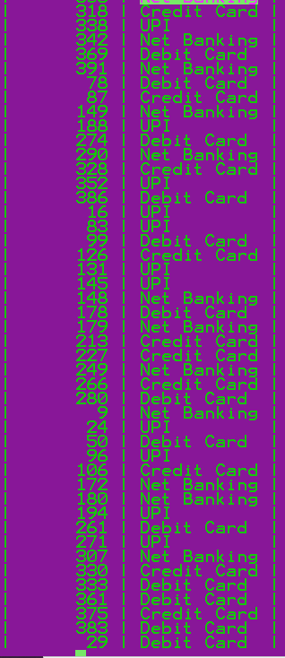
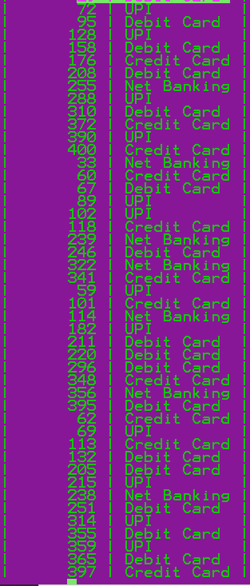
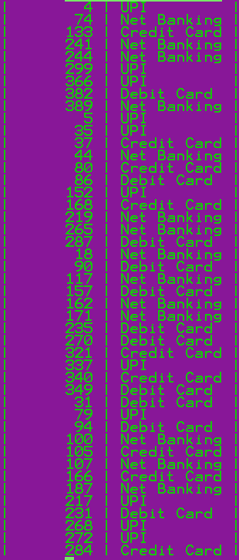
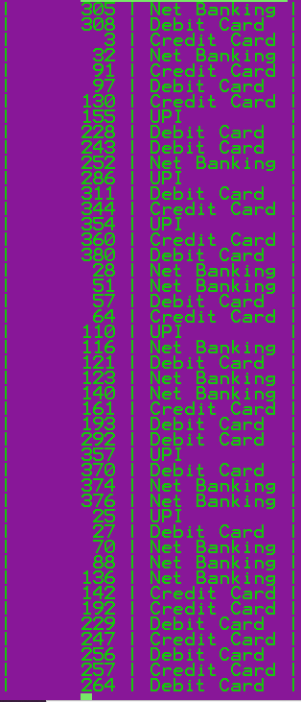
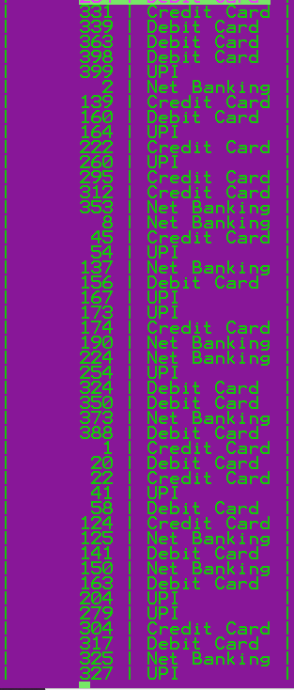
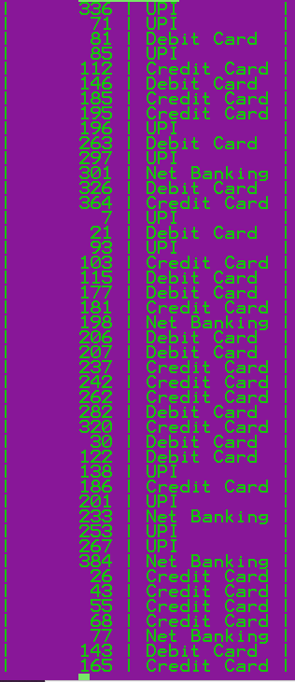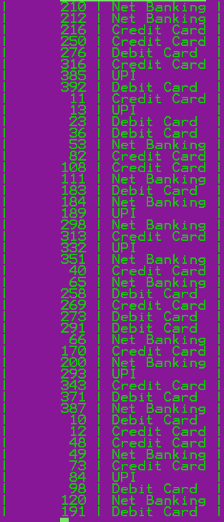
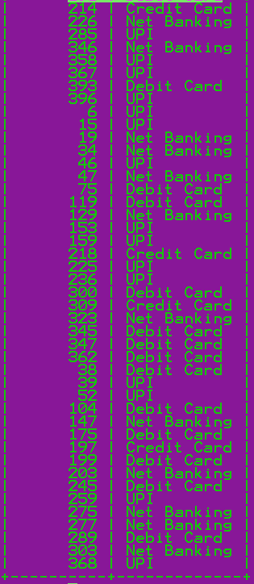
400 rows in set (0.01 sec)

4. Get list of customers and their orders (LEFT JOIN)
Used to find all customers and see who has or hasn’t placed orders.

Query: SELECT c.name, o.order_id FROM customers c LEFT JOIN orders o ON c.customer_id=o.customer_id;










400 rows in set (0.00 sec)

5. List all products along with order item quantity (LEFT JOIN)
Useful for inventory teams to track what sold and what hasn’t.

Query: SELECT p.name, oi.quantity FROM products p LEFT JOIN order_items oi ON p.product_id=oi.product_id;

# p.name oi.quantity
Plant No 1
Plant No 3
Plant No 1
Plant No 1
Plant No 2
Plant No 3
Plant No 2
Plant No 2
Plant No 2
Plant No 2
Plant No 2
Plant No 3
Plant No 3
Plant No 2
Plant No 2
Plant No 2
Plant No 3
Plant No 1
Plant No 1
Plant No 3
Plant No 1
Plant No 1
Population Social 2
Population Social 2
Population Social 2
Population Social 3
Population Social 3
Population Social 2
Population Social 3
Population Social 1
Population Social 2
Population Social 2
Population Social 3
Population Social 2
Population Social 3
Population Social 1
Population Social 1
Population Social 1
Available Answer 1
Available Answer 1
Available Answer 2
Available Answer 3
Available Answer 2
Available Answer 1
Available Answer 1
Available Answer 1
Available Answer 1
Available Answer 3
Available Answer 1
Available Answer 1
Available Answer 1
Available Answer 1
Available Answer 2
Available Answer 3
Available Answer 3
Available Answer 3
Available Answer 2
Available Answer 3
Available Answer 2
Available Answer 2
Available Answer 2
Available Answer 2
Available Answer 3
Any Question 3
Any Question 1
Any Question 3
Any Question 2
Any Question 2
Any Question 2
Any Question 3
Any Question 1
Any Question 3
Any Question 3
Any Question 3
Any Question 2
Any Question 2
Natural Network 3
Natural Network 1
Natural Network 3
Natural Network 3
Natural Network 2
Natural Network 3
Natural Network 3
Natural Network 2
Natural Network 1
Natural Network 1
Natural Network 2
Natural Network 3
Natural Network 1
Natural Network 1
Natural Network 3
Natural Network 3
Natural Network 3
Natural Network 1
Natural Network 1
Natural Network 1
Natural Network 3
If Whatever 3
If Whatever 1
If Whatever 1
If Whatever 3
If Whatever 2
If Whatever 2
If Whatever 1
If Whatever 1
If Whatever 1
If Whatever 2
If Whatever 3
If Whatever 3
If Whatever 2
If Whatever 3
If Whatever 3
If Whatever 2
If Whatever 1
If Whatever 3
If Whatever 1
If Whatever 3
If Whatever 1
If Whatever 3
If Whatever 1
If Whatever 1
If Whatever 3
If Whatever 1
If Whatever 3
Response Indeed 2
Response Indeed 3
Response Indeed 3
Response Indeed 3
Response Indeed 1
Response Indeed 1
Response Indeed 2
Response Indeed 3
Response Indeed 1
Response Indeed 1
Response Indeed 2
Response Indeed 2
Response Indeed 2
Response Indeed 1
Response Indeed 2
Response Indeed 2
Response Indeed 1
Response Indeed 3
Response Indeed 2
Response Indeed 1
Response Indeed 1
Every Amount 3
Every Amount 1
Every Amount 3
Every Amount 2
Every Amount 1
Every Amount 3
Every Amount 3
Every Amount 3
Every Amount 1
Every Amount 2
Every Amount 1
Every Amount 3
Every Amount 3
Every Amount 1
Every Amount 2
Every Amount 3
Every Amount 3
Every Amount 3
Every Amount 1
Every Amount 3
Every Amount 2
Every Amount 3
Every Amount 1
Every Amount 1
Every Amount 3
Every Amount 3
Every Amount 3
Common Study 3
Common Study 1
Common Study 3
Common Study 3
Common Study 3
Common Study 1
Common Study 2
Common Study 1
Common Study 2
Common Study 2
Common Study 2
Common Study 3
Common Study 1
Common Study 1
Common Study 2
Common Study 3
Common Study 2
Common Study 3
Common Study 1
Common Study 3
Common Study 2
Common Study 3
Common Study 2
Common Study 2
Common Study 3
Common Study 3
Development System 3
Development System 3
Development System 2
Development System 3
Development System 1
Development System 3
Development System 1
Development System 1
Development System 3
Development System 2
Development System 2
Development System 3
Development System 3
Development System 3
Development System 3
Development System 3
Development System 3
Development System 1
Development System 2
Development System 2
Development System 3
Development System 1
Development System 2
Build Her 2
Build Her 2
Build Her 2
Build Her 3
Build Her 2
Build Her 1
Build Her 2
Build Her 3
Build Her 1
Build Her 3
Build Her 3
Build Her 3
Build Her 2
Build Her 1
Build Her 3
Build Her 2
Build Her 2
Build Her 1
Build Her 2
Build Her 1
Build Her 3
Build Her 3
Build Her 2
Build Her 1
Action Ask 2
Action Ask 3
Action Ask 1
Action Ask 2
Action Ask 1
Action Ask 3
Action Ask 3
Action Ask 2
Action Ask 3
Action Ask 1
Action Ask 2
Action Ask 3
Action Ask 1
Action Ask 2
Action Ask 1
Action Ask 1
Action Ask 1
Action Ask 1
Action Ask 1
Action Ask 1
Action Ask 3
Action Ask 2
Action Ask 1
Action Ask 3
Action Ask 3
Full West 1
Full West 2
Full West 3
Full West 2
Full West 3
Full West 1
Full West 3
Full West 2
Full West 1
Full West 3
Full West 2
Full West 2
Full West 3
Full West 3
Full West 3
Full West 2
Full West 2
Full West 2
Full West 3
Full West 3
Listen Development 3
Listen Development 2
Listen Development 1
Listen Development 1
Listen Development 2
Listen Development 1
Listen Development 1
Listen Development 1
Listen Development 2
Listen Development 2
Listen Development 3
Listen Development 2
Listen Development 3
Listen Development 2
Listen Development 3
Listen Development 3
Listen Development 3
Listen Development 2
Listen Development 3
Listen Development 2
Listen Development 1
Place Low 1
Place Low 1
Place Low 2
Place Low 3
Place Low 2
Place Low 1
Place Low 3
Place Low 2
Place Low 3
Place Low 2
Place Low 2
Place Low 2
Place Low 1
Place Low 3
Place Low 3
Place Low 2
Place Low 2
Place Low 1
Special Fact 3
Special Fact 3
Special Fact 2
Special Fact 1
Special Fact 3
Special Fact 2
Special Fact 1
Special Fact 1
Special Fact 1
Special Fact 1
Special Fact 3
Special Fact 2
Special Fact 1
Special Fact 3
Special Fact 3
Special Fact 1
Special Fact 1
Special Fact 2
Special Fact 1
Special Fact 1
Special Fact 3
Special Fact 3
Special Fact 3
Special Fact 2
Special Fact 3
Everything Plant 2
Everything Plant 1
Everything Plant 3
Everything Plant 3
Everything Plant 1
Everything Plant 1
Everything Plant 3
Everything Plant 1
Everything Plant 3
Everything Plant 1
Everything Plant 3
Everything Plant 3
Everything Plant 1
Everything Plant 2
Everything Plant 3
Everything Plant 1
Everything Plant 3
Everything Plant 1
Everything Plant 2
Everything Plant 3
Everything Plant 3
Everything Plant 3
Everything Plant 1
Everything Plant 3
Everything Plant 2
Everything Plant 1
Everything Plant 2
Everything Plant 2
Some Them 3
Some Them 2
Some Them 3
Some Them 2
Some Them 3
Some Them 1
Some Them 3
Some Them 1
Some Them 2
Some Them 3
Some Them 2
Some Them 2
Some Them 1
Some Them 1
Some Them 3
Some Them 2
Some Them 2
Some Them 1
Some Them 1
Some Them 1
Some Them 3
Some Them 3
Some Them 3
Some Them 1
Some Them 1
Some Them 1
Some Them 3
Some Them 2
Some Them 1
Some Them 2
Some Them 2
Some Them 2
Build High 2
Build High 1
Build High 1
Build High 2
Build High 2
Build High 1
Build High 3
Build High 1
Build High 3
Build High 3
Build High 2
Build High 1
Build High 2
Build High 1
Build High 1
Build High 2
Build High 2
Build High 1
Build High 1
Build High 2
Build High 2
Build High 2
Build High 3
Build High 3
Build High 1
Build High 1
Real Source 1
Real Source 2
Real Source 3
Real Source 2
Real Source 1
Real Source 1
Real Source 3
Real Source 3
Real Source 1
Real Source 1
Real Source 2
Real Source 3
Real Source 1
Real Source 2
Real Source 3
Real Source 3
Real Source 2
Real Source 2
Real Source 2
Real Source 3
Real Source 3
Real Source 3
Real Source 3
Real Source 1
Real Source 1
Real Source 2
Real Source 3
Real Source 2
Real Source 1
Bed Including 3
Bed Including 2
Bed Including 2
Bed Including 3
Bed Including 3
Bed Including 3
Bed Including 2
Bed Including 2
Bed Including 1
Bed Including 3
Bed Including 1
Bed Including 1
Bed Including 2
Bed Including 2
Bed Including 1
Bed Including 2
Bed Including 3
Bed Including 1
Bed Including 2
Bed Including 2
Bed Including 1
Bed Including 3
Bed Including 3
Move Small 3
Move Small 3
Move Small 2
Move Small 2
Move Small 3
Move Small 2
Move Small 2
Move Small 1
Move Small 3
Move Small 1
Move Small 1
Move Small 1
Move Small 3
Move Small 2
Move Small 3
Move Small 1
Move Small 2
Move Small 3
Move Small 1
Move Small 3
Move Small 3
Move Small 1
Move Small 2
Move Small 3
Move Small 3
Move Small 1
Move Small 3
Move Small 2
Life Series 1
Life Series 2
Life Series 2
Life Series 3
Life Series 3
Life Series 3
Life Series 2
Life Series 2
Life Series 3
Life Series 2
Life Series 3
Life Series 1
Life Series 2
Life Series 1
Life Series 1
Life Series 2
Life Series 3
Life Series 2
Life Series 1
Life Series 2
Life Series 2
Life Series 3
Life Series 3
Life Series 1
Life Series 1
Life Series 1
Assume Serve 2
Assume Serve 3
Assume Serve 1
Assume Serve 2
Assume Serve 2
Assume Serve 3
Assume Serve 1
Assume Serve 1
Assume Serve 2
Assume Serve 1
Assume Serve 1
Assume Serve 2
Assume Serve 3
Assume Serve 3
Assume Serve 2
Assume Serve 3
Assume Serve 2
Assume Serve 2
Assume Serve 3
Assume Serve 3
Assume Serve 2
Assume Serve 3
Assume Serve 3
Assume Serve 2
Assume Serve 1
Assume Serve 2
Assume Serve 2
Assume Serve 3
Assume Serve 3
Assume Serve 3
Assume Serve 2
Assume Serve 1
Assume Serve 3
Assume Serve 1
Assume Serve 3
Assume Serve 3
Assume Serve 2
Assume Serve 2
South Free 2
South Free 2
South Free 3
South Free 1
South Free 1
South Free 3
South Free 1
South Free 1
South Free 3
South Free 3
South Free 2
South Free 1
South Free 2
South Free 2
South Free 3
South Free 1
South Free 3
South Free 2
South Free 1
South Free 3
South Free 1
South Free 2
South Free 1
South Free 2
South Free 3
South Free 2
Movement Future 1
Movement Future 1
Movement Future 3
Movement Future 1
Movement Future 3
Movement Future 2
Movement Future 1
Movement Future 1
Movement Future 3
Movement Future 3
Movement Future 3
Movement Future 3
Movement Future 2
Movement Future 1
Movement Future 1
Movement Future 3
Movement Future 2
Movement Future 3
Movement Future 3
Movement Future 2
Movement Future 1
Movement Future 1
Movement Future 2
Movement Future 1
Movement Future 1
Movement Future 3
Answer But 3
Answer But 1
Answer But 2
Answer But 3
Answer But 3
Answer But 3
Answer But 1
Answer But 2
Answer But 2
Answer But 1
Answer But 3
Answer But 1
Answer But 1
Answer But 1
Answer But 1
Answer But 1
Answer But 1
Answer But 3
Answer But 2
Answer But 1
Answer But 2
Answer But 1
Answer But 2
Answer But 1
Answer But 1
Answer But 3
East Foot 2
East Foot 3
East Foot 2
East Foot 1
East Foot 1
East Foot 2
East Foot 3
East Foot 3
East Foot 1
East Foot 1
East Foot 2
East Foot 1
East Foot 2
East Foot 2
East Foot 3
East Foot 3
East Foot 1
East Foot 1
East Foot 3
East Foot 3
Drop Remember 1
Drop Remember 3
Drop Remember 3
Drop Remember 3
Drop Remember 1
Drop Remember 1
Drop Remember 3
Drop Remember 1
Drop Remember 1
Drop Remember 2
Drop Remember 3
Drop Remember 2
Drop Remember 2
Drop Remember 3
Drop Remember 2
Drop Remember 2
Drop Remember 3
Drop Remember 3
Drop Remember 2
Drop Remember 1
Drop Remember 2
Drop Remember 2
Future Sort 1
Future Sort 3
Future Sort 3
Future Sort 1
Future Sort 3
Future Sort 3
Future Sort 2
Future Sort 1
Future Sort 1
Future Sort 1
Future Sort 1
Future Sort 2
Future Sort 1
Future Sort 2
Future Sort 2
Future Sort 2
Future Sort 3
Future Sort 3
Future Sort 1
Future Sort 3
Future Sort 2
Future Sort 1
Future Sort 1
Future Sort 1
Future Sort 3
Series Page 2
Series Page 3
Series Page 1
Series Page 3
Series Page 2
Series Page 3
Series Page 2
Series Page 2
Series Page 2
Series Page 2
Series Page 2
Series Page 1
Series Page 3
Series Page 3
Series Page 2
Series Page 2
Series Page 3
Series Page 1
Series Page 3
Series Page 2
Series Page 2
Series Page 1
Series Page 2
Series Page 2
Series Page 2
Series Page 1
Factor Where 3
Factor Where 3
Factor Where 1
Factor Where 1
Factor Where 1
Factor Where 1
Factor Where 2
Factor Where 3
Factor Where 2
Factor Where 3
Factor Where 1
Factor Where 1
Factor Where 2
Factor Where 2
Factor Where 2
Factor Where 1
Factor Where 2
Factor Where 3
Factor Where 1
Factor Where 2
Involve Officer 2
Involve Officer 2
Involve Officer 1
Involve Officer 2
Involve Officer 1
Involve Officer 3
Involve Officer 1
Involve Officer 3
Involve Officer 3
Involve Officer 2
Involve Officer 3
Involve Officer 2
Involve Officer 1
Involve Officer 2
Involve Officer 3
Involve Officer 1
Involve Officer 2
Involve Officer 2
Involve Officer 1
Involve Officer 2
Involve Officer 3
Involve Officer 2
Involve Officer 1
Involve Officer 2
Involve Officer 2
Involve Officer 3
Despite Win 2
Despite Win 1
Despite Win 2
Despite Win 1
Despite Win 2
Despite Win 3
Despite Win 3
Despite Win 3
Despite Win 2
Despite Win 2
Despite Win 3
Despite Win 3
Despite Win 3
Despite Win 2
Despite Win 3
Despite Win 3
Despite Win 1
Despite Win 1
Despite Win 2
Despite Win 1
Despite Win 1
Despite Win 2
Fire Often 2
Fire Often 3
Fire Often 1
Fire Often 2
Fire Often 3
Fire Often 1
Fire Often 2
Fire Often 3
Fire Often 2
Fire Often 2
Fire Often 1
Fire Often 3
Fire Often 1
Fire Often 2
Fire Often 1
Fire Often 2
Fire Often 1
Fire Often 3
Fire Often 2
Fire Often 3
Fire Often 2
Fire Often 1
Fire Often 3
Fire Often 1
Fire Often 1
Fire Often 2
Fire Often 2
Fire Often 3
Fire Often 3
Television Stock 2
Television Stock 3
Television Stock 1
Television Stock 2
Television Stock 3
Television Stock 3
Television Stock 1
Television Stock 1
Television Stock 1
Television Stock 3
Television Stock 1
Television Stock 1
Television Stock 2
Television Stock 3
Television Stock 2
Television Stock 1
Television Stock 2
Television Stock 1
Between Up 1
Between Up 3
Between Up 1
Between Up 3
Between Up 3
Between Up 2
Between Up 2
Between Up 3
Between Up 1
Between Up 1
Between Up 2
Between Up 1
Between Up 1
Between Up 3
Between Up 1
Between Up 2
Between Up 3
Between Up 1
Between Up 2
Between Up 2
Between Up 2
Between Up 2
Between Up 3
Between Up 1
Between Up 1
Between Up 1
Between Up 3
Between Up 1
Between Up 2
Between Up 1
Between Up 3
Study Total 1
Study Total 1
Study Total 3
Study Total 2
Study Total 1
Study Total 2
Study Total 1
Study Total 3
Study Total 2
Study Total 3
Study Total 1
Study Total 3
Study Total 3
Study Total 1
Study Total 2
Study Total 3
Study Total 3
Study Total 2
Study Total 2
Data Add 3
Data Add 2
Data Add 3
Data Add 3
Data Add 1
Data Add 2
Data Add 3
Data Add 1
Data Add 3
Data Add 1
Data Add 2
Data Add 2
Data Add 2
Data Add 1
Data Add 3
Data Add 1
Data Add 1
Data Add 1
Data Add 1
Data Add 1
Toward Minute 3
Toward Minute 1
Toward Minute 2
Toward Minute 3
Toward Minute 3
Toward Minute 2
Toward Minute 3
Toward Minute 1
Toward Minute 1
Toward Minute 3
Toward Minute 1
Toward Minute 1
Toward Minute 2
Toward Minute 3
Toward Minute 3
Toward Minute 3
Toward Minute 3
Toward Minute 3
Serious Recognize 3
Serious Recognize 2
Serious Recognize 1
Serious Recognize 2
Serious Recognize 3
Serious Recognize 1
Serious Recognize 3
Serious Recognize 1
Serious Recognize 1
Serious Recognize 2
Serious Recognize 1
Serious Recognize 2
Serious Recognize 2
Serious Recognize 2
Serious Recognize 2
Serious Recognize 2
Serious Recognize 3
Serious Recognize 1
Serious Recognize 2
Serious Recognize 3
Serious Recognize 3
Serious Recognize 2
Serious Recognize 2
Weight Enter 2
Weight Enter 3
Weight Enter 1
Weight Enter 3
Weight Enter 1
Weight Enter 2
Weight Enter 3
Weight Enter 2
Weight Enter 2
Weight Enter 2
Weight Enter 1
Weight Enter 2
Weight Enter 2
Weight Enter 2
Weight Enter 1
Weight Enter 2
Weight Enter 2
Weight Enter 2
Weight Enter 2

6. List all payments including those with no matching orders (RIGHT JOIN)
Rare but used when ensuring all payments are mapped correctly.
Query: SELECT pay.payment_id, o.order_id FROM payments pay LEFT JOIN orders o ON pay.order_id=o.order_id;

# payment_id order_id
1 1
2 2
3 3
4 4
5 5
6 6
7 7
8 8
9 9
10 10
11 11
12 12
13 13
14 14
15 15
16 16
17 17
18 18
19 19
20 20
21 21
22 22
23 23
24 24
25 25
26 26
27 27
28 28
29 29
30 30
31 31
32 32
33 33
34 34
35 35
36 36
37 37
38 38
39 39
40 40
41 41
42 42
43 43
44 44
45 45
46 46
47 47
48 48
49 49
50 50
51 51
52 52
53 53
54 54
55 55
56 56
57 57
58 58
59 59
60 60
61 61
62 62
63 63
64 64
65 65
66 66
67 67
68 68
69 69
70 70
71 71
72 72
73 73
74 74
75 75
76 76
77 77
78 78
79 79
80 80
81 81
82 82
83 83
84 84
85 85
86 86
87 87
88 88
89 89
90 90
91 91
92 92
93 93
94 94
95 95
96 96
97 97
98 98
99 99
100 100
101 101
102 102
103 103
104 104
105 105
106 106
107 107
108 108
109 109
110 110
111 111
112 112
113 113
114 114
115 115
116 116
117 117
118 118
119 119
120 120
121 121
122 122
123 123
124 124
125 125
126 126
127 127
128 128
129 129
130 130
131 131
132 132
133 133
134 134
135 135
136 136
137 137
138 138
139 139
140 140
141 141
142 142
143 143
144 144
145 145
146 146
147 147
148 148
149 149
150 150
151 151
152 152
153 153
154 154
155 155
156 156
157 157
158 158
159 159
160 160
161 161
162 162
163 163
164 164
165 165
166 166
167 167
168 168
169 169
170 170
171 171
172 172
173 173
174 174
175 175
176 176
177 177
178 178
179 179
180 180
181 181
182 182
183 183
184 184
185 185
186 186
187 187
188 188
189 189
190 190
191 191
192 192
193 193
194 194
195 195
196 196
197 197
198 198
199 199
200 200
201 201
202 202
203 203
204 204
205 205
206 206
207 207
208 208
209 209
210 210
211 211
212 212
213 213
214 214
215 215
216 216
217 217
218 218
219 219
220 220
221 221
222 222
223 223
224 224
225 225
226 226
227 227
228 228
229 229
230 230
231 231
232 232
233 233
234 234
235 235
236 236
237 237
238 238
239 239
240 240
241 241
242 242
243 243
244 244
245 245
246 246
247 247
248 248
249 249
250 250
251 251
252 252
253 253
254 254
255 255
256 256
257 257
258 258
259 259
260 260
261 261
262 262
263 263
264 264
265 265
266 266
267 267
268 268
269 269
270 270
271 271
272 272
273 273
274 274
275 275
276 276
277 277
278 278
279 279
280 280
281 281
282 282
283 283
284 284
285 285
286 286
287 287
288 288
289 289
290 290
291 291
292 292
293 293
294 294
295 295
296 296
297 297
298 298
299 299
300 300
301 301
302 302
303 303
304 304
305 305
306 306
307 307
308 308
309 309
310 310
311 311
312 312
313 313
314 314
315 315
316 316
317 317
318 318
319 319
320 320
321 321
322 322
323 323
324 324
325 325
326 326
327 327
328 328
329 329
330 330
331 331
332 332
333 333
334 334
335 335
336 336
337 337
338 338
339 339
340 340
341 341
342 342
343 343
344 344
345 345
346 346
347 347
348 348
349 349
350 350
351 351
352 352
353 353
354 354
355 355
356 356
357 357
358 358
359 359
360 360
361 361
362 362
363 363
364 364
365 365
366 366
367 367
368 368
369 369
370 370
371 371
372 372
373 373
374 374
375 375
376 376
377 377
378 378
379 379
380 380
381 381
382 382
383 383
384 384
385 385
386 386
387 387
388 388
389 389
390 390
391 391
392 392
393 393
394 394
395 395
396 396
397 397
398 398
399 399
400 400

7. Combine data from three tables: customer, order, and payment
Used for detailed transaction reports.

Query: SELECT c.name, o.order_id, pay.method, pay.amount_paid FROM customers c JOIN orders o ON c.customer_id=o.customer_id JOIN payments pay ON o.order_id=pay.order_id;

# name order_id method amount_paid
Thomas Owens 14 UPI 15803.34
Thomas Owens 17 UPI 11173.77
Thomas Owens 61 Net Banking 13053.00
Thomas Owens 76 Credit Card 23506.81
Thomas Owens 92 Net Banking 834.75
Thomas Owens 109 UPI 12190.14
Thomas Owens 127 Debit Card 20160.64
Thomas Owens 135 Debit Card 8891.79
Thomas Owens 144 UPI 12093.54
Thomas Owens 221 UPI 12437.61
Thomas Owens 278 UPI 32015.16
Thomas Owens 379 Credit Card 21586.89
Charles Grant 56 Credit Card 6828.61
Charles Grant 169 Credit Card 9426.30
Charles Grant 209 Debit Card 7690.62
Charles Grant 223 Debit Card 41020.75
Charles Grant 230 Credit Card 22655.32
Charles Grant 232 UPI 9583.84
Charles Grant 248 Credit Card 9829.50
Charles Grant 283 Net Banking 14493.79
Charles Grant 315 UPI 42056.04
Charles Grant 319 Net Banking 1024.92
Charles Grant 329 UPI 31387.01
Charles Grant 334 Net Banking 27857.86
Charles Grant 335 Net Banking 11713.56
Charles Grant 377 Credit Card 13580.06
Charles Grant 378 Debit Card 10030.43
Charles Grant 381 Credit Card 7087.16
Charles Grant 394 Net Banking 18154.30
Kaitlin Richards 42 UPI 21622.22
Kaitlin Richards 63 Net Banking 36236.03
Kaitlin Richards 134 Net Banking 15483.53
Kaitlin Richards 151 Net Banking 13798.34
Kaitlin Richards 154 Credit Card 6138.46
Kaitlin Richards 202 Debit Card 2529.51
Kaitlin Richards 234 Net Banking 18473.60
Kaitlin Richards 240 Debit Card 11267.39
Kaitlin Richards 281 Net Banking 41679.11
Kaitlin Richards 294 Debit Card 13240.61
Kaitlin Richards 302 Credit Card 3282.54
Kaitlin Richards 306 Net Banking 14702.63
Kaitlin Richards 318 Credit Card 13886.38
Kaitlin Richards 338 UPI 2317.96
Kaitlin Richards 342 Net Banking 888.51
Kaitlin Richards 369 Debit Card 33503.41
Kaitlin Richards 391 Net Banking 4733.08
Christina Williams 78 Debit Card 20246.47
Christina Williams 87 Credit Card 14479.67
Christina Williams 149 Net Banking 12420.50
Christina Williams 188 UPI 11186.49
Christina Williams 274 Debit Card 20124.38
Christina Williams 290 Net Banking 15135.69
Christina Williams 328 Credit Card 4017.01
Christina Williams 352 UPI 14204.67
Christina Williams 386 Debit Card 25747.34
David Allen 16 UPI 22856.73
David Allen 83 UPI 8745.98
David Allen 99 Debit Card 1669.50
David Allen 126 Credit Card 9995.54
David Allen 131 UPI 23329.06
David Allen 145 UPI 10387.06
David Allen 148 Net Banking 34099.39
David Allen 178 Debit Card 23350.80
David Allen 179 Net Banking 16419.52
David Allen 213 Credit Card 9046.20
David Allen 227 Credit Card 18487.65
David Allen 249 Net Banking 28575.10
David Allen 266 Credit Card 39921.78
David Allen 280 Debit Card 15619.88
Mark Duke 9 Net Banking 24219.20
Mark Duke 24 UPI 22882.19
Mark Duke 50 Debit Card 14204.67
Mark Duke 96 UPI 1537.38
Mark Duke 106 Credit Card 11486.99
Mark Duke 172 Net Banking 16661.54
Mark Duke 180 Net Banking 2680.68
Mark Duke 194 UPI 296.17
Mark Duke 261 Debit Card 1447.94
Mark Duke 271 UPI 10972.29
Mark Duke 307 Net Banking 8776.60
Mark Duke 330 Credit Card 39003.19
Mark Duke 333 Debit Card 30371.42
Mark Duke 361 Debit Card 2573.55
Mark Duke 375 Credit Card 6911.65
Mark Duke 383 Debit Card 18148.12
Briana Wright 29 Debit Card 26308.25
Briana Wright 72 UPI 4160.45
Briana Wright 95 Debit Card 18138.80
Briana Wright 128 UPI 28589.04
Briana Wright 158 Debit Card 4021.02
Briana Wright 176 Credit Card 1429.45
Briana Wright 208 Debit Card 9469.78
Briana Wright 255 Net Banking 8336.16
Briana Wright 288 UPI 5295.87
Briana Wright 310 Debit Card 20034.78
Briana Wright 372 Credit Card 18814.53
Briana Wright 390 UPI 18092.48
Briana Wright 400 Credit Card 5269.50
John Bryan 33 Net Banking 36147.09
John Bryan 60 Credit Card 9246.62
John Bryan 67 Debit Card 21146.47
John Bryan 89 UPI 4398.66
John Bryan 102 UPI 10497.44
John Bryan 118 Credit Card 10193.09
John Bryan 239 Net Banking 30576.99
John Bryan 246 Debit Card 19441.36
John Bryan 322 Net Banking 17090.84
John Bryan 341 Credit Card 5963.22
Jason Thompson 59 UPI 857.85
Jason Thompson 101 Credit Card 4590.28
Jason Thompson 114 Net Banking 15356.31
Jason Thompson 182 UPI 6356.42
Jason Thompson 211 Debit Card 11186.49
Jason Thompson 220 Debit Card 17287.19
Jason Thompson 296 Debit Card 5260.77
Jason Thompson 348 Credit Card 21414.44
Jason Thompson 356 Net Banking 11584.94
Jason Thompson 395 Debit Card 12331.34
Shawn Hill 62 Credit Card 35723.17
Shawn Hill 69 UPI 18042.82
Shawn Hill 113 Credit Card 20866.68
Shawn Hill 132 Debit Card 13537.48
Shawn Hill 205 Debit Card 8126.76
Shawn Hill 215 UPI 28056.77
Shawn Hill 238 Net Banking 26142.33
Shawn Hill 251 Debit Card 20263.22
Shawn Hill 314 UPI 7713.77
Shawn Hill 355 Debit Card 20291.05
Shawn Hill 359 UPI 13569.30
Shawn Hill 365 Debit Card 13569.30
Shawn Hill 397 Credit Card 26820.10
Walter Jenkins 4 UPI 9469.78
Walter Jenkins 74 Net Banking 18915.11
Walter Jenkins 133 Credit Card 37129.82
Walter Jenkins 241 Net Banking 4180.23
Walter Jenkins 244 Net Banking 16733.86
Walter Jenkins 299 UPI 30321.27
Walter Jenkins 366 UPI 20054.80
Walter Jenkins 382 Debit Card 16304.96
Walter Jenkins 389 Net Banking 20299.18
Mary Knight 5 UPI 14501.86
Mary Knight 35 UPI 9469.78
Mary Knight 37 Credit Card 639.43
Mary Knight 44 Net Banking 17686.50
Mary Knight 80 Credit Card 38656.26
Mary Knight 86 Debit Card 5157.42
Mary Knight 152 UPI 7750.36
Mary Knight 168 Credit Card 26688.78
Mary Knight 219 Net Banking 21322.74
Mary Knight 265 Net Banking 13016.70
Mary Knight 287 Debit Card 14763.96
Leslie Wilson 18 Net Banking 32001.24
Leslie Wilson 90 Debit Card 1970.38
Leslie Wilson 117 Net Banking 8197.24
Leslie Wilson 157 Debit Card 14441.04
Leslie Wilson 162 Net Banking 1802.74
Leslie Wilson 171 Net Banking 1278.86
Leslie Wilson 235 Debit Card 16888.03
Leslie Wilson 270 Debit Card 29673.12
Leslie Wilson 321 Credit Card 23590.16
Leslie Wilson 337 UPI 7768.73
Leslie Wilson 340 Credit Card 177.40
Leslie Wilson 349 Debit Card 14938.76
Deborah Arias 31 Debit Card 22651.79
Deborah Arias 79 UPI 16942.23
Deborah Arias 94 Debit Card 19135.47
Deborah Arias 100 Net Banking 20490.85
Deborah Arias 105 Credit Card 5489.17
Deborah Arias 107 Net Banking 48042.06
Deborah Arias 166 Credit Card 14925.84
Deborah Arias 187 Net Banking 24962.90
Deborah Arias 217 UPI 31469.34
Deborah Arias 231 Debit Card 27402.85
Deborah Arias 268 UPI 15422.53
Deborah Arias 272 UPI 24574.22
Deborah Arias 284 Credit Card 27770.12
Deborah Arias 305 Net Banking 24633.46
Deborah Arias 308 Debit Card 36411.35
Austin Flores 3 Credit Card 5164.56
Austin Flores 32 Net Banking 23536.35
Austin Flores 91 Credit Card 27466.27
Austin Flores 97 Debit Card 11891.01
Austin Flores 130 Credit Card 14554.16
Austin Flores 155 UPI 421.73
Austin Flores 228 Debit Card 14405.34
Austin Flores 243 Debit Card 40510.54
Austin Flores 252 Net Banking 26734.02
Austin Flores 286 UPI 26952.09
Austin Flores 311 Debit Card 8488.18
Austin Flores 344 Credit Card 14093.33
Austin Flores 354 UPI 14760.32
Austin Flores 360 Credit Card 29852.51
Austin Flores 380 Debit Card 1669.50
Amy Landry 28 Net Banking 639.43
Amy Landry 51 Net Banking 24811.55
Amy Landry 57 Debit Card 2680.68
Amy Landry 64 Credit Card 24892.90
Amy Landry 110 UPI 19306.22
Amy Landry 116 Net Banking 14440.93
Amy Landry 121 Debit Card 37415.67
Amy Landry 123 Net Banking 30071.03
Amy Landry 140 Net Banking 33436.86
Amy Landry 161 Credit Card 10254.61
Amy Landry 193 Debit Card 23707.29
Amy Landry 292 Debit Card 9582.36
Amy Landry 357 UPI 6050.37
Amy Landry 370 Debit Card 22871.46
Amy Landry 374 Net Banking 17291.69
Amy Landry 376 Net Banking 1016.68
Randy Mooney 25 UPI 23749.66
Randy Mooney 27 Debit Card 2955.57
Randy Mooney 70 Net Banking 8827.36
Randy Mooney 88 Net Banking 20399.23
Randy Mooney 136 Net Banking 6291.38
Randy Mooney 142 Credit Card 12051.03
Randy Mooney 192 Credit Card 26225.28
Randy Mooney 229 Debit Card 21570.92
Randy Mooney 247 Credit Card 7916.30
Randy Mooney 256 Debit Card 40944.10
Randy Mooney 257 Credit Card 11285.23
Randy Mooney 264 Debit Card 22179.72
Randy Mooney 331 Credit Card 3728.83
Randy Mooney 339 Debit Card 20278.23
Randy Mooney 363 Debit Card 1016.68
Randy Mooney 398 Debit Card 13212.61
Randy Mooney 399 UPI 19557.58
Jeffrey Bray 2 Net Banking 532.20
Jeffrey Bray 139 Credit Card 39857.19
Jeffrey Bray 160 Debit Card 28077.66
Jeffrey Bray 164 UPI 25354.04
Jeffrey Bray 222 Credit Card 23628.52
Jeffrey Bray 260 UPI 20012.07
Jeffrey Bray 295 Credit Card 33872.19
Jeffrey Bray 312 Credit Card 16231.58
Jeffrey Bray 353 Net Banking 12257.63
Amanda Bright 8 Net Banking 32714.06
Amanda Bright 45 Credit Card 27016.65
Amanda Bright 54 UPI 7198.10
Amanda Bright 137 Net Banking 5958.51
Amanda Bright 156 Debit Card 4734.89
Amanda Bright 167 UPI 1537.38
Amanda Bright 173 UPI 6875.62
Amanda Bright 174 Credit Card 35676.00
Amanda Bright 190 Net Banking 4168.08
Amanda Bright 224 Net Banking 9000.15
Amanda Bright 254 UPI 9701.84
Amanda Bright 324 Debit Card 19188.81
Amanda Bright 350 Debit Card 11472.47
Amanda Bright 373 Net Banking 29373.72
Amanda Bright 388 Debit Card 17639.96
Megan Lee 1 Credit Card 9414.28
Megan Lee 20 Debit Card 6400.68
Megan Lee 22 Credit Card 21281.44
Megan Lee 41 UPI 723.97
Megan Lee 58 Debit Card 9782.58
Megan Lee 124 Credit Card 10906.44
Megan Lee 125 Net Banking 1447.94
Megan Lee 141 Debit Card 14625.43
Megan Lee 150 Net Banking 22538.79
Megan Lee 163 Debit Card 6336.99
Megan Lee 204 UPI 7717.75
Megan Lee 279 UPI 27437.94
Megan Lee 304 Credit Card 16291.08
Megan Lee 317 Debit Card 5007.28
Megan Lee 325 Net Banking 16090.75
Megan Lee 327 UPI 39563.51
Megan Lee 336 UPI 13868.44
Jessica Zamora 71 UPI 19189.46
Jessica Zamora 81 Debit Card 21158.45
Jessica Zamora 85 UPI 22275.02
Jessica Zamora 112 Credit Card 15599.31
Jessica Zamora 146 Debit Card 19098.17
Jessica Zamora 185 Credit Card 19797.69
Jessica Zamora 195 Credit Card 857.85
Jessica Zamora 196 UPI 24096.64
Jessica Zamora 263 Debit Card 5101.94
Jessica Zamora 297 UPI 19631.91
Jessica Zamora 301 Net Banking 8591.32
Jessica Zamora 326 Debit Card 11783.59
Jessica Zamora 364 Credit Card 18410.90
Peter Phillips 7 UPI 3043.67
Peter Phillips 21 Debit Card 25364.11
Peter Phillips 93 UPI 16683.36
Peter Phillips 103 Credit Card 5005.51
Peter Phillips 115 Debit Card 25414.53
Peter Phillips 177 Debit Card 18138.37
Peter Phillips 181 Credit Card 4313.18
Peter Phillips 198 Net Banking 36504.68
Peter Phillips 206 Debit Card 21372.85
Peter Phillips 207 Debit Card 5394.18
Peter Phillips 237 Credit Card 21819.19
Peter Phillips 242 Credit Card 16976.89
Peter Phillips 262 Credit Card 3875.18
Peter Phillips 282 Debit Card 26969.05
Peter Phillips 320 Credit Card 7005.24
Kathryn Mathews 30 Debit Card 18628.74
Kathryn Mathews 122 Debit Card 12962.29
Kathryn Mathews 138 UPI 15439.86
Kathryn Mathews 186 Credit Card 25725.31
Kathryn Mathews 201 UPI 21443.02
Kathryn Mathews 233 Net Banking 19486.54
Kathryn Mathews 253 UPI 10872.30
Kathryn Mathews 267 UPI 33419.96
Kathryn Mathews 384 Net Banking 9232.97
Brandy Wright 26 Credit Card 35167.92
Brandy Wright 43 Credit Card 19045.53
Brandy Wright 55 Credit Card 26001.31
Brandy Wright 68 Credit Card 36159.92
Brandy Wright 77 Net Banking 22046.32
Brandy Wright 143 Debit Card 30951.54
Brandy Wright 165 Credit Card 16503.38
Brandy Wright 210 Net Banking 28853.75
Brandy Wright 212 Net Banking 1188.33
Brandy Wright 216 Credit Card 28524.05
Brandy Wright 250 Credit Card 33000.22
Brandy Wright 276 Debit Card 23080.38
Brandy Wright 316 Credit Card 27863.48
Brandy Wright 385 UPI 23042.67
Brandy Wright 392 Debit Card 27858.02
Cindy Hart 11 Credit Card 16196.13
Cindy Hart 13 UPI 9627.36
Cindy Hart 23 Debit Card 18045.05
Cindy Hart 36 Debit Card 34125.89
Cindy Hart 53 Net Banking 7125.00
Cindy Hart 82 Credit Card 31627.15
Cindy Hart 108 Credit Card 31063.66
Cindy Hart 111 Net Banking 5388.41
Cindy Hart 183 Debit Card 26833.57
Cindy Hart 184 Net Banking 25007.76
Cindy Hart 189 UPI 40872.29
Cindy Hart 298 Net Banking 20011.26
Cindy Hart 313 Credit Card 24245.67
Cindy Hart 332 UPI 23648.72
Cindy Hart 351 Net Banking 21283.02
Victoria Hall 40 Credit Card 24649.49
Victoria Hall 65 Net Banking 3964.64
Victoria Hall 258 Debit Card 38836.44
Victoria Hall 269 Credit Card 9414.28
Victoria Hall 273 Debit Card 20528.80
Victoria Hall 291 Debit Card 14646.15
Adrienne Green 66 Net Banking 26176.05
Adrienne Green 170 Credit Card 18568.69
Adrienne Green 200 Net Banking 19065.76
Adrienne Green 293 UPI 18184.99
Adrienne Green 343 Credit Card 20754.96
Adrienne Green 371 Debit Card 532.20
Adrienne Green 387 Net Banking 6155.64
Joseph Stuart 10 Debit Card 24342.52
Joseph Stuart 12 Credit Card 9890.72
Joseph Stuart 48 Credit Card 28719.50
Joseph Stuart 49 Net Banking 23353.47
Joseph Stuart 73 Credit Card 20819.95
Joseph Stuart 84 UPI 19007.10
Joseph Stuart 98 Debit Card 29744.18
Joseph Stuart 120 Net Banking 13569.30
Joseph Stuart 191 Debit Card 3543.58
Joseph Stuart 214 Credit Card 28031.01
Joseph Stuart 226 Net Banking 4523.10
Joseph Stuart 285 UPI 30722.49
Joseph Stuart 346 Net Banking 9469.78
Joseph Stuart 358 UPI 4288.35
Joseph Stuart 367 UPI 33025.01
Joseph Stuart 393 Debit Card 44504.56
Joseph Stuart 396 UPI 35029.57
Kara Zavala 6 UPI 31050.17
Kara Zavala 15 UPI 12421.88
Kara Zavala 19 Net Banking 843.46
Kara Zavala 34 Net Banking 21148.44
Kara Zavala 46 UPI 24408.08
Kara Zavala 47 Net Banking 1016.68
Kara Zavala 75 Debit Card 15875.36
Kara Zavala 119 Debit Card 2171.91
Kara Zavala 129 Net Banking 30752.72
Kara Zavala 153 UPI 12190.14
Kara Zavala 159 UPI 25595.89
Kara Zavala 218 Credit Card 26218.37
Kara Zavala 225 UPI 41885.52
Kara Zavala 236 UPI 20296.56
Kara Zavala 300 Debit Card 41322.58
Kara Zavala 309 Credit Card 43867.08
Kara Zavala 323 Net Banking 24962.31
Kara Zavala 345 Debit Card 30411.52
Kara Zavala 347 Debit Card 1429.45
Kara Zavala 362 Debit Card 27540.77
Victoria Acevedo 38 Debit Card 14681.26
Victoria Acevedo 39 UPI 15439.15
Victoria Acevedo 52 UPI 30529.35
Victoria Acevedo 104 Debit Card 23699.22
Victoria Acevedo 147 Net Banking 22594.47
Victoria Acevedo 175 Debit Card 15372.41
Victoria Acevedo 197 Credit Card 10668.23
Victoria Acevedo 199 Debit Card 4993.36
Victoria Acevedo 203 Net Banking 28369.14
Victoria Acevedo 245 Debit Card 2496.68
Victoria Acevedo 259 UPI 12043.33
Victoria Acevedo 275 Net Banking 15495.63
Victoria Acevedo 277 Net Banking 18188.67
Victoria Acevedo 289 Debit Card 985.19
Victoria Acevedo 303 Net Banking 31523.38
Victoria Acevedo 368 UPI 34761.91

Level 5: Subqueries (Inner Queries)

1. List all products priced above the average product price
Used by pricing analysts to identify premium-priced products.

Query: SELECT * FROM products WHERE price > (SELECT AVG(price) FROM products);

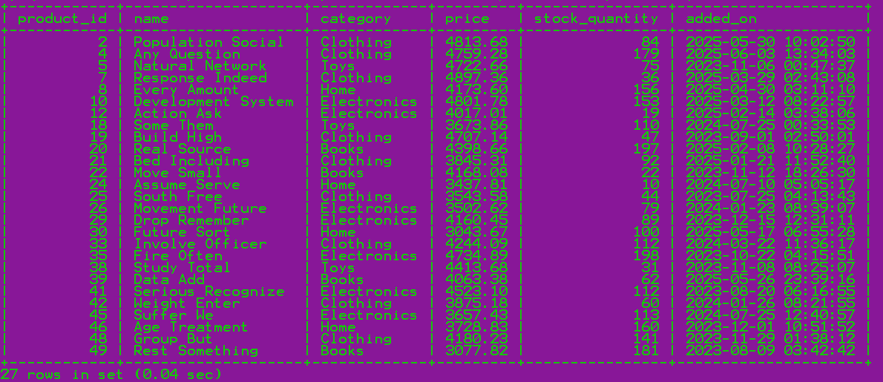

2. Find customers who have placed at least one order
Used to identify active customers for loyalty campaigns.

Query: SELECT * FROM customers WHERE customer_id IN (SELECT DISTINCT customer_id FROM orders);



3. Show orders whose total amount is above the average for that customer
Used to detect unusually high purchases per customer.

Query: SELECT * FROM orders o1 WHERE total_amount > (SELECT AVG(total_amount) FROM orders o2 WHERE o1.customer_id=o2.customer_id);







4. Display customers who haven’t placed any orders
Used for re-engagement campaigns targeting inactive users.

Query: SELECT * FROM customers WHERE customer_id NOT IN (SELECT DISTINCT customer_id FROM orders);
Empty set (0.01 sec)

5. Show products that were never ordered
Helps with inventory clearance decisions or product deactivation.

Query: SELECT * FROM products WHERE product_id NOT IN (SELECT DISTINCT product_id FROM order_items);
Empty set (0.00 sec)

6. Show highest value order per customer
Used to identify the largest transaction made by each customer.

Query: SELECT customer_id, MAX(total_amount) FROM orders GROUP BY customer_id;



7. Highest Order Per Customer (Including Names)
Used to identify the largest transaction made by each customer. Outputs name as well.

Query: SELECT c.name, MAX(o.total_amount) FROM customers c JOIN orders o ON c.customer_id=o.customer_id GROUP BY c.name;



Level 6: Set Operations
1. List all customers who have either placed an order or written a product review
Used to identify engaged customers from different activity areas.

Query: SELECT customer_id FROM orders UNION SELECT customer_id FROM product_reviews;



2. List all customers who have placed an order as well as reviewed a product [intersect not supported]
Used to identify highly engaged customers for rewards.

Query: SELECT customer_id FROM orders INTERSECT SELECT customer_id FROM product_reviews;

