MARKETING FUNNEL & CONVERSION
PERFORMANCE ANALYSIS
Internship Project Report

Prepared by: Abhay
Program: BCA (Bachelor of Computer Applications)
Domain: Data Analytics / Growth Marketing
Analysis Period: 2025-01-01 to 2025-05-05
Tools Used: Python (Pandas, NumPy, Matplotlib) and Microsoft Excel

Table of Contents
1. Project Objective 3
2. Dataset Description 3
3. Tools and Methodology 3
4. Funnel Overview 4
5. Drop-off Analysis 5
6. Channel Performance Analysis 6
7. Revenue and Spend Trend 8
8. Key Findings Summary 9
9. Insights and Recommendations 9
9.1 Reallocate Budget Toward High-ROI Channels 9
9.2 Strengthen the Sales Follow-up Process 9
9.3 Improve Lead Qualification 9
9.4 Optimize Low-CTR Paid Channels 9
9.5 Treat LinkedIn Ads as a Premium, Lower-Volume Channel 9
9.6 Monitor Monthly Trend Continuously 9
10. Conclusion 10

1. Project Objective
This project analyzes marketing funnel data across multiple acquisition channels to understand how potential customers move through each stage of the funnel — from the first impression of an advertisement to becoming a paying customer. The goal is to identify where the business is losing the most potential customers (conversion drop-off), which marketing channels perform best and worst, and which channel delivers the highest return on investment (ROI).
Based on this analysis, the report provides practical, data-backed recommendations to improve lead-to-customer conversion and make marketing budget allocation more efficient.

2. Dataset Description
A synthetic but realistic dataset of 1,000 records was created, covering 8 marketing channels over a daily period from 2025-01-01 to 2025-05-05. Each record represents one channel's performance on one day, and contains the following fields:
Column | Description
Date | Calendar date of the recorded activity
Marketing Channel | Source of traffic (e.g. Google Ads, Email Marketing, Referral)
Impressions | Number of times an advertisement/content was shown
Clicks | Number of users who clicked through
Leads | Visitors who showed interest (e.g. filled a form)
Qualified Leads | Leads verified as genuine sales prospects
Sales Calls | Qualified leads who were contacted/called by sales
Customers | Leads who finally made a purchase
Revenue | Revenue generated from converted customers
Ad Spend | Marketing budget spent on that channel for that day

3. Tools and Methodology
The analysis was carried out using Python, with the Pandas library for data processing and aggregation, and Matplotlib for visualizations. A formula-driven Excel dashboard was also built so the figures stay fully editable and update automatically if the underlying data changes.
- Data Generation: Python (NumPy, Pandas) was used to create the dataset with realistic channel-specific conversion behaviour.
- Funnel Analysis: Stage-by-stage totals were calculated and conversion percentages derived between each pair of stages.
- Channel Comparison: Channels were ranked by CTR, conversion rate, and ROAS to identify top and bottom performers.
- Visualization: Matplotlib charts and an Excel dashboard (with native charts and KPI cards) were created for easy interpretation.

4. Funnel Overview
The table below shows the total volume reached at every stage of the funnel, combined across all 8 channels and the full analysis period.
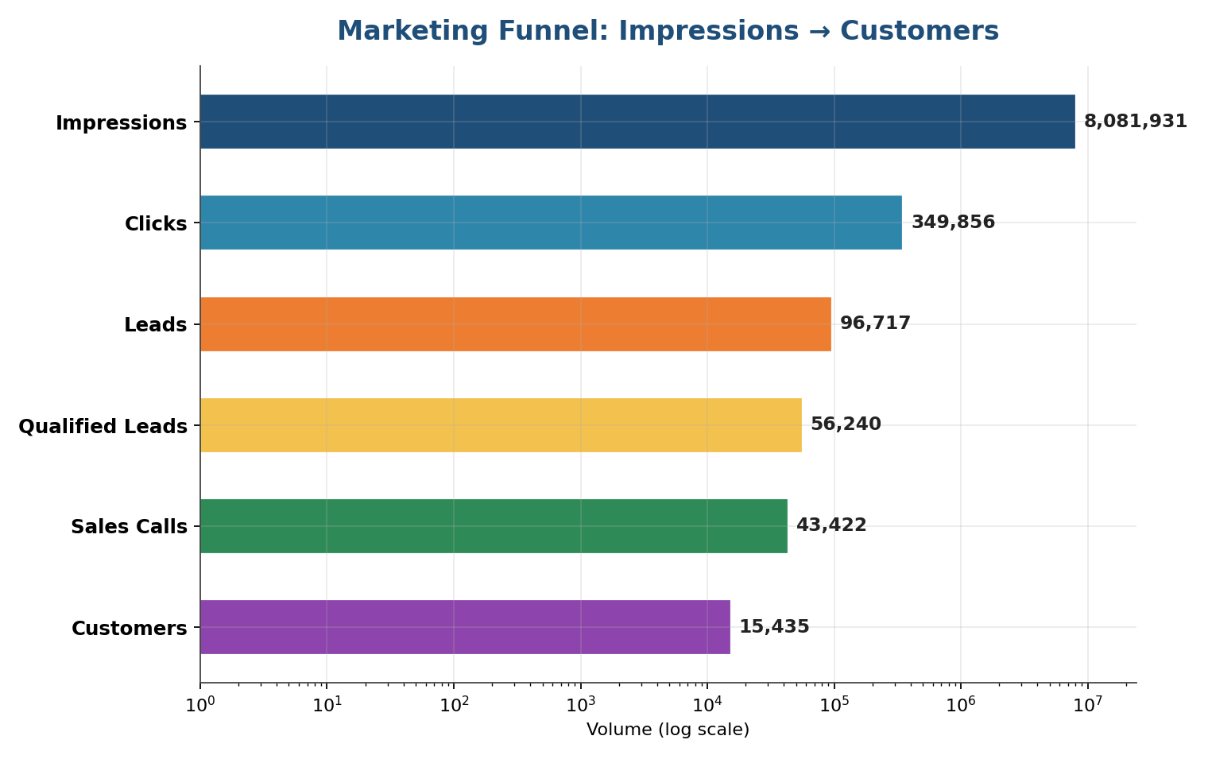
Funnel Stage | Total Volume
Impressions | 80,81,931
Clicks | 3,49,856
Leads | 96,717
Qualified Leads | 56,240
Sales Calls | 43,422
Customers | 15,435
Key Funnel Ratios
- Click-Through Rate (CTR): 4.33%
- Lead Conversion Rate (Clicks to Leads): 27.64%
- Qualification Rate (Leads to Qualified Leads): 58.15%
- Close Rate (Sales Calls to Customers): 35.55%
- Lead-to-Customer Conversion: 15.96%
- Overall Funnel Conversion (Impressions to Customers): 0.19%
- Overall ROAS (Return on Ad Spend): 36.23x — every ₹1 spent on advertising returned ₹36.23 in revenue

5. Drop-off Analysis
Drop-off analysis identifies exactly where the funnel loses the most potential customers. The table and chart below break down the percentage lost at every stage transition.
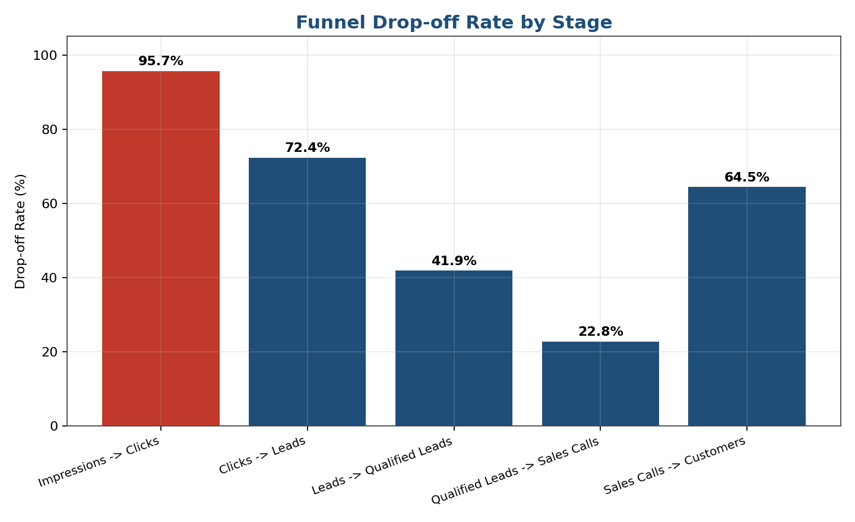
Funnel Stage | Entered | Passed Through | Lost | Drop-off %
Impressions -> Clicks | 80,81,931 | 3,49,856 | 77,32,075 | 95.67%
Clicks -> Leads | 3,49,856 | 96,717 | 2,53,139 | 72.36%
Leads -> Qualified Leads | 96,717 | 56,240 | 40,477 | 41.85%
Qualified Leads -> Sales Calls | 56,240 | 43,422 | 12,818 | 22.79%
Sales Calls -> Customers | 43,422 | 15,435 | 27,987 | 64.45%
Biggest Drop-off
The single largest drop-off occurs at the "Impressions -> Clicks" stage, where 95.67% of all impressions never turn into a click. This is expected in digital marketing since average click-through rates are naturally low (industry CTR benchmarks are usually 1–6%), but it still represents the single largest volume loss in absolute terms (77,32,075 users lost).
A more actionable drop-off is at the "Sales Calls -> Customers" stage, where 64.45% of sales calls do not convert into paying customers (27,987 potential customers lost). Unlike the click-through stage, this stage is directly controlled by the sales process and is the best opportunity for improvement through better sales follow-up, pitch quality, and faster response time.

6. Channel Performance Analysis
Each marketing channel was compared on click-through rate, conversion rate, and return on ad spend (ROAS) to identify which channels are the most efficient at turning impressions into paying customers.
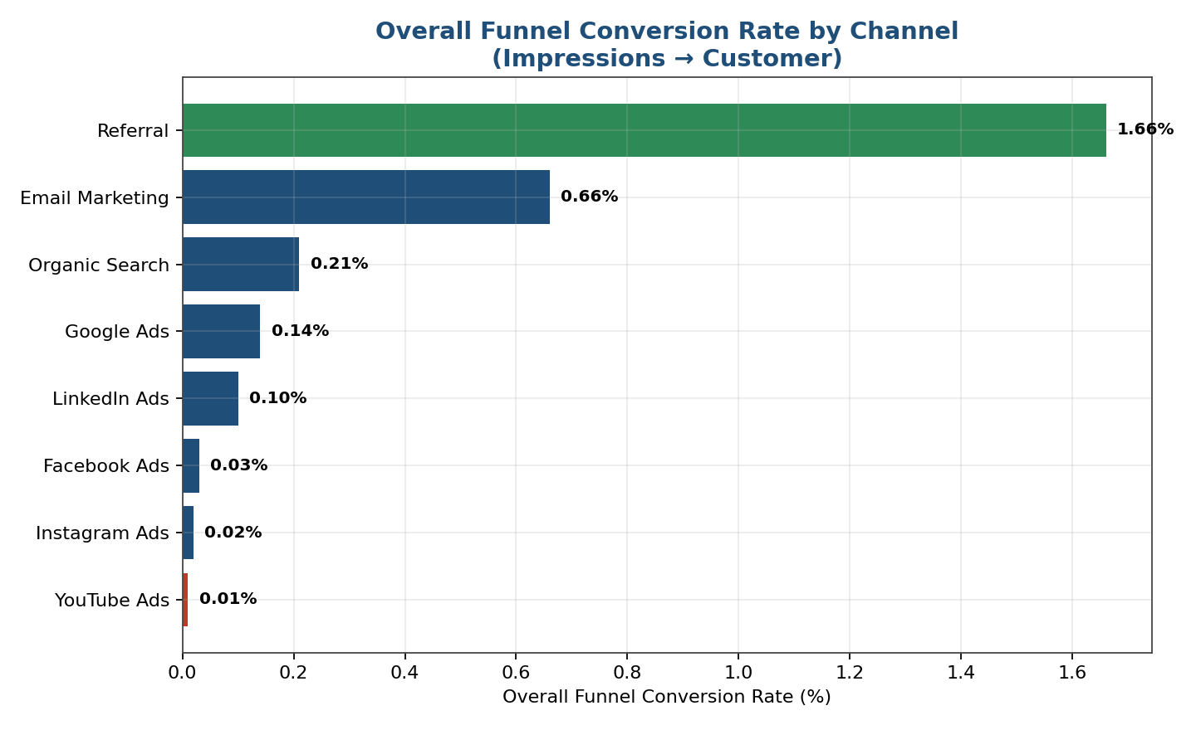
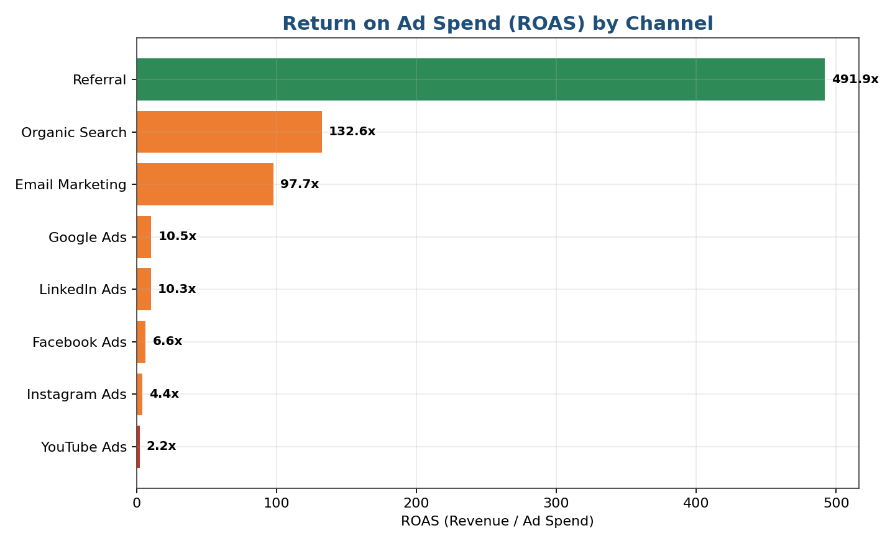
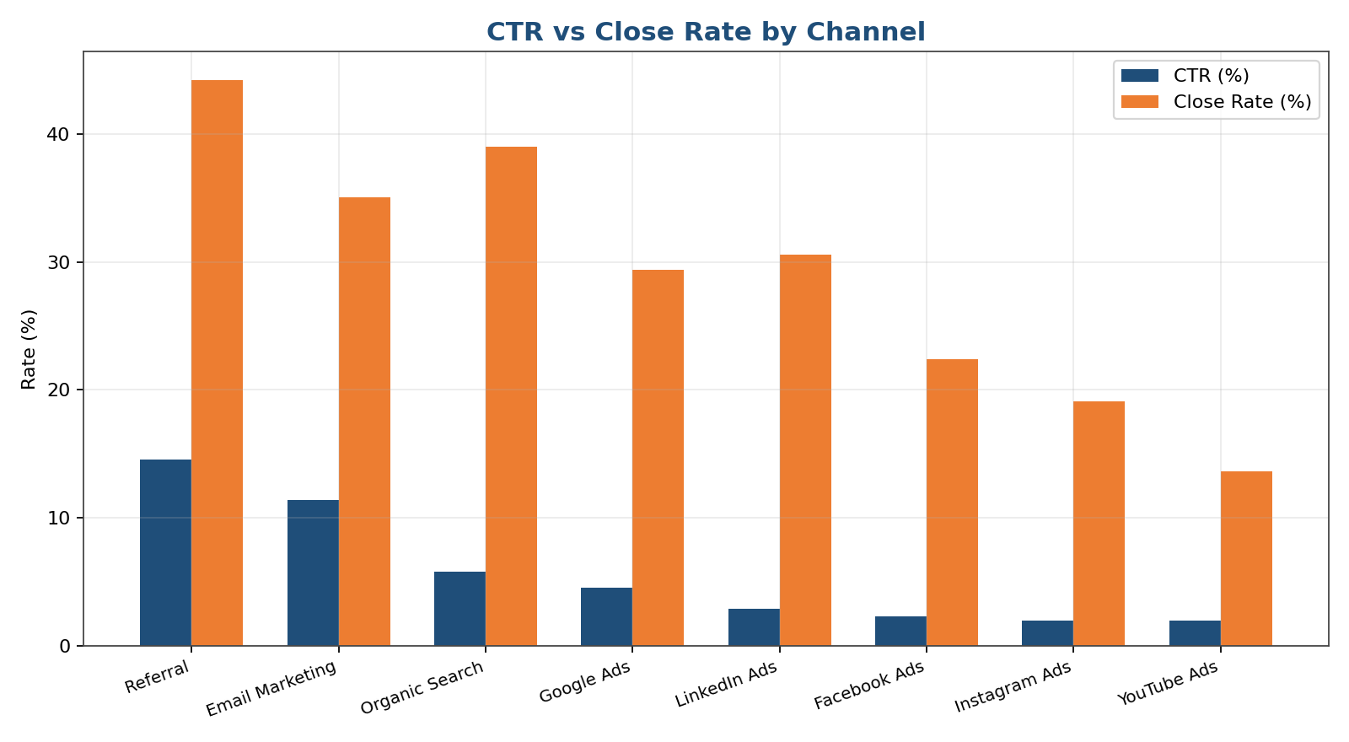
Channel Performance Summary
Channel | Impressions | Clicks | CTR % | Leads | Customers | Conv. % | ROAS
Referral | 3,19,918 | 46,607 | 14.57 | 20,828 | 5,302 | 1.66 | 491.89x
Email Marketing | 6,59,916 | 75,319 | 11.41 | 26,012 | 4,329 | 0.66 | 97.71x
Organic Search | 12,58,572 | 72,730 | 5.78 | 17,231 | 2,673 | 0.21 | 132.61x
Google Ads | 12,02,219 | 54,681 | 4.55 | 13,515 | 1,714 | 0.14 | 10.54x
LinkedIn Ads | 4,50,431 | 13,029 | 2.89 | 2,931 | 440 | 0.10 | 10.35x
Facebook Ads | 16,58,844 | 37,800 | 2.28 | 7,472 | 569 | 0.03 | 6.57x
Instagram Ads | 14,95,263 | 29,262 | 1.96 | 5,016 | 278 | 0.02 | 4.37x
YouTube Ads | 10,36,768 | 20,428 | 1.97 | 3,712 | 130 | 0.01 | 2.22x
Best Performing Channel
Referral has the highest overall funnel conversion rate at 1.66%, helped by a strong CTR of 14.57% and close rate of 44.22%. Customers arriving through this channel are clearly the most ready to buy.
Worst Performing Channel
YouTube Ads has the lowest overall funnel conversion rate at 0.01% and the lowest close rate (13.64%), suggesting that traffic from this channel is less targeted or less ready to convert.
Highest ROI Channel
Referral delivers the highest ROAS at 491.89x, meaning every ₹1 spent returns ₹491.89 in revenue, with a very low cost per customer of ₹17.30.

7. Revenue and Spend Trend
The monthly trend of revenue versus ad spend shows whether marketing investment is translating into proportional revenue growth over time, and the revenue-share chart shows which channels contribute the most to total revenue.
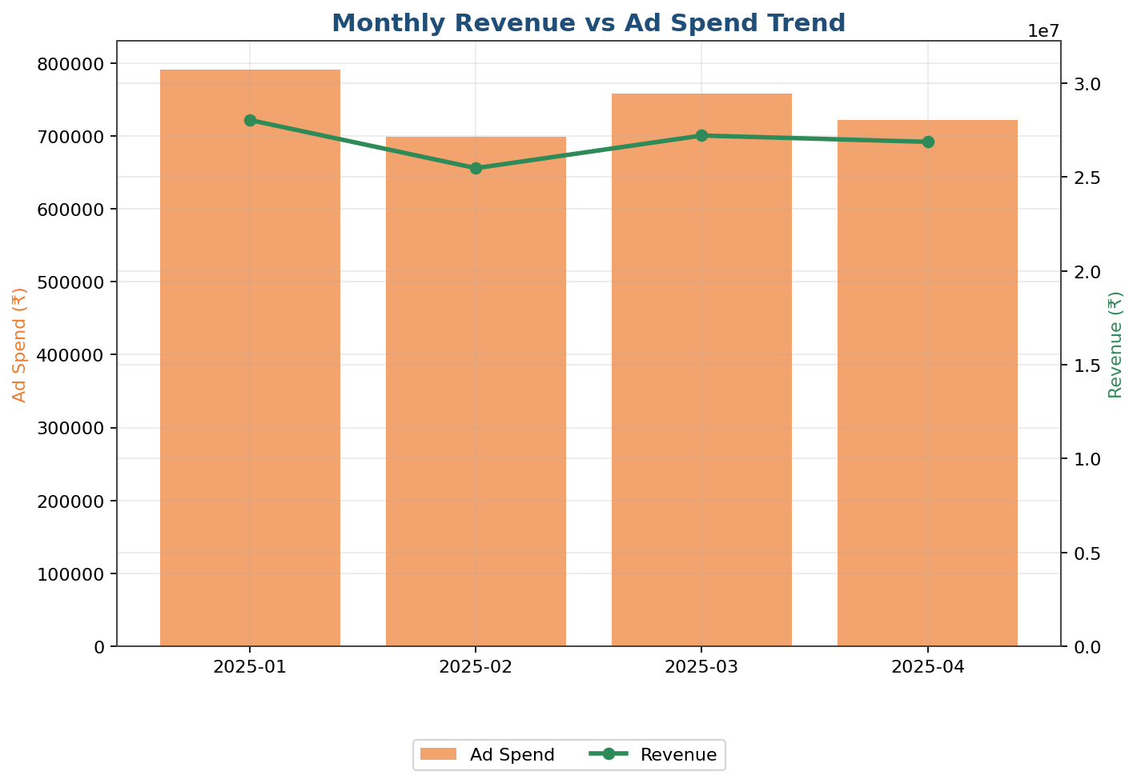
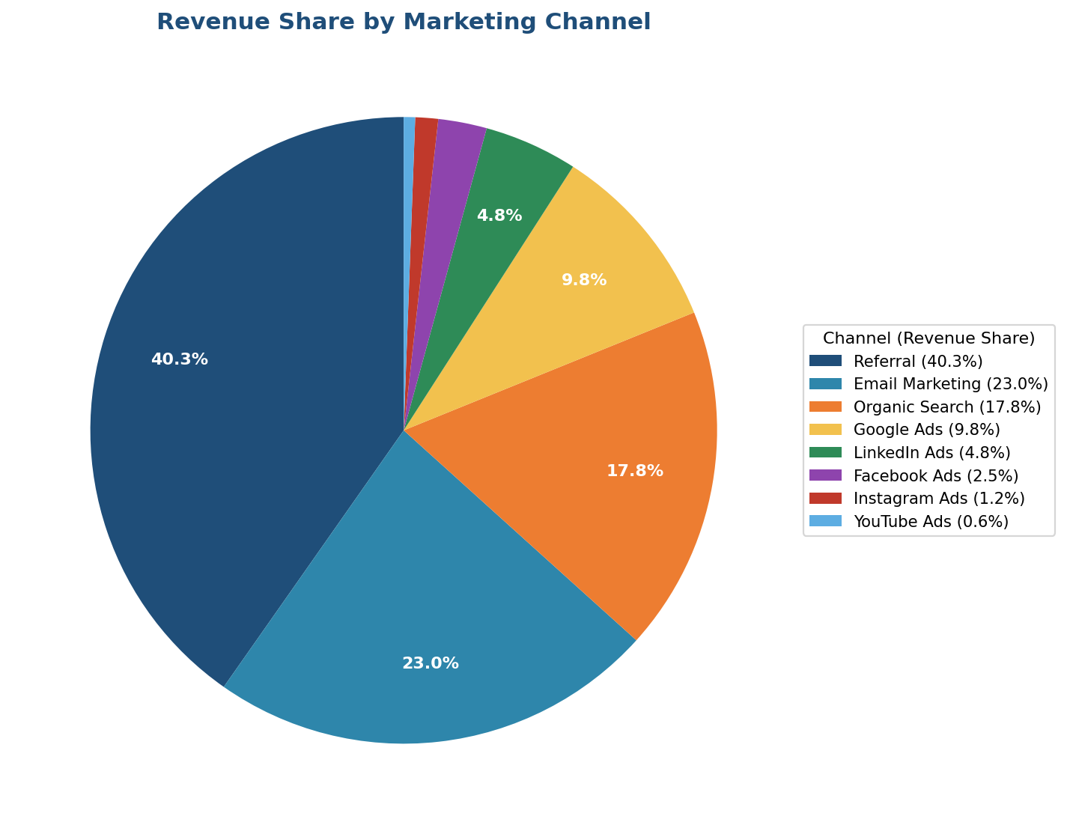

8. Key Findings Summary
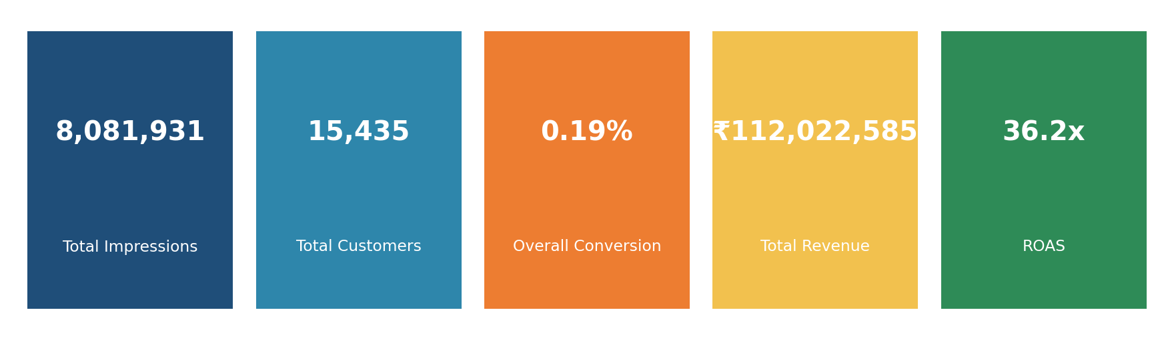
- Total Revenue Generated: ₹11,20,22,585 against Total Ad Spend of ₹30,91,777
- Overall ROAS: 36.23x
- Biggest Drop-off (by volume): Impressions -> Clicks (95.67%)
- Biggest Controllable Drop-off: Sales Calls -> Customers (64.45%)
- Best Channel (Conversion): Referral (1.66% overall conversion)
- Worst Channel (Conversion): YouTube Ads (0.01% overall conversion)
- Highest ROI Channel: Referral (491.89x ROAS)
- Lowest ROI Channel: YouTube Ads (2.22x ROAS)

9. Insights and Recommendations

9.1 Reallocate Budget Toward High-ROI Channels
Referral, Email Marketing, and Organic Search together generate the strongest ROAS and the lowest cost per customer, while Facebook Ads, Instagram Ads, and YouTube Ads generate the weakest returns. Gradually shifting a portion of ad spend away from the weakest paid social channels toward referral incentive programs, email list growth, and SEO/content investment should improve overall marketing efficiency without increasing total budget.

9.2 Strengthen the Sales Follow-up Process
Since 64.45% of sales calls fail to convert into customers, this is the single biggest controllable leak in the funnel. Recommended actions include faster response times to qualified leads, structured follow-up call scripts, sales team training, and personalised offers for high-intent leads.

9.3 Improve Lead Qualification
A significant share of leads (41.85%) do not pass the qualification stage. Refining the lead-scoring criteria and qualifying questions earlier in the funnel can help the sales team focus effort on leads who are genuinely likely to buy.

9.4 Optimize Low-CTR Paid Channels
Channels such as Instagram Ads, Facebook Ads, and YouTube Ads show low click-through rates. A/B testing ad creatives, refining audience targeting, and improving ad copy could raise CTR and reduce wasted impressions.

9.5 Treat LinkedIn Ads as a Premium, Lower-Volume Channel
LinkedIn Ads has a high cost per click but a strong qualification rate, suggesting it attracts a smaller but more serious, higher-value audience. It should be retained for premium/B2B-style lead generation rather than judged purely on volume.

9.6 Monitor Monthly Trend Continuously
Revenue and ad spend should be tracked monthly using the accompanying Excel dashboard so that any sudden drop in ROAS or conversion rate can be caught and acted on early.

10. Conclusion
This analysis shows that the marketing funnel converts 0.19% of total impressions into paying customers overall, generating ₹11,20,22,585 in revenue from ₹30,91,777 in ad spend (36.23x ROAS). While the impression-to-click stage naturally loses the most volume, the sales-call-to-customer stage is the most actionable opportunity for improvement. Referral stands out as the single most efficient channel, leading both in conversion rate and return on ad spend, and deserves increased investment, while YouTube Ads should be optimized or scaled back. Acting on these data-backed recommendations can meaningfully improve lead-to-customer conversion and overall marketing ROI.

