Backend:-

MySQL:

Before execution:-

After execution:-

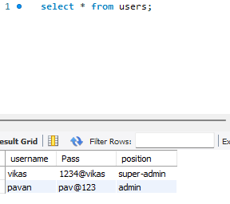

Terminal :

