# Segmentation

## Basics

**Goal**: Find where each musical element starts and ends.

**Input**: Wave.

**Output**: Onset locations.

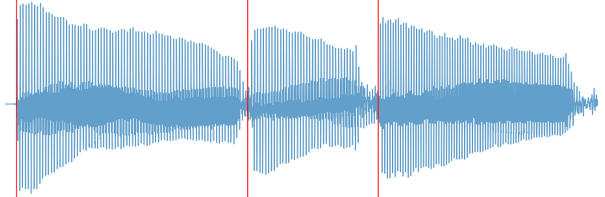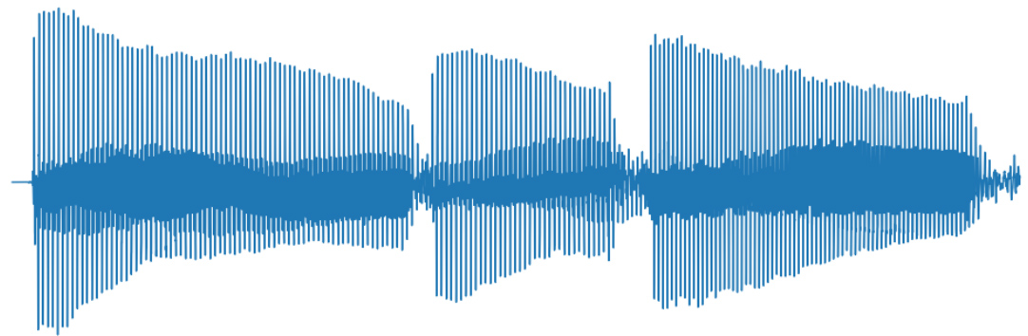

## CRNN segmentation

### Architecture

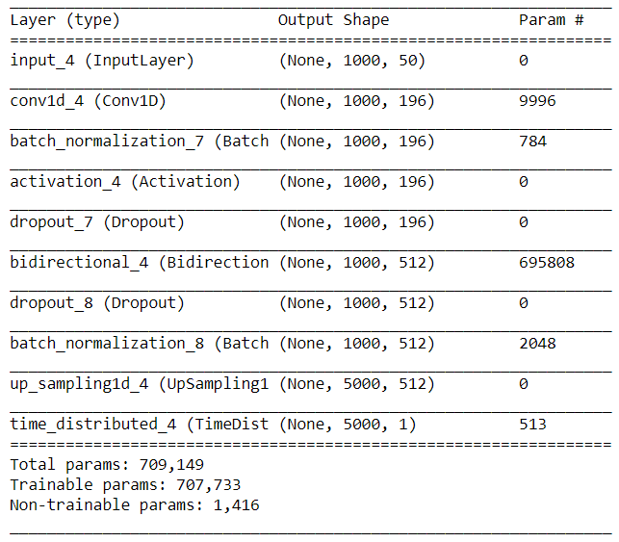

**Input**: 1000 spectrograms consisting of 50 frequencies.

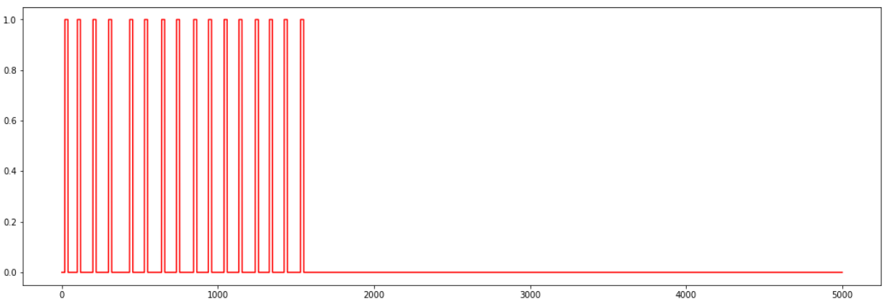**Output**: Step function consisting of 5000 samples indicating onsets.

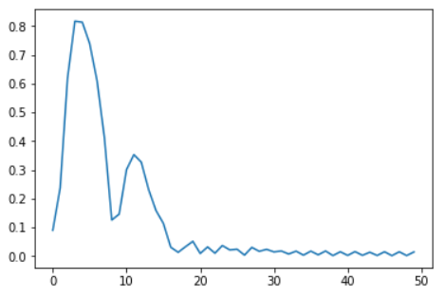

x1000

### Loss function

0.75 * sensitivity_loss(y_pred, y_true) + precision_loss(y_pred, y_true)

where *x*_loss = 1 – *x*

**Sensitivity**: Minimize false negatives.

**Precision**: Minimize false positives.

Seems to work better than binary cross entropy because of the low occurrence of positives.