
UNIVERSIDADE FEDERAL DO RIO GRANDE DO NORTE

Professor: Samaherni Morais Dias
Alunos: Lian Guedes Silva (20160142700)
Atyson Jaime de Sousa Martin (2016012955)

1)
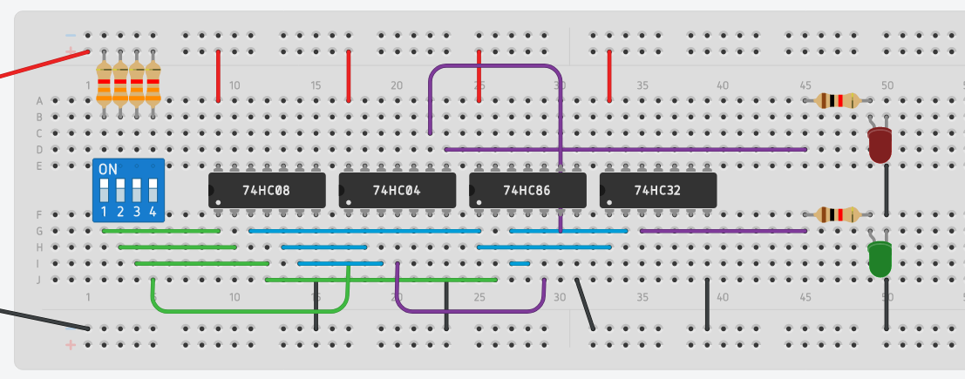
S1 = (A · B) + ((A · B) ⊕ C)
S2 = (((A · B) ⊕ C) ⊕ (C · D’)’ )’

A | B | C | D | S1 | S2
0 | 0 | 0 | 0 | 0 | 0
0 | 0 | 0 | 1 | 0 | 0
0 | 0 | 1 | 0 | 1 | 0
0 | 0 | 1 | 1 | 1 | 1
0 | 1 | 0 | 0 | 0 | 0
0 | 1 | 0 | 1 | 0 | 0
0 | 1 | 1 | 0 | 1 | 0
0 | 1 | 1 | 1 | 1 | 1
1 | 0 | 0 | 0 | 0 | 0
1 | 0 | 0 | 1 | 0 | 0
1 | 0 | 1 | 0 | 1 | 0
1 | 0 | 1 | 1 | 1 | 1
1 | 1 | 0 | 0 | 1 | 1
1 | 1 | 0 | 1 | 1 | 1
1 | 1 | 1 | 0 | 1 | 1
1 | 1 | 1 | 1 | 1 | 0

2)
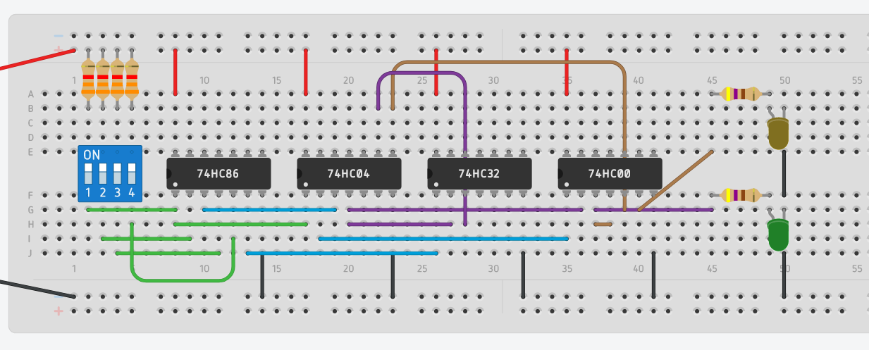
S1 = (A’ · (A ⊕ B)’ )’
S2 = ( (A’ · (A ⊕ B)’ )’ · ( (A ⊕ B)’ + (C ⊕ D))’ )’

A | B | C | D | S1 | S2
0 | 0 | 0 | 0 | 0 | 1
0 | 0 | 0 | 1 | 0 | 1
0 | 0 | 1 | 0 | 0 | 1
0 | 0 | 1 | 1 | 0 | 1
0 | 1 | 0 | 0 | 1 | 0
0 | 1 | 0 | 1 | 1 | 1
0 | 1 | 1 | 0 | 1 | 1
0 | 1 | 1 | 1 | 1 | 0
1 | 0 | 0 | 0 | 1 | 0
1 | 0 | 0 | 1 | 1 | 1
1 | 0 | 1 | 0 | 1 | 1
1 | 0 | 1 | 1 | 1 | 0
1 | 1 | 0 | 0 | 1 | 1
1 | 1 | 0 | 1 | 1 | 1
1 | 1 | 1 | 0 | 1 | 1
1 | 1 | 1 | 1 | 1 | 1

