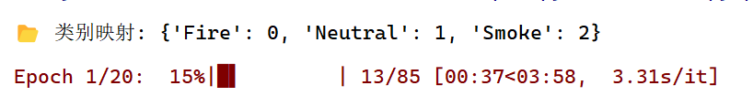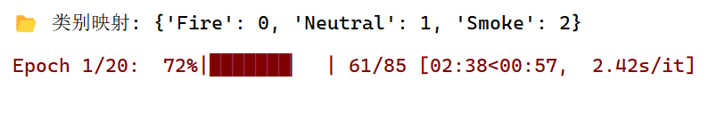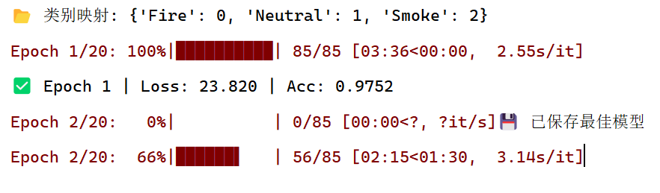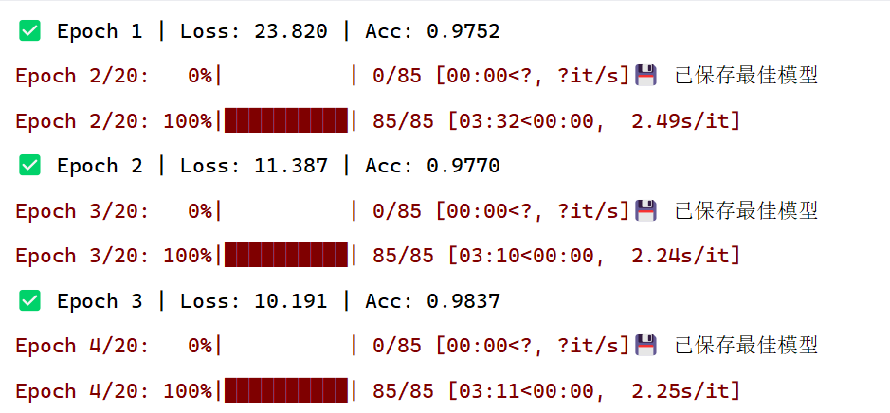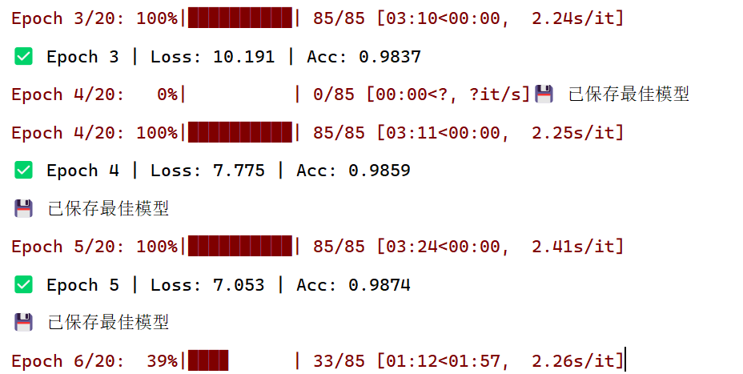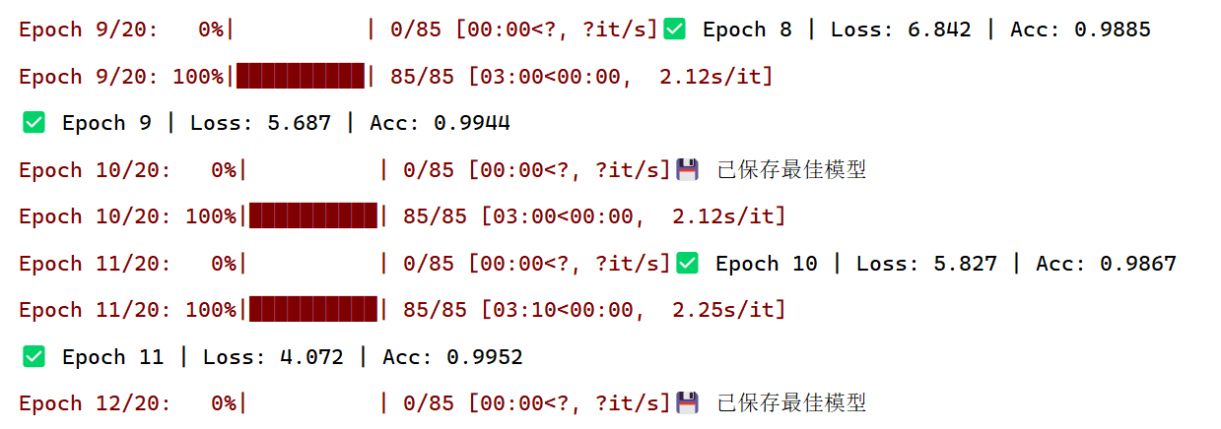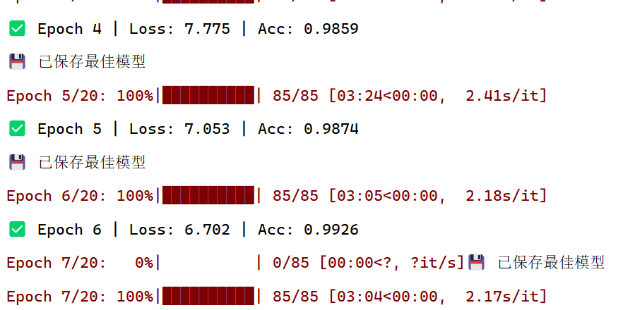

D:\Python_envs\fire-smoke-detection\Scripts\python.exe D:\py_project_end\fire-smoke-detection\video_train.py
📂 类别映射: {'Fire': 0, 'Neutral': 1, 'Smoke': 2}
Epoch 1/20: 100%|██████████| 85/85 [03:36<00:00, 2.55s/it]
✅ Epoch 1 | Loss: 23.820 | Acc: 0.9752
Epoch 2/20: 0%| | 0/85 [00:00<?, ?it/s]💾 已保存最佳模型
Epoch 2/20: 100%|██████████| 85/85 [03:32<00:00, 2.49s/it]
✅ Epoch 2 | Loss: 11.387 | Acc: 0.9770
Epoch 3/20: 0%| | 0/85 [00:00<?, ?it/s]💾 已保存最佳模型
Epoch 3/20: 100%|██████████| 85/85 [03:10<00:00, 2.24s/it]
✅ Epoch 3 | Loss: 10.191 | Acc: 0.9837
Epoch 4/20: 0%| | 0/85 [00:00<?, ?it/s]💾 已保存最佳模型
Epoch 4/20: 100%|██████████| 85/85 [03:11<00:00, 2.25s/it]
✅ Epoch 4 | Loss: 7.775 | Acc: 0.9859
💾 已保存最佳模型
Epoch 5/20: 100%|██████████| 85/85 [03:24<00:00, 2.41s/it]
✅ Epoch 5 | Loss: 7.053 | Acc: 0.9874
💾 已保存最佳模型
Epoch 6/20: 100%|██████████| 85/85 [03:05<00:00, 2.18s/it]
✅ Epoch 6 | Loss: 6.702 | Acc: 0.9926
Epoch 7/20: 0%| | 0/85 [00:00<?, ?it/s]💾 已保存最佳模型
Epoch 7/20: 100%|██████████| 85/85 [03:04<00:00, 2.17s/it]
Epoch 8/20: 0%| | 0/85 [00:00<?, ?it/s]✅ Epoch 7 | Loss: 5.980 | Acc: 0.9893
Epoch 8/20: 100%|██████████| 85/85 [03:02<00:00, 2.14s/it]
Epoch 9/20: 0%| | 0/85 [00:00<?, ?it/s]✅ Epoch 8 | Loss: 6.842 | Acc: 0.9885
Epoch 9/20: 100%|██████████| 85/85 [03:00<00:00, 2.12s/it]
✅ Epoch 9 | Loss: 5.687 | Acc: 0.9944
Epoch 10/20: 0%| | 0/85 [00:00<?, ?it/s]💾 已保存最佳模型
Epoch 10/20: 100%|██████████| 85/85 [03:00<00:00, 2.12s/it]
Epoch 11/20: 0%| | 0/85 [00:00<?, ?it/s]✅ Epoch 10 | Loss: 5.827 | Acc: 0.9867
Epoch 11/20: 100%|██████████| 85/85 [03:10<00:00, 2.25s/it]
✅ Epoch 11 | Loss: 4.072 | Acc: 0.9952
Epoch 12/20: 0%| | 0/85 [00:00<?, ?it/s]💾 已保存最佳模型
Epoch 12/20: 16%|█▋ | 14/85 [00:43<03:41, 3.12s/it]
Traceback (most recent call last):
File "D:\py_project_end\fire-smoke-detection\video_train.py", line 73, in <module>
for imgs, labels in tqdm(train_loader, desc=f"Epoch {epoch+1}/{EPOCHS}"):
File "D:\Python_envs\fire-smoke-detection\Lib\site-packages\tqdm\std.py", line 1181, in __iter__
for obj in iterable:
File "D:\Python_envs\fire-smoke-detection\Lib\site-packages\torch\utils\data\dataloader.py", line 732, in __next__
data = self._next_data()
^^^^^^^^^^^^^^^^^
File "D:\Python_envs\fire-smoke-detection\Lib\site-packages\torch\utils\data\dataloader.py", line 788, in _next_data
data = self._dataset_fetcher.fetch(index) # may raise StopIteration
^^^^^^^^^^^^^^^^^^^^^^^^^^^^^^^^^^
File "D:\Python_envs\fire-smoke-detection\Lib\site-packages\torch\utils\data\_utils\fetch.py", line 52, in fetch
data = [self.dataset[idx] for idx in possibly_batched_index]
^^^^^^^^^^^^^^^^^^^^^^^^^^^^^^^^^^^^^^^^^^^^^^^^^^^^^
File "D:\Python_envs\fire-smoke-detection\Lib\site-packages\torch\utils\data\_utils\fetch.py", line 52, in <listcomp>
data = [self.dataset[idx] for idx in possibly_batched_index]
~~~~~~~~~~~~^^^^^
File "D:\Python_envs\fire-smoke-detection\Lib\site-packages\torchvision\datasets\folder.py", line 247, in __getitem__
sample = self.transform(sample)
^^^^^^^^^^^^^^^^^^^^^^
File "D:\Python_envs\fire-smoke-detection\Lib\site-packages\torchvision\transforms\transforms.py", line 95, in __call__
img = t(img)
^^^^^^
File "D:\Python_envs\fire-smoke-detection\Lib\site-packages\torch\nn\modules\module.py", line 1775, in _wrapped_call_impl
return self._call_impl(*args, **kwargs)
^^^^^^^^^^^^^^^^^^^^^^^^^^^^^^^^
File "D:\Python_envs\fire-smoke-detection\Lib\site-packages\torch\nn\modules\module.py", line 1786, in _call_impl
return forward_call(*args, **kwargs)
^^^^^^^^^^^^^^^^^^^^^^^^^^^^^
File "D:\Python_envs\fire-smoke-detection\Lib\site-packages\torchvision\transforms\transforms.py", line 1276, in forward
img = F.adjust_contrast(img, contrast_factor)
^^^^^^^^^^^^^^^^^^^^^^^^^^^^^^^^^^^^^^^
File "D:\Python_envs\fire-smoke-detection\Lib\site-packages\torchvision\transforms\functional.py", line 907, in adjust_contrast
return F_pil.adjust_contrast(img, contrast_factor)
^^^^^^^^^^^^^^^^^^^^^^^^^^^^^^^^^^^^^^^^^^^
File "D:\Python_envs\fire-smoke-detection\Lib\site-packages\torchvision\transforms\_functional_pil.py", line 86, in adjust_contrast
img = enhancer.enhance(contrast_factor)
^^^^^^^^^^^^^^^^^^^^^^^^^^^^^^^^^
File "D:\Python_envs\fire-smoke-detection\Lib\site-packages\PIL\ImageEnhance.py", line 40, in enhance
return Image.blend(self.degenerate, self.image, factor)
^^^^^^^^^^^^^^^^^^^^^^^^^^^^^^^^^^^^^^^^^^^^^^^^
File "D:\Python_envs\fire-smoke-detection\Lib\site-packages\PIL\Image.py", line 3601, in blend
return im1._new(core.blend(im1.im, im2.im, alpha))
^^^^^^^^^^^^^^^^^^^^^^^^^^^^^^^^^
KeyboardInterrupt

进程已结束，退出代码为 -1073741510 (0xC000013A: interrupted by Ctrl+C)

