Dear {{ name }},

{% if name == “Marty” %}

If my calculations are correct, you will receive this letter immediately after you saw the DeLorean struck by lightning. First, let me assure you that I am alive and well. I've been living happily these past eight months in the year 1885.

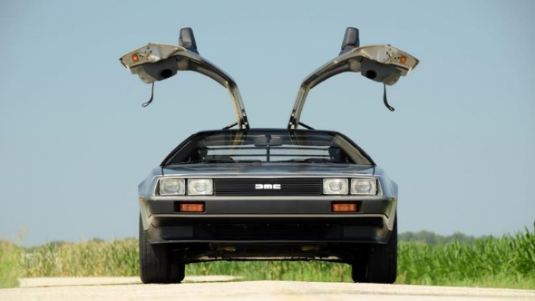

{% else %}

It is with great excitement and enthusiasm that I write to you about a programming language that has, quite literally, stood the test of time – Python!

In this era of rapid technological advancement, where the DeLorean is but a quaint relic of my own escapades, Python has emerged as a programming language that transcends the ages. Its simplicity, readability, and versatility make it a formidable tool for the scientific minds of both the present and the past. Here's a quick breakdown:

|  |  |
| --- | --- |
| Aspect | Praise |
| **Readability** | Clear syntax akin to the flux bands on my DeLorean. |
| **Versatility** | A companion for data manipulation, algorithm crafting, and beyond. |
| **Community** | An ever-growing, collaborative community across epochs. |
| **Adaptability** | Thrives on various platforms, navigating the coding time-stream. |

May Python guide your coding odyssey, as you embark on byte-sized victories across the ages.

{% endif %}

*Temporal Regards,*

*Doc*