Submatrix

Problem Description
Given the following definition:
Submatrix: A new matrix formed by selecting the intersection positions of some rows and some columns from a matrix (keeping the relative order of rows and columns) is called a submatrix of the original matrix.
For example, in the left image below, select the elements at the intersection of rows 2 and 4 and columns 2, 4, and 5, and get a 2*3 submatrix as shown in the right image.

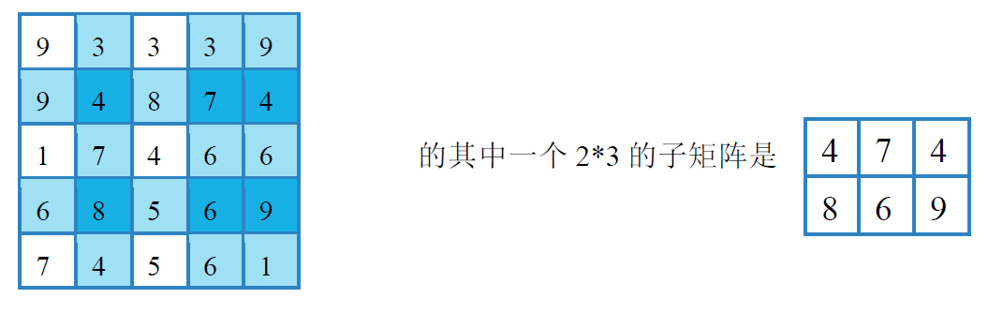


One of its submatrixes is:

Adjacent elements: An element in a matrix is adjacent to the four elements above, below, on its left, and on its right (if any).
The score of a matrix: The sum of the absolute values of the differences between each pair of adjacent elements in the matrix.
Task: Given a positive integer matrix with n rows and m columns, select a submatrix with r rows and c columns from the matrix such that the score of the submatrix is minimized, and output the score.

Input
The first line contains four integers n, m, r, and c, separated by a space between every two integers. The meanings of these integers are as described in the problem description.
The next n rows, each containing m integers separated by spaces, are used to represent that matrix with n rows and m columns in the problem description.

Output
The output consists of one row which contains an integer representing the minimum score of the submatrix that satisfies the problem description.

Sample Input
5 5 2 3
9 3 3 3 9
9 4 8 7 4
1 7 4 6 6
6 8 5 6 9
7 4 5 6 1

Sample Output
6

Hint
For 50% of the data, 1 ≤ n ≤ 12, 1 ≤ m ≤ 12, and every element in the matrix satisfies: 1 ≤ a[i][j] ≤ 20;
For 100% of the data, 1 ≤ n ≤ 16, 1 ≤ m ≤ 16, and every element in the matrix satisfies: 1 ≤ a[i][j] ≤ 1000, 1 ≤ r ≤ n, 1 ≤ c ≤ m.

