Sum

Problem Description
A long, narrow strip of paper is evenly divided into n squares, numbered from 1 to n. Each square is colored by color_i (represented by an integer in [1,m]) and a number_i is written on it.
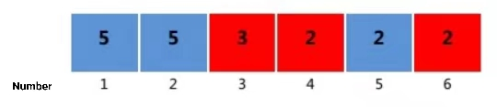
Now define a special triplet: (x,y,z), where x, y, z represent the number of the square on the tape. The triplet should satisfy the following two conditions:
x, y, z are integers, x<y<z, y−x=z−y
colorx=colorz
The score of a triple satisfying the above condition is specified as (x+z)×(number_x+number_z). The score of the whole tape is prescribed as the sum of the scores of all triples that satisfy the condition. This score can be quite large; you should output the remainder of the score of the entire tape divided by 10,007.

Input
The first row is two positive integers n and m separated by a space, where n represents the number of squares on the tape and m represents the number of types of colors on the tape.
The second row has n positive integers separated by spaces, and the i^{th} number is the number written on the i square on the tape.
The third row has n positive integers separated by spaces, and the i^{th} number indicates the color of the i square on the tape.

Output
An integer representing the remainder of the score of the tape divided by 10007.

Sample Input
6 2
5 5 3 2 2 2
2 2 1 1 2 1

Sample Output
82

Hint
[Explanation of sample 1]
The tape is shown in the figure in the problem description.
All triples that satisfy the condition are: (1, 3, 5), (4, 5, 6).
So the score of the tape is (1+5)×(5+2)+(4+6)×(2+2)=42+40=82.

For the data from group 1 to group 2, 1≤ n≤100, 1≤m≤5;
For the data from group 3 to group 4, 1≤ n≤3000, 1≤m≤100;
For the data from groups 5 to 6, 1≤ n≤100000, 1≤m≤100000, and there is no color with more than 20 occurrences;
For the whole 10 data sets, 1≤n ≤100000, 1≤m≤100000, 1≤color_i≤ M, 1≤number_i≤100000.

