Date: July 19, 2022

SISC/QSF-OIR-015

Rev. 002 08/23/21

I, Aubrey Juliet L. Bantolo, hereby declare that this paper entitled ISA: A mobile-based system application for invoice monitoring for BELERON Enterprises is of my original work and that, to the best of my knowledge and belief, it neither does contain any material previously published or written by another person nor material to which to a significant extent has been accepted for grant of any other academic degree or diploma of any other higher education institution, lest due acknowledgement is made in the text.

I hereby also declare that the intellectual content of this thesis is the product of my effort and labor, though I may have been assisted by others in terms of style, presentation, and language expression.

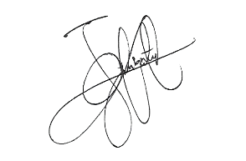

TurnItIn™ Similarity Index: ___17%___

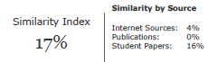

Aubrey Juliet L. Bantolo

**Student Researcher**

Endorsed by: Noted by:

**Aris E. Ignacio, DIT, MCP, MCE** **Ruel A. Cajili, RPm, PhDc**

**Research Adviser College Research Head**

Approved by:

**Aris E. Ignacio, DIT, MCP, MCE**

**College Dean**

