Evan Akers

Salyee Dharne

Kyle O’Connor

Smit Patel

Lab 8

Linked lists utilize the functionality of pointers and are more dynamic than arrays. Linked lists allow data to be stored without knowing the size of the list, and is only limited in size by memory. While they are not quick to sort, they are very useful when there are a lot of adding and removing, because only one pointer is changed and no shifting occurs.

**Task 2 screenshot**

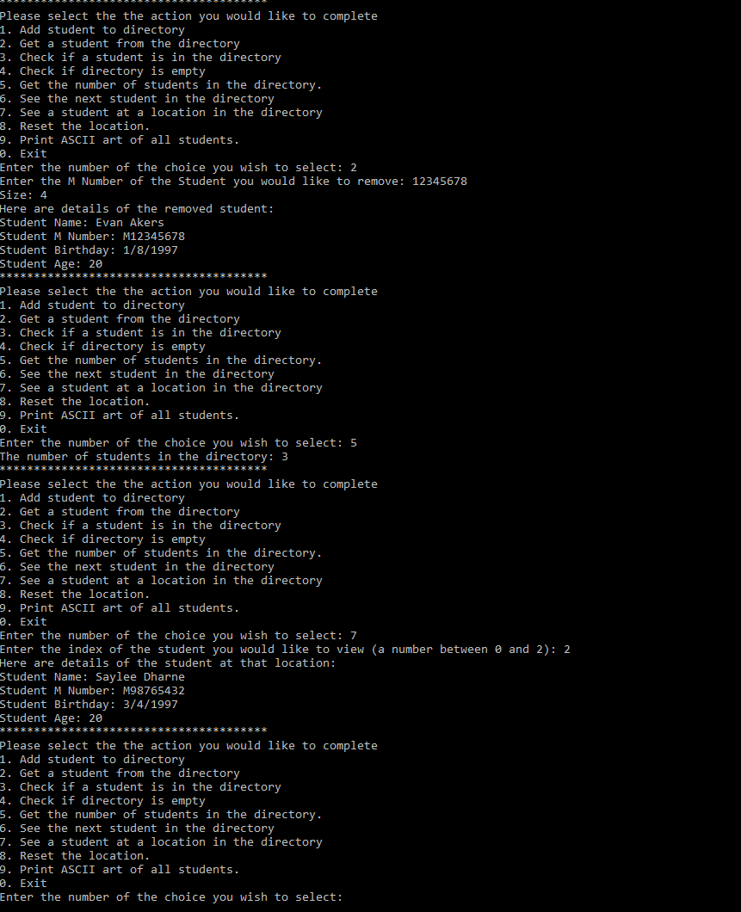

**Task 4**

Code for task 4 wasn’t implemented until then so no code was modified, only added to the list and student class.

Key information was name and Mnumber because task 4 was designed as a Bearcat card printer, and only those members are found on the card.

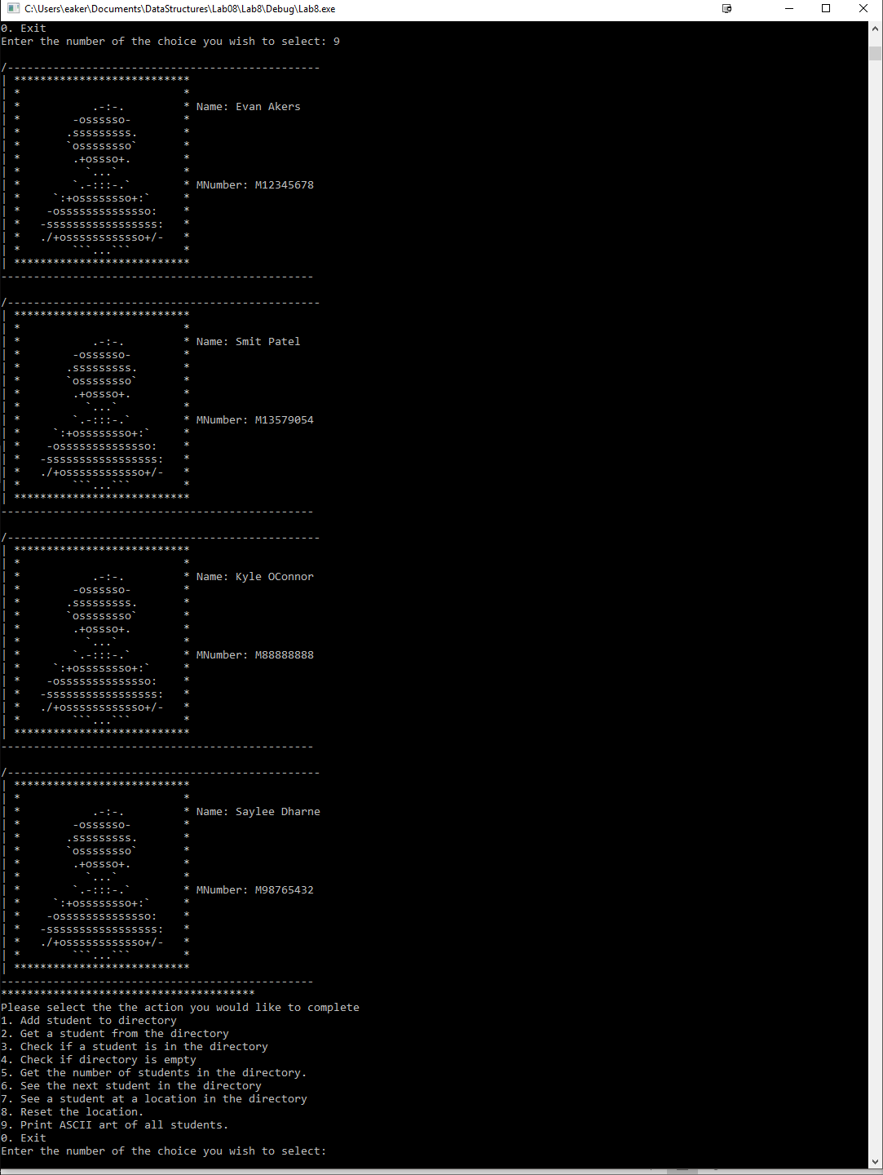

Compilation Instructions

This has been tested by creating a new project within Visual Studios with the following options:

Win32 Console Application

Create directory for solution OFF

Empty project ON

Precompiled header OFF

SDL OFF

Then:

Add the following files to the projext:

1. LinkedList.h
2. Lab08Task03TestProgram.cpp

Build and run

Contribution of Team Members

Each person wrote the portion of the lab report for their task,

Kyle O’Connor did task 1 (before spring break)

Smit Patel did task 2

Saylee Dharne did task 3

Evan Akers did task 4 and lab report