We implement AlexNet model classification on CIFAR-10.

Here is the model structure of AlexNet. We construct this model using Tensorflow Keras and follow the architecture mentioned in the reference paper [*ImageNet Classification with Deep Convolutional Neural Networks*](http://www.cs.toronto.edu/~fritz/absps/imagenet.pdf) *.*

There are 8 layers with weight including 5 convolutional layers and 3 fully-connected layers.

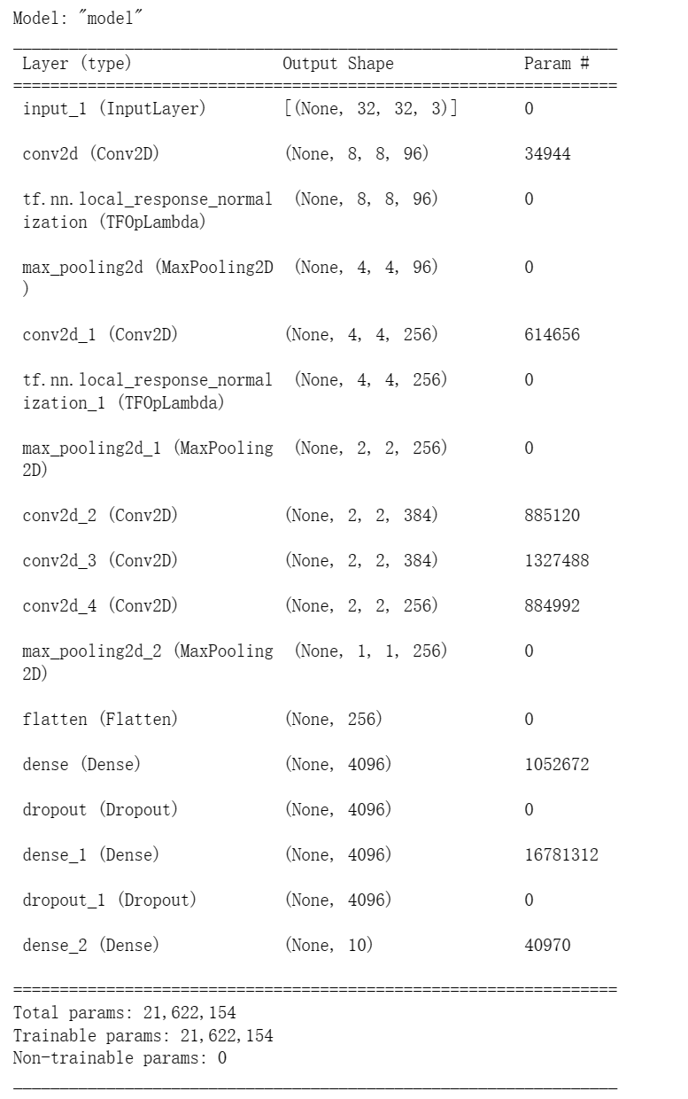

As you can see in the picture of the model structure. In this model, Relu is the activation function used in every convolutional layer. There are two local response normalization layers, one is behind the first convolutional layer, and another is behind the second convolutional layer. There are three MaxPooling layers in the model, and two MaxPooling layers are behind the first convolutional layer and the second convolutional layer following the local response normalization layer. The last MaxPooling layer is behind the fifth convolutional layer. In the end, we use dropout which are in the fully-connected layers to reduce the overfitting. Since the CIFAR-10 dataset has only 10 class, we add the last softmax layer with 10 outputs.

Here is the code of every layer in the model:

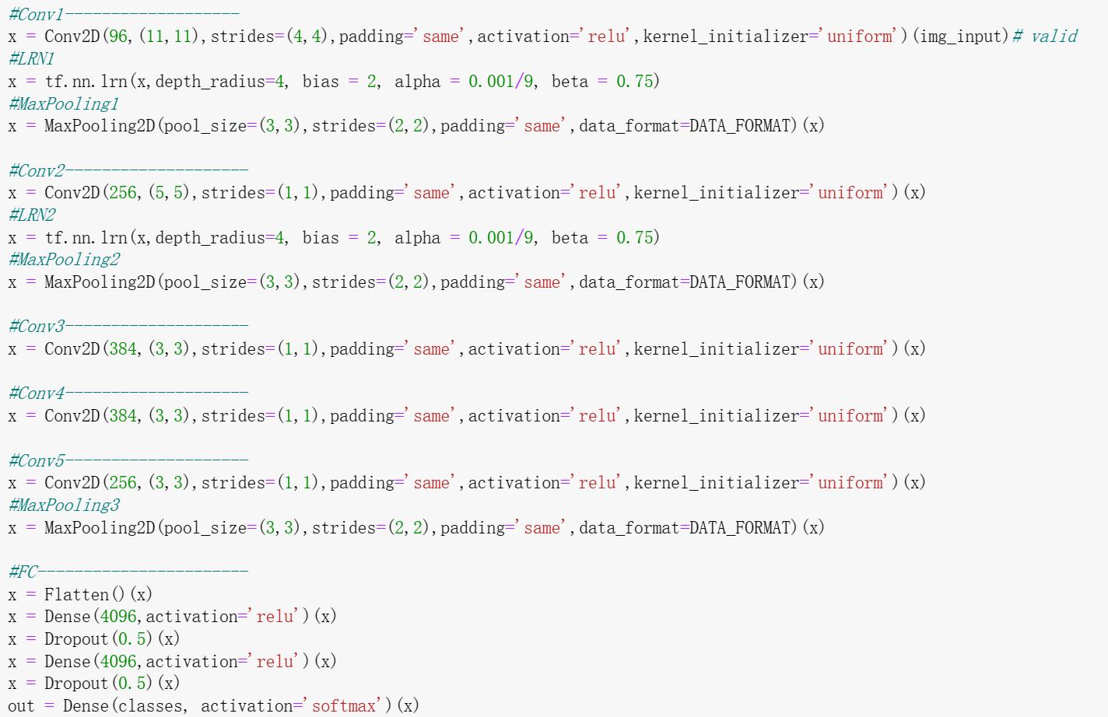

After fitting the model, we train the CIFAR-10 datasets with 10 epochs and 64 batch size. The following graph shows the accuracy and the loss of the training and validation.

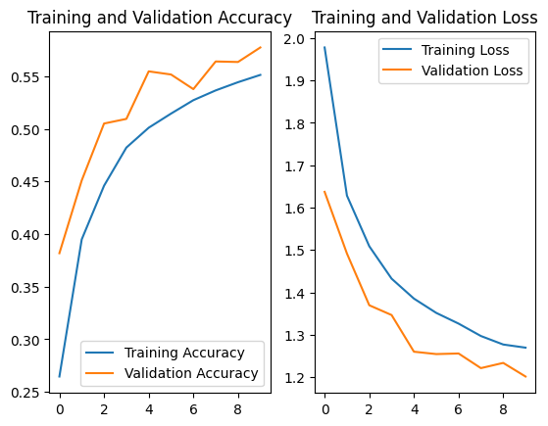

From the diagram, we found that as the epochs getting bigger (the number of parameters increasing), the accuracy become higher and reaches 55%, while loss become smaller.

Since we want to compare the performance of different models, we unify the epochs=10. So the maximal accuracy of Alex model here is only around 55%. But if we set the epochs to over 300, we can get close to 100%.

We also implement AlexNet by modify every layer in class.

