Experiments

In this section, we implement Efficient Net model classification on CIFAR-10.

* 1. EfficientNetB0-B7 Classification on CIFAR-10

Here we construct Efficient Net model families base on Keras Appications. The used function reference paper is [EfficientNet: Rethinking Model Scaling for Convolutional Neural Networks](https://arxiv.org/abs/1905.11946) (ICML 2019). Keras implement function returns this image classification model, with changeable weights and hyper-parameters. In this EfficientNet Keras Application model, input preprocessing is included as part of the model, which means the input of model already has the probability of preprocessing. Here for experiment, we use pre-trained weights on ImageNet and then do classification on 10-Class dataset CIFAR-10 and do show model EfficientNetB0-B7 parameter numbers and training accuracy and loss with validation accuracy and validation loss.

Since CIFAR-10 dataset has only 10 classes, we add a softmax layer as last layer with 10 outputs.

Here we train on 50000 samples, validate on 10000 samples.

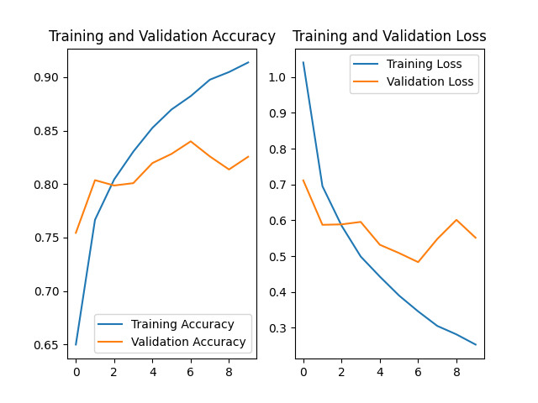

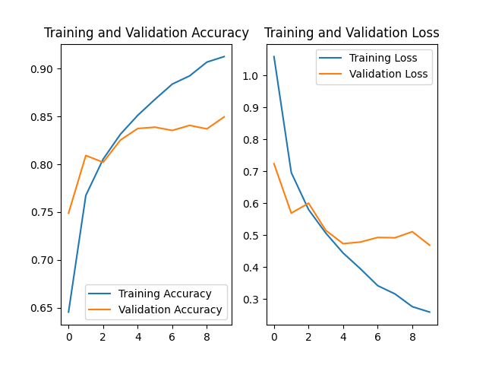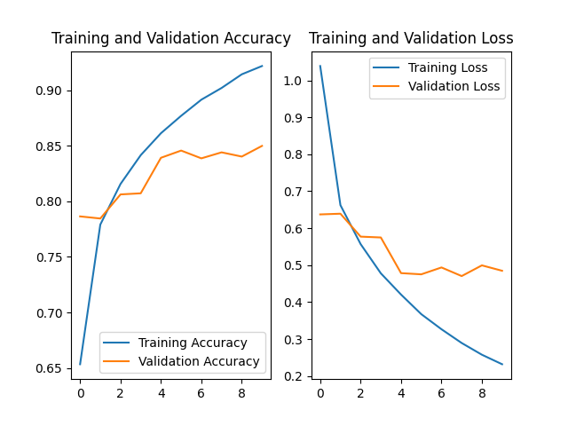

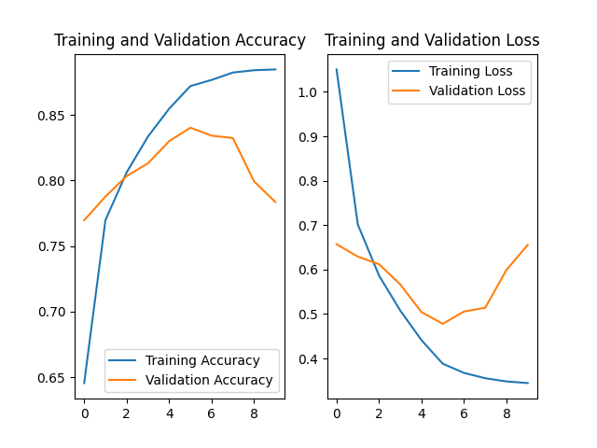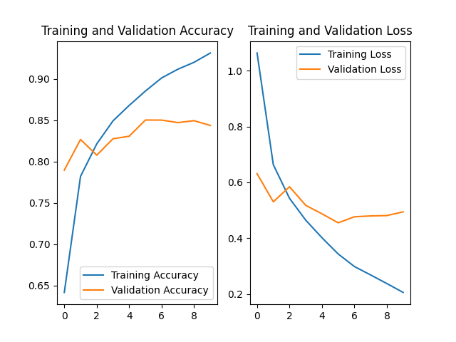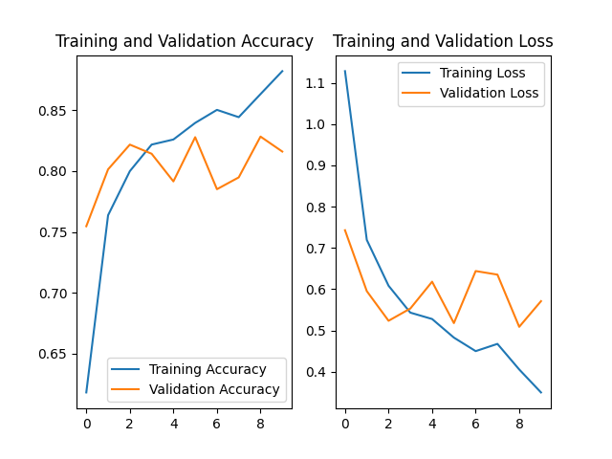

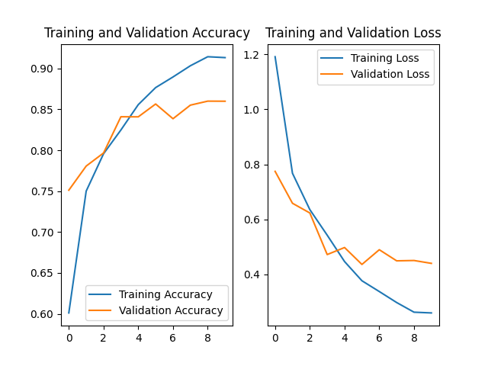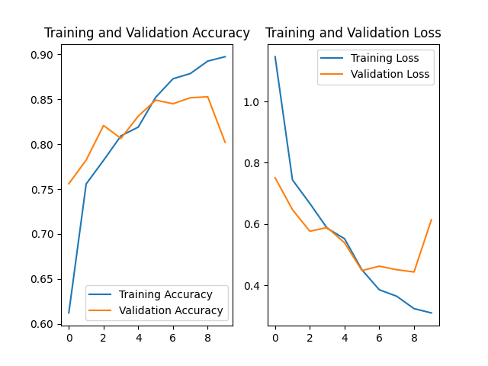

From these diagrams, we can see that as parameters become more and more, accuracy may not become better within same epochs.

Table below shows each model training parameter numbers and total number:

|  |  |  |  |
| --- | --- | --- | --- |
| Model Name | Total Params | Trainable Params | Non-trainable Params |
| EfficientNetB0 | 4,062,374, | 4,020,358 | 42,016 |
| EfficientNetB1 | 6,588,042 | 6,525,994 | 62,048 |
| EfficientNetB2 | 7,782,652 | 7,715,084 | 67,568 |
| EfficientNetB3 | 10,798,898 | 10,711,602 | 87,296 |
| EfficientNetB4 | 17,691,746 | 17,566,546 | 125,200 |
| EfficientNetB5 | 28,534,010 | 28,361,274 | 172,736 |
| EfficientNetB6 | 40,983,186 | 40,758,754 | 224,432 |
| EfficientNetB7 | 64,123,290 | 63,812,570 | 310,720 |

From B0 to B7, the number of feature maps increased, which also cause the number of parameters increase. But compare to previous models, number of parameters in EfficientNet family is quite low.

Here, I give the table from original paper (Tan et al., 2019), showing that EfficientNet families use less parameters but provide better results.

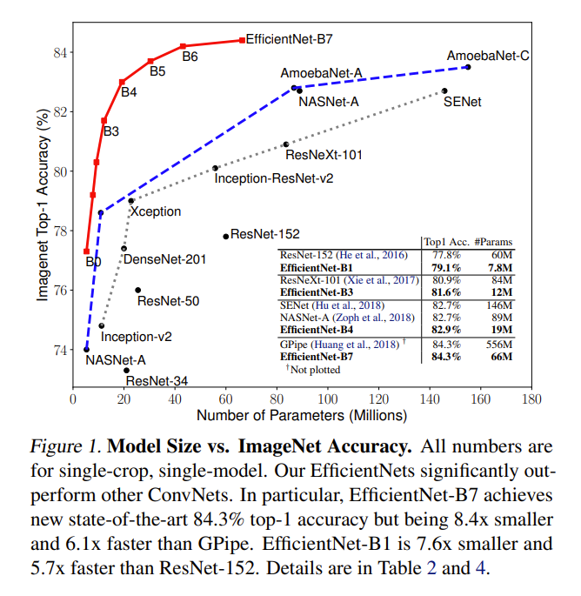

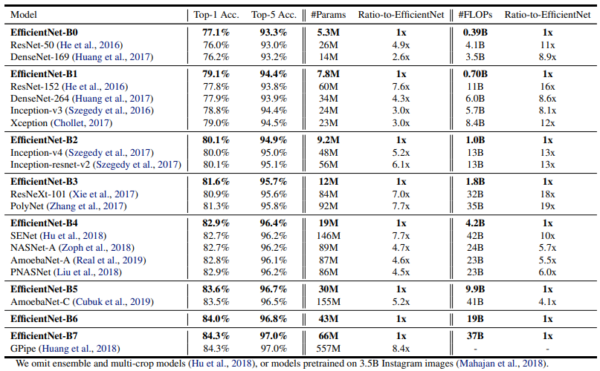

* 1. EfficientNetB0 with pretrained weights

Here we use EfficientNetB0 with pre-trained weights from ImageNet and without initial weight parameters to train on CIFAR-10 dataset.

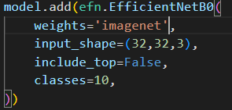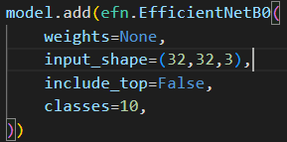

1. ImageNet weights



(b) No pre-trained weights

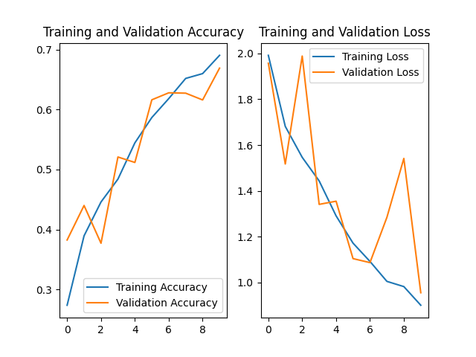

As shown in (a) and (b), pre-trained weights can result in huge improvement in accuracy and loss. With 10 epochs, model train by random initialization can only reach an accuracy of nearly 70%, which is quite lower than pre-trained weights. Besides, loss variate a lot if no pre-trained weights given.