Cifar-10 is an encapsulated data set, which includes 10 categories of things. Let's take a look at the effect of cifar10 classification based on Lenet-5.

The structure of Lenet5:

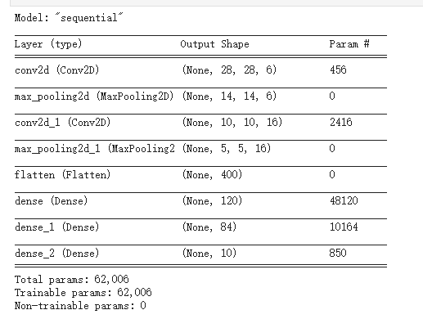

In this experiment, we set batch size=128, epoch=50,

Visualization of results:

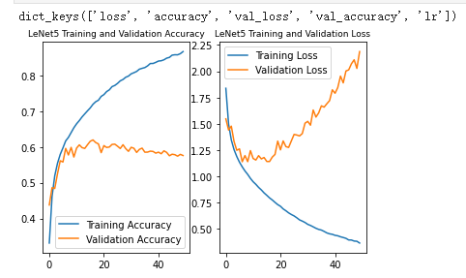

Since it is the earliest convolutional neural network, it has no very high accuracy rate, only about 60%. We can clearly see that the overfitting of the model is quite serious. It is normal to have such deficiencies.

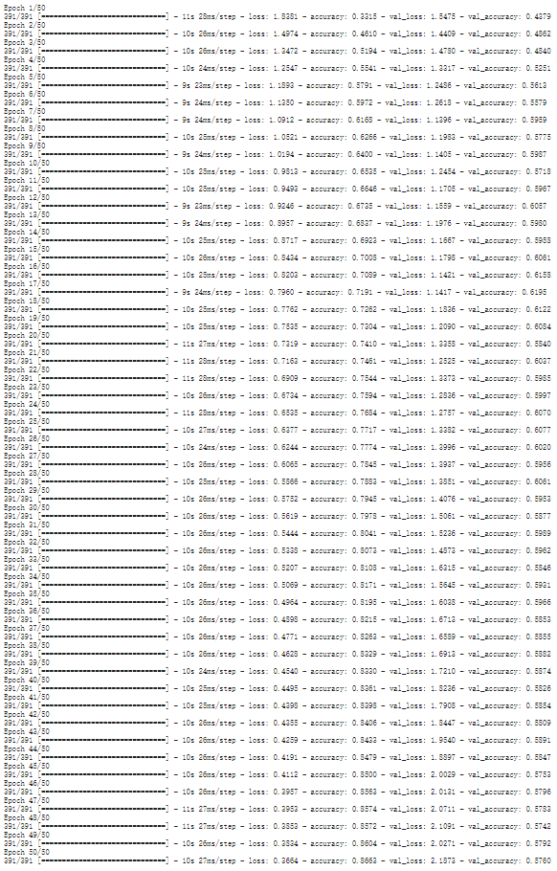

What’s more, the accuracy of epochs has not been improved since it was increased from 50 to 180. This proves that simply increasing the number of epochs cannot improve the accuracy of the model.

Compared with VGG, the lenet5 with 40 epochs can achieve the effect of VGG with 10 epochs. But validation still is bad.