In this section, we implement Resnet model classification on CIFAR-10.

Here we construct Resnet base on Keras Applications. Here for the experiment, we do classification on 10-Class dataset CIFAR-10 and show model Resnet parameter numbers and training accuracy and loss with validation accuracy and validation loss.

Since CIFAR-10 dataset has only 10 classes, we add a softmax layer as the last layer with 10 outputs.

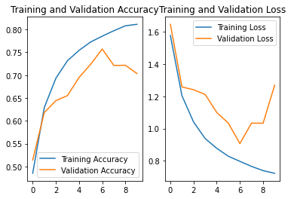

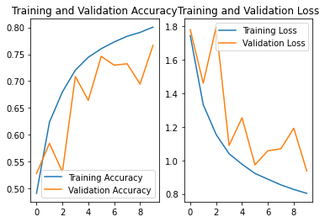

The first picture is Resnet 1, and the second model is Resnet 2. According to the above pictures, we can know that the second one’s accuracy trend is higher than the first one. And the loss trend is smaller than the first one. As a result, Resnet 2 is much better than Resnet 1.