VGG16

Here we construct VGG16 model by using Keras package.

We define the layers of VGG16 and add them to the model.

And here is the information of the model we constructed.

We can see that the total number of parameters is 33,638,218. We change the shape of output layer from 1000 to 10, because we need to fit the cifar-10 datasets.

After we constructed this model, we put the cifar-10 datasets into this model to do the training.

First, we do the data preprocessing in order to fit the input shape of this model.

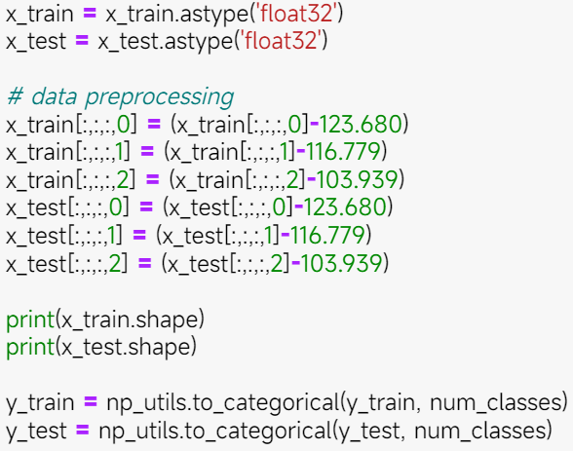

Add we use the weight from imageNet to train this model.

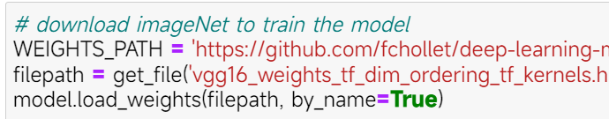

We set the optimizer as SGD and set the learning rate as 0.01.

Then we can use cifar-10 to train the model.

Then we can plot this result.

We can find that the more epochs the model are, the higher the training accuracy is, but the validation may decrease since it may overfit. After 10 epochs training, the accuracy of this model can be more than 80%. If we do more training, the accuracy may even higher than 90%.

We also design a VGG19 model, which has more layers and parameters.

And the training accuracy is better than VGG16, but the validation accuracy is lower than VGG16. It seems that the model which has more layers is easier to overfit.

